# Tables

Table 2.1. Studies of Pacific cod natural mortality and statistics on the combined values. Use? Column indicates whether the value was used in developing this year’s assessment model prior on natural mortality.

|  |  |  |  |  |  |  |  |
| --- | --- | --- | --- | --- | --- | --- | --- |
| **Area** | **Author** | **Year** | **Value** | **ln(value)** | **Use?** | **Statistics** | |
| EBS | Low | 1974 | 0.375 | -0.981 | Y | mu: | -0.815 |
| EBS | Wespestad et al. | 1982 | 0.7 | -0.357 | Y | sigma: | 0.423 |
| EBS | Bakkala and Wespestad | 1985 | 0.45 | -0.799 | Y | Arithmetic: | 0.484 |
| EBS | Thompson and Shimada | 1990 | 0.29 | -1.238 | Y | Geometric: | 0.443 |
| EBS | Thompson and Methot | 1993 | 0.37 | -0.994 | Y | Harmonic: | 0.405 |
| EBS | Shimada and Kimura | 1994 | 0.96 | -0.041 | Y | Mode: | 0.370 |
| EBS | Shi et al. | 2007 | 0.45 | -0.799 | Y | L95%: | 0.193 |
| EBS | Thompson et al. | 2007 | 0.34 | -1.079 | Y | U95%: | 1.015 |
| EBS | Thompson | 2016 | 0.36 | -1.022 | Y |  |  |
| GOA | Thompson and Zenger | 1993 | 0.27 | -1.309 | Y |  |  |
| GOA | Thompson and Zenger | 1995 | 0.5 | -0.693 | Y |  |  |
| GOA | Thompson | 2007 | 0.38 | -0.968 | Y |  |  |
| GOA | Barbeaux et al. | 2016 | 0.47 | -0.755 | N |  |  |
| BC | Ketchen | 1964 | 0.595 | -0.519 | Y |  |  |
| BC | Fournier | 1983 | 0.65 | -0.431 | Y |  |  |

Table 2.2. Catch (t) for 1991 through 2021 by jurisdiction and gear type (as of 2021-10-04)

|  |  |  |  |  |  |  |  |  |  |  |
| --- | --- | --- | --- | --- | --- | --- | --- | --- | --- | --- |
|  | **Federal** | | | | | **State** | | | | |
| **Year** | **Trawl** | **Long-line** | **Pot** | **Other** | **Subtotal** | **Long-line** | **Pot** | **Other** | **Subtotal** | **Total** |
| 1991 | 58,093 | 7,656 | 10,464 | 115 | 76,328 | 0 | 0 | 0 | 0 | 76,328 |
| 1992 | 54,593 | 15,675 | 10,154 | 325 | 80,747 | 0 | 0 | 0 | 0 | 80,747 |
| 1993 | 37,806 | 8,963 | 9,708 | 11 | 56,488 | 0 | 0 | 0 | 0 | 56,488 |
| 1994 | 31,447 | 6,778 | 9,161 | 100 | 47,485 | 0 | 0 | 0 | 0 | 47,485 |
| 1995 | 41,875 | 10,978 | 16,055 | 77 | 68,985 | 0 | 0 | 0 | 0 | 68,985 |
| 1996 | 45,991 | 10,196 | 12,040 | 53 | 68,280 | 0 | 0 | 0 | 0 | 68,280 |
| 1997 | 48,406 | 10,978 | 9,065 | 26 | 68,476 | 0 | 7,224 | 1,319 | 8,542 | 77,018 |
| 1998 | 41,570 | 10,012 | 10,510 | 29 | 62,121 | 0 | 9,088 | 1,316 | 10,404 | 72,525 |
| 1999 | 37,167 | 12,363 | 19,015 | 70 | 68,614 | 0 | 12,075 | 1,096 | 13,171 | 81,785 |
| 2000 | 25,443 | 11,660 | 17,351 | 54 | 54,508 | 0 | 10,388 | 1,643 | 12,031 | 66,560 |
| 2001 | 24,383 | 9,910 | 7,171 | 155 | 41,619 | 0 | 7,836 | 2,084 | 9,920 | 51,542 |
| 2002 | 19,810 | 14,666 | 7,694 | 176 | 42,345 | 0 | 10,423 | 1,714 | 12,137 | 54,483 |
| 2003 | 18,884 | 9,525 | 12,765 | 161 | 41,335 | 62 | 7,943 | 3,242 | 11,247 | 52,582 |
| 2004 | 17,513 | 10,326 | 14,966 | 400 | 43,205 | 51 | 10,602 | 2,765 | 13,419 | 56,624 |
| 2005 | 14,549 | 5,732 | 14,749 | 203 | 35,233 | 26 | 9,653 | 2,673 | 12,351 | 47,584 |
| 2006 | 13,132 | 10,244 | 14,540 | 118 | 38,034 | 55 | 9,146 | 662 | 9,863 | 47,897 |
| 2007 | 14,775 | 11,539 | 13,573 | 44 | 39,932 | 270 | 11,378 | 682 | 12,329 | 52,261 |
| 2008 | 20,293 | 12,106 | 11,230 | 63 | 43,691 | 317 | 13,438 | 1,568 | 15,323 | 59,014 |
| 2009 | 13,976 | 13,968 | 11,951 | 206 | 40,101 | 676 | 9,919 | 2,500 | 13,096 | 53,196 |
| 2010 | 21,765 | 16,540 | 20,116 | 429 | 58,850 | 826 | 14,604 | 4,045 | 19,475 | 78,325 |
| 2011 | 16,453 | 16,668 | 29,233 | 722 | 63,076 | 1,035 | 16,675 | 4,627 | 22,337 | 85,412 |
| 2012 | 20,072 | 14,467 | 21,238 | 722 | 56,499 | 866 | 15,940 | 4,613 | 21,419 | 77,918 |
| 2013 | 21,700 | 12,866 | 17,011 | 476 | 52,053 | 1,089 | 14,156 | 1,303 | 16,547 | 68,600 |
| 2014 | 26,798 | 14,749 | 19,957 | 1,046 | 62,550 | 1,007 | 18,445 | 2,838 | 22,290 | 84,841 |
| 2015 | 22,269 | 13,054 | 20,653 | 408 | 56,384 | 578 | 19,719 | 2,808 | 23,104 | 79,489 |
| 2016 | 15,217 | 8,153 | 19,248 | 346 | 42,964 | 806 | 18,609 | 1,708 | 21,123 | 64,087 |
| 2017 | 13,041 | 8,978 | 13,426 | 67 | 35,512 | 149 | 13,011 | 62 | 13,222 | 48,734 |
| 2018 | 3,817 | 2,964 | 4,014 | 121 | 10,916 | 36 | 3,660 | 194 | 3,889 | 14,805 |
| 2019 | 4,537 | 2,737 | 3,732 | 178 | 11,184 | 78 | 3,820 | 329 | 4,227 | 15,411 |
| 2020 | 3,427 | 459 | 30 | 0 | 3,916 | 50 | 1,780 | 488 | 2,318 | 6,233 |
| 2021 | 5,257 | 2,967 | 2,653 | 52 | 10,930 | 276 | 4,229 | 1,068 | 5,573 | 16,502 |

Table 2.3 History of Pacific cod catch (t, includes catch from State waters), Federal TAC (does not include State guideline harvest level), ABC, OFL and Alaska State GHL (1997-Present). ABC was not used in management of GOA groundfish prior to 1986. Catch for 2021 is current through 2021-10-04 and includes catch from Alaska state waters fisheries and inside waters. The values in the column labeled “TAC” correspond to “optimum yield” for the years 1980-1986, “target quota” for the year 1987, and true TAC for the years 1988-present. The ABC value listed for 1987 is the upper bound of the range. Source: NPFMC staff.

|  |  |  |  |  |  |
| --- | --- | --- | --- | --- | --- |
| **Year** | **Catch** | **TAC** | **ABC** | **OFL** | **GHL** |
| 1980 | 35,345 | 60,000 | - | - | - |
| 1981 | 36,131 | 70,000 | - | - | - |
| 1982 | 29,465 | 60,000 | - | - | - |
| 1983 | 36,540 | 60,000 | - | - | - |
| 1984 | 23,898 | 60,000 | - | - | - |
| 1985 | 14,428 | 60,000 |  | - | - |
| 1986 | 25,012 | 75,000 | 136,000 | - | - |
| 1987 | 32,939 | 50,000 | 125,000 | - | - |
| 1988 | 33,802 | 80,000 | 99,000 | - | - |
| 1989 | 43,293 | 71,200 | 71,200 | - | - |
| 1990 | 72,517 | 90,000 | 90,000 | - | - |
| 1991 | 76,328 | 77,900 | 77,900 | - | - |
| 1992 | 80,747 | 63,500 | 63,500 | 87,600 | - |
| 1993 | 56,488 | 56,700 | 56,700 | 78,100 | - |
| 1994 | 47,485 | 50,400 | 50,400 | 71,100 | - |
| 1995 | 68,985 | 69,200 | 69,200 | 126,000 | - |
| 1996 | 68,280 | 65,000 | 65,000 | 88,000 | - |
| 1997 | 68,476 | 69,115 | 81,500 | 180,000 | 12,385 |
| 1998 | 62,121 | 66,060 | 77,900 | 141,000 | 11,840 |
| 1999 | 68,614 | 67,835 | 84,400 | 134,000 | 16,565 |
| 2000 | 54,508 | 59,800 | 76,400 | 102,000 | 17,685 |
| 2001 | 41,619 | 52,110 | 67,800 | 91,200 | 15,690 |
| 2002 | 42,345 | 44,230 | 57,600 | 77,100 | 13,370 |
| 2003 | 52,582 | 40,540 | 52,800 | 70,100 | 12,260 |
| 2004 | 56,624 | 48,033 | 62,810 | 102,000 | 14,777 |
| 2005 | 47,584 | 44,433 | 58,100 | 86,200 | 13,667 |
| 2006 | 47,897 | 52,264 | 68,859 | 95,500 | 16,595 |
| 2007 | 52,261 | 52,264 | 68,859 | 97,600 | 16,595 |
| 2008 | 59,014 | 50,269 | 64,493 | 88,660 | 16,224 |
| 2009 | 53,196 | 41,807 | 55,300 | 66,000 | 13,493 |
| 2010 | 78,325 | 59,563 | 79,100 | 94,100 | 19,537 |
| 2011 | 85,412 | 65,100 | 86,800 | 102,600 | 21,700 |
| 2012 | 77,918 | 65,700 | 87,600 | 104,000 | 21,900 |
| 2013 | 68,600 | 60,600 | 80,800 | 97,200 | 20,200 |
| 2014 | 84,840 | 64,738 | 88,500 | 107,300 | 23,762 |
| 2015 | 79,489 | 75,202 | 102,850 | 140,300 | 27,648 |
| 2016 | 64,087 | 71,925 | 98,600 | 116,700 | 26,675 |
| 2017 | 48,734 | 64,442 | 88,342 | 105,378 | 23,900 |
| 2018 | 15,247 | 13,096 | 18,000 | 23,565 | 4,904 |
| 2019 | 15,411 | 12,368 | 17,000 | 23,669 | 4,632 |
| 2020 | 6,233 | 6,431 | 14,621 | 17,794 | 2,537 |
| *2021 | 16,502 | 17,321 | 23,627 | 28,977 | 5,864 |

*As of 10/04/2021

Table 2.4. History of GOA Pacific cod allocations by regulatory area (in percent) for 1991-2021 and proposed for 2022. See Barbeaux et al. (2018) for 1977-1990.

|  |  |  |  |
| --- | --- | --- | --- |
| **Year(s)** | **Western** | **Central** | **Eastern** |
| 1991 | 33 | 62 | 5 |
| 1992 | 37 | 61 | 2 |
| 1993-1994 | 33 | 62 | 5 |
| 1995-1996 | 29 | 66 | 5 |
| 1997-1999 | 35 | 63 | 2 |
| 2000-2001 | 36 | 57 | 7 |
| 2002 | 39 | 55 | 6 |
| 2002 | 38 | 56 | 6 |
| 2003 | 39 | 55 | 6 |
| 2003 | 38 | 56 | 6 |
| 2004 | 36 | 57 | 7 |
| 2004 | 35.3 | 56.5 | 8.2 |
| 2005 | 36 | 57 | 7 |
| 2005 | 35.3 | 56.5 | 8.2 |
| 2006 | 39 | 55 | 6 |
| 2006 | 38.54 | 54.35 | 7.11 |
| 2007 | 39 | 55 | 6 |
| 2007 | 38.54 | 54.35 | 7.11 |
| 2008 | 39 | 57 | 4 |
| 2008 | 38.69 | 56.55 | 4.76 |
| 2009 | 39 | 57 | 4 |
| 2009 | 38.69 | 56.55 | 4.76 |
| 2010 | 35 | 62 | 3 |
| 2010 | 34.86 | 61.75 | 3.39 |
| 2011 | 35 | 62 | 3 |
| 2011 | 35 | 62 | 3 |
| 2012 | 35 | 62 | 3 |
| 2012 | 32 | 65 | 3 |
| 2013 | 38 | 60 | 3 |
| 2014 | 37 | 60 | 3 |
| 2015 | 38 | 60 | 3 |
| 2016 | 41 | 50 | 9 |
| 2017 | 41 | 50 | 9 |
| 2018 | 44.9 | 45.1 | 10 |
| 2019 | 44.9 | 45.1 | 10 |
| 2020 | 33.8 | 57.8 | 8.4 | |
| 2021 | 33.8 | 57.8 | 8.4 | |
| *2022* | *30.3* | *60.2* | *9.5* | |

Table 2.5 Estimated retained-and discarded GOA Pacific cod ( *as of 2021-10-04)

|  |  |  |  |
| --- | --- | --- | --- |
| Year | Discarded | Retained | Grand Total |
| 1991 | 1,429 | 74,899 | 76,328 |
| 1992 | 3,873 | 76,199 | 80,073 |
| 1993 | 5,844 | 49,865 | 55,709 |
| 1994 | 3,109 | 43,540 | 46,649 |
| 1995 | 3,546 | 64,560 | 68,085 |
| 1996 | 7,555 | 60,530 | 68,064 |
| 1997 | 4,783 | 63,057 | 67,840 |
| 1998 | 1,709 | 59,811 | 61,520 |
| 1999 | 1,617 | 66,311 | 67,928 |
| 2000 | 1,362 | 52,904 | 54,266 |
| 2001 | 1,901 | 39,632 | 41,533 |
| 2002 | 3,713 | 38,594 | 42,307 |
| 2003 | 2,414 | 50,047 | 52,461 |
| 2004 | 1,265 | 55,304 | 56,569 |
| 2005 | 1,039 | 46,499 | 47,538 |
| 2006 | 1,835 | 45,986 | 47,822 |
| 2007 | 1,438 | 50,456 | 51,895 |
| 2008 | 3,299 | 55,367 | 58,666 |
| 2009 | 3,877 | 48,756 | 52,633 |
| 2010 | 2,881 | 74,821 | 77,703 |
| 2011 | 2,116 | 82,439 | 84,556 |
| 2012 | 938 | 76,273 | 77,211 |
| 2013 | 4,436 | 62,963 | 67,398 |
| 2014 | 5,248 | 78,572 | 83,820 |
| 2015 | 1,637 | 76,149 | 77,786 |
| 2016 | 831 | 62,133 | 62,963 |
| 2017 | 679 | 47,587 | 48,266 |
| 2018 | 583 | 14,222 | 14,805 |
| 2019 | 1,141 | 14,270 | 15,411 |
| 2020 | 1,492 | 4,741 | 6,233 |
| *2021 | 1,237 | 15,266 | 16,502 |

Table 2.6 – Weight of groundfish bycatch (t), discarded (D) and retained (R), for 2017 – 2021 for GOA Pacific cod as target species (AKFIN; as of 2021-10-04). For 2018 and later the discard of halibut bycatch is no longer reported in the AKFIN tables.

|  |  |  |  |  |  |  |  |  |  |  |  |
| --- | --- | --- | --- | --- | --- | --- | --- | --- | --- | --- | --- |
|  | **2017** | | **2018** | | **2019** | | **2020** | | **2021** | | **Grand Total** |
|  | **D** | **R** | **D** | **R** | **D** | **R** | **D** | **R** | **D** | **R** |  |
| Bering flounder |  |  |  |  |  |  |  |  | 0.00006 |  | 0.00 |
| flounder, Alaska plaice | 0.03 |  | 0.06 |  | 0.06 |  |  |  | 0.00009 |  | 0.15 |
| flounder, arrowtooth | 226.87 | 262.27 | 89.91 | 5.11 | 220.24 | 17.13 | 50.25 | 0.26 | 41.32 | 0.18 | 913.54 |
| flounder, general |  | 1.46 | 0.11 |  |  |  |  |  | 0.00004 | 0.003 | 1.57 |
| flounder, starry | 3.55 | 2.66 | 0.17 |  | 0.06 |  |  |  | 0.0001 |  | 6.44 |
| greenling, atka mackerel | 351.62 | 31.80 | 3.01 | 0.24 | 32.79 | 0.24 |  |  | 2.88 | 0.01 | 422.59 |
| groundfish, general | 5.85 |  | 3.63 |  | 2.96 |  | 3.31 |  | 5.07 |  | 20.82 |
| halibut, Pacific | 11.04 | 24.67 | 1.81 | 11.35 | 1.40 | 4.31 |  | 0.21 | 2.75 | 5.13 | 62.67 |
| Kamchatka flounder | 11.77 | 0.04 | 0.03 | 0.00 | 0.15 | 0.01 | 0.0008 |  | 0.02 |  | 12.02 |
| octopus, North Pacific | 26.58 | 196.91 | 10.25 | 142.35 | 39.70 | 192.28 | 0.03 | 12.01 | 9.42 | 9.78 | 639.31 |
| Pacific sleeper shark | 1.79 |  | 6.27 |  | 10.19 |  | 0.20 |  | 0.36 |  | 18.81 |
| perch, Pacific ocean | 46.27 | 30.56 | 0.07 | 0.01 | 0.16 | 19.37 | 0.01 | 7.76 | 0.16 | 1.48 | 105.85 |
| pollock, walleye | 316.62 | 485.93 | 24.59 | 71.58 | 71.50 | 31.05 | 11.37 | 4.38 | 219.19 | 18.92 | 1255.13 |
| rockfish, bocaccio |  |  |  |  |  |  |  |  |  |  | 0.00 |
| rockfish, canary |  | 0.06 |  | 0.15 | 0.11 | 0.05 | 0.002 | 0.03 |  | 0.12 | 0.52 |
| rockfish, china |  | 0.02 |  | 0.00 |  | 0.01 | 0.002 |  | 0.00022 | 0.002 | 0.03 |
| rockfish, copper |  | 0.01 |  | 0.00 |  | 0.01 |  |  |  | 0.004 | 0.02 |
| rockfish, dusky | 77.72 | 17.34 | 3.45 | 3.94 | 2.34 | 5.44 | 0.00001 | 0.81 | 0.45 | 1.92 | 113.41 |
| rockfish, harlequin | 0.64 |  | 0.02 |  |  |  |  |  | 0.00 |  | 0.66 |
| rockfish, northern | 44.34 | 9.22 | 3.57 | 1.40 | 3.33 | 0.25 |  | 0.00 | 0.03 | 0.20 | 62.34 |
| rockfish, other | 15.88 | 0.04 | 3.84 |  | 0.74 |  | 0.06 |  | 0.44 |  | 21.00 |
| rockfish, quillback | 1.54 | 7.67 | 0.07 | 2.10 | 0.90 | 2.98 | 0.01 | 0.33 | 0.28 | 6.83 | 22.71 |
| rockfish, redbanded | 1.38 | 0.53 | 0.61 | 0.02 | 0.07 | 0.02 | 0.27 | 0.07 | 0.01 | 0.03 | 3.01 |
| rockfish, redstripe | 0.25 | 0.13 |  | 0.00 |  | 0.00 |  |  | 0.003 | 0.01 | 0.39 |
| rockfish, rosethorn |  | 0.01 | 0.01 | 0.00 | 0.04 |  |  |  | 0.00001 | 0.01 | 0.07 |
| rockfish, rougheye | 8.16 | 2.46 | 5.95 | 1.72 | 0.62 | 1.22 | 0.03 | 0.22 | 2.03 | 0.80 | 23.21 |
| rockfish, sharpchin |  |  |  |  |  |  |  |  | 0.00 |  | 0.00 |
| rockfish, shortraker | 5.25 | 2.60 | 7.61 | 0.31 | 1.17 | 0.18 | 0.04 | 0.03 | 4.52 | 0.38 | 22.09 |
| rockfish, silvergray | 0.08 | 0.36 | 0.06 | 0.10 | 0.01 | 0.04 |  | 0.03 | 0.00 | 0.32 | 1.00 |
| rockfish, thornyhead (idiots) | 11.27 | 24.59 | 0.52 | 1.99 | 0.61 | 1.16 | 0.02 |  | 0.01 | 0.60 | 40.77 |
| rockfish, tiger | 0.16 | 0.22 | 0.03 | 0.03 | 0.16 | 0.05 |  |  | 0.004 | 0.20 | 0.85 |
| rockfish, widow |  |  |  |  | 0.15 |  |  |  | 0.001 |  | 0.15 |
| rockfish, yelloweye (red snapper) | 44.57 | 34.44 | 1.55 | 15.88 | 3.34 | 13.45 | 0.10 | 0.23 | 3.90 | 4.83 | 122.29 |
| rockfish, yellowtail |  |  |  | 0.01 |  |  |  |  |  | 0.01 | 0.02 |
| sablefish (blackcod) | 84.53 | 22.55 | 55.95 | 2.88 | 36.44 | 53.04 | 5.32 | 24.37 | 48.54 | 11.33 | 344.95 |
| sculpin, bigmouth | 16.51 |  | 0.36 |  | 1.18 |  |  |  |  |  | 18.05 |
| sculpin, general | 0.52 | 2.76 | 0.05 | 0.32 |  | 0.24 |  | 0.20 |  |  | 4.09 |
| sculpin, great | 324.91 |  | 18.62 |  | 4.28 |  | 0.01 |  |  |  | 347.82 |
| sculpin, other large | 226.33 |  | 42.93 |  | 79.41 |  | 0.34 |  |  |  | 349.01 |
| sculpin, plain | 0.07 |  |  |  | 0.12 |  |  |  |  |  | 0.19 |
| sculpin, warty |  |  |  |  |  |  |  |  |  |  | 0.00 |
| sculpin, yellow irish lord | 407.76 |  | 21.33 |  | 15.90 |  | 0.22 |  |  |  | 445.21 |
| shark, other |  |  |  |  | 0.61 | 0.45 |  |  | 0.005 | 0.01 | 1.08 |
| shark, salmon |  |  | 0.45 |  |  |  |  | 0.28 |  |  | 0.73 |
| shark, spiny dogfish | 242.25 |  | 104.24 | 0.00 | 104.22 | 0.00 | 12.84 |  | 49.32 |  | 512.87 |
| skate, Alaskan |  | 1.14 |  | 0.07 |  | 0.08 |  |  |  | 0.004 | 1.29 |
| skate, Aleutian |  | 18.18 |  | 2.11 |  | 1.13 |  |  |  | 0.33 | 21.75 |
| skate, big | 459.55 | 148.88 | 54.26 | 20.65 | 133.55 | 29.95 | 3.26 | 1.10 | 145.74 | 45.13 | 1042.07 |
| skate, longnose | 321.56 | 91.79 | 30.54 | 39.74 | 50.28 | 35.96 | 4.44 | 3.05 | 59.76 | 36.20 | 673.32 |
| skate, other | 943.29 | 85.13 | 170.91 | 12.66 | 202.34 | 32.58 | 3.47 | 0.09 | 119.07 | 8.49 | 1578.03 |
| skate, Whiteblotched |  | 0.74 |  | 0.01 |  |  |  |  |  |  | 0.75 |
| sole, butter | 1.87 | 9.29 | 2.79 |  | 0.17 | 0.05 |  |  | 0.04 |  | 14.21 |
| sole, dover | 0.41 | 0.50 | 0.02 | 0.01 | 0.02 |  | 0.10 | 0.001 | 0.49 |  | 1.55 |
| sole, English | 2.46 | 0.98 | 0.54 |  | 3.50 | 0.46 | 0.06 |  | 2.08 |  | 10.08 |
| sole, flathead | 51.79 | 93.20 | 22.12 | 0.68 | 92.54 | 8.53 | 0.10 | 0.002 | 12.68 | 2.77 | 284.41 |
| sole, rex | 2.75 | 14.93 | 4.51 | 0.01 | 27.68 | 2.00 | 0.15 |  | 1.50 | 0.02 | 53.55 |
| sole, rock | 263.62 | 547.33 | 19.51 | 0.37 | 36.27 | 37.47 |  | 0.04 | 14.00 | 0.005 | 918.62 |
| sole, sand |  |  |  |  |  |  |  |  | 0.00002 |  | 0.00 |
| sole, yellowfin | 1.57 | 0.02 | 4.56 | 0.00 | 0.90 |  |  |  |  |  | 7.05 |
| squid, majestic | 0.02 | 0.11 |  |  |  |  | 0.001 |  | 0.00005 | 0.38 | 0.51 |
| turbot, Greenland | 6.56 |  | 0.00 |  | 0.47 |  |  |  | 0.003 |  | 7.03 |
| Grand Total | 4571.54 | 2173.52 | 720.91 | 337.81 | 1182.67 | 491.19 | 96.02 | 55.50 | 746.08 | 156.44 | 10531.67 |

Table 2.7 - Incidental catch (t or *birds by number*) of non-target species groups by GOA Pacific cod fisheries, 2017-2021 (as of 2021-10-14). 0.0 indicates less and 0.005 tons, a blank indicates no catch.

|  |  |  |  |  |  |
| --- | --- | --- | --- | --- | --- |
| **Species Group** | **2021** | **2020** | **2019** | **2018** | **2017** |
| Benthic urochordata |  |  | 0.233 | 0.006 | 1.368 |
| *Birds* | *42* |  | *23* | *337* | *379* |
| Bivalves |  |  | 0.234 | 2.737 | 0.922 |
| Brittle star unidentified |  |  |  | 0.000 | 0.041 |
| Corals Bryozoans - Corals Bryozoans Unidentified | 0.098 | 0.172 | 1.548 | 1.461 | 1.890 |
| Eelpouts |  |  | 0.187 |  | 0.110 |
| Eulachon |  |  |  |  | 0.004 |
| Giant Grenadier | 124.671 |  | 0.116 | 0.125 | 13.784 |
| Greenlings | 0.150 |  | 0.769 | 0.769 | 5.460 |
| Grenadier - Rattail Grenadier Unidentified | 0.090 |  | 0.146 | 0.594 | 0.029 |
| Hermit crab unidentified | 0.013 |  | 0.923 | 0.088 | 0.136 |
| Invertebrate unidentified | 0.008 | 0.109 | 0.083 | 0.082 | 0.626 |
| Misc crabs | 0.157 |  | 0.143 | 0.427 | 0.802 |
| Misc crustaceans |  |  | 0.000 |  | 0.008 |
| Misc fish | 29.114 | 7.708 | 15.349 | 31.400 | 177.898 |
| Pacific Sand lance |  |  |  |  | 0.013 |
| Sculpin (ecosystem component in 2021) | 128.18 |  |  |  |  |
| Scypho jellies | 0.367 | 0.019 | 2.649 |  | 0.893 |
| Sea anemone unidentified | 0.296 | 0.002 | 1.313 | 2.633 | 12.569 |
| Sea pens whips | 0.020 |  | 0.456 | 0.335 | 0.798 |
| Sea star | 16.376 | 1.594 | 37.471 | 37.687 | 385.659 |
| Snails | 0.419 | 0.060 | 4.741 | 6.782 | 9.464 |
| Sponge unidentified | 0.038 |  | 5.357 | 2.094 | 2.338 |
| State-managed Rockfish | 1.822 |  | 3.446 | 2.798 | 68.548 |
| Stichaeidae |  |  |  |  | 0.275 |
| urchins dollars cucumbers | 0.014 |  | 0.315 | 0.393 | 4.562 |

Table 2.8 – Pacific cod catch (t) by trip target in Gulf of Alaska groundfish fisheries. *Data for 2021 is as of 10/04/2021.

|  |  |  |  |  |  |
| --- | --- | --- | --- | --- | --- |
| **Trip Target** | **2021** | **2020** | **2019** | **2018** | **2017** |
| Arrowtooth Flounder | 364 | 1,237 | 1,439 | 880 | 1,256 |
| Atka Mackerel |  |  |  | 2 | 5 |
| Flathead Sole |  |  | 18 | 2 | 2 |
| Halibut | 415 | 461 | 284 | 273 | 194 |
| Other Species |  |  |  |  | 2 |
| Pacific Cod | 12,431 | 2,330 | 11,977 | 12,009 | 45,318 |
| Pollock - bottom | 2,477 | 899 | 711 | 782 | 819 |
| Pollock - midwater | 50 | 141 | 100 | 65 | 68 |
| Rex Sole - GOA |  | 14 | 83 | 76 | 6 |
| Rockfish | 523 | 170 | 322 | 401 | 253 |
| Sablefish | 29 | 44 | 39 | 39 | 75 |
| Shallow Water Flatfish - GOA | 214 | 938 | 405 | 251 | 124 |
| Grant Total | 16,502 | 6,233 | 15,377 | 14,779 | 48,121 |
| Non-Pacific cod trip target total | 4,071 | 3,903 | 3,400 | 2,770 | 2,803 |

Table 2.9 – Noncommercial fishery catch (in kg); total source amounts less than 1 kg were omitted (AFSC for GOA bottom trawl survey values; AKFIN for other values, as of 2021-10-29)

|  |  |  |  |  |  |
| --- | --- | --- | --- | --- | --- |
| **Source** | **2020** | **2019** | **2018** | **2017** | **2016** |
| AFSC Annual Longline Survey | 10,200 | 5,530 | 10,242 | 15,597 | 24,203 |
| Bait for Crab Fishery | - | - | - | - | 498 |
| GOA Shelf and Slope Walleye Pollock Acoustic-Trawl Survey | - | - | - | 53 | - |
| Gulf of Alaska Bottom Trawl Survey | - | 7,796 | - | 5,197 | - |
| IPHC Annual Longline Survey | 30,032 | 104,968 | 89,231 | 38,927 | 46,273 |
| IPHC Research | - | - | 34 | - | - |
| Kachemak Bay Large Mesh Trawl Survey | - | - | - | 1,254 | - |
| Kenai/Prince William Sound Walleye Pollock Acoustic-Trawl Survey | - | - | - | 15 | - |
| Kodiak Scallop Dredge | - | - | - | 1 | - |
| Large-Mesh Trawl Survey | 7,921 | 7,317 | 6,361 | 6,597 | 6,076 |
| Prince William Sound Large Mesh Trawl Survey | - | - | - | 164 | - |
| Scallop Dredge Survey | - | - | - | - | - |
| Shumagin Islands Walleye Pollock Acoustic-Trawl Survey | - | - | 23 | 11 | - |
| Small-Mesh Trawl Survey | 664 | 341 | 151 | 161 | 160 |
| Sport Fishery | 70,054 | 78,575 | 42,446 | 56,994 | 122,501 |
| Spot Shrimp Survey | 3 | 4 | 1 | - | 2 |
| Summer Acoustic-Trawl Survey of Walleye Pollock in the Gulf of Alaska | - | 70 | - | - | - |
| Winter Acoustic-Trawl Survey of Walleye Pollock in Shelikof Strait and Vicinity | 5 | - | - | - | - |
| Total | 118,879 | 204,601 | 148,489 | 124,971 | 199,713 |

Table 2.10 – Pacific cod abundance measured in biomass (t) and numbers of fish (1000s), as assessed by the GOA bottom trawl survey. Point estimates are shown along with coefficients of variation.

|  |  |  |  |  |
| --- | --- | --- | --- | --- |
|  |  | | | |
| **Year** | **Biomass(t)** | **CV** | **Abundance** | **CV** |
| 1984 | 550,971 | 0.096 | 320,525 | 0.102 |
| 1987 | 394,987 | 0.085 | 247,020 | 0.121 |
| 1990 | 416,788 | 0.100 | 212,132 | 0.135 |
| 1993 | 409,848 | 0.117 | 231,963 | 0.124 |
| 1996 | 538,154 | 0.131 | 319,068 | 0.140 |
| 1999 | 306,413 | 0.083 | 166,584 | 0.074 |
| 2001 | 257,614 | 0.133 | 158,424 | 0.118 |
| 2003 | 297,402 | 0.098 | 159,749 | 0.085 |
| 2005 | 308,175 | 0.170 | 139,895 | 0.135 |
| 2007 | 232,035 | 0.091 | 192,306 | 0.114 |
| 2009 | 752,651 | 0.195 | 573,469 | 0.185 |
| 2011 | 500,975 | 0.089 | 348,060 | 0.116 |
| 2013 | 506,362 | 0.097 | 337,992 | 0.099 |
| 2015 | 253,694 | 0.069 | 196,334 | 0.079 |
| 2017 | 107,342 | 0.128 | 56,199 | 0.117 |
| 2019 | 181,581 | 0.218 | 127,188 | 0.243 |
| 2021 | 174,414 | 0.088 | 90,914 | 0.087 |

Table 2.11 – ABL Longline Relative Population Numbers (RPNs) and CVs for Pacific cod.

|  |  |  |  |  |  |
| --- | --- | --- | --- | --- | --- |
| **Year** | **RPN** | **CV** | **Year** | **RPN** | **CV** |
| 1990 | 116,398 | 0.139 | 2007 | 34,992 | 0.140 |
| 1991 | 110,036 | 0.141 | 2008 | 26,881 | 0.228 |
| 1992 | 136,311 | 0.087 | 2009 | 68,391 | 0.138 |
| 1993 | 153,894 | 0.114 | 2010 | 86,722 | 0.138 |
| 1994 | 96,532 | 0.094 | 2011 | 93,732 | 0.141 |
| 1995 | 120,700 | 0.100 | 2012 | 63,749 | 0.148 |
| 1996 | 84,530 | 0.141 | 2013 | 48,534 | 0.162 |
| 1997 | 104,610 | 0.169 | 2014 | 69,653 | 0.143 |
| 1998 | 125,846 | 0.115 | 2015 | 88,410 | 0.160 |
| 1999 | 91,407 | 0.113 | 2016 | 83,887 | 0.172 |
| 2000 | 54,310 | 0.145 | 2017 | 39,523 | 0.101 |
| 2001 | 33,841 | 0.181 | 2018 | 23,853 | 0.121 |
| 2002 | 51,900 | 0.170 | 2019 | 14,933 | 0.185 |
| 2003 | 59,952 | 0.150 | 2020 | 19,459 | 0.218 |
| 2004 | 53,108 | 0.118 | 2021 | 30,830 | 0.162 |
| 2005 | 29,864 | 0.214 |  |  |  |
| 2006 | 34,316 | 0.197 |  |  |  |

Table 2.12 – Age-0 Pacific cod beach seine index (number/haul) and CVs.

|  |  |  |
| --- | --- | --- |
| **Year** | **Number/haul** | **CV** |
| 2006 | 113.28 | 0.32 |
| 2007 | 7.42 | 0.39 |
| 2008 | 26.23 | 0.38 |
| 2009 | 26.58 | 0.57 |
| 2010 | 9.19 | 0.52 |
| 2011 | 30.58 | 0.41 |
| 2012 | 170.75 | 0.37 |
| 2013 | 8.14 | 0.43 |
| 2014 | 7.68 | 0.55 |
| 2015 | 1.04 | 0.96 |
| 2016 | 1.66 | 0.48 |
| 2017 | 74.71 | 0.32 |
| 2018 | 103.57 | 0.24 |
| 2019 | 1.84 | 0.58 |
| 2020 | 179.03 | 0.29 |
| 2021 | 20.2 | 0.28 |

Table 2.13 – IPHC Longline Relative Population Numbers (RPNs) and CVs for Pacific cod. A full survey was not conducted in 2020 due to COVID-19.

|  |  |  |  |  |  |  |
| --- | --- | --- | --- | --- | --- | --- |
| **Year** | **RPN** | **CV** |  | **Year** | **RPN** | **CV** |
| 1997 | 29,431.30 | 0.24 |  | 2010 | 27,815.33 | 0.16 |
| 1998 | 16,367.53 | 0.21 |  | 2011 | 31,746.63 | 0.17 |
| 1999 | 12,373.39 | 0.22 |  | 2012 | 23,509.36 | 0.18 |
| 2000 | 14,641.58 | 0.22 |  | 2013 | 26,432.41 | 0.19 |
| 2001 | 12,169.30 | 0.24 |  | 2014 | 27,750.79 | 0.16 |
| 2002 | 16,494.80 | 0.22 |  | 2015 | 16,722.46 | 0.20 |
| 2003 | 15,404.35 | 0.24 |  | 2016 | 11,917.64 | 0.22 |
| 2004 | 16,046.61 | 0.20 |  | 2017 | 10,355.52 | 0.24 |
| 2005 | 16,301.24 | 0.23 |  | 2018 | 13,909.87 | 0.22 |
| 2006 | 15,804.85 | 0.21 |  | 2019 | 13,412.09 | 0.20 |
| 2007 | 18,205.76 | 0.20 |  | 2020 |  |  |
| 2008 | 22,217.52 | 0.18 |  | 2021 |  |  |
| 2009 | 30,159.79 | 0.16 |  |  |  |  |

Table 2.14 – ADFG trawl survey deltaGLM biomass index and CVs for Pacific cod.

|  |  |  |  |  |  |  |
| --- | --- | --- | --- | --- | --- | --- |
| Year | Index | CV |  | Year | Index | CV |
| 1988 | 2.747 | 0.093 |  | 2005 | 1.037 | 0.092 |
| 1989 | 3.641 | 0.086 |  | 2006 | 0.892 | 0.088 |
| 1990 | 2.721 | 0.080 |  | 2007 | 1.064 | 0.080 |
| 1991 | 1.851 | 0.138 |  | 2008 | 1.230 | 0.066 |
| 1992 | 2.818 | 0.084 |  | 2009 | 1.238 | 0.070 |
| 1993 | 2.281 | 0.086 |  | 2010 | 1.049 | 0.072 |
| 1994 | 2.048 | 0.082 |  | 2011 | 1.347 | 0.070 |
| 1995 | 2.264 | 0.109 |  | 2012 | 2.550 | 0.090 |
| 1996 | 2.295 | 0.085 |  | 2013 | 1.924 | 0.098 |
| 1997 | 2.473 | 0.079 |  | 2014 | 1.320 | 0.097 |
| 1998 | 2.228 | 0.085 |  | 2015 | 1.191 | 0.096 |
| 1999 | 1.235 | 0.071 |  | 2016 | 0.821 | 0.112 |
| 2000 | 0.960 | 0.077 |  | 2017 | 0.867 | 0.106 |
| 2001 | 0.845 | 0.075 |  | 2018 | 1.132 | 0.097 |
| 2002 | 1.068 | 0.069 |  | 2019 | 0.953 | 0.092 |
| 2003 | 0.857 | 0.079 |  | 2020 | 1.347 | 0.090 |
| 2004 | 1.313 | 0.073 |  | 2021 | 1.079 | 0.091 |

Table 2.15 – CFSR bottom temperature index for 0-10 cm and 40-60 cm Pacific cod in June and marine heatwave cumulative intensity index (MHCI) in °C days for full year, winter (Jan-Mar & Oct-Dec), and spawning (Feb-Mar) for 1979-2021. Note that the MHCI for 2021 are only through October 16.

|  |  |  |  |  |  |  |  |  |  |  |  |
| --- | --- | --- | --- | --- | --- | --- | --- | --- | --- | --- | --- |
| Year | 0-10 cm | 40-60 cm | Ann. MHCI | Winter MHC1 | Spawn MHCI | Year | 0-20 cm | 40-60 cm | Ann. MHCI | Winter MHCI | Spawn MHCI |
| 1979 | 4.91 | 5.08 | 0 | 0 | 0 | 2001 | 4.98 | 5.02 | 46.91 | 23.35 | 11.33 |
| 1980 | 5.03 | 4.92 | 0 | 0 | 0 | 2002 | 4.20 | 4.36 | 51.27 | 51.27 | 0 |
| 1981 | 5.71 | 5.36 | 0 | 0 | 0 | 2003 | 5.30 | 5.39 | 207.85 | 151.48 | 108.12 |
| 1982 | 4.00 | 4.52 | 0 | 0 | 0 | 2004 | 4.60 | 4.98 | 117.64 | 0 | 0 |
| 1983 | 5.11 | 5.25 | 31.88 | 15.20 | 4.73 | 2005 | 4.91 | 5.27 | 284.60 | 3.78 | 0 |
| 1984 | 4.73 | 5.23 | 88.21 | 43.10 | 0.00 | 2006 | 4.63 | 4.97 | 35.14 | 5.81 | 0 |
| 1985 | 4.57 | 5.17 | 24.61 | 24.61 | 19.68 | 2007 | 4.13 | 4.29 | 0 | 0 | 0 |
| 1986 | 4.73 | 5.00 | 16.35 | 16.35 | 0 | 2008 | 4.33 | 4.56 | 0 | 0 | 0 |
| 1987 | 5.30 | 5.31 | 5.58 | 0 | 0 | 2009 | 3.66 | 4.31 | 0 | 0 | 0 |
| 1988 | 4.70 | 4.95 | 0 | 0 | 0 | 2010 | 5.21 | 5.08 | 6.52 | 0 | 0 |
| 1989 | 4.05 | 4.40 | 0 | 0 | 0 | 2011 | 4.55 | 4.66 | 0 | 0 | 0 |
| 1990 | 4.12 | 4.53 | 8.72 | 0 | 0 | 2012 | 4.00 | 4.08 | 0 | 0 | 0 |
| 1991 | 4.38 | 4.62 | 0 | 0 | 0 | 2013 | 4.18 | 4.64 | 0 | 0 | 0 |
| 1992 | 4.89 | 4.89 | 0 | 0 | 0 | 2014 | 4.73 | 4.96 | 283.02 | 105.44 | 0.00 |
| 1993 | 4.52 | 4.70 | 19.10 | 0 | 0 | 2015 | 5.88 | 5.59 | 402.32 | 202.38 | 133.28 |
| 1994 | 4.47 | 4.82 | 0 | 0 | 0 | 2016 | 5.71 | 5.10 | 630.87 | 314.57 | 155.56 |
| 1995 | 4.04 | 4.62 | 0 | 0 | 0 | 2017 | 4.75 | 4.58 | 53.03 | 38.78 | 0 |
| 1996 | 4.50 | 4.77 | 0 | 0 | 0 | 2018 | 5.10 | 5.02 | 128.50 | 99.89 | 0 |
| 1997 | 4.56 | 4.85 | 142.05 | 23.24 | 0 | 2019 | 5.94 | 5.63 | 496.74 | 199.48 | 100.45 |
| 1998 | 5.73 | 5.52 | 150.85 | 87.05 | 80.81 | 2020 | 4.30 | 4.70 | 146.45 | 31.38 | 0 |
| 1999 | 4.43 | 4.86 | 0 | 0 | 0 | 2021 | 4.26 | 4.70 | 15.38 | 15.38 | 10.71 |
| 2000 | 4.51 | 4.79 | 0 | 0 | 0 |  |  |  |  |  |  |

Table 2.16 – Number of parameters by category for model configurations presented.

|  |  |  |  |
| --- | --- | --- | --- |
|  | **M19.1** | **M21.1** | **M21.2** |
| **Recruitment** |  |  |  |
| Early Init Ages | 10 | 10 | 10 |
| Early Rec. Devs (1977) | 1 | 1 | 1 |
| Main Rec. Devs  (1978-2018) | 39 | 39 | 39 |
| Late Rec. Devs  (2019-2021) | 3 | 3 | 3 |
| Future Rec. Devs. (2022-2036) | 15 | 15 | 15 |
| R0 | 1 | 1 | 2 |
| 1976 R reg. | 1 | 1 | 1 |
| Steepness (H) | 0 | 0 | 0 |
| **Natural mortality** | 2 | 2 | 2 |
| **Growth** | 5 | 5 | 8 |
| **Aging Bias** | 2 | 2 | 2 |
| **Catchability** |  |  |  |
| Qtrawl | 1 | 1 | 1 |
| Qlongline | 2 | 2 | 2 |
| QSeine | 0 | 0 | 2 |
| **Initial F** | 0 | 0 | 0 |
| **Selectivity** |  |  |  |
| Trawl Survey | 16 | 16 | 16 |
| Longline survey | 5 | 5 | 5 |
| Trawl Fishery | 58(39 dev) | 58(39 dev) | 58(39 dev) |
| Longline Fishery | 39(24 dev) | 39 (24 dev) | 39 (24 dev) |
| Pot Fishery | 8 | 8 | 8 |
| **Total** | 210 | 210 | 216 |
|  |  |  |  |

Table 2.17 – Likelihood components and derived quantities for models reviewed in 2021.

|  |  |  |  |
| --- | --- | --- | --- |
|  | **Model 19.1** | **Model 21.1** | **Model 21.2** |
| TOTAL_like | 3567.18 | 3549.61 | 3547.06 |
| Survey_like | -15.70 | -16.00 | 10.54 |
| Length_comp_like | 1631.89 | 1623.05 | 1628.95 |
| Age_comp_like | 1939.10 | 1937.28 | 1908.45 |
| Recruitment | -3.46 | -8.52 | -12.12 |
| InitEQ_Regime | 1.60 | 1.94 | 2.71 |
| Forecast_Recruitment | 5.68 | 5.20 | 1.97 |
| Parm_priors_like | 1.44 | 0.07 | 0.01 |
| Recr_Virgin_millions | 516.69 | 480.53 | 585.72 |
| SR_LN(R0) | 13.16 | 13.08 | 13.29 |
| SR_LN(R0)_ENV_mult |  |  | -0.01 |
| NatM (min) | 0.50 | 0.49 | 0.48 |
| NatM (max) | 0.87 | 0.94 | 1.07 |
| L_at_Amin | 6.39 | 6.47 | 1.10 |
| L at Amin ENV mult. |  |  | 1.80 |
| L_at_Amax | 99.46 | 99.46 | 99.46 |
| L at Amax ENV mult. |  |  | 0.05 |
| VonBert K | 0.19 | 0.19 | 0.19 |
| VonBert K ENV mult |  |  | -0.03 |
| Q bottom trawl index | 1.11 | 1.15 | 1.06 |
| SSB unfished 1000’s t | 165.51 | 159.95 | 162.43 |
| SSB unfished CV | 0.075 | 0.076 | 0.075 |
| FMSY (sum apical F) | 0.696 | 0.687 | 0.734 |
| 2022 FABC (sum apical F) | 0.495 | 0.447 | 0.44 |
| SSBratio 2021 | 0.27 | 0.25 | 0.23 |
| SSBratio 2022 | 0.29 | 0.27 | 0.25 |
| Root mean squared standard residual (RMSSR) | | | |
| Bottom trawl survey | 1.47 | 1.82 | 1.85 |
| Longline survey | 1.89 | 1.73 | 1.93 |
| Beach seine survey | NA | NA | 0.99 |
| Std.Dev(Ln(age-0)) 1978-2019 | 0.50 | 0.45 | 0.41 |

Table 2.18 – Likelihood components by fleet for all proposed models.

|  |  |  |  |  |  |  |  |  |
| --- | --- | --- | --- | --- | --- | --- | --- | --- |
| **Label** | **ALL** | **FshTrawl** | **FshLL** | **FshPot** | **Srv** | **LLSrv** | **Seine** | **Model** |
| Age_like | 1939.10 | 409.58 | 448.61 | 378.12 | 702.80 |  |  | 19.1 |
| Age_like | 1937.28 | 409.94 | 448.17 | 377.92 | 701.25 |  |  | 21.1 |
| Age_like | 1908.45 | 401.97 | 441.67 | 374.19 | 690.62 |  |  | 21.2 |
| Catch_like | 2.25E-12 | 6.71E-13 | 7.60E-13 | 8.18E-13 |  |  |  | 19.1 |
| Catch_like | 3.35E-12 | 1.01E-12 | 1.14E-12 | 1.20E-12 |  |  |  | 21.1 |
| Catch_like | 2.25E-12 | 6.74E-13 | 7.65E-13 | 8.08E-13 |  |  |  | 21.2 |
| Length_like | 1631.89 | 492.69 | 319.11 | 375.57 | 205.37 | 239.15 |  | 19.1 |
| Length_like | 1623.05 | 487.66 | 315.63 | 374.19 | 205.47 | 240.09 |  | 21.1 |
| Length_like | 1628.95 | 490.73 | 319.19 | 379.59 | 201.03 | 238.42 |  | 21.2 |
| Surv_like | -15.70 |  |  |  | -10.87 | -4.83 |  | 19.1 |
| Surv_like | -16.00 |  |  |  | -2.03 | -13.97 |  | 21.1 |
| Surv_like | 10.54 |  |  |  | -1.58 | -2.20 | 14.32 | 21.2 |

Table 2.19 – Retrospective analysis results for 10-year peal.

|  |  |  |  |  |  |  |
| --- | --- | --- | --- | --- | --- | --- |
|  | **Spawning stock biomass** | | | **Age-0 Recruitment** | | |
| **Model** | **Mohn’s**  **ρ** | **Woodshole ρ** | **RMSE** | **Mohn’s ρ** | **Woodshole ρ** | **RMSE** |
| 19.1 | -0.0002 | 0.0837 | 0.1159 | 0.1084 | 0.1195 | 0.1737 |
| 21.1 | 0.0440 | 0.1280 | 0.1476 | 0.0564 | 0.1339 | 0.1503 |
| 21.2 | 0.0557 | 0.0841 | 0.1230 | 0.0448 | 0.1034 | 0.1716 |

Table 2.20 – Jitter analysis, all jitters set with a jitter fraction of 0.05.

|  |  |  |  |  |  |
| --- | --- | --- | --- | --- | --- |
| **Model** | **Total #** | **Not Converged** | **At MLE** | **Below MLE** | **% converged at MLE** |
| 19.1 | 50 | 1 | 32 | 0 | 65% |
| 21.1 | 50 | 3 | 37 | 0 | 79% |
| 21.2 | 50 | 12 | 23 | 0 | 61% |

Table 2.21 – Leave-one-out bias analysis results. MLE are the maximum likelihood estimated values. Mean bias is the average difference from the MLE. Note that the SSB is female spawning biomass.

|  |  |  |  |  |  |  |
| --- | --- | --- | --- | --- | --- | --- |
|  | **MLE** | | | **Leave-one-out** | |  |
| **Label** | **Value** | **σ** | **CV** | **Mean bias** | **Mean bias/MLE Value** | **Model** |
| ABC2022 | 32811 | 6335 | 0.193 | 2860.32 | 0.0872 | 19.1 |
| ABC2022 | 26759 | 5513 | 0.206 | 1873.84 | 0.0700 | 21.1 |
| ABC2022 | 23099 | 4345 | 0.188 | 1378.89 | 0.0597 | 21.2 |
| F40% | 0.696 | 0.054 | 0.077 | 0.0054 | 0.0078 | 19.1 |
| F40% | 0.687 | 0.056 | 0.086 | 0.0067 | 0.0098 | 21.1 |
| F40% | 0.734 | 0.051 | 0.082 | 0.0066 | 0.0090 | 21.2 |
| Mbase | 0.499 | 0.019 | 0.038 | 0.0024 | 0.0049 | 19.1 |
| Mbase | 0.499 | 0.022 | 0.044 | 0.0032 | 0.0066 | 21.1 |
| Mbase | 0.369 | 0.020 | 0.054 | 0.0033 | 0.0090 | 21.2 |
| QBottom trawl | 0.101 | 0.081 | NA | -0.0045 | -0.0041 | 19.1 |
| QBottom trawl | 0.091 | 0.088 | NA | -0.0060 | -0.0052 | 21.1 |
| QBottom trawl | 0.063 | 0.080 | NA | -0.0055 | -0.0052 | 21.2 |
| SSBUnfished | 165508 | 12407 | 0.075 | 1755.86 | 0.0106 | 19.1 |
| SSBUnfished | 159948 | 12114 | 0.076 | 1645.18 | 0.0103 | 21.1 |
| SSBUnfished | 162426 | 12205 | 0.075 | 1178.41 | 0.0073 | 21.2 |
| SSB2022 | 48061 | 4476 | 0.093 | 1934.96 | 0.0403 | 19.1 |
| SSB2022 | 42763 | 4175 | 0.098 | 1354.25 | 0.0317 | 21.1 |
| SSB2022 | 39873 | 3651 | 0.092 | 1109.95 | 0.0278 | 21.2 |

Table 2.22 – Leave-one-out deviance analysis. MLE are the maximum likelihood estimated values. Mean SD are the standard deviation of the leave-one-out runs, SD of SD is the standard deviation of the LOO runs standard deviations, and CV is the SD of SD/Mean SD. Note that the SSB is female spawning biomass.

|  |  |  |  |  |  |
| --- | --- | --- | --- | --- | --- |
|  |  | **Leave-one-out** | | |  |
| **Label** | **MLE σ** | **Mean SD** | **SD of SD** | **CV of SD** | **Model** |
| ABC2022 | 6335 | 7335 | 2644 | 0.360 | 19.1 |
| ABC2022 | 5513 | 6298 | 1946 | 0.309 | 21.1 |
| ABC2022 | 4345 | 4961 | 1365 | 0.275 | 21.2 |
| F40% | 0.054 | 0.055 | 0.0014 | 0.026 | 19.1 |
| F40% | 0.056 | 0.057 | 0.0021 | 0.037 | 21.1 |
| F40% | 0.051 | 0.052 | 0.0026 | 0.051 | 21.2 |
| Mbase | 0.019 | 0.019 | 0.0013 | 0.067 | 19.1 |
| Mbase | 0.022 | 0.021 | 0.0008 | 0.039 | 21.1 |
| Mbase | 0.020 | 0.020 | 0.0008 | 0.037 | 21.2 |
| QBottom trawl | 0.081 | 0.082 | 0.0042 | 0.051 | 19.1 |
| QBottom trawl | 0.088 | 0.088 | 0.0025 | 0.028 | 21.1 |
| QBottom trawl | 0.080 | 0.080 | 0.0073 | 0.091 | 21.2 |
| SSBUnfished | 12407 | 12595 | 352 | 0.028 | 19.1 |
| SSBUnfished | 12114 | 12342 | 407 | 0.033 | 21.1 |
| SSBUnfished | 12204 | 12275 | 159 | 0.013 | 21.2 |
| SSB2022 | 4476 | 4969 | 1226 | 0.247 | 19.1 |
| SSB2022 | 4175 | 4623 | 1024 | 0.221 | 21.1 |
| SSB2022 | 3651 | 4053 | 919 | 0.227 | 21.2 |

Table 2.23 – Model 21.2 MCMC and MLE estimates of environmental link parameters. The p column indicates the proportion of the MCMC with a value above (for negative parameters) or below (for positive parameters) 0.

|  |  |  |  |  |  |  |  |  |
| --- | --- | --- | --- | --- | --- | --- | --- | --- |
|  |  | **MCMC link posterior percentile** | | | | **Link MLE** | | |
| **Parameter** | **Link** | **2.50%** | **50%** | **97.50%** | **p** | **Value** | **σ** | **Gradient** |
| M | η | 1.0974 | 1.3865 | 1.7005 | < 0.002 | 1.4098 | 0.14725 | -3.91E-06 |
| L1 | γ | 1.3676 | 1.7659 | 2.1559 | < 0.002 | 1.8003 | 0.20917 | 5.98E-07 |
| L2 | ν | 0.0023 | 0.0434 | 0.0854 | 0.02 | 0.0476 | 0.02208 | 2.68E-06 |
| K | ϕ | -0.0893 | -0.0235 | 0.0423 | 0.25 | -0.0299 | 0.03510 | 1.32E-06 |
| R0 | ω | -0.0141 | -0.0076 | -0.0015 | 0.002 | -0.0072 | 0.00351 | -2.66E-06 |
| QBT | τ | 0.5235 | 1.1259 | 2.2078 | < 0.002 | 1.3188 | 0.56170 | 9.55E-0.8 |

Table 2.24 – Model 21.2 analysis of environmental link parameters using priors. This shows the change in value of the environmental link parameter as the CV of a normal prior with mean of 0 was reduced. %Δ is the percent change in the value from using an uninformative prior. LLΔ is the change in log likelihood from a uniform prior. This test was proposed by the October 2021 SSC.

|  |  |  |  |  |  |  |  |
| --- | --- | --- | --- | --- | --- | --- | --- |
| **Prior μ** | **Prior CV** | **Prior σ** | **Parameter** | **Link** | **Value** | **% Δ** | **LL Δ** |
| 0 | 0.1 | 0.002990 | K | ϕ | -0.00022 | 99.3% | 0.364 |
| 0 | 0.25 | 0.007474 | K | ϕ | -0.00131 | 95.6% | 0.350 |
| 0 | 0.5 | 0.014949 | K | ϕ | -0.00464 | 84.5% | 0.309 |
| 0 | 1 | 0.029898 | K | ϕ | -0.01264 | 57.7% | 0.211 |
| 0 | 0.1 | 0.004763 | L2 | ν | 0.00223 | 95.3% | 2.301 |
| 0 | 0.25 | 0.011909 | L2 | ν | 0.011098 | 76.7% | 1.843 |
| 0 | 0.5 | 0.023817 | L2 | ν | 0.025918 | 45.6% | 1.084 |
| 0 | 1 | 0.047635 | L2 | ν | 0.039279 | 17.5% | 0.412 |
| 0 | 0.1 | 0.180026 | L1 | γ | 0.755919 | 58.0% | 21.564 |
| 0 | 0.25 | 0.450065 | L1 | γ | 1.499503 | 16.7% | 6.434 |
| 0 | 0.5 | 0.900130 | L1 | γ | 1.709467 | 5.0% | 1.899 |
| 0 | 1 | 1.800260 | L1 | γ | 1.776392 | 1.3% | 0.493 |
| 0 | 0.1 | 0.140976 | M | η | 0.656814 | 53.4% | 23.445 |
| 0 | 0.25 | 0.352440 | M | η | 1.197071 | 15.1% | 6.799 |
| 0 | 0.5 | 0.704880 | M | η | 1.350543 | 4.2% | 1.916 |
| 0 | 1 | 1.409760 | M | η | 1.39453 | 1.1% | 0.495 |
| 0 | 0.1 | 0.000716 | R0 | ω | -0.0003 | 95.9% | 2.046 |
| 0 | 0.25 | 0.001791 | R0 | ω | -0.00151 | 78.8% | 1.679 |
| 0 | 0.5 | 0.003581 | R0 | ω | -0.00369 | 48.5% | 1.026 |
| 0 | 1 | 0.007163 | R0 | ω | -0.00578 | 19.3% | 0.404 |

Table 2.25 –Harmonic mean effective N for length and age compositions, and recruitment variability for selected assessed models.

|  |  |  |  |  |  |
| --- | --- | --- | --- | --- | --- |
|  |  | | **M19.1** | **M21.1** | **M21.2** |
| **Size Comp** | | |  |  |  |
| *Har. Mean EffN* Trawl | | | 299.387 | 300.474 | 298.93 |
|  | | Longline | 465.929 | 470.819 | 461.600 |
|  | | Pot | 355.708 | 357.580 | 351.420 |
|  | | AFSC Trawl | 314.485 | 314.845 | 316.110 |
| AFSC Longline | | | 300.479 | 301.330 | 298.837 |
| *Mean input N* Trawl | | | **148.591** | | |
|  | | Longline | **151.976**  **168.625**  **100.000**  **100.000** | | |
|  | | Pot |
|  | | AFSC Trawl |
| AFSC Longline | | |
| **Age Data** | | |  |  |  |
| *Har. Mean EffN* Trawl | | | 1.728 | 1.724 | 1.752 |
| Longline | | | 2.354 | 2.353 | 2.402 |
| Pot | | | 2.278 | 2.275 | 2.335 |
| AFSC Trawl | | | 2.824 | 2.832 | 3.001 |
| *Mean input N* Trawl | | | **0.424**  **1.183**  **0.872**  **1.124** | | |
| Longline | | |
| Pot | | |
| AFSC Trawl | | |

Table 2.26 – Female spawning biomass, ABC, and OFL results for evaluated models.

|  |  |  |  |  |  |
| --- | --- | --- | --- | --- | --- |
|  |  | **M19.1** | **M21.1** | **M21.2A** | **M21.2B** |
| **Results** | |  |  |  |  |
| SSB1978 (t) | | 117,226 | 111,119 | 128,478  162,426 | |
| SSB100% (t) | | 165,508 | 159,948 |
| SSB2021 (t) | | 46,190 | 40,128 | 38,019  0.234 | |
| SSB2021% | | 0.279 | 0.251 |
| SSB2022(t) | | 48,061 | 42,763 | 39,873 | |
| SSB2022% | | 0.290 | 0.267 | 0.245 | |
| SSB2023(t) | | 44,530 | 42,873 | 38,594 | 35,050 |
| SSB2023% | | 0.269 | 0.268 | 0.238 | 0.216 |
| F35% | | 0.866 | 0.854 | 0.913  0.734 | |
| F40% | | 0.696 | 0.687 |
|  | **2022** ABC (t) | 32,811 | 26,759 | 24,043 | 23,099 |
|  | FABC | 0.495 | 0.447 | 0.436 | 0.436 |
|  | OFL (t) | 39,555 | 32,366 | 29,131 | 28,000 |
|  | FOFL | 0.616 | 0.556 | 0.542 | 0.542 |
|  | **2023** ABC (t) | 28,708 | 27,195 | 22,882 | 18,170 |
|  | FABC | 0.456 | 0.448 | 0.421 | 0.379 |
|  | OFL (t) | 34,673 | 32,869 | 27,715 | 22,072 |
|  | FOFL | 0.568 | 0.558 | 0.523 | 0.471 |

Table 2.27 – Natural mortality for all models evaluated. Darker red indicates higher value.

|  |  |  |  |  |  |  |  |
| --- | --- | --- | --- | --- | --- | --- | --- |
| **Year** | **Model 19.1** | **Model 21.1** | **Model 21.2** | **Year** | **Model 19.1** | **Model 21.1** | **Model 21.2** |
| 1977 | 0.4992 | 0.4879 | 0.4783 | 2000 | 0.4992 | 0.4879 | 0.4783 |
| 1978 | 0.4992 | 0.4879 | 0.4783 | 2001 | 0.4992 | 0.4879 | 0.5030 |
| 1979 | 0.4992 | 0.4879 | 0.4783 | 2002 | 0.4992 | 0.4879 | 0.5055 |
| 1980 | 0.4992 | 0.4879 | 0.4783 | 2003 | 0.4992 | 0.4879 | 0.6227 |
| 1981 | 0.4992 | 0.4879 | 0.4783 | 2004 | 0.4992 | 0.4879 | 0.5487 |
| 1982 | 0.4992 | 0.4879 | 0.4783 | 2005 | 0.4992 | 0.4879 | 0.6987 |
| 1983 | 0.4992 | 0.4879 | 0.4946 | 2006 | 0.4992 | 0.4879 | 0.4964 |
| 1984 | 0.4992 | 0.4879 | 0.5284 | 2007 | 0.4992 | 0.4879 | 0.4783 |
| 1985 | 0.4992 | 0.4879 | 0.4908 | 2008 | 0.4992 | 0.4879 | 0.4783 |
| 1986 | 0.4992 | 0.4879 | 0.4865 | 2009 | 0.4992 | 0.4879 | 0.4783 |
| 1987 | 0.4992 | 0.4879 | 0.4811 | 2010 | 0.4992 | 0.4879 | 0.4815 |
| 1988 | 0.4992 | 0.4879 | 0.4783 | 2011 | 0.4992 | 0.4879 | 0.4783 |
| 1989 | 0.4992 | 0.4879 | 0.4783 | 2012 | 0.4992 | 0.4879 | 0.4783 |
| 1990 | 0.4992 | 0.4879 | 0.4826 | 2013 | 0.4992 | 0.4879 | 0.4783 |
| 1991 | 0.4992 | 0.4879 | 0.4783 | 2014 | 0.8748 | 0.4879 | 0.6970 |
| 1992 | 0.4992 | 0.4879 | 0.4783 | 2015 | 0.8748 | 0.9377 | 0.8300 |
| 1993 | 0.4992 | 0.4879 | 0.4879 | 2016 | 0.8748 | 0.9377 | 1.0658 |
| 1994 | 0.4992 | 0.4879 | 0.4783 | 2017 | 0.4992 | 0.9377 | 0.5065 |
| 1995 | 0.4992 | 0.4879 | 0.4783 | 2018 | 0.4992 | 0.4879 | 0.5566 |
| 1996 | 0.4992 | 0.4879 | 0.4783 | 2019 | 0.4992 | 0.4879 | 0.9360 |
| 1997 | 0.4992 | 0.4879 | 0.5670 | 2020 | 0.4992 | 0.4879 | 0.5383 |
| 1998 | 0.4992 | 0.4879 | 0.5739 | 2021 | 0.4992 | 0.4879 | 0.4860 |
| 1999 | 0.4992 | 0.4879 | 0.4783 |  |  |  |  |

Table 2.28 – Estimated beginning year weight and length at age from Model 19.1.

|  |  |  |
| --- | --- | --- |
| **Age** | **Weight (kg)** | **Length (cm)** |
| 0 | 0.0004 | 0.5 |
| 1 | 0.03 | 14.8 |
| 2 | 0.24 | 29.4 |
| 3 | 0.68 | 41.4 |
| 4 | 1.33 | 51.4 |
| 5 | 2.11 | 59.7 |
| 6 | 2.95 | 66.5 |
| 7 | 3.80 | 72.2 |
| 8 | 4.62 | 76.9 |
| 9 | 5.39 | 80.8 |
| 10+ | 7.26 | 88.9 |

Table 2.29 – Estimated beginning year weight and length at age from Model 21.1 and Model 21.2.

|  |  |  |  |  |  |
| --- | --- | --- | --- | --- | --- |
| **Model 21.1** | | | **Model 21.2** | | |
| **Age** | **Weight (kg)** | **Length (cm)** | **Age** | **Weight (kg)** | **Length (cm)** |
| 0 | 0.0004 | 0.5 | 0 | 0.0004 | 0.5 |
| 1 | 0.03 | 14.8 | 1 | 0.04 | 15.0 |
| 2 | 0.24 | 29.4 | 2 | 0.26 | 33.4 |
| 3 | 0.68 | 41.4 | 3 | 0.72 | 42.8 |
| 4 | 1.33 | 51.4 | 4 | 1.38 | 52.0 |
| 5 | 2.10 | 59.6 | 5 | 2.17 | 62.0 |
| 6 | 2.94 | 66.5 | 6 | 3.03 | 69.2 |
| 7 | 3.79 | 72.1 | 7 | 3.90 | 73.4 |
| 8 | 4.61 | 76.8 | 8 | 4.75 | 77.7 |
| 9 | 5.37 | 80.7 | 9 | 5.54 | 81.6 |
| 10+ | 7.25 | 88.8 | 10+ | 6.59 | 86.2 |

Table 2.30 – Estimated female spawning biomass (t) from the last year’s assessment and the author’s recommended Model 21.2.

|  |  |  |  |  |  |  |
| --- | --- | --- | --- | --- | --- | --- |
|  | **Last Year's Model** | | | **Model 21.2** | | |
|  | Sp.Bio | **St.dev** | **Tot. Bio. 0+** | **Sp.Bio** | **St.dev** | **Tot. Bio. 0+** |
| 1977 | 110,410 | 24,581 | 364,209 | 114,766 | 24,011 | 367,899 |
| 1978 | 119,850 | 25,067 | 405,023 | 128,475 | 25,792 | 387,984 |
| 1979 | 117,990 | 23,590 | 471,526 | 126,181 | 24,678 | 448,597 |
| 1980 | 120,265 | 22,926 | 530,446 | 125,789 | 23,272 | 536,489 |
| 1981 | 143,780 | 27,033 | 556,366 | 154,447 | 27,302 | 596,105 |
| 1982 | 166,785 | 30,771 | 579,603 | 199,210 | 34,239 | 666,234 |
| 1983 | 172,375 | 30,733 | 618,424 | 207,011 | 34,384 | 702,843 |
| 1984 | 173,590 | 29,945 | 651,063 | 216,064 | 34,546 | 753,449 |
| 1985 | 188,540 | 30,012 | 690,522 | 228,933 | 33,424 | 760,530 |
| 1986 | 211,100 | 29,897 | 742,523 | 248,705 | 32,098 | 786,725 |
| 1987 | 227,490 | 28,914 | 787,267 | 258,935 | 29,584 | 816,227 |
| 1988 | 233,010 | 26,573 | 794,280 | 265,790 | 27,189 | 845,182 |
| 1989 | 243,170 | 24,688 | 787,561 | 275,204 | 24,667 | 839,938 |
| 1990 | 243,230 | 22,323 | 769,439 | 266,736 | 21,249 | 801,170 |
| 1991 | 223,300 | 19,714 | 736,250 | 239,931 | 18,319 | 750,211 |
| 1992 | 205,080 | 17,718 | 707,463 | 219,830 | 16,472 | 725,674 |
| 1993 | 191,450 | 16,417 | 665,035 | 212,183 | 15,750 | 708,781 |
| 1994 | 194,485 | 15,679 | 628,624 | 216,130 | 15,082 | 679,288 |
| 1995 | 194,410 | 14,283 | 585,143 | 218,287 | 14,167 | 641,051 |
| 1996 | 172,765 | 12,123 | 519,793 | 195,737 | 12,660 | 569,401 |
| 1997 | 146,845 | 10,039 | 465,313 | 170,765 | 11,155 | 523,091 |
| 1998 | 123,625 | 8,519 | 416,933 | 134,686 | 8,715 | 444,086 |
| 1999 | 110,480 | 7,689 | 377,406 | 118,872 | 7,393 | 394,747 |
| 2000 | 97,345 | 7,072 | 338,761 | 106,767 | 7,112 | 360,248 |
| 2001 | 87,890 | 6,394 | 324,757 | 100,344 | 6,925 | 356,364 |
| 2002 | 83,510 | 5,809 | 328,461 | 98,767 | 6,647 | 379,910 |
| 2003 | 82,880 | 5,531 | 323,780 | 97,608 | 6,488 | 389,894 |
| 2004 | 83,425 | 5,551 | 300,952 | 95,757 | 5,866 | 348,192 |
| 2005 | 79,040 | 5,302 | 274,389 | 91,629 | 5,484 | 311,004 |
| 2006 | 70,960 | 4,687 | 266,500 | 70,562 | 3,852 | 249,486 |
| 2007 | 62,375 | 4,190 | 284,405 | 62,041 | 3,472 | 257,368 |
| 2008 | 58,345 | 4,129 | 321,322 | 56,418 | 3,344 | 287,118 |
| 2009 | 63,025 | 4,683 | 365,206 | 60,904 | 3,780 | 326,772 |
| 2010 | 82,160 | 5,914 | 412,065 | 75,943 | 4,722 | 365,593 |
| 2011 | 93,315 | 7,026 | 425,550 | 91,344 | 5,808 | 394,309 |
| 2012 | 99,360 | 8,160 | 431,913 | 98,574 | 6,903 | 398,698 |
| 2013 | 102,620 | 9,141 | 475,139 | 99,812 | 7,792 | 414,466 |
| 2014 | 106,775 | 10,451 | 553,456 | 102,241 | 9,009 | 486,477 |
| 2015 | 78,265 | 6,746 | 408,888 | 85,984 | 7,950 | 455,312 |
| 2016 | 62,895 | 4,957 | 266,608 | 81,032 | 7,008 | 350,920 |
| 2017 | 44,961 | 3,601 | 157,240 | 55,125 | 4,085 | 191,168 |
| 2018 | 35,940 | 3,578 | 131,650 | 48,374 | 4,193 | 172,440 |
| 2019 | 34,794 | 3,513 | 149,969 | 46,938 | 3,931 | 184,803 |
| 2020 | 34,631 | 3,762 | 186,666 | 34,006 | 2,823 | 141,337 |
| 2021 | 44,559 | 5,019 | 247,415 | 38,019 | 2,982 | 150,093 |
| 2022 |  |  |  | 39,873 | 3,651 | 160,755 |

Table 2.31 – Age-0 recruitment and standard deviation of age-0 recruits by year for last year’s model and Model 21.2. Highlighted are the 1977 and 2012 year classes.

|  |  |  |  |  |
| --- | --- | --- | --- | --- |
|  | **M19.1 - 2020** | | **M21.2** | |
| **Year** | **Age-0 x 109** | **Stdev** | **Age-0 x 109** | **Stdev** |
| 1977 | 1.208 | 0.335 | 1.263 | 0.321 |
| 1978 | 0.378 | 0.132 | 0.604 | 0.189 |
| 1979 | 0.370 | 0.118 | 0.507 | 0.150 |
| 1980 | 0.624 | 0.180 | 0.496 | 0.146 |
| 1981 | 0.690 | 0.185 | 0.981 | 0.214 |
| 1982 | 0.756 | 0.205 | 0.982 | 0.237 |
| 1983 | 0.539 | 0.167 | 0.570 | 0.169 |
| 1984 | 0.709 | 0.196 | 0.699 | 0.182 |
| 1985 | 0.887 | 0.211 | 1.125 | 0.215 |
| 1986 | 0.499 | 0.135 | 0.444 | 0.118 |
| 1987 | 0.588 | 0.133 | 0.663 | 0.123 |
| 1988 | 0.598 | 0.132 | 0.734 | 0.131 |
| 1989 | 0.632 | 0.137 | 0.786 | 0.142 |
| 1990 | 0.749 | 0.152 | 0.850 | 0.150 |
| 1991 | 0.445 | 0.100 | 0.496 | 0.102 |
| 1992 | 0.385 | 0.083 | 0.500 | 0.091 |
| 1993 | 0.310 | 0.068 | 0.375 | 0.074 |
| 1994 | 0.348 | 0.072 | 0.449 | 0.080 |
| 1995 | 0.438 | 0.082 | 0.615 | 0.098 |
| 1996 | 0.309 | 0.061 | 0.390 | 0.072 |
| 1997 | 0.294 | 0.057 | 0.397 | 0.073 |
| 1998 | 0.272 | 0.052 | 0.316 | 0.054 |
| 1999 | 0.367 | 0.066 | 0.577 | 0.087 |
| 2000 | 0.439 | 0.076 | 0.574 | 0.090 |
| 2001 | 0.251 | 0.048 | 0.496 | 0.079 |
| 2002 | 0.193 | 0.037 | 0.304 | 0.055 |
| 2003 | 0.244 | 0.043 | 0.367 | 0.057 |
| 2004 | 0.308 | 0.053 | 0.427 | 0.062 |
| 2005 | 0.420 | 0.070 | 0.550 | 0.077 |
| 2006 | 0.687 | 0.112 | 0.725 | 0.095 |
| 2007 | 0.443 | 0.079 | 0.490 | 0.071 |
| 2008 | 0.652 | 0.112 | 0.689 | 0.096 |
| 2009 | 0.392 | 0.076 | 0.391 | 0.068 |
| 2010 | 0.507 | 0.097 | 0.447 | 0.071 |
| 2011 | 0.655 | 0.132 | 0.696 | 0.116 |
| 2012 | 1.215 | 0.261 | 1.332 | 0.239 |
| 2013 | 0.638 | 0.159 | 0.924 | 0.198 |
| 2014 | 0.211 | 0.060 | 0.367 | 0.093 |
| 2015 | 0.260 | 0.064 | 0.224 | 0.061 |
| 2016 | 0.168 | 0.042 | 0.512 | 0.102 |
| 2017 | 0.246 | 0.058 | 0.322 | 0.062 |
| 2018 | 0.390 | 0.108 | 0.361 | 0.074 |
| 2019 | 0.399 | 0.160 | 0.207 | 0.059 |
| 2020 | 0.464 | 0.223 | 0.315 | 0.080 |
| 2021 |  |  | 0.473 | 0.215 |
| Mean 1977-2019 | 0.493 |  | 0.587 |  |
| Stdev(Ln(x)) |  | 0.471 |  | 0.422 |

Table 2.32 – Estimated fishing mortality in Apical F and Total exploitation for Model 21.2.

|  |  |  |  |  |  |  |  |
| --- | --- | --- | --- | --- | --- | --- | --- |
|  | **Sum Apical F** | | **Total Exploitation** |  | **Sum Apical F** | | **Total Exploitation** |
| **Year** | F | σ | **Year** | F | σ |
| 1977 | 0.009 | 0.002 | 0.007 | 2001 | 0.273 | 0.021 | 0.142 |
| 1978 | 0.042 | 0.009 | 0.036 | 2002 | 0.286 | 0.021 | 0.134 |
| 1979 | 0.055 | 0.012 | 0.047 | 2003 | 0.381 | 0.026 | 0.156 |
| 1980 | 0.127 | 0.027 | 0.076 | 2004 | 0.422 | 0.027 | 0.179 |
| 1981 | 0.079 | 0.014 | 0.068 | 2005 | 0.577 | 0.096 | 0.177 |
| 1982 | 0.059 | 0.010 | 0.051 | 2006 | 0.674 | 0.103 | 0.230 |
| 1983 | 0.076 | 0.013 | 0.065 | 2007 | 0.623 | 0.045 | 0.262 |
| 1984 | 0.049 | 0.008 | 0.036 | 2008 | 0.759 | 0.061 | 0.276 |
| 1985 | 0.043 | 0.009 | 0.021 | 2009 | 0.608 | 0.049 | 0.194 |
| 1986 | 0.064 | 0.011 | 0.036 | 2010 | 0.707 | 0.057 | 0.260 |
| 1987 | 0.056 | 0.010 | 0.047 | 2011 | 0.661 | 0.052 | 0.244 |
| 1988 | 0.056 | 0.006 | 0.043 | 2012 | 0.562 | 0.048 | 0.232 |
| 1989 | 0.070 | 0.009 | 0.058 | 2013 | 0.473 | 0.045 | 0.205 |
| 1990 | 0.179 | 0.016 | 0.101 | 2014 | 0.641 | 0.064 | 0.233 |
| 1991 | 0.210 | 0.018 | 0.113 | 2015 | 0.720 | 0.071 | 0.206 |
| 1992 | 0.238 | 0.020 | 0.125 | 2016 | 0.686 | 0.059 | 0.199 |
| 1993 | 0.172 | 0.014 | 0.087 | 2017 | 0.671 | 0.082 | 0.291 |
| 1994 | 0.142 | 0.011 | 0.076 | 2018 | 0.209 | 0.024 | 0.116 |
| 1995 | 0.213 | 0.015 | 0.115 | 2019 | 0.251 | 0.026 | 0.107 |
| 1996 | 0.233 | 0.017 | 0.131 | 2020 | 0.120 | 0.011 | 0.060 |
| 1997 | 0.279 | 0.020 | 0.147 | 2021 | 0.422 | 0.043 | 0.185 |
| 1998 | 0.314 | 0.022 | 0.154 |  |  |  |  |
| 1999 | 0.407 | 0.029 | 0.196 |  |  |  |  |
| 2000 | 0.352 | 0.026 | 0.174 |  |  |  |  |

Table 2.33 – Biological reference points from GOA Pacific cod SAFE documents for years 2002 – 2021, and recommended for 2022 from Model 21.2 Projection B.

|  |  |  |  |  |  |  |
| --- | --- | --- | --- | --- | --- | --- |
| **Year** |  | **SB100%** | **SB40%** | **F40%** | **SBy+1** | **ABCy+1** |
| 2002 |  | 212,000 | 85,000 | 0.41 | 82,000 | 57,600 |
| 2003 |  | 226,000 | 90,300 | 0.35 | 88,300 | 52,800 |
| 2004 |  | 222,000 | 88,900 | 0.34 | 103,000 | 62,810 |
| 2005 |  | 211,000 | 84,400 | 0.31 | 91,700 | 58,100 |
| 2006 |  | 329,000 | 132,000 | 0.56 | 165,000 | 68,859 |
| 2007 |  | 259,000 | 103,000 | 0.46 | 136,000 | 68,859 |
| 2008 |  | 302,000 | 121,000 | 0.49 | 108,000 | 66,493 |
| 2009 |  | 255,500 | 102,200 | 0.52 | 88,000 | 55,300 |
| 2010 |  | 291,500 | 116,600 | 0.49 | 117,600 | 79,100 |
| 2011 |  | 256,300 | 102,500 | 0.42 | 124,100 | 86,800 |
| 2012 |  | 261,000 | 104,000 | 0.44 | 121,000 | 87,600 |
| 2013 |  | 234,800 | 93,900 | 0.49 | 111,000 | 80,800 |
| 2014 |  | 227,800 | 91,100 | 0.54 | 120,100 | 88,500 |
| 2015 |  | 316,500 | 126,600 | 0.50 | 155,400 | 102,850 |
| 2016 |  | 325,200 | 130,000 | 0.41 | 116,600 | 98,600 |
| 2017 |  | 196,776 | 78,711 | 0.53 | 105,378 | 88,342 |
| 2018 |  | 168,583 | 67,433 | 0.80 | 35,973 | 18,972 |
| 2019 |  | 172,240 | 68,896 | 0.76 | 34,515 | 19,665 |
| 2020 |  | 187,780 | 75,112 | 0.67 | 32,957 | 14,621 |
| 2021 |  | 180,111 | 72,045 | 0.62 | 39,977 | 23,627 |
| *2022* |  | *162,426* | *64,970* | *0.73* | *28,000* | *23,099* |

Table 2.34 – Results for the projection scenarios from Model 19.1. Catch in tons, fishing mortality (F), and Female spawning stock biomass (SSB) in tons for the 7 standard projection scenarios.

|  |  |  |  |  |  |  |  |
| --- | --- | --- | --- | --- | --- | --- | --- |
| Catch | Scenario 1 | Scenario 2 | Scenario 3 | Scenario 4 | Scenario 5 | Scenario 6 | Scenario 7 |
| 2021 | 23,627 | 23,627 | 23,627 | 23,627 | 23,627 | 23,627 | 23,627 |
| 2022 | 32,811 | 32,811 | 22,067 | 8,083 | 0 | 39,555 | 32,811 |
| 2023 | 28,708 | 28,708 | 22,623 | 10,156 | 0 | 31,283 | 28,708 |
| 2024 | 30,798 | 30,798 | 25,381 | 12,702 | 0 | 33,156 | 37,294 |
| 2025 | 50,300 | 50,300 | 40,435 | 17,912 | 0 | 55,398 | 56,719 |
| 2026 | 70,067 | 70,067 | 52,085 | 22,978 | 0 | 80,110 | 80,064 |
| 2027 | 76,440 | 76,440 | 59,331 | 27,348 | 0 | 84,912 | 84,829 |
| 2028 | 78,921 | 78,921 | 63,161 | 30,321 | 0 | 86,185 | 86,143 |
| 2029 | 79,757 | 79,757 | 64,927 | 32,091 | 0 | 86,434 | 86,418 |
| 2030 | 80,068 | 80,068 | 65,771 | 33,180 | 0 | 86,499 | 86,493 |
| 2031 | 80,211 | 80,211 | 66,217 | 33,893 | 0 | 86,533 | 86,531 |
| 2032 | 80,257 | 80,257 | 66,404 | 34,276 | 0 | 86,540 | 86,539 |
| 2033 | 80,272 | 80,272 | 66,483 | 34,481 | 0 | 86,541 | 86,541 |
| 2034 | 80,277 | 80,277 | 66,516 | 34,591 | 0 | 86,541 | 86,541 |
| F |  |  |  |  |  |  |  |
| 2021 | 0.34 | 0.34 | 0.34 | 0.34 | 0.34 | 0.34 | 0.34 |
| 2022 | 0.50 | 0.50 | 0.32 | 0.11 | 0.00 | 0.62 | 0.50 |
| 2023 | 0.46 | 0.46 | 0.32 | 0.12 | 0.00 | 0.53 | 0.46 |
| 2024 | 0.46 | 0.46 | 0.34 | 0.14 | 0.00 | 0.54 | 0.58 |
| 2025 | 0.61 | 0.61 | 0.43 | 0.15 | 0.00 | 0.71 | 0.73 |
| 2026 | 0.70 | 0.70 | 0.45 | 0.15 | 0.00 | 0.87 | 0.87 |
| 2027 | 0.70 | 0.70 | 0.45 | 0.15 | 0.00 | 0.87 | 0.87 |
| 2028 | 0.70 | 0.70 | 0.45 | 0.15 | 0.00 | 0.87 | 0.87 |
| 2029 | 0.70 | 0.70 | 0.45 | 0.15 | 0.00 | 0.87 | 0.87 |
| 2030 | 0.70 | 0.70 | 0.45 | 0.15 | 0.00 | 0.87 | 0.87 |
| 2031 | 0.70 | 0.70 | 0.45 | 0.15 | 0.00 | 0.87 | 0.87 |
| 2032 | 0.70 | 0.70 | 0.45 | 0.15 | 0.00 | 0.87 | 0.87 |
| 2033 | 0.70 | 0.70 | 0.45 | 0.15 | 0.00 | 0.87 | 0.87 |
| 2034 | 0.70 | 0.70 | 0.45 | 0.15 | 0.00 | 0.87 | 0.87 |
| SSB |  |  |  |  |  |  |  |
| 2021 | 46,190 | 46,190 | 46,190 | 46,190 | 46,190 | 46,190 | 46,190 |
| 2022 | 48,061 | 48,061 | 48,061 | 48,061 | 48,061 | 48,061 | 48,061 |
| 2023 | 44,530 | 44,530 | 48,429 | 53,594 | 56,623 | 42,117 | 44,530 |
| 2024 | 45,293 | 45,293 | 50,615 | 59,378 | 65,652 | 42,449 | 45,293 |
| 2025 | 58,145 | 58,145 | 64,077 | 75,373 | 84,942 | 55,197 | 55,977 |
| 2026 | 72,672 | 72,672 | 80,519 | 97,126 | 111,113 | 68,760 | 68,773 |
| 2027 | 79,894 | 79,894 | 92,298 | 115,876 | 135,329 | 73,429 | 73,366 |
| 2028 | 82,927 | 82,927 | 98,898 | 129,259 | 154,767 | 74,815 | 74,778 |
| 2029 | 84,015 | 84,015 | 102,102 | 137,596 | 168,408 | 75,126 | 75,110 |
| 2030 | 84,446 | 84,446 | 103,723 | 143,032 | 178,533 | 75,216 | 75,210 |
| 2031 | 84,655 | 84,655 | 104,631 | 146,807 | 186,409 | 75,265 | 75,263 |
| 2032 | 84,721 | 84,721 | 105,010 | 148,828 | 191,190 | 75,274 | 75,273 |
| 2033 | 84,742 | 84,742 | 105,170 | 149,913 | 194,092 | 75,276 | 75,275 |
| 2034 | 84,750 | 84,750 | 105,237 | 150,494 | 195,854 | 75,276 | 75,276 |

Table 2.35 – Results for the projection scenarios from Model 21.1. Catch in tons, fishing mortality (F), and Female spawning stock biomass (SSB) in tons for the 7 standard projection scenarios.

|  |  |  |  |  |  |  |  |
| --- | --- | --- | --- | --- | --- | --- | --- |
| Catch | Scenario 1 | Scenario 2 | Scenario 3 | Scenario 4 | Scenario 5 | Scenario 6 | Scenario 7 |
| 2021 | 23,627 | 23,627 | 23,627 | 23,627 | 23,627 | 23,627 | 23,627 |
| 2022 | 26,759 | 26,759 | 18,412 | 6,519 | 0 | 32,366 | 26,759 |
| 2023 | 27,195 | 27,195 | 21,371 | 9,134 | 0 | 30,064 | 27,195 |
| 2024 | 31,082 | 31,082 | 25,675 | 12,321 | 0 | 33,675 | 37,609 |
| 2025 | 50,391 | 50,391 | 41,175 | 17,404 | 0 | 55,416 | 56,685 |
| 2026 | 67,753 | 67,753 | 51,564 | 22,371 | 0 | 77,355 | 77,319 |
| 2027 | 74,258 | 74,258 | 58,796 | 26,676 | 0 | 82,448 | 82,373 |
| 2028 | 76,938 | 76,938 | 62,675 | 29,648 | 0 | 83,986 | 83,947 |
| 2029 | 77,890 | 77,890 | 64,483 | 31,438 | 0 | 84,359 | 84,344 |
| 2030 | 78,257 | 78,257 | 65,354 | 32,556 | 0 | 84,471 | 84,465 |
| 2031 | 78,425 | 78,425 | 65,813 | 33,292 | 0 | 84,522 | 84,520 |
| 2032 | 78,480 | 78,480 | 66,007 | 33,692 | 0 | 84,535 | 84,534 |
| 2033 | 78,499 | 78,499 | 66,089 | 33,909 | 0 | 84,538 | 84,538 |
| 2034 | 78,506 | 78,506 | 66,125 | 34,027 | 0 | 84,539 | 84,539 |
| F |  |  |  |  |  |  |  |
| 2021 | 0.41 | 0.41 | 0.41 | 0.41 | 0.41 | 0.41 | 0.41 |
| 2022 | 0.45 | 0.45 | 0.30 | 0.10 | 0.00 | 0.56 | 0.45 |
| 2023 | 0.45 | 0.45 | 0.32 | 0.12 | 0.00 | 0.53 | 0.45 |
| 2024 | 0.47 | 0.47 | 0.35 | 0.14 | 0.00 | 0.55 | 0.59 |
| 2025 | 0.62 | 0.62 | 0.45 | 0.15 | 0.00 | 0.73 | 0.74 |
| 2026 | 0.69 | 0.69 | 0.45 | 0.15 | 0.00 | 0.85 | 0.85 |
| 2027 | 0.69 | 0.69 | 0.45 | 0.15 | 0.00 | 0.85 | 0.85 |
| 2028 | 0.69 | 0.69 | 0.45 | 0.15 | 0.00 | 0.85 | 0.85 |
| 2029 | 0.69 | 0.69 | 0.45 | 0.15 | 0.00 | 0.85 | 0.85 |
| 2030 | 0.69 | 0.69 | 0.45 | 0.15 | 0.00 | 0.85 | 0.85 |
| 2031 | 0.69 | 0.69 | 0.45 | 0.15 | 0.00 | 0.85 | 0.85 |
| 2032 | 0.69 | 0.69 | 0.45 | 0.15 | 0.00 | 0.85 | 0.85 |
| 2033 | 0.69 | 0.69 | 0.45 | 0.15 | 0.00 | 0.85 | 0.85 |
| 2034 | 0.69 | 0.69 | 0.45 | 0.15 | 0.00 | 0.85 | 0.85 |
| SSB |  |  |  |  |  |  |  |
| 2021 | 40,128 | 40,128 | 40,128 | 40,128 | 40,128 | 40,128 | 40,128 |
| 2022 | 42,763 | 42,763 | 42,763 | 42,763 | 42,763 | 42,763 | 42,763 |
| 2023 | 42,872 | 42,872 | 45,902 | 50,286 | 52,721 | 40,862 | 42,872 |
| 2024 | 45,207 | 45,207 | 49,795 | 57,929 | 63,384 | 42,543 | 45,207 |
| 2025 | 57,946 | 57,946 | 63,397 | 74,596 | 83,492 | 55,006 | 55,747 |
| 2026 | 71,849 | 71,849 | 79,211 | 96,402 | 109,852 | 67,911 | 67,927 |
| 2027 | 79,312 | 79,312 | 90,841 | 115,192 | 134,211 | 72,900 | 72,842 |
| 2028 | 82,600 | 82,600 | 97,423 | 128,739 | 153,917 | 74,553 | 74,518 |
| 2029 | 83,837 | 83,837 | 100,641 | 137,251 | 167,836 | 74,992 | 74,976 |
| 2030 | 84,342 | 84,342 | 102,281 | 142,876 | 178,273 | 75,134 | 75,127 |
| 2031 | 84,587 | 84,587 | 103,196 | 146,793 | 186,396 | 75,202 | 75,200 |
| 2032 | 84,666 | 84,666 | 103,581 | 148,919 | 191,383 | 75,218 | 75,217 |
| 2033 | 84,694 | 84,694 | 103,745 | 150,073 | 194,444 | 75,222 | 75,222 |
| 2034 | 84,703 | 84,703 | 103,815 | 150,700 | 196,324 | 75,223 | 75,223 |

Table 2.36 – Results for the projection scenarios from Model 21.2A. Catch in tons, fishing mortality (F), and Female spawning stock biomass (SSB) in tons for the 7 standard projection scenarios.

|  |  |  |  |  |  |  |  |
| --- | --- | --- | --- | --- | --- | --- | --- |
| Catch | Scenario 1 | Scenario 2 | Scenario 3 | Scenario 4 | Scenario 5 | Scenario 6 | Scenario 7 |
| 2021 | 23,627 | 23,627 | 23,627 | 23,627 | 23,627 | 23,627 | 23,627 |
| 2022 | 24,043 | 24,043 | 13,375 | 5,811 | 0 | 29,131 | 24,043 |
| 2023 | 22,882 | 22,882 | 15,261 | 7,535 | 0 | 25,403 | 22,882 |
| 2024 | 25,806 | 25,806 | 18,396 | 9,804 | 0 | 28,191 | 31,320 |
| 2025 | 43,314 | 43,314 | 30,310 | 16,146 | 0 | 48,150 | 49,215 |
| 2026 | 64,305 | 64,305 | 41,282 | 20,492 | 0 | 70,371 | 70,372 |
| 2027 | 68,833 | 68,833 | 46,850 | 24,162 | 0 | 77,675 | 77,609 |
| 2028 | 70,512 | 70,512 | 49,955 | 26,611 | 0 | 77,729 | 77,696 |
| 2029 | 71,046 | 71,046 | 51,480 | 28,073 | 0 | 77,474 | 77,462 |
| 2030 | 71,217 | 71,217 | 52,199 | 28,909 | 0 | 77,338 | 77,335 |
| 2031 | 71,275 | 71,275 | 52,535 | 29,380 | 0 | 77,290 | 77,288 |
| 2032 | 71,295 | 71,295 | 52,690 | 29,640 | 0 | 77,274 | 77,274 |
| 2033 | 71,302 | 71,302 | 52,760 | 29,782 | 0 | 77,269 | 77,269 |
| 2034 | 71,305 | 71,305 | 52,792 | 29,859 | 0 | 77,268 | 77,268 |
| F |  |  |  |  |  |  |  |
| 2021 | 0.42 | 0.42 | 0.42 | 0.42 | 0.42 | 0.42 | 0.42 |
| 2022 | 0.44 | 0.44 | 0.23 | 0.10 | 0.00 | 0.54 | 0.44 |
| 2023 | 0.42 | 0.42 | 0.25 | 0.11 | 0.00 | 0.50 | 0.42 |
| 2024 | 0.44 | 0.44 | 0.27 | 0.13 | 0.00 | 0.52 | 0.55 |
| 2025 | 0.59 | 0.59 | 0.35 | 0.16 | 0.00 | 0.69 | 0.70 |
| 2026 | 0.73 | 0.73 | 0.39 | 0.16 | 0.00 | 0.86 | 0.86 |
| 2027 | 0.73 | 0.73 | 0.39 | 0.16 | 0.00 | 0.91 | 0.91 |
| 2028 | 0.73 | 0.73 | 0.39 | 0.16 | 0.00 | 0.91 | 0.91 |
| 2029 | 0.73 | 0.73 | 0.39 | 0.16 | 0.00 | 0.91 | 0.91 |
| 2030 | 0.73 | 0.73 | 0.39 | 0.16 | 0.00 | 0.91 | 0.91 |
| 2031 | 0.73 | 0.73 | 0.39 | 0.16 | 0.00 | 0.91 | 0.91 |
| 2032 | 0.73 | 0.73 | 0.39 | 0.16 | 0.00 | 0.91 | 0.91 |
| 2033 | 0.73 | 0.73 | 0.39 | 0.16 | 0.00 | 0.91 | 0.91 |
| 2034 | 0.73 | 0.73 | 0.39 | 0.16 | 0.00 | 0.91 | 0.91 |
| SSB |  |  |  |  |  |  |  |
| 2021 | 38,019 | 38,019 | 38,019 | 38,019 | 38,019 | 38,019 | 38,019 |
| 2022 | 39,873 | 39,873 | 39,873 | 39,873 | 39,873 | 39,873 | 39,873 |
| 2023 | 38,594 | 38,594 | 42,322 | 45,006 | 47,090 | 36,842 | 38,594 |
| 2024 | 40,343 | 40,343 | 45,963 | 50,865 | 55,271 | 38,097 | 40,343 |
| 2025 | 52,585 | 52,585 | 59,222 | 65,859 | 72,657 | 50,164 | 50,811 |
| 2026 | 64,928 | 64,928 | 74,101 | 83,856 | 94,603 | 61,604 | 61,627 |
| 2027 | 69,902 | 69,902 | 84,576 | 99,225 | 114,704 | 65,390 | 65,339 |
| 2028 | 71,904 | 71,904 | 90,708 | 109,904 | 130,342 | 65,560 | 65,531 |
| 2029 | 72,592 | 72,592 | 93,891 | 116,618 | 141,531 | 65,362 | 65,350 |
| 2030 | 72,824 | 72,824 | 95,459 | 120,625 | 149,154 | 65,239 | 65,235 |
| 2031 | 72,905 | 72,905 | 96,214 | 122,952 | 154,201 | 65,191 | 65,190 |
| 2032 | 72,933 | 72,933 | 96,570 | 124,267 | 157,449 | 65,175 | 65,175 |
| 2033 | 72,942 | 72,942 | 96,733 | 124,995 | 159,496 | 65,170 | 65,170 |
| 2034 | 72,946 | 72,946 | 96,808 | 125,391 | 160,766 | 65,168 | 65,168 |

Table 2.37 – Results for the projection scenarios from Model 21.2B. Catch in tons, fishing mortality (F), and Female spawning stock biomass (SSB) in tons for the 7 standard projection scenarios.

|  |  |  |  |  |  |  |  |
| --- | --- | --- | --- | --- | --- | --- | --- |
| Catch | Scenario 1 | Scenario 2 | Scenario 3 | Scenario 4 | Scenario 5 | Scenario 6 | Scenario 7 |
| 2021 | 23,627 | 23,627 | 23,627 | 23,627 | 23,627 | 23,627 | 23,627 |
| 2022 | 23,099 | 23,099 | 12,837 | 5,574 | 0 | 28,000 | 23,099 |
| 2023 | 18,170 | 18,170 | 12,067 | 5,935 | 0 | 20,205 | 18,170 |
| 2024 | 17,720 | 17,720 | 12,385 | 6,481 | 0 | 19,502 | 21,596 |
| 2025 | 25,540 | 25,540 | 17,375 | 9,097 | 0 | 28,662 | 29,397 |
| 2026 | 32,194 | 32,194 | 22,435 | 12,057 | 0 | 35,753 | 35,847 |
| 2027 | 33,658 | 33,658 | 24,564 | 13,831 | 0 | 36,710 | 36,673 |
| 2028 | 33,455 | 33,455 | 25,048 | 14,624 | 0 | 36,246 | 36,225 |
| 2029 | 33,256 | 33,256 | 25,087 | 14,940 | 0 | 36,020 | 36,015 |
| 2030 | 33,193 | 33,193 | 25,059 | 15,055 | 0 | 35,976 | 35,976 |
| 2031 | 33,183 | 33,183 | 25,040 | 15,085 | 0 | 35,978 | 35,978 |
| 2032 | 33,184 | 33,184 | 25,031 | 15,089 | 0 | 35,981 | 35,981 |
| 2033 | 33,185 | 33,185 | 25,027 | 15,091 | 0 | 35,982 | 35,982 |
| 2034 | 33,185 | 33,185 | 25,026 | 15,091 | 0 | 35,982 | 35,982 |
| F |  |  |  |  |  |  |  |
| 2021 | 0.42 | 0.42 | 0.42 | 0.42 | 0.42 | 0.42 | 0.42 |
| 2022 | 0.44 | 0.44 | 0.23 | 0.10 | 0.00 | 0.54 | 0.44 |
| 2023 | 0.38 | 0.38 | 0.22 | 0.10 | 0.00 | 0.45 | 0.38 |
| 2024 | 0.37 | 0.37 | 0.22 | 0.10 | 0.00 | 0.43 | 0.46 |
| 2025 | 0.45 | 0.45 | 0.27 | 0.12 | 0.00 | 0.53 | 0.54 |
| 2026 | 0.51 | 0.51 | 0.31 | 0.14 | 0.00 | 0.61 | 0.61 |
| 2027 | 0.53 | 0.53 | 0.32 | 0.15 | 0.00 | 0.62 | 0.62 |
| 2028 | 0.53 | 0.53 | 0.33 | 0.16 | 0.00 | 0.61 | 0.61 |
| 2029 | 0.52 | 0.52 | 0.33 | 0.16 | 0.00 | 0.61 | 0.61 |
| 2030 | 0.52 | 0.52 | 0.33 | 0.16 | 0.00 | 0.61 | 0.61 |
| 2031 | 0.52 | 0.52 | 0.33 | 0.16 | 0.00 | 0.61 | 0.61 |
| 2032 | 0.52 | 0.52 | 0.33 | 0.16 | 0.00 | 0.61 | 0.61 |
| 2033 | 0.52 | 0.52 | 0.33 | 0.16 | 0.00 | 0.61 | 0.61 |
| 2034 | 0.52 | 0.52 | 0.33 | 0.16 | 0.00 | 0.61 | 0.61 |
| SSB |  |  |  |  |  |  |  |
| 2021 | 38,019 | 38,019 | 38,019 | 38,019 | 38,019 | 38,019 | 38,019 |
| 2022 | 39,873 | 39,873 | 39,873 | 39,873 | 39,873 | 39,873 | 39,873 |
| 2023 | 35,050 | 35,050 | 38,437 | 40,876 | 42,770 | 33,458 | 35,050 |
| 2024 | 34,117 | 34,117 | 38,571 | 42,406 | 45,820 | 32,318 | 34,117 |
| 2025 | 41,139 | 41,139 | 45,830 | 50,367 | 54,870 | 39,386 | 39,947 |
| 2026 | 46,380 | 46,380 | 52,118 | 57,876 | 63,960 | 44,240 | 44,318 |
| 2027 | 47,516 | 47,516 | 54,611 | 61,989 | 70,229 | 44,911 | 44,892 |
| 2028 | 47,405 | 47,405 | 55,228 | 63,846 | 74,183 | 44,639 | 44,627 |
| 2029 | 47,269 | 47,269 | 55,310 | 64,615 | 76,586 | 44,497 | 44,494 |
| 2030 | 47,224 | 47,224 | 55,293 | 64,909 | 78,005 | 44,469 | 44,468 |
| 2031 | 47,216 | 47,216 | 55,275 | 65,015 | 78,832 | 44,469 | 44,469 |
| 2032 | 47,216 | 47,216 | 55,265 | 65,050 | 79,299 | 44,471 | 44,471 |
| 2033 | 47,217 | 47,217 | 55,261 | 65,061 | 79,559 | 44,472 | 44,472 |
| 2034 | 47,217 | 47,217 | 55,259 | 65,064 | 79,702 | 44,472 | 44,472 |

# Figures



Figure 2.1 Gulf of Alaska mean lengths with climate reconstruction. The shaded boxes represent periods of significant changes in air temperature, sea surface temperature, storminess, and ocean circulation that drive ocean productivity. The lightly shaded boxes represent periods of cooler and stormier environments, which are generally more productive, while the darkly shaded boxes represent warmer and generally less productive environments. Dates are presented as calibrated means; (From Betts *et al.* 2011; Figure 11.4).

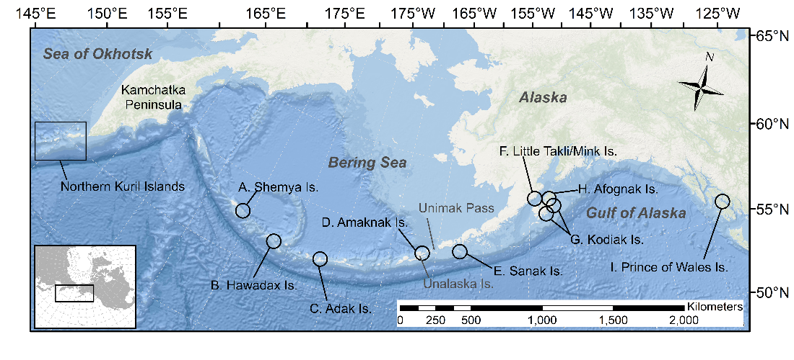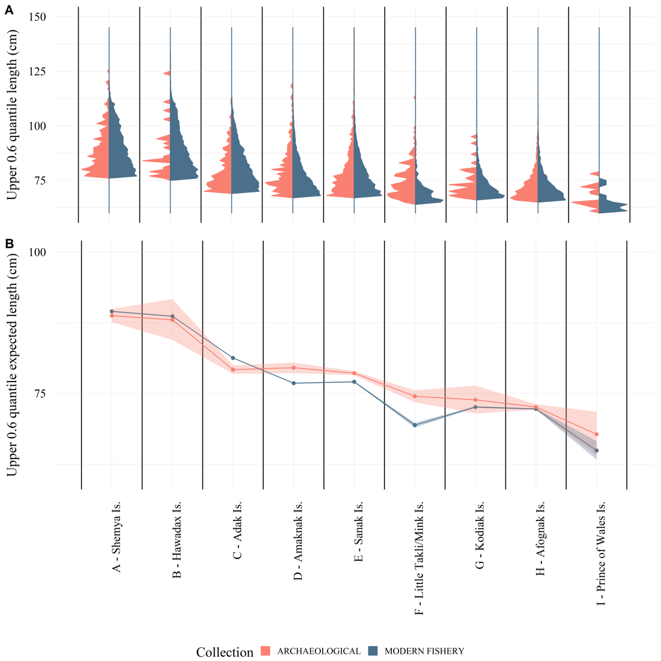

Figure 2.2 (A) The 0.6 quantile of the length distribution of Pacific cod from the Alaska archaeological collections (red) and modern longline and jig commercial fishery data (blue) within 50 km of the archaeological sites; and (B) log-linked gamma generalized linear regression results of Alaska modern fishery and archaeological collections by site showing expected lengths and 95% confidence intervals (From West *et al.* 2020; Figure 1 and Figure 5).

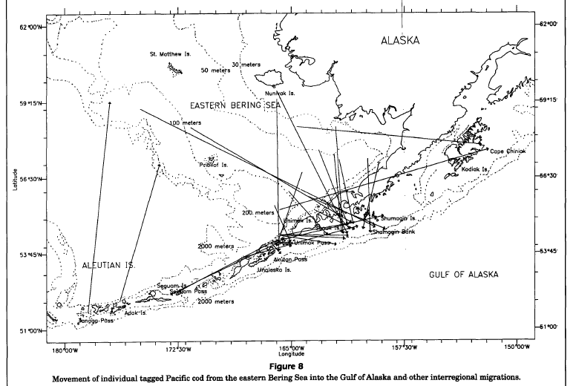

Figure 2.3 Tag recoveries from Shimada and Kimura 1994 (Figure 8), showing movement of individual tagged Pacific cod from eastern Bering Sea into the Gulf of Alaska and other interregional migrations.

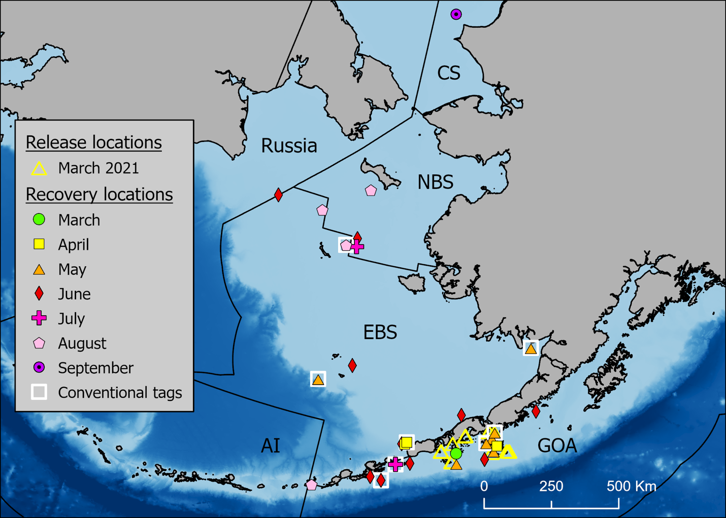

Figure 2.4 Release and monthly satellite and conventional tag recovery locations through September 2021 by region (NBS = Northern Bering Sea, EBS = Eastern Bering Sea, AI = Aleutian Islands, and GOA = Gulf of Alaska, CS = Chukchi Sea). Conventional tag recaptures are indicated by a white square around the symbol.

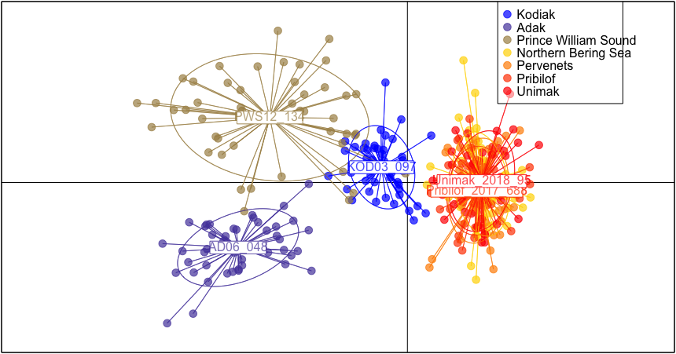

Figure 2.5 Discriminant analysis of principal components (DAPC) scatterplot with the following populations represented: Adak (2006), Prince William Sound, PWS (2012), Kodiak (2003), Unimak (2018), Pervenets (2016), Pribilof (2017), and Norton Sound, NBS (2017). All populations represent spawning groups except the Norton Sound sample, which was sampled in August, 2017. Note: The Norton Sound sample in panel b. is behind the Unimak and Pribilof labels, and barely visible (Spies et al. 2020).

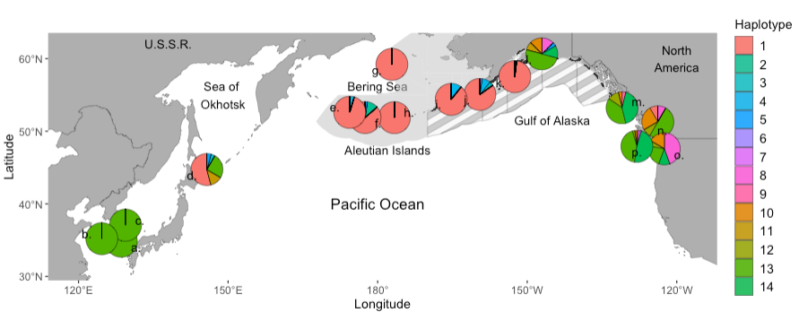

Figure 2.6 Map with pie charts showing relative haplotype frequencies between all collections, and Numbers on map represent the name of the collection, west to east: a. Geoje, Korea, b. Yellow Sea, Korea, c. Jukbyeon, Korea, d. Sea of Okhotsk, Japan, e. Near Islands, f. Kiska Island, g. Pervenets Canyon, h. Adak Island, i. Unimak Island, j. Shumagin Islands, k. Kodiak Island, l. Prince William Sound, m. Hecate Strait, n. Strait of Georgia, o. Puget Sound, p. Washington Coast. The spatial area comprising the Gulf of Alaska Fishery Management Plan is shown with grey stripes and the area comprising the Bering Sea and Aleutian Islands Fishery Management Plan is light grey (Spies et al. 2021).

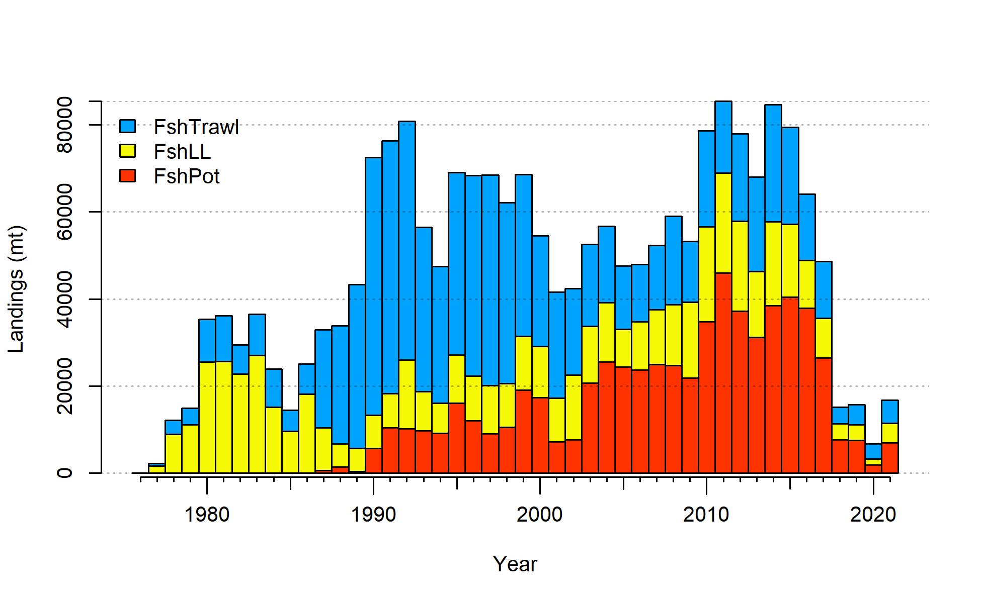

Figure 2.7 Gulf of Alaska Pacific cod catch from 1977-2021. Note that 2021 catch was through October 1.



Figure 2.8 Commercial catch of Pacific cod in the Gulf of Alaska by 20km2 grid for 1990-2015.

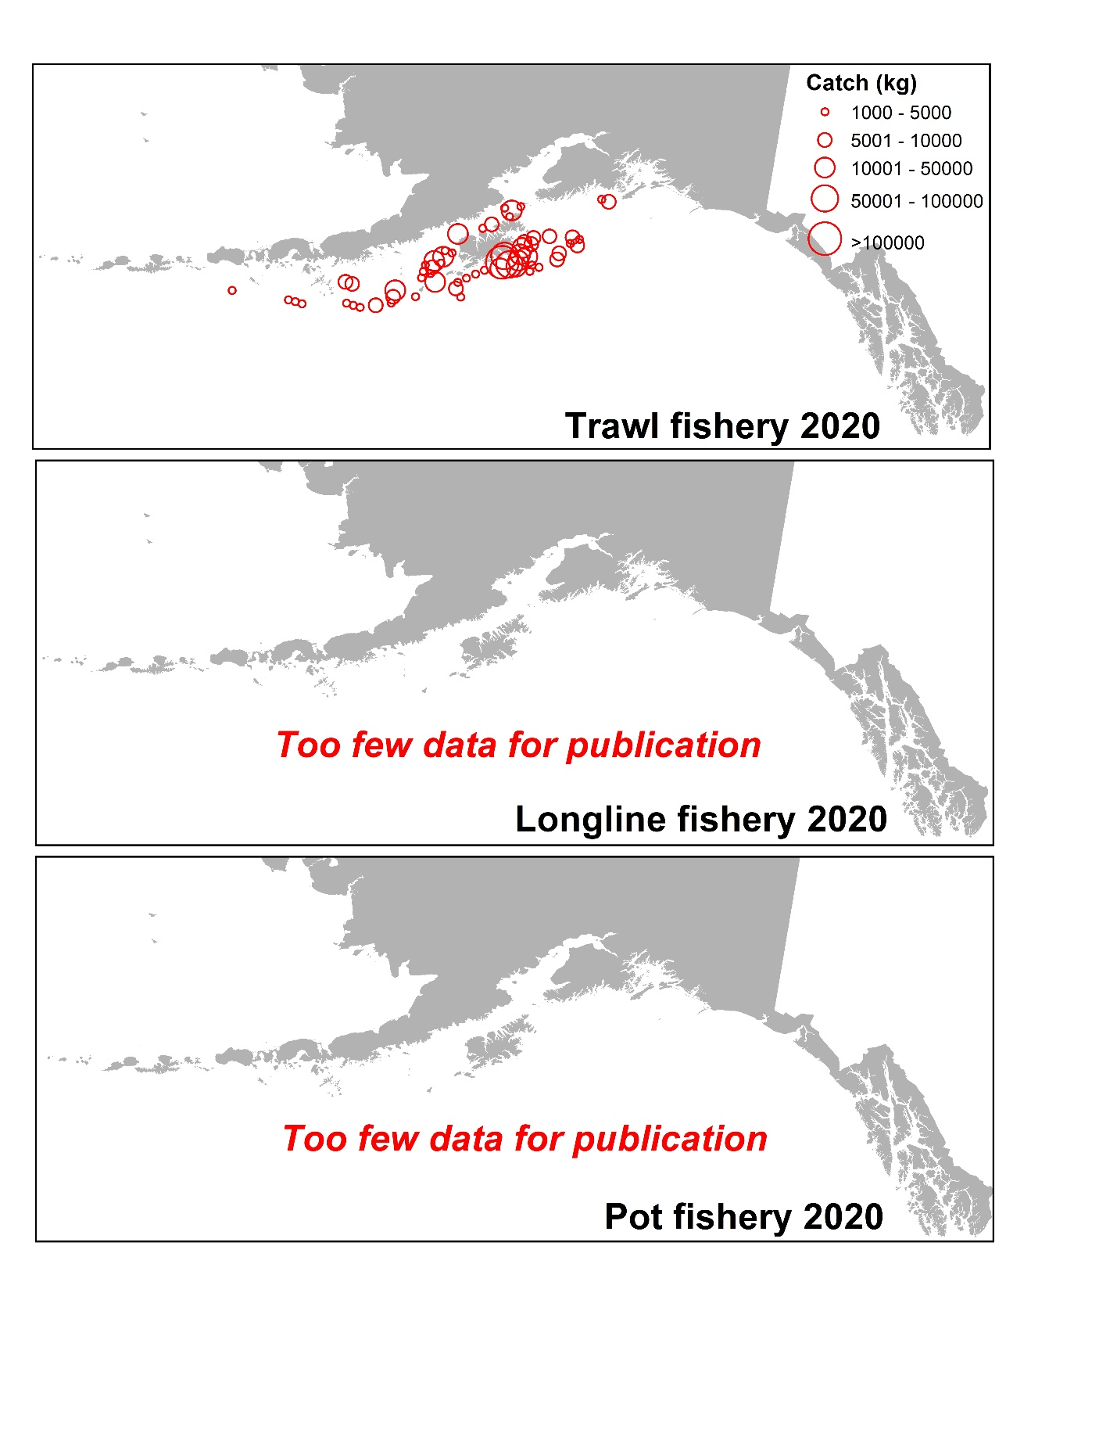

Figure 2.9 Commercial catch of Pacific cod in the Gulf of Alaska by 20km2 grid for 2020 for catch greater than 1000 kg. Observed catch in red circles and EM catch for longline and pot in blue squares. These data include bycatch Pacific cod.

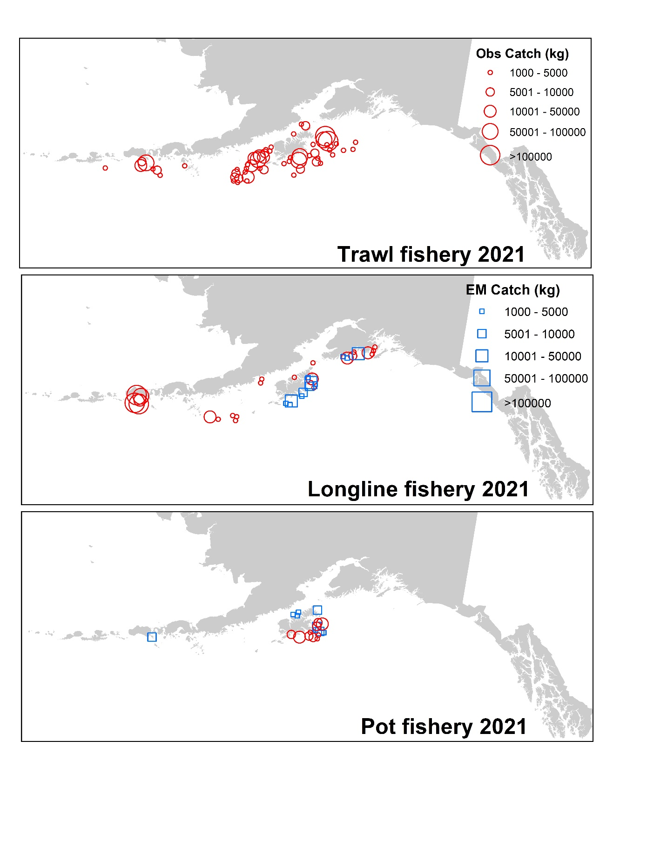

Figure 2.10 Observed commercial catch of Pacific cod in the Gulf of Alaska by 20km2 grid for 2021 as of October 23, 2021 for catch greater than 1000 kg. These data include bycatch Pacific cod, but do not include trawl EM data as locations are not yet available.

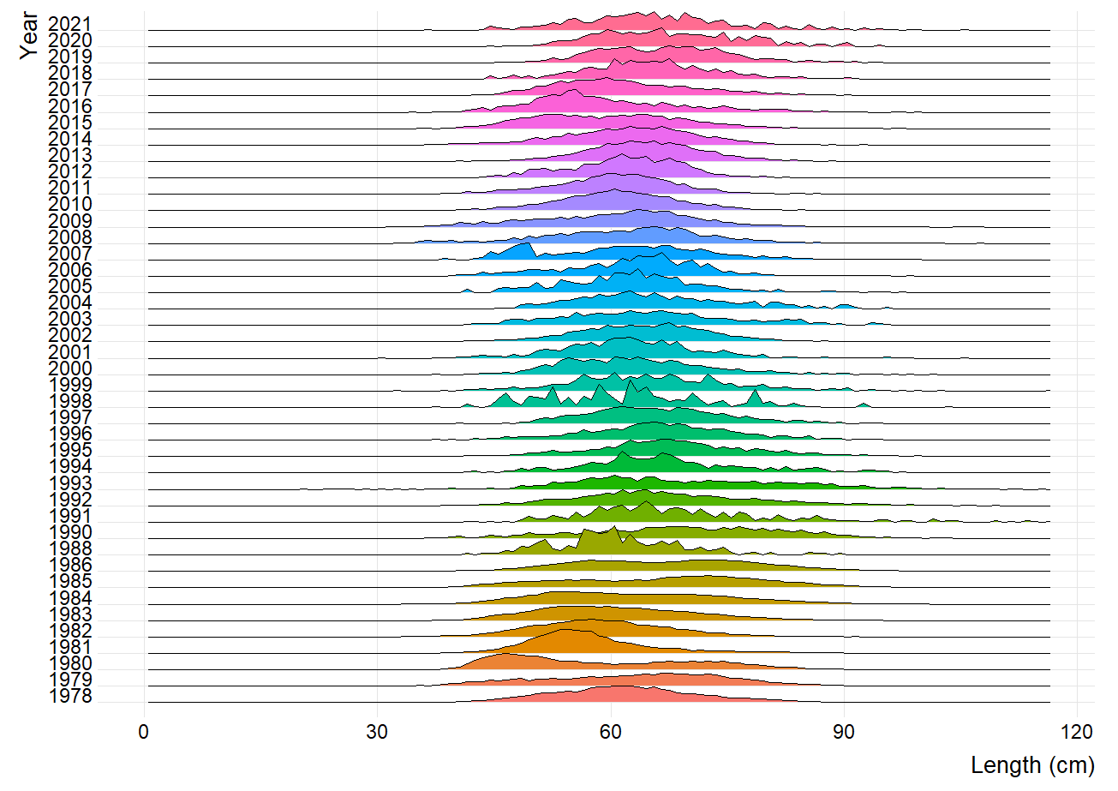

Figure 2.11 Pacific cod length composition by annual proportion from the Gulf of Alaska longline fishery.

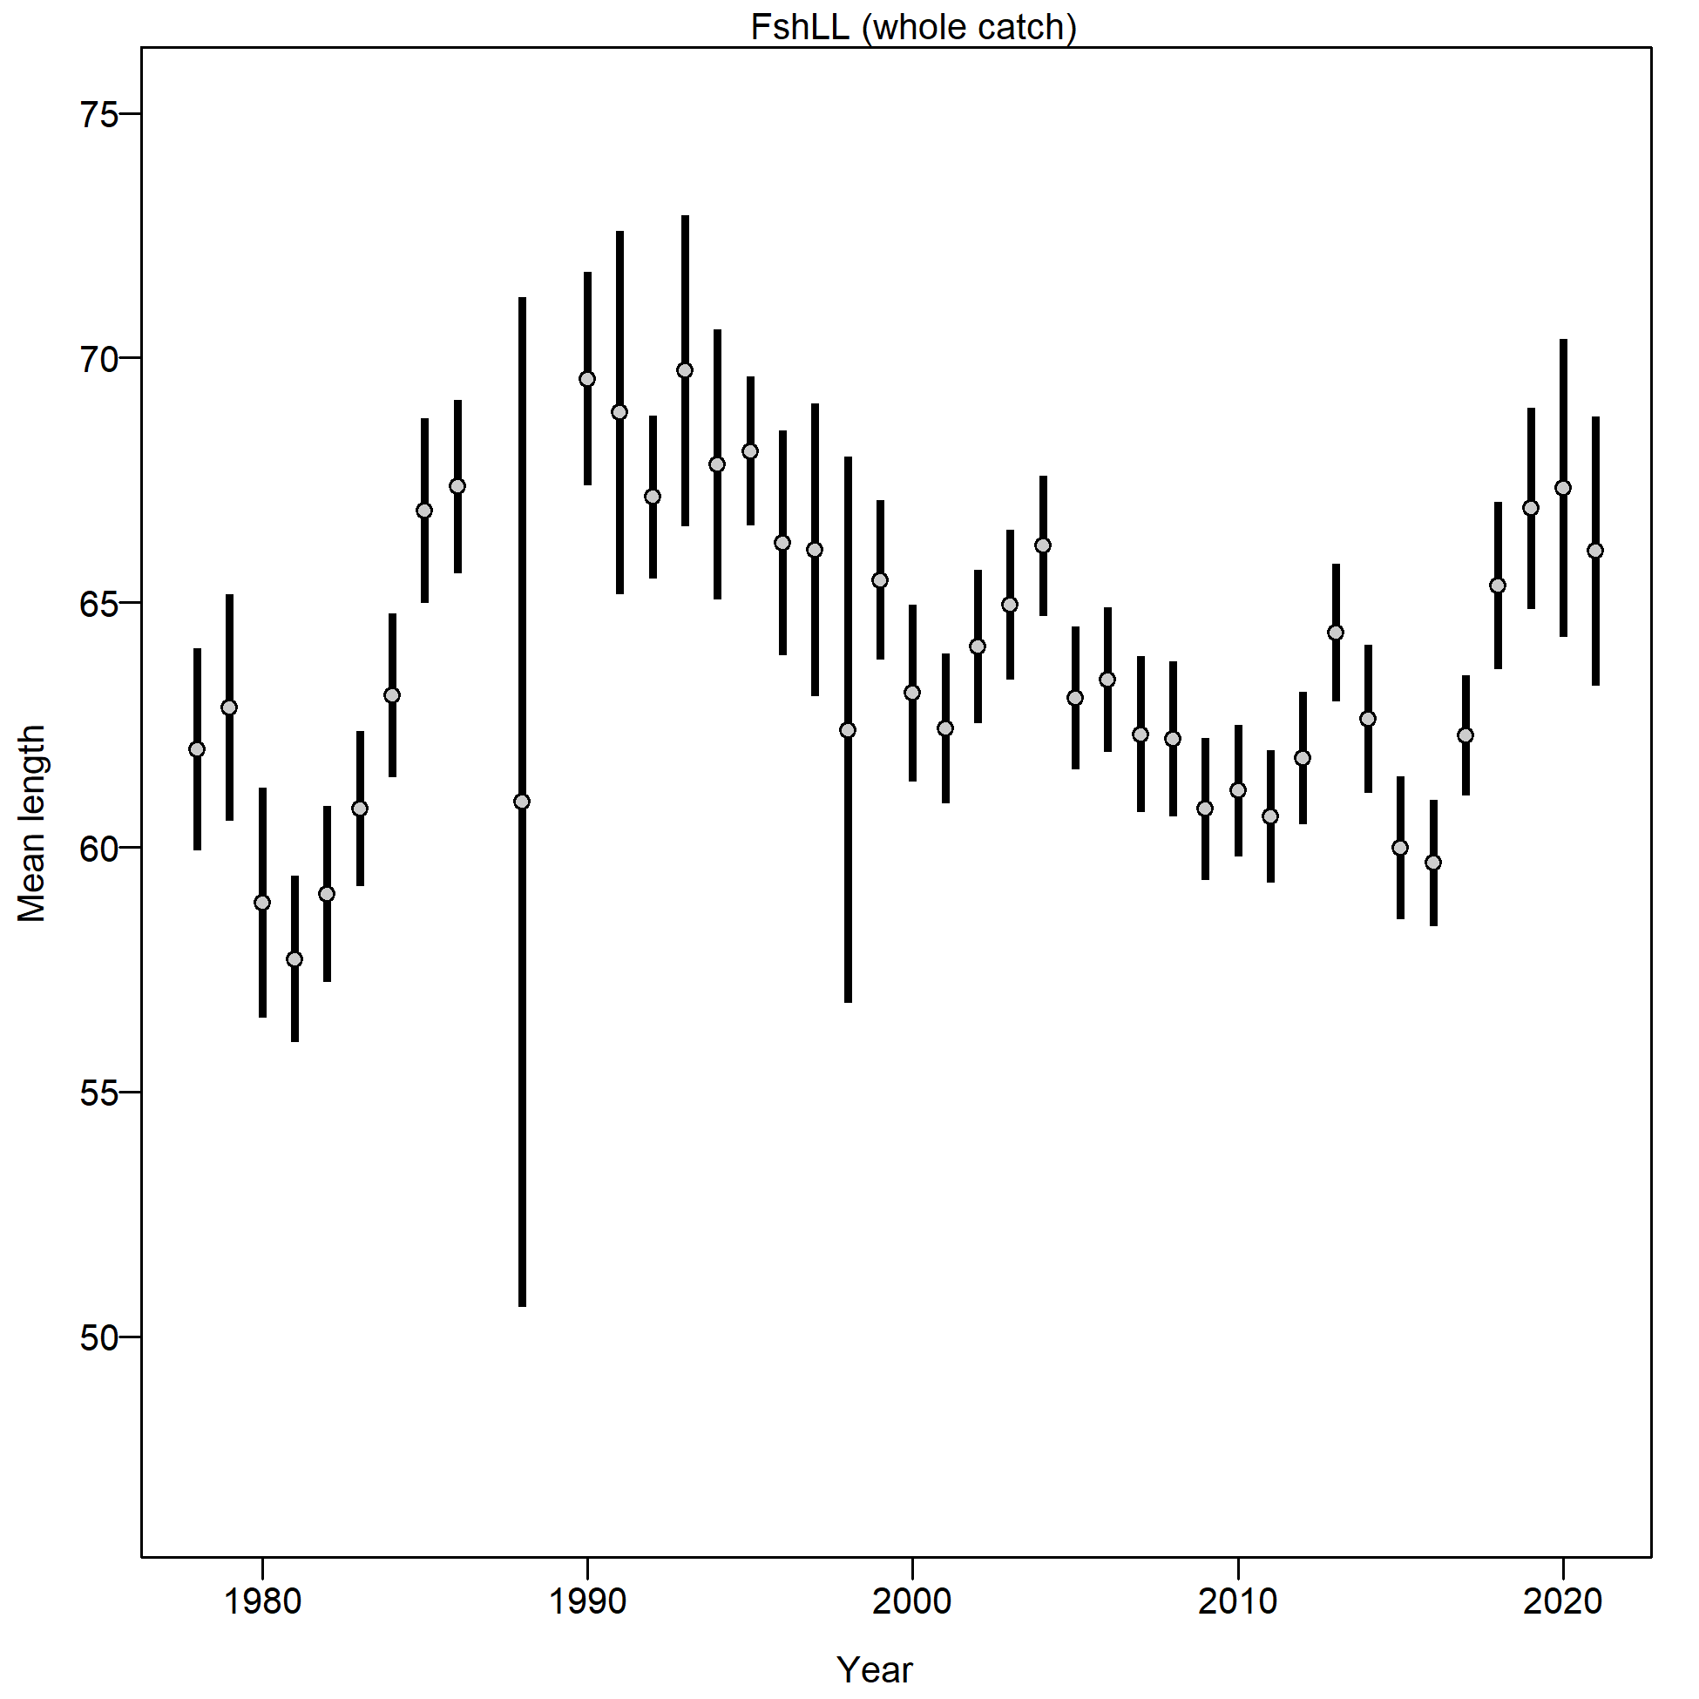

Figure 2.12 Mean length (cm) of Pacific cod from the Gulf of Alaska longline fishery.

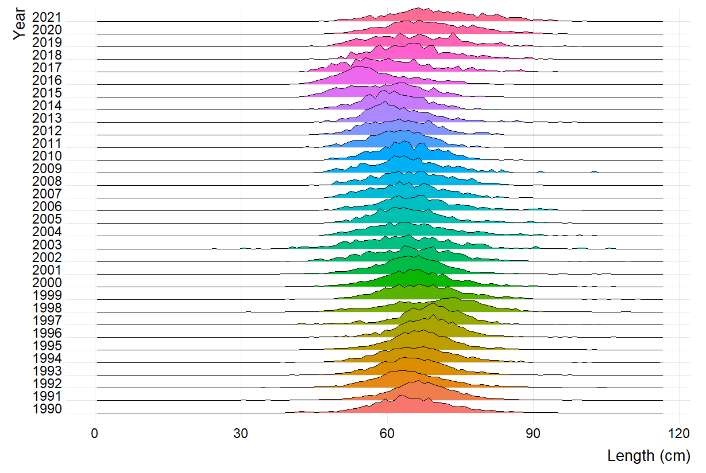

Figure 2.13 Pacific cod length composition by annual proportion from the Gulf of Alaska pot fishery.

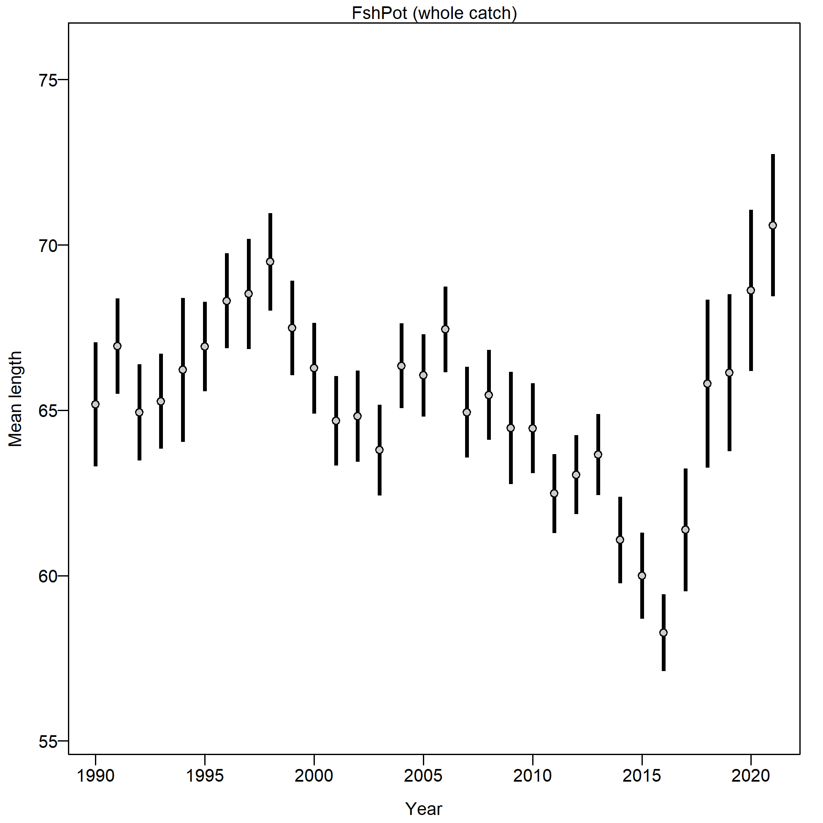

Figure 2.14 Mean length (cm) of Pacific cod from the Gulf of Alaska pot fishery.

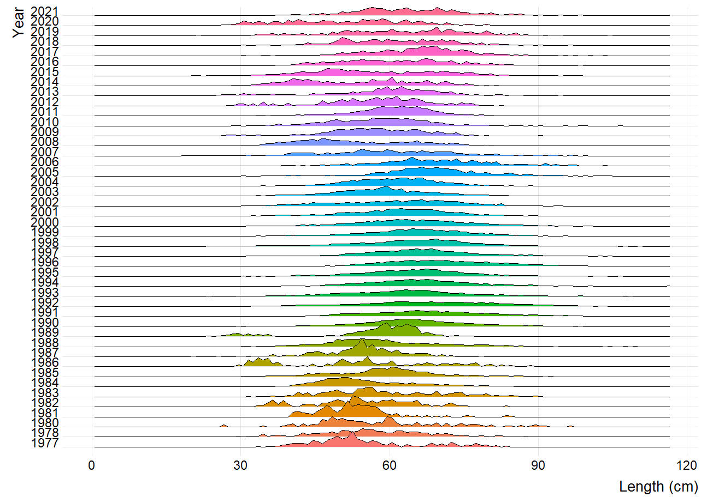

Figure 2.15 Pacific cod length composition by annual proportion from the Gulf of Alaska trawl fishery.

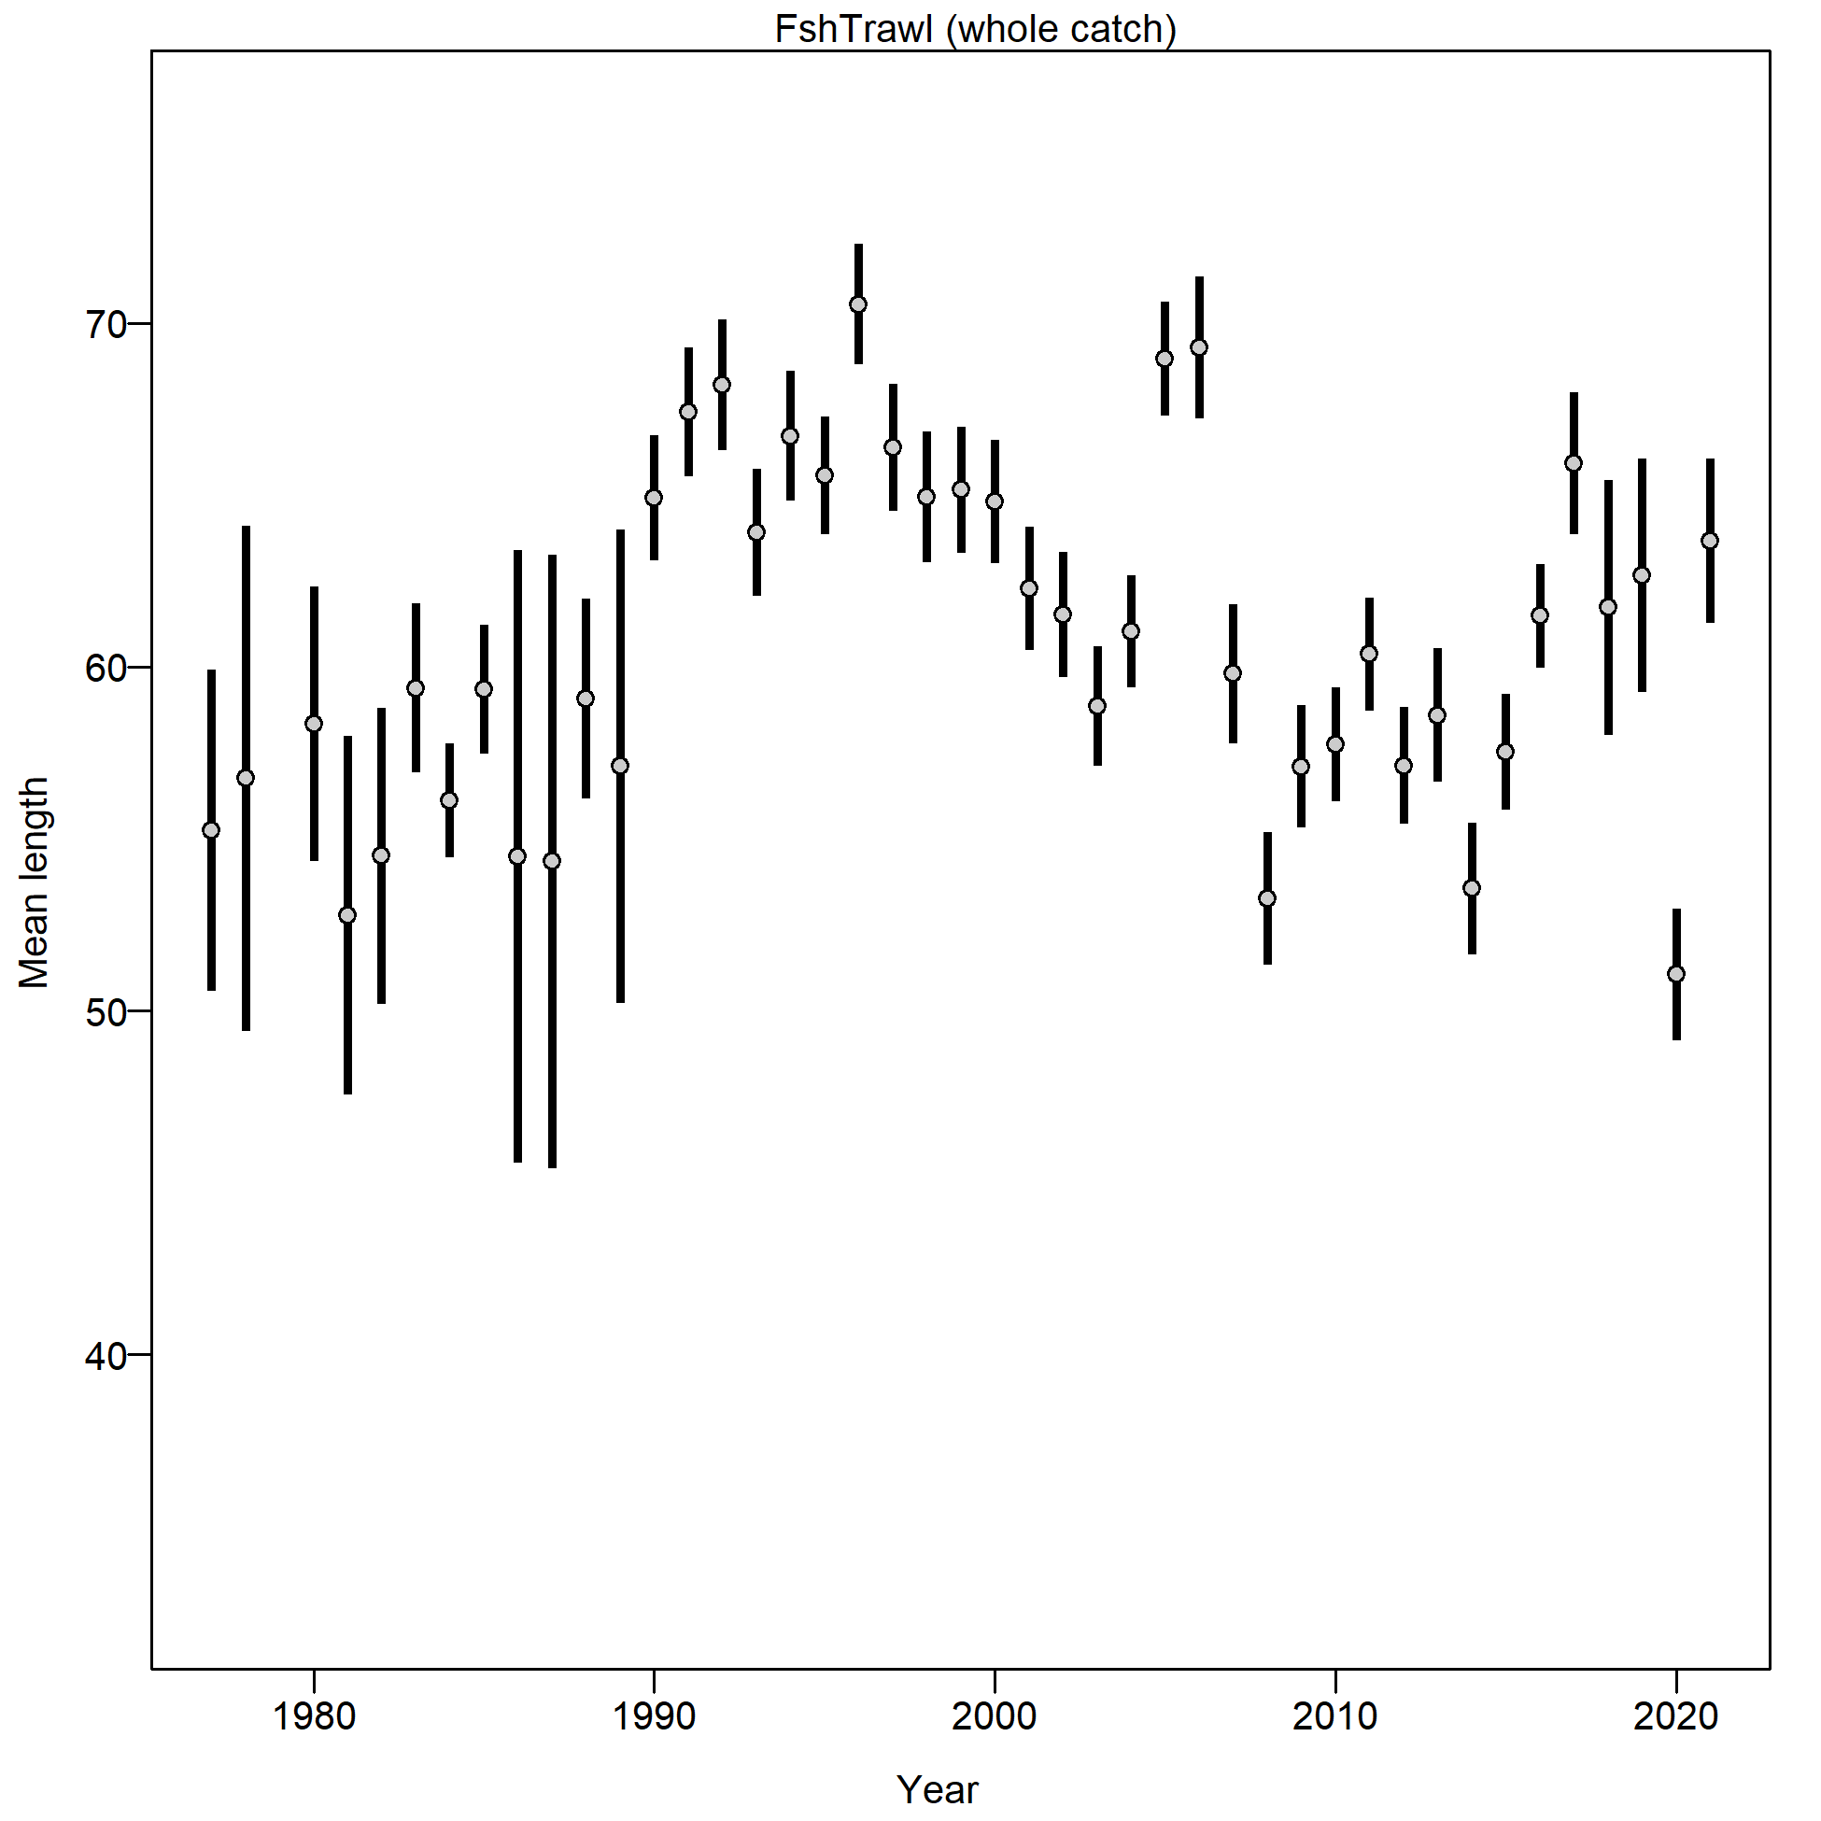

Figure 2.16 Mean length (cm) of Pacific cod from the Gulf of Alaska trawl fishery.

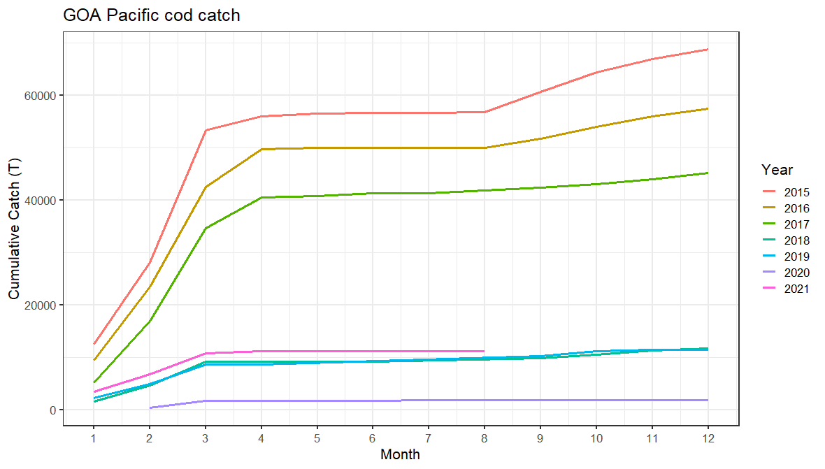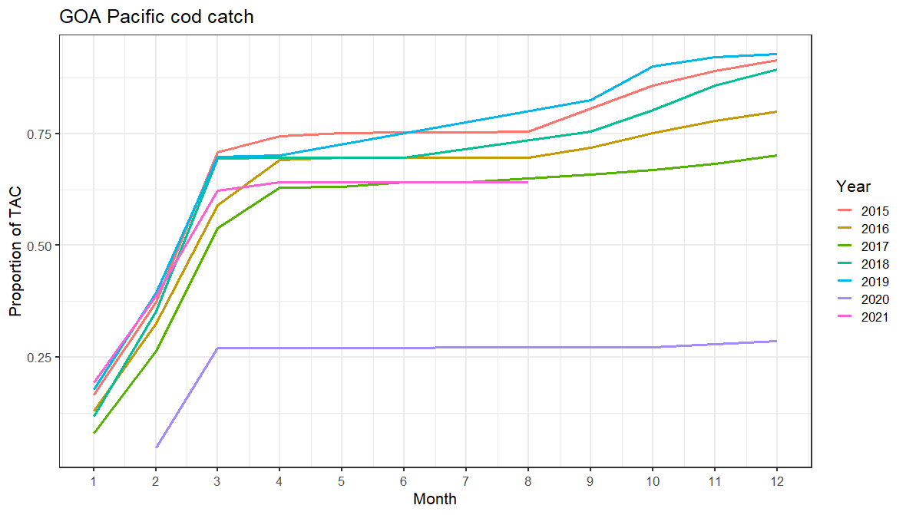

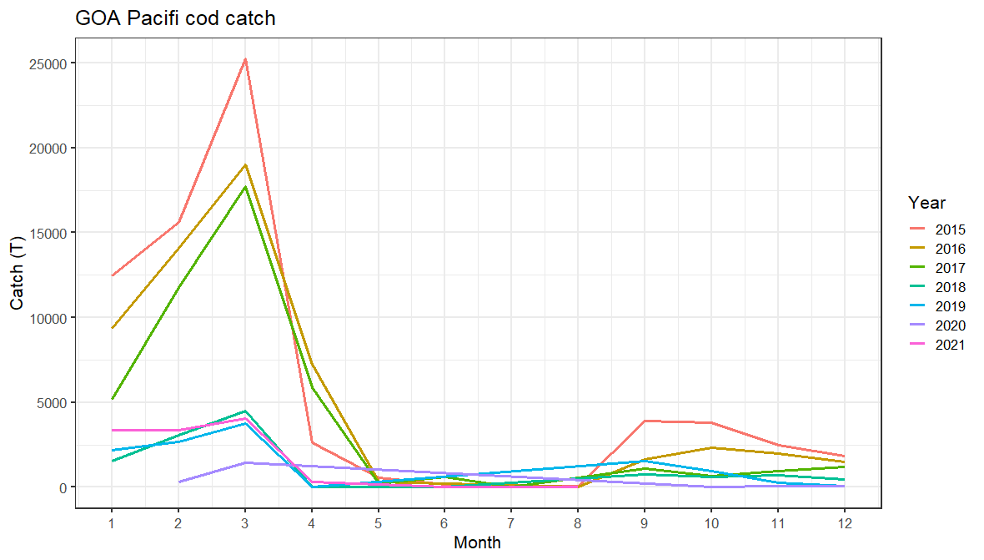

Figure 2.17 Cumulative catch (top left), cumulative proportion of catch (top right), and monthly catch (bottom) by month of the year for 2015-2021.

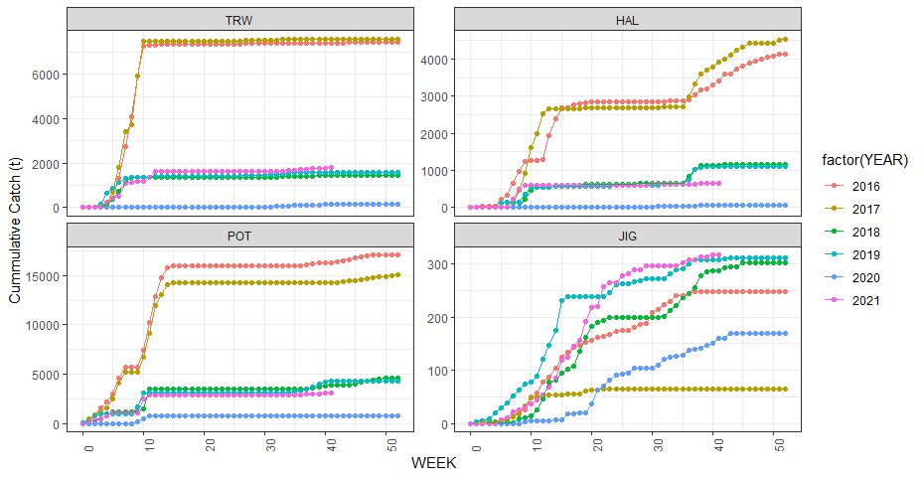

Figure 2.18 Cumulative catch week of the year for 2016-2021 by fleet for the Western Gulf of Alaska.

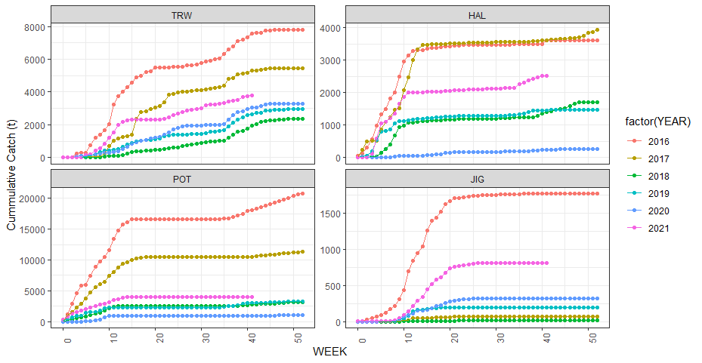

Figure 2.19 Cumulative catch week of the year for 2016-2021 by fleet for the Central Gulf of Alaska.

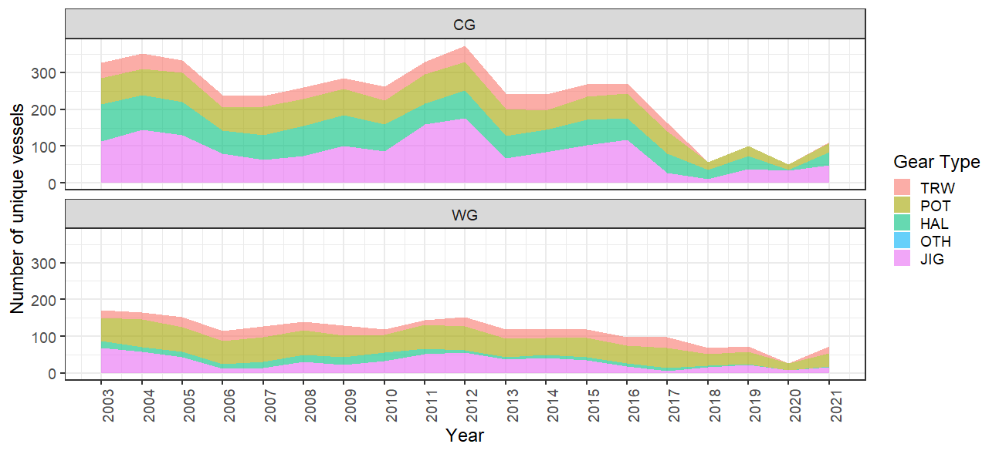

Figure 2.20 Vessel participation in the directed cod fishery by year.

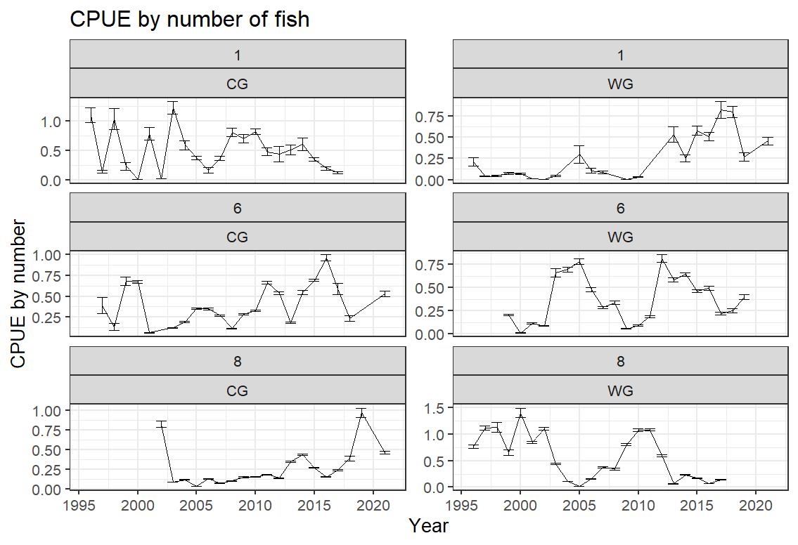 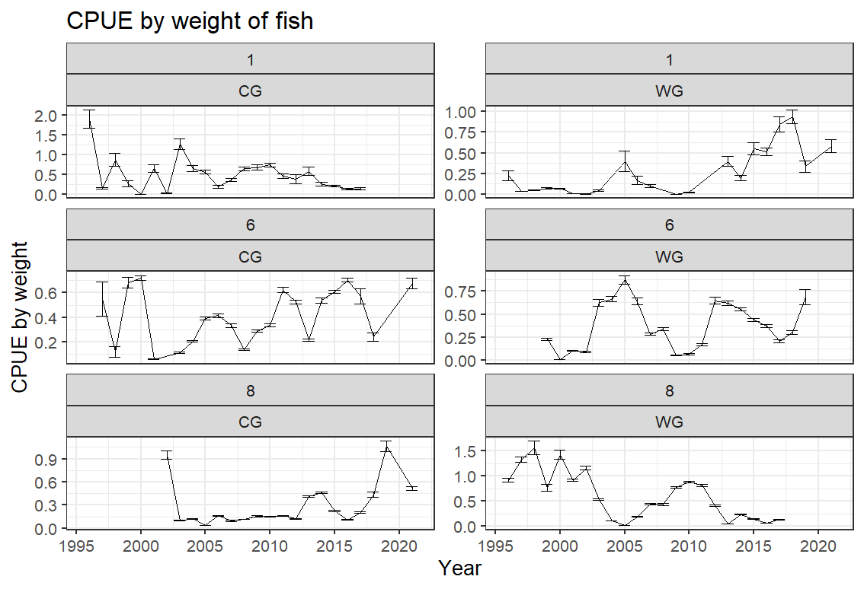

Pot

Longline

Longline

Longline

Longline

Pot

Pot

Pot

Bottom trawl

Bottom trawl

Bottom trawl

Bottom trawl

Figure 2.21 Boxplot of CPUE by number (left) and weight (right) from the 1996-2021 Pacific cod CPUE for the Central (CG) and Western (WG) regulatory areas by gear type. Note that the data in these figures are not controlled for vessel or gear differences within a gear type across time, but shows the raw CPUE data distribution for a year. These represent all observed catches and is limited to the directed cod fishery.

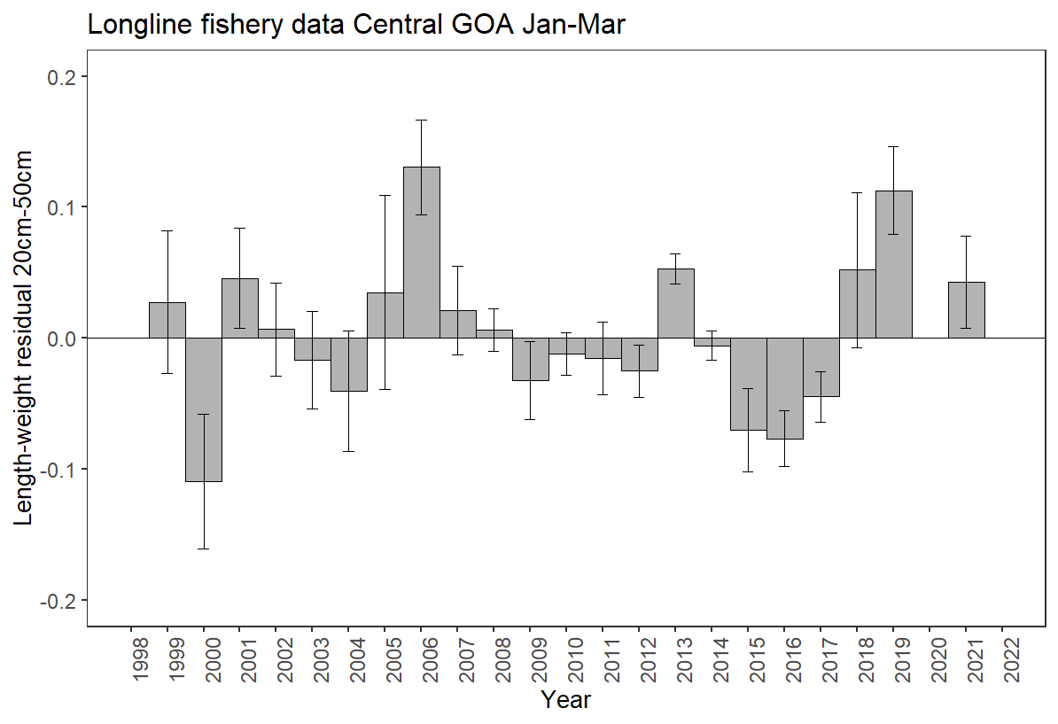

Figure 2.22 Condition of Pacific cod by year in the Central GOA for the longline fishery January-March. Years with zero residuals without error bars are without data.

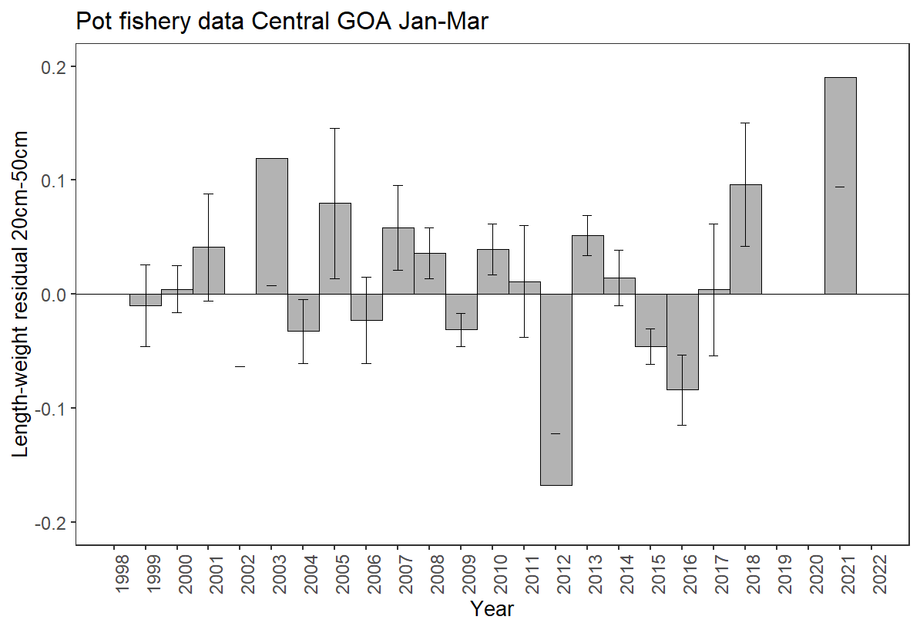

Figure 2.23 Condition of Pacific cod by year in the Central GOA for the pot fishery January-March. Years with zero residuals without error bars are years without data.

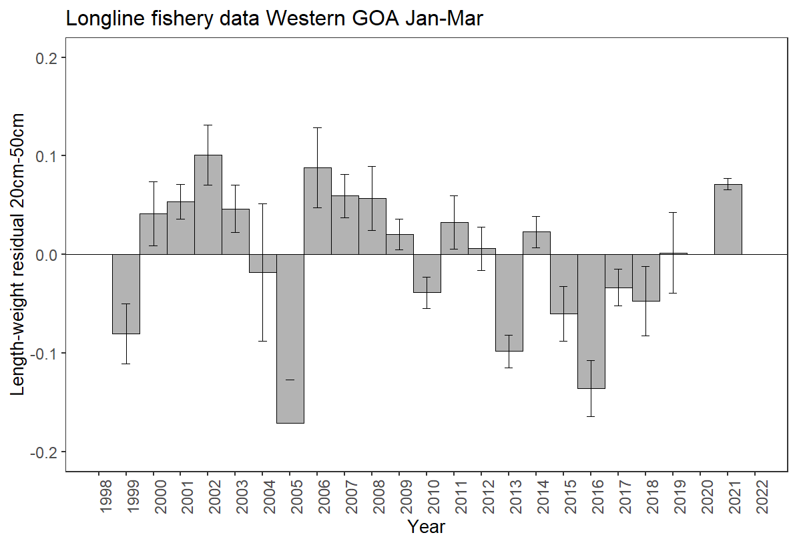

Figure 2.24 Condition of Pacific cod by year in the Western GOA for the longline fishery January-March. Years with zero residuals without error bars are years without data.

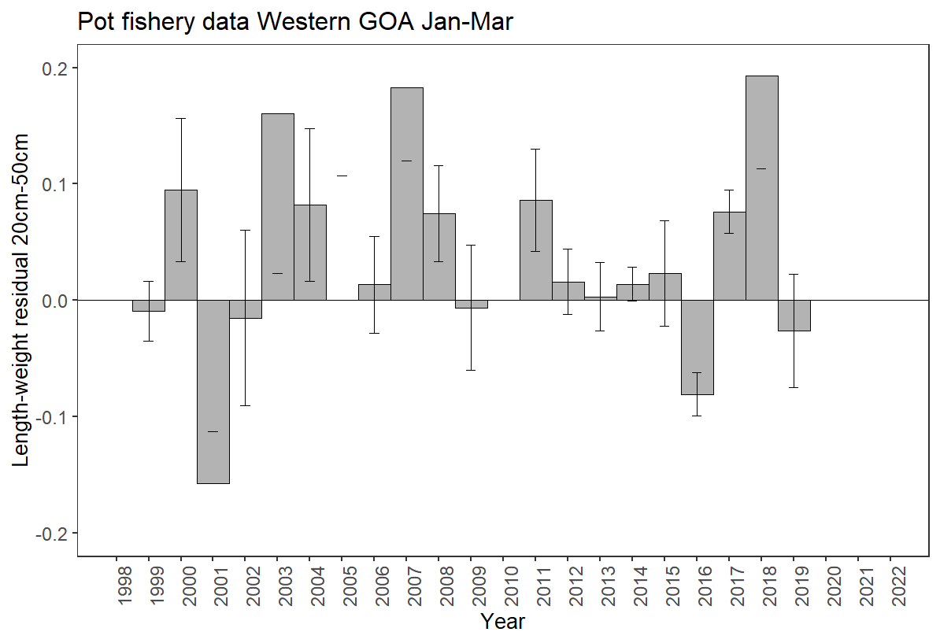

Figure 2.25 Condition of Pacific cod by year in the Western GOA for pot January-March. Years with zero residuals without error bars are years without data.

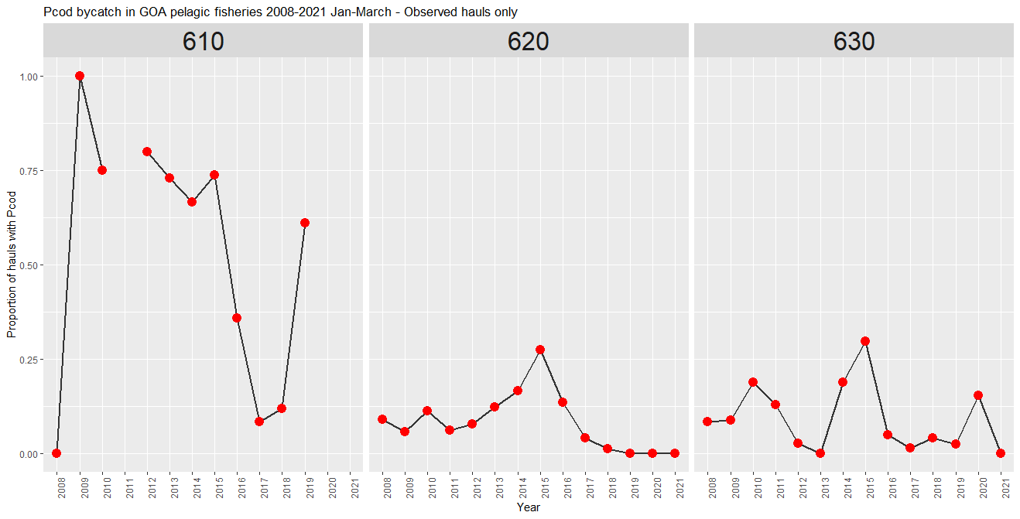

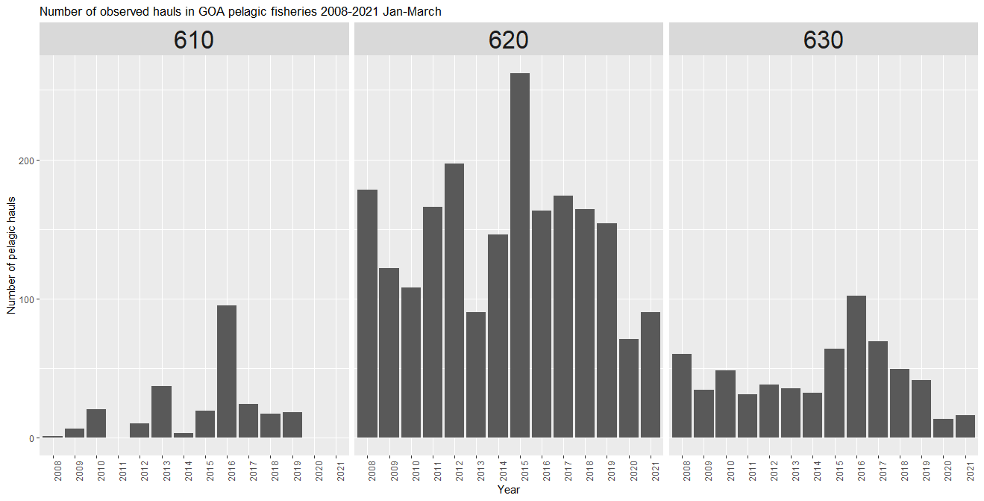

Figure 2.26 Proportion of pelagic trawls in the A Season (January-April) walleye pollock fishery with Pacific cod present by region (top) and number of hauls (bottom).

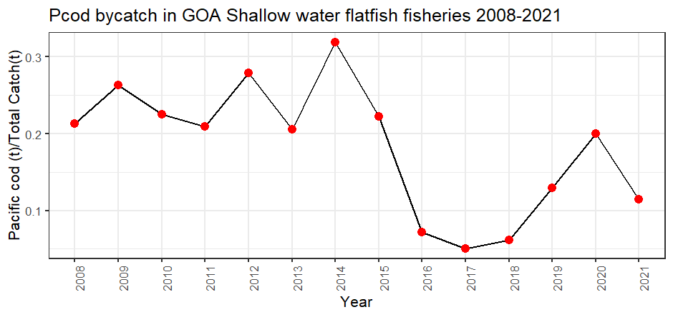

Figure 2.27 Pacific cod bycatch in the Gulf of Alaska shallow water flatfish fishery as tons of Pacific cod per tons of total catch in the fishery by year.

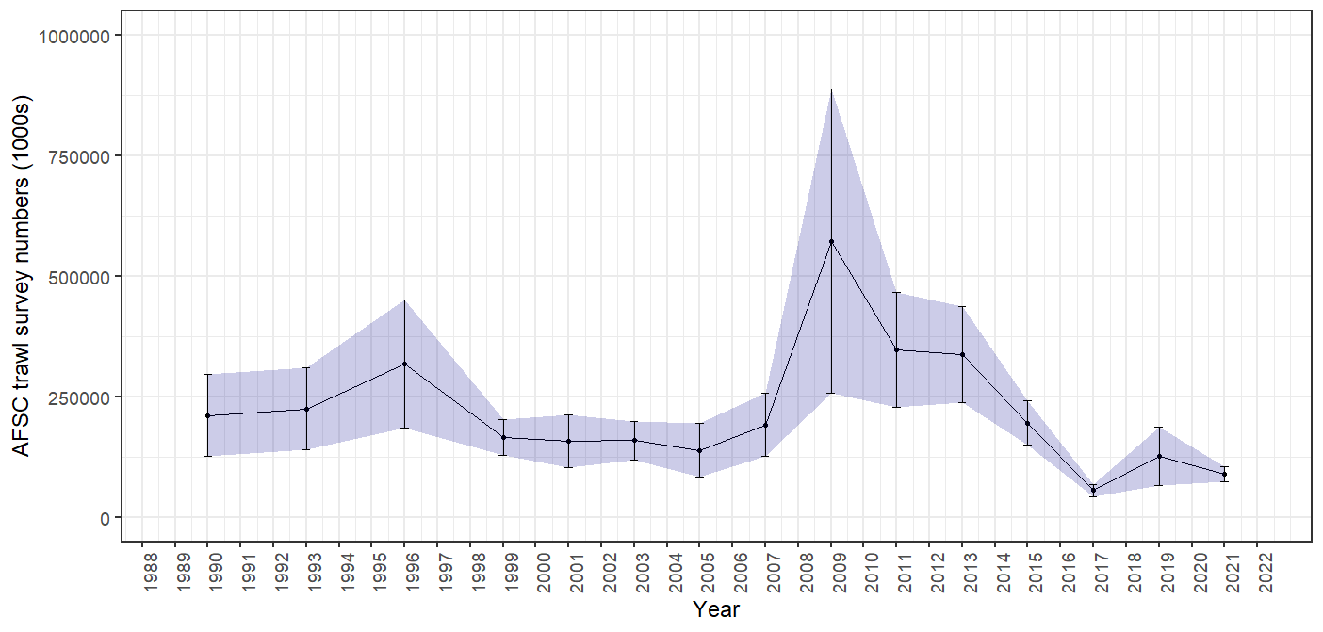

Figure 2.28 GOA bottom trawl survey abundance (numbers) estimate. Bars and shading indicate the 95th percentile confidence intervals.

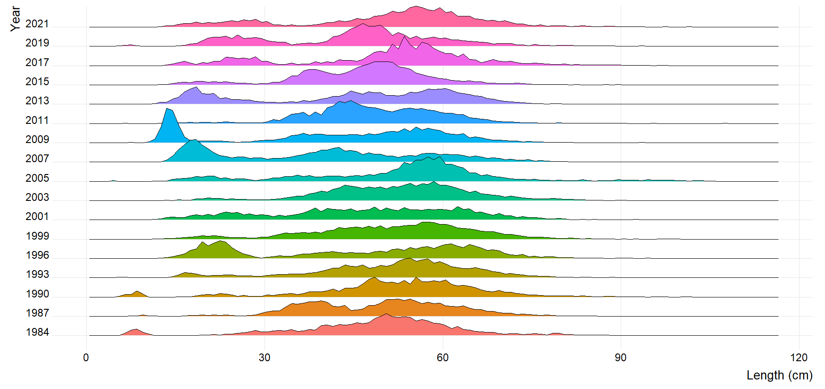

Figure 2.29 GOA bottom trawl survey Pacific cod population numbers at length estimates (max = 0.07).



Figure 2.30 Mean length (cm) of Pacific cod in the GOA bottom trawl survey.



Figure 2.31 Distribution of AFSC bottom trawl survey CPUE of Pacific cod for 2017-2019.

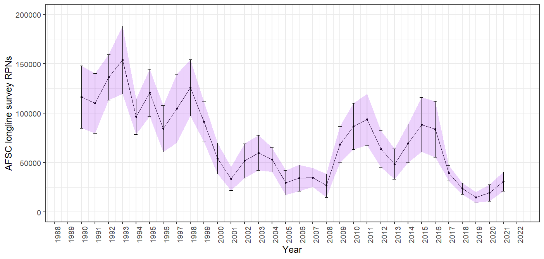

Figure 2.32 AFSC longline survey Pacific cod relative population numbers (RPN) time series. Bars and shading indicate the 95th percentile confidence intervals.

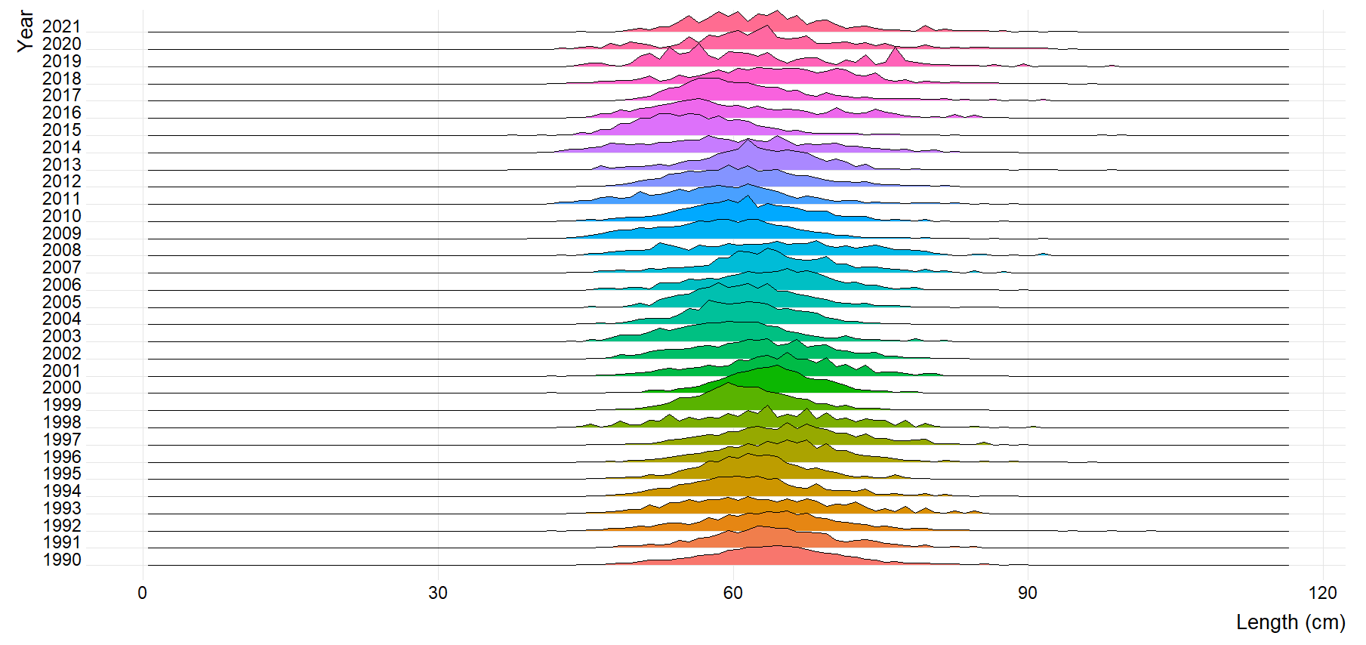

Figure 2.33 AFSC longline survey Pacific cod size composition (max=0.09).

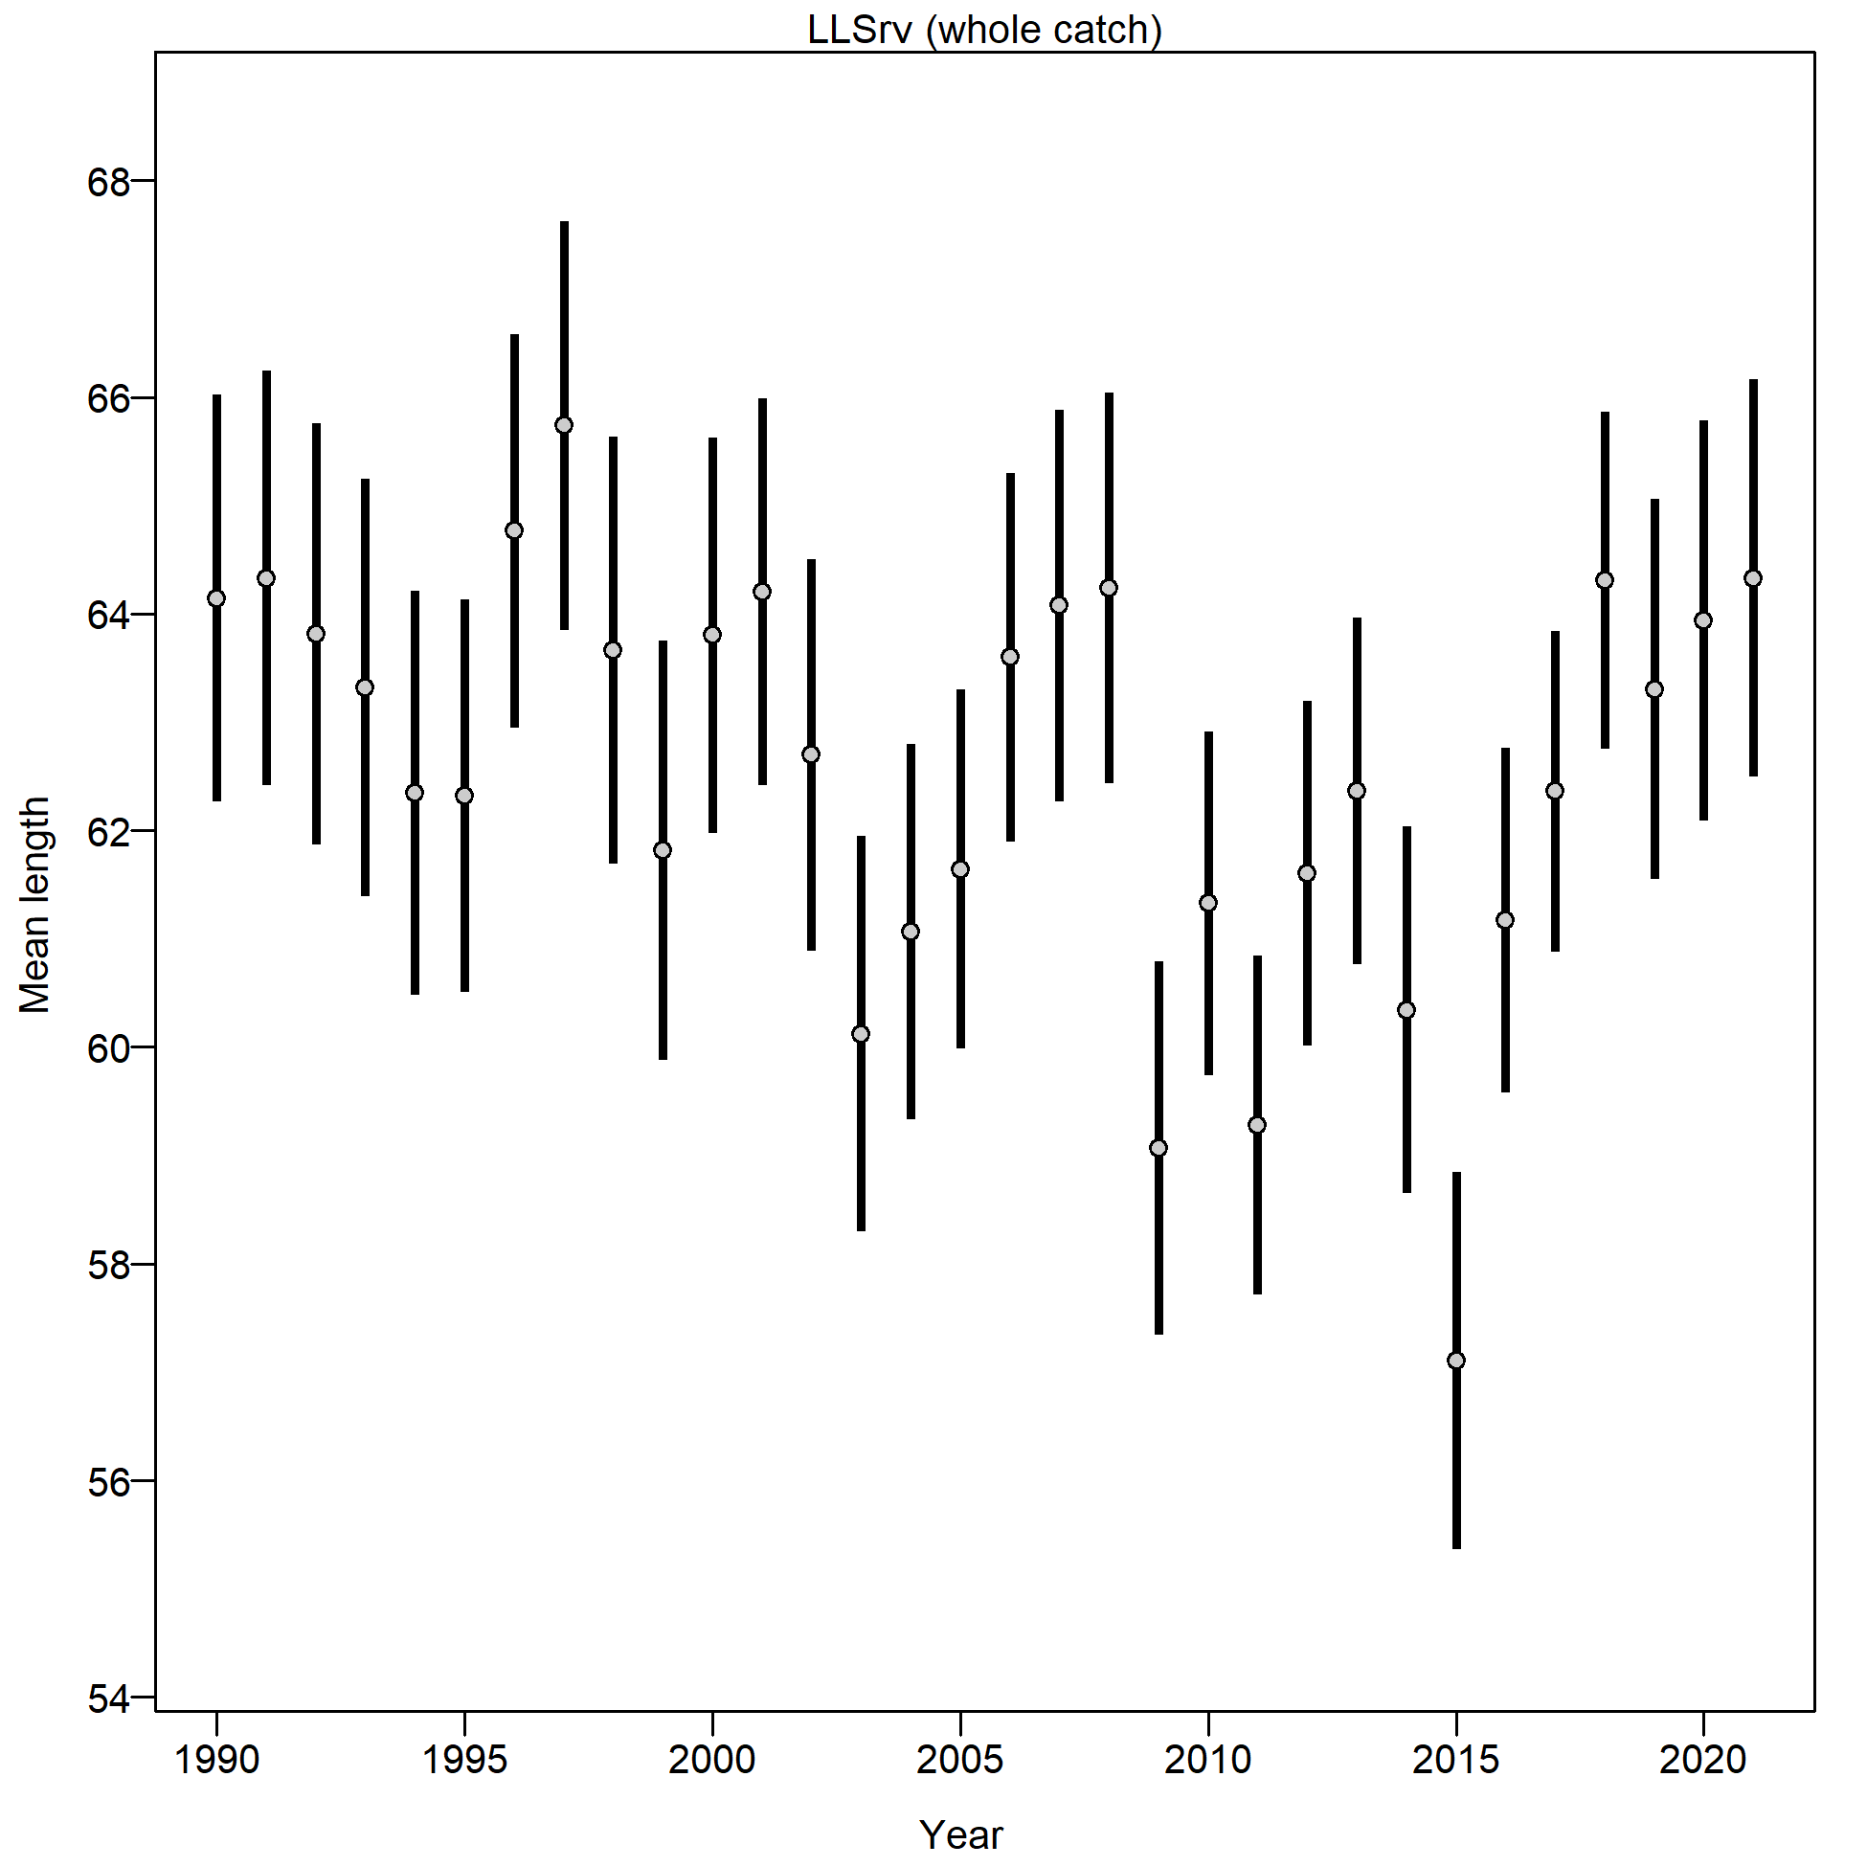

Figure 2.34 Mean length (cm) of Pacific cod from the AFSC longline survey.

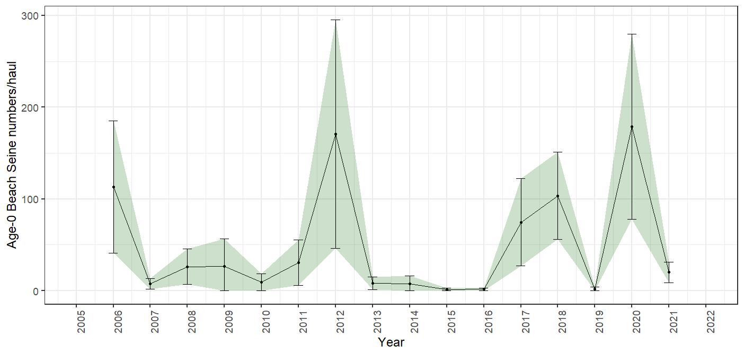

Figure 2.35 Age-0 beach seine survey numbers per haul, bars and shading indicate the 95th percentile confidence intervals.

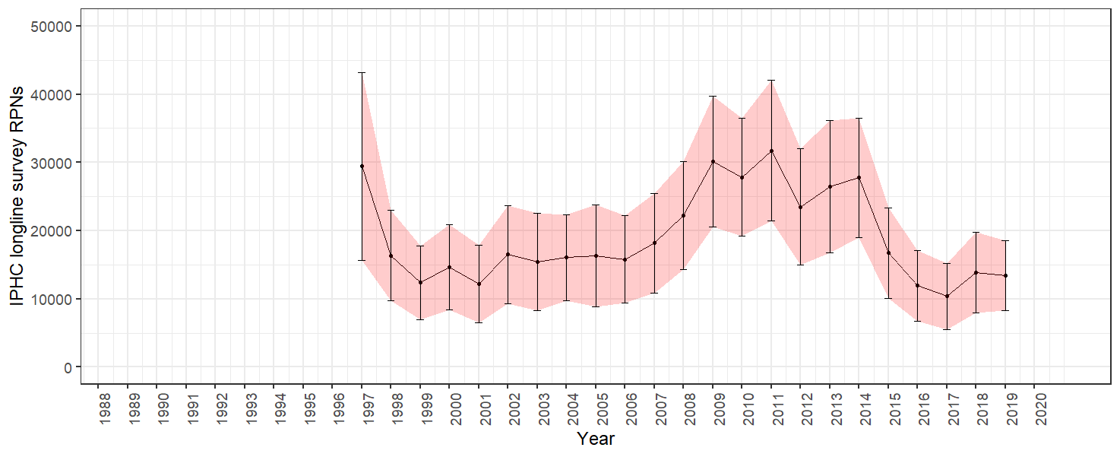

Figure 2.36 IPHC halibut longline survey Pacific cod RPN time series. Bars and shading indicate the 95th percentile confidence intervals.

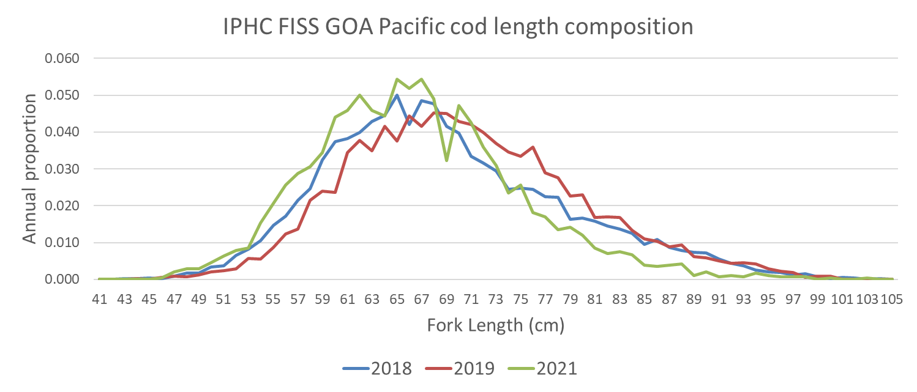

Figure 2.37 IPHC Fishery-independent setline survey (FISS) Pacific cod length composition collection for 2018, 2019, and 2021. These are raw frequency collections and have not been proportioned by FISS RPN.

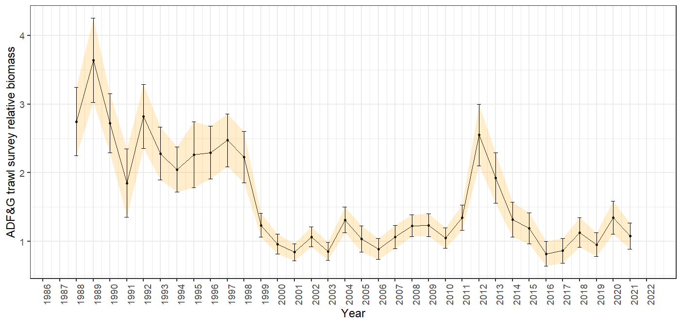

Figure 2.38 ADFG bottom trawl survey delta-glm Pacific cod density index time series. Bars and shading indicate the 95th percentile confidence intervals.

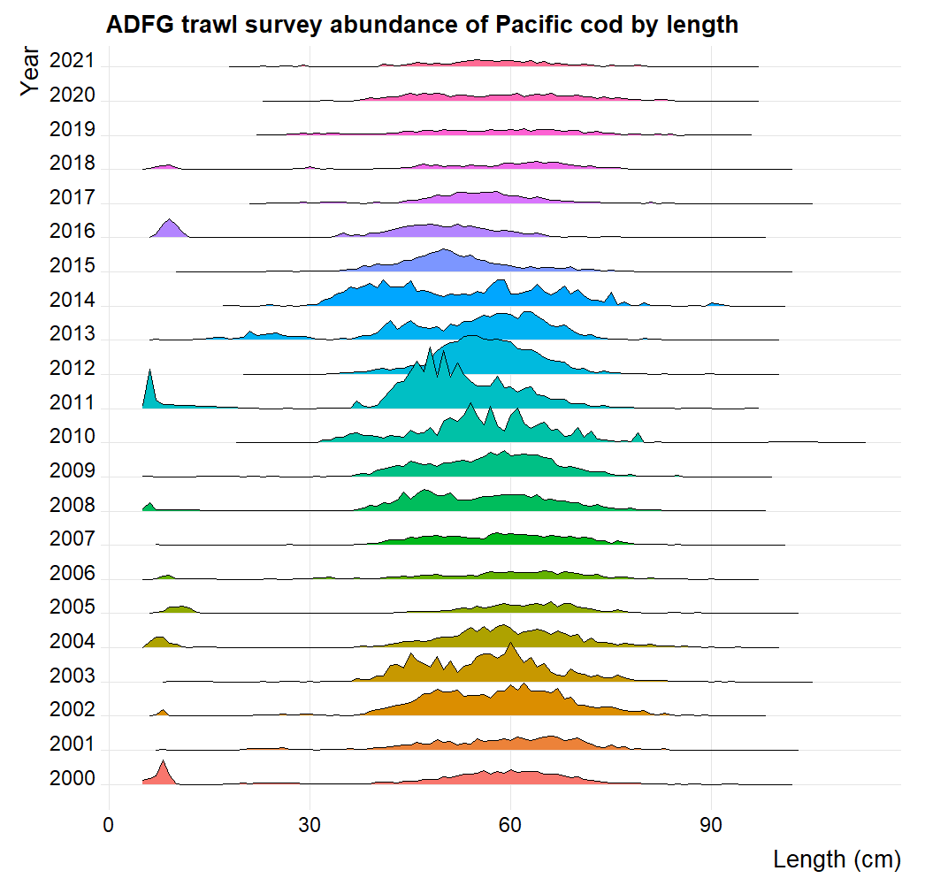

Figure 2.39 ADFG large-mesh trawl survey Pacific cod population numbers at length estimates.

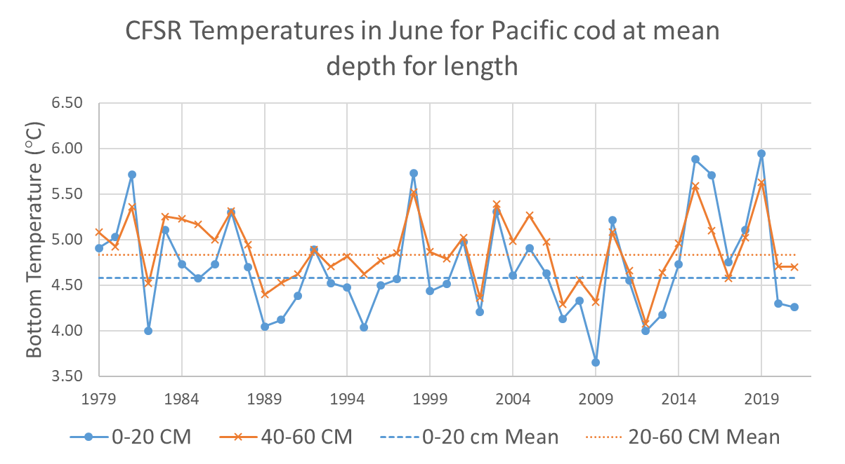

Figure 2.40 Climate Forcast System Reanalysis (CFSR) Central Gulf of Alaska bottom temperatures at the AFSC bottom trawl survey mean depths for 0-20 cm and 40-60 cm Pacific cod in June.

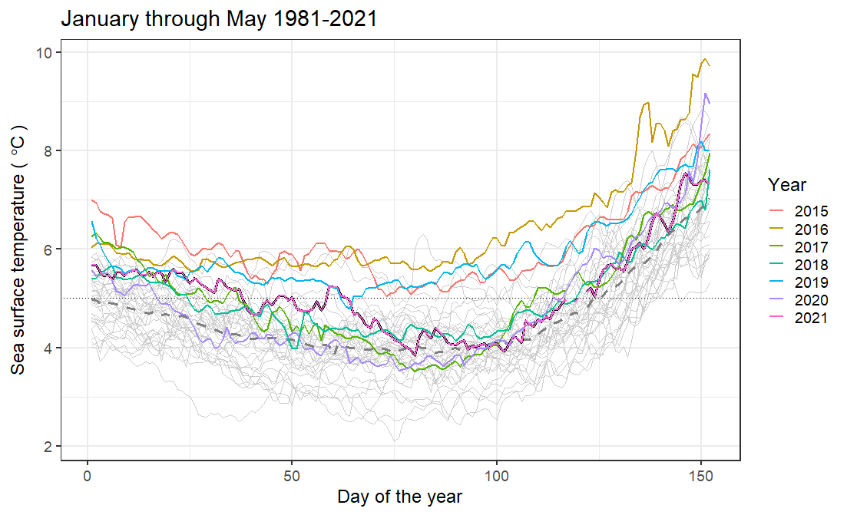 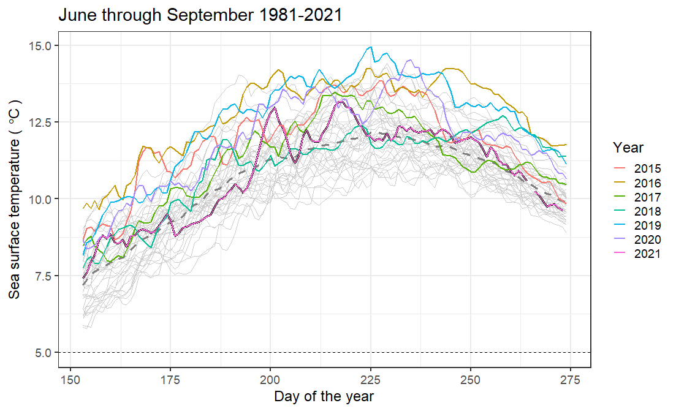

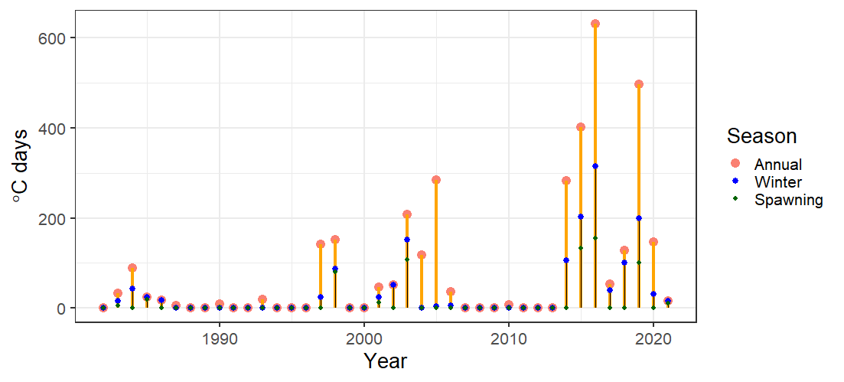

Figure 2.41 Sea surface temperatures (top left) February to March, (top right) June through September, and (bottom) index of the sum of the annual marine heatwave cumulative intensity (℃ days) for 1981-2021 (larger yellow points) and index of the sum of the annual winter marine heatwave cumulative intensity for 1981-2021 (smaller blue points) from the daily mean sea surface temperatures NOAA high resolution blended analysis data for the Central Gulf of Alaska. The 2021 index value is the sum through 30 September 2021.

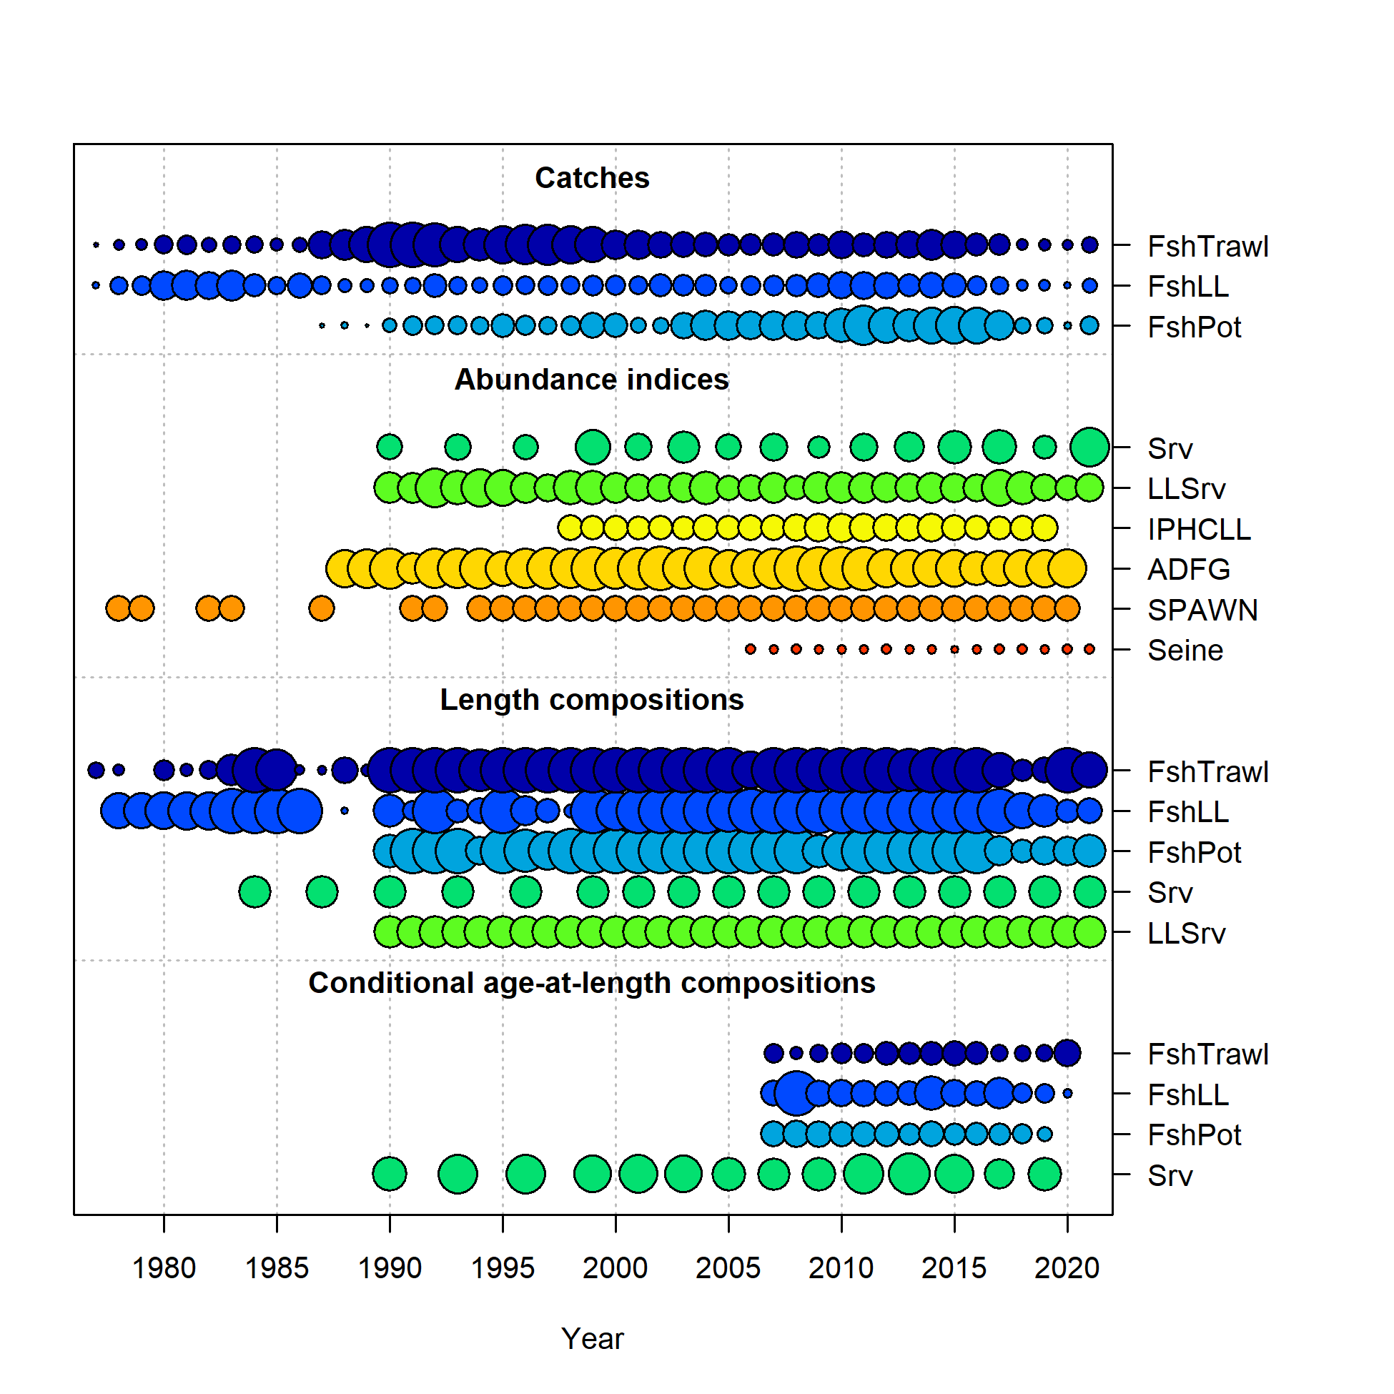

Figure 2.42 Data in the 2021 models, circle area is relative to initial precision within data type. Note that the ADFG, IPHC, and SPAWN are included in the data, but are not fit in any of the models presented this year. In addition the Seine (Age-0 index) data were not included in Models 19.1 or 21.1. Data presence by year for each fleet, where circle area is relative within a data type. Circles are proportional to total catch for catches; to precision for indices and to total sample size for compositions and length-at-age observations. Note that since the circles are scaled relative to maximum within each type, the scaling within separate plots should not be compared.

**Trawl Longline Pot**

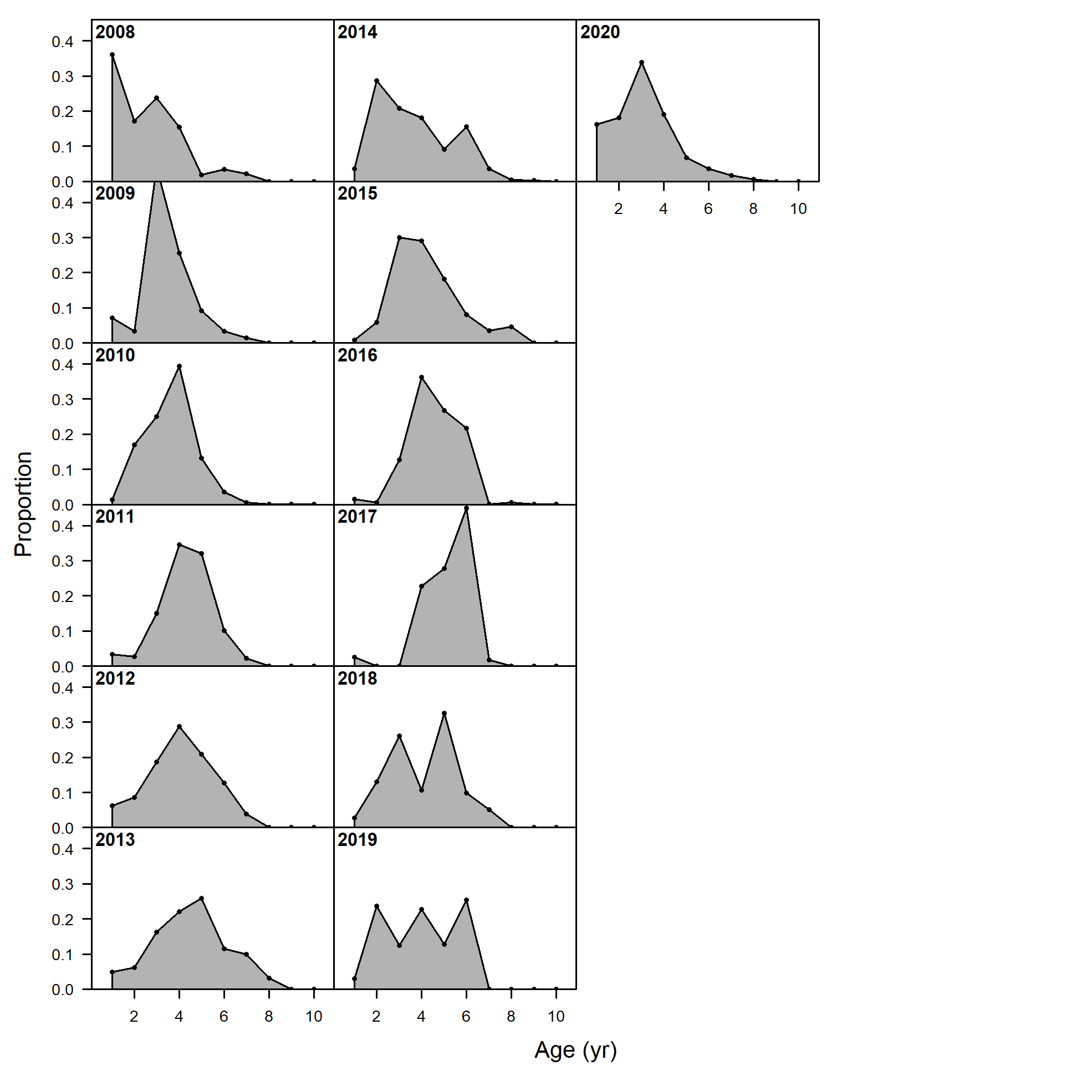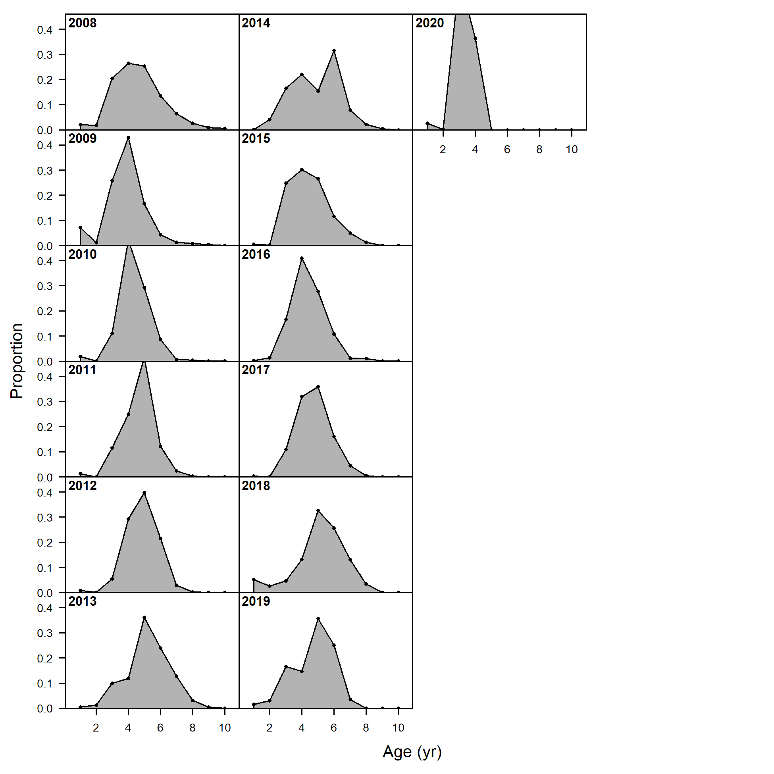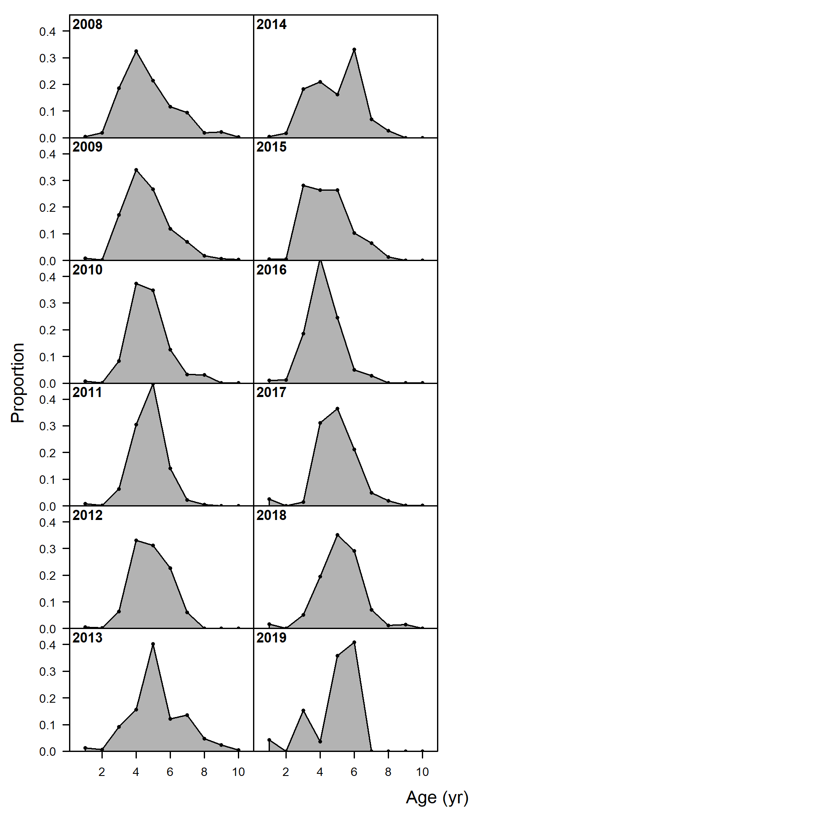

**Age**

Figure 2.43 Pacific cod age composition data from the Gulf of Alaska fisheries by gear type.

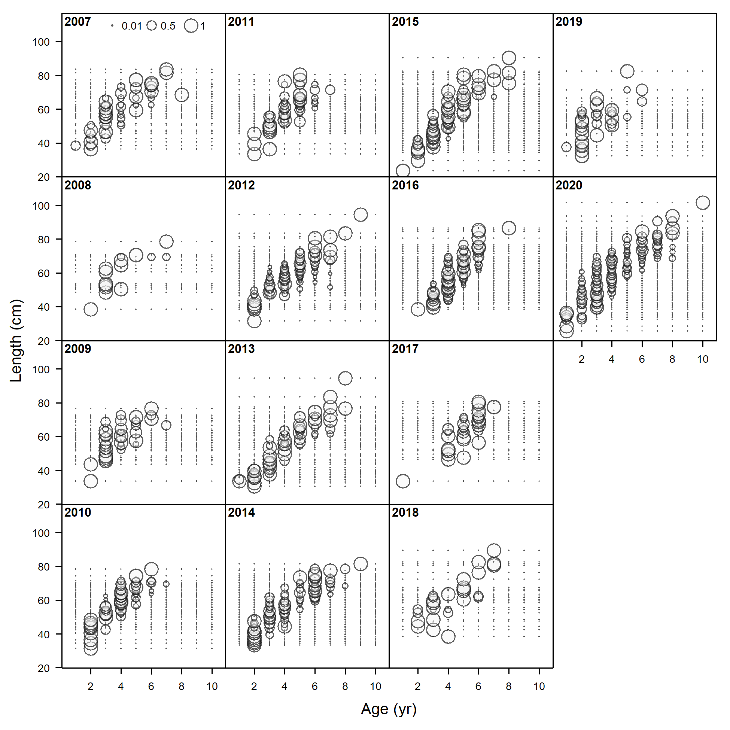

Figure 2.44 Pacific cod conditional length at age from the Gulf of Alaska trawl fishery.

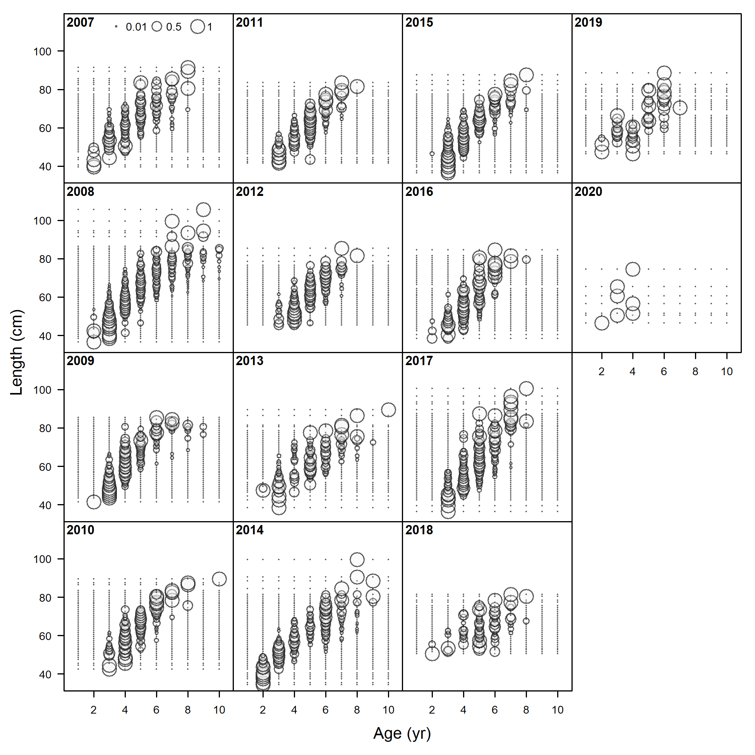

Figure 2.45 Pacific cod conditional length at age from the Gulf of Alaska bottom longline fishery.

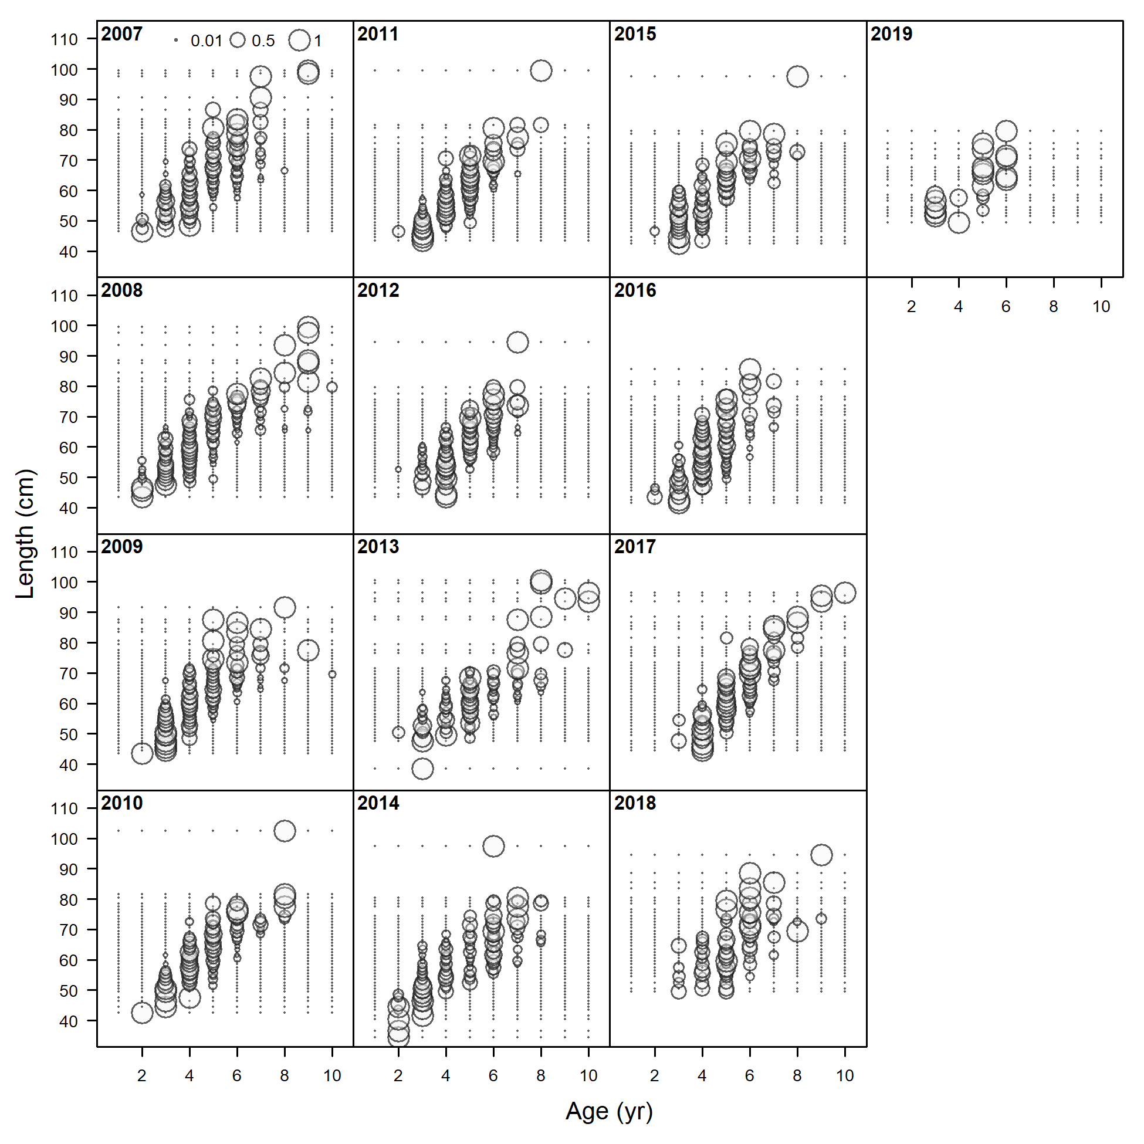

Figure 2.46 Pacific cod conditional length at age from the Gulf of Alaska pot fishery.

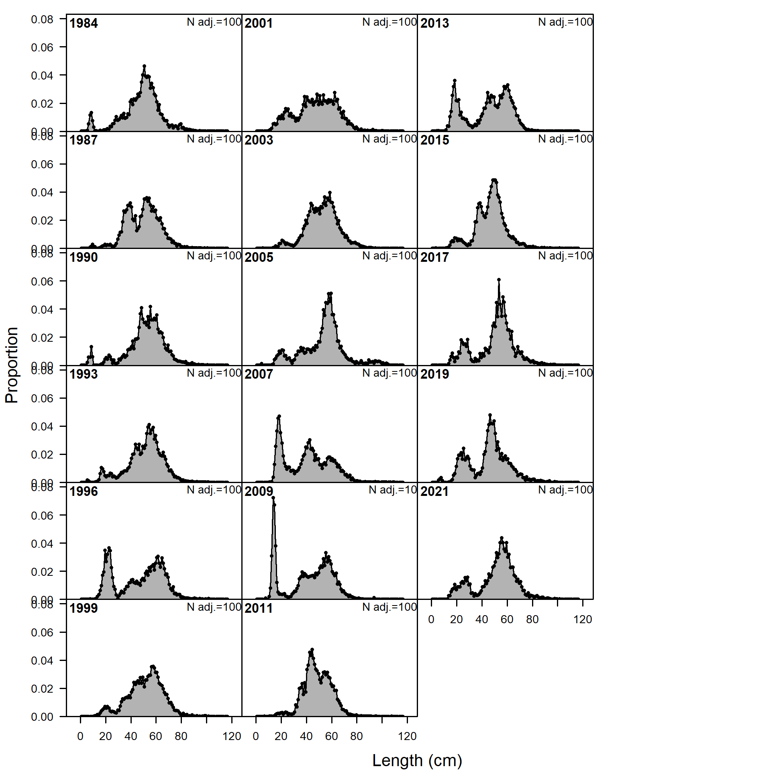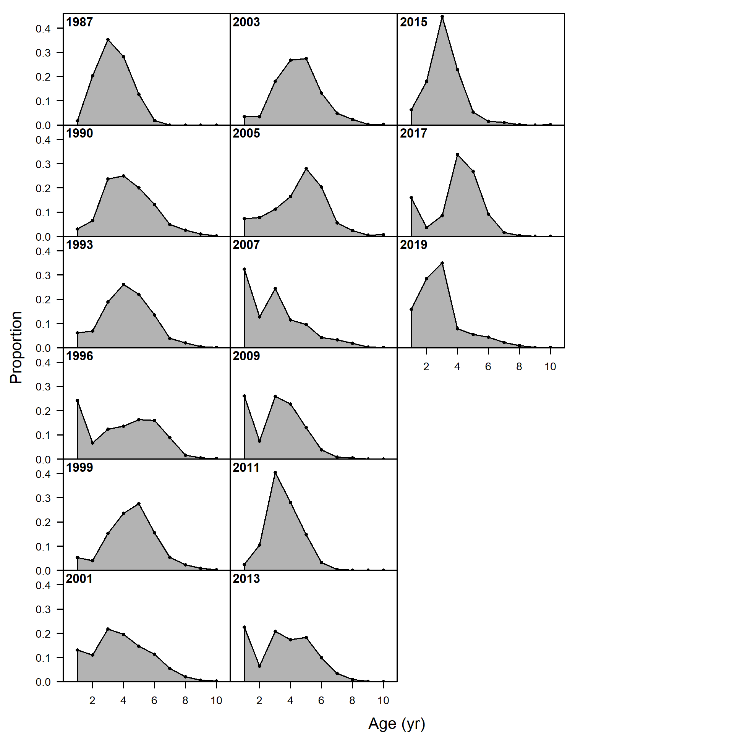

Figure 2.47 Available Pacific cod length (left) and age (right) composition data from the Gulf of Alaska bottom trawl survey 1984-2021.

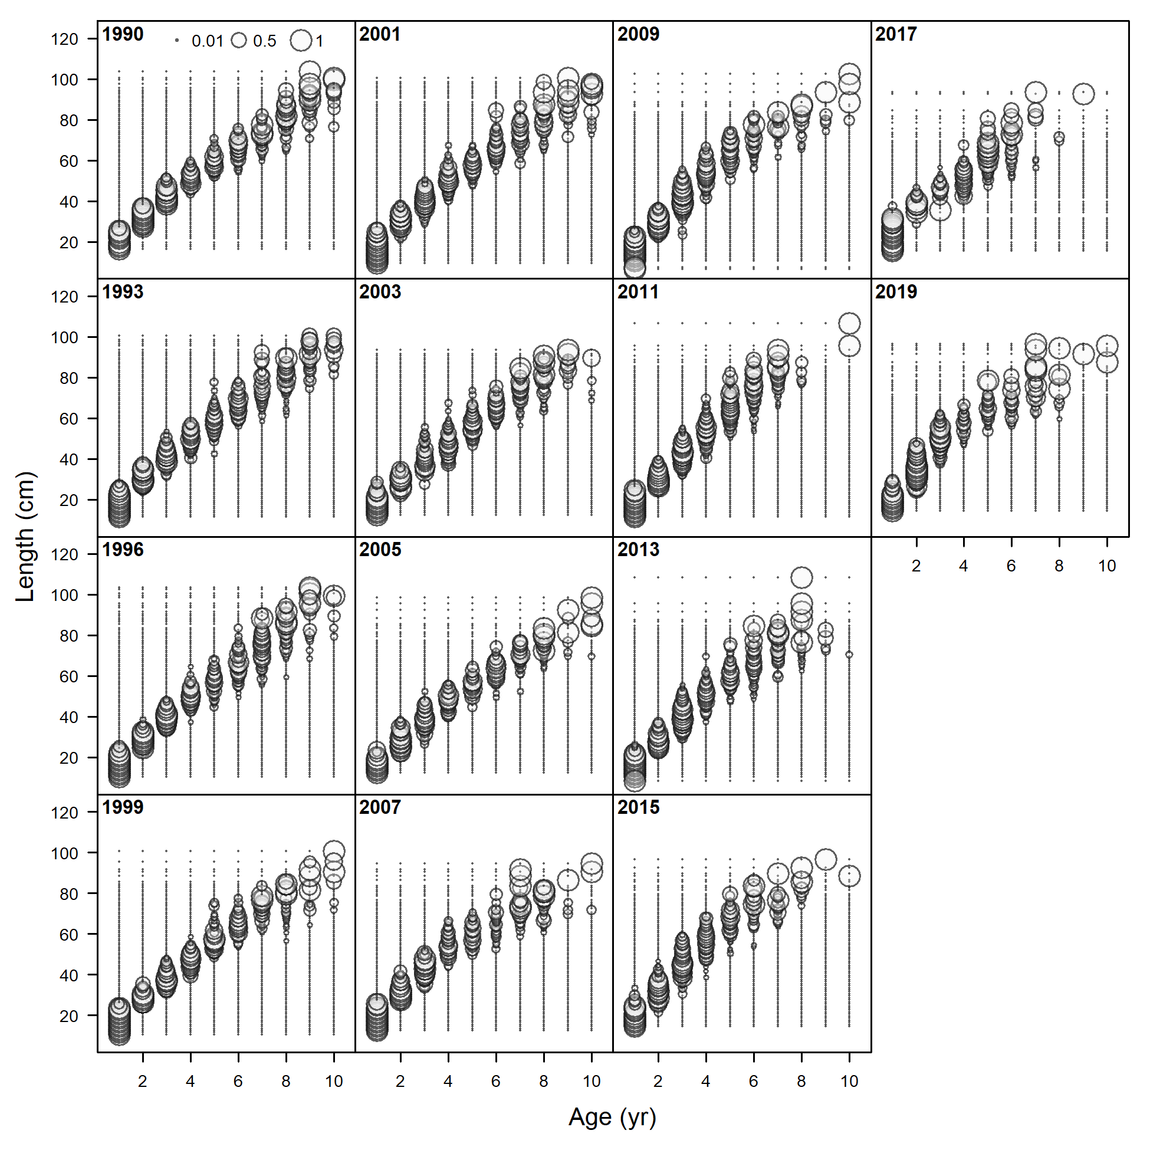

Figure 2.48 Pacific cod conditional length at age from the Gulf of Alaska bottom trawl survey 1990-2019.

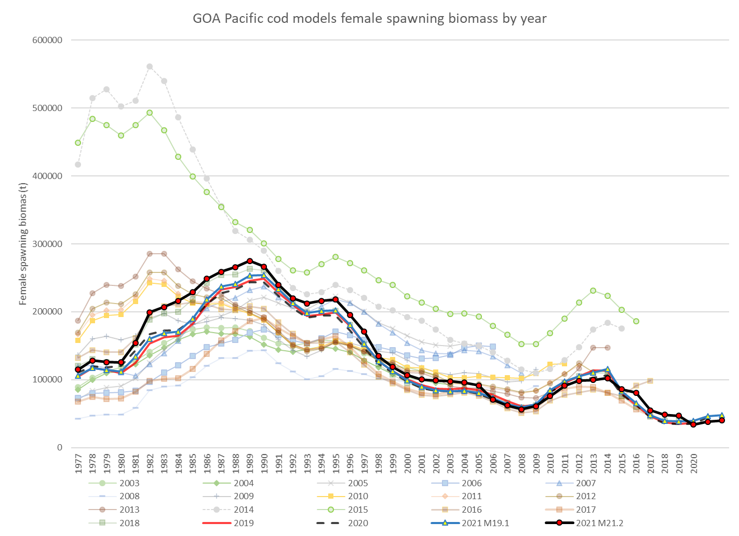

Figure 2.49 1977-2021 Gulf of Alaska Pacific cod female spawning biomass from the 2003 through 2021 stock assessments with estimates from both the author’s preferred (Model 21.2) and last year’s base model (Model 19.1) model results and (inset) images from the NMFS small net surveys off Kodiak Alaska showing change in species composition over time from: <https://www.thenakedscientists.com/articles/science-features/ecosystem-shifts-and-sharks-alaska>

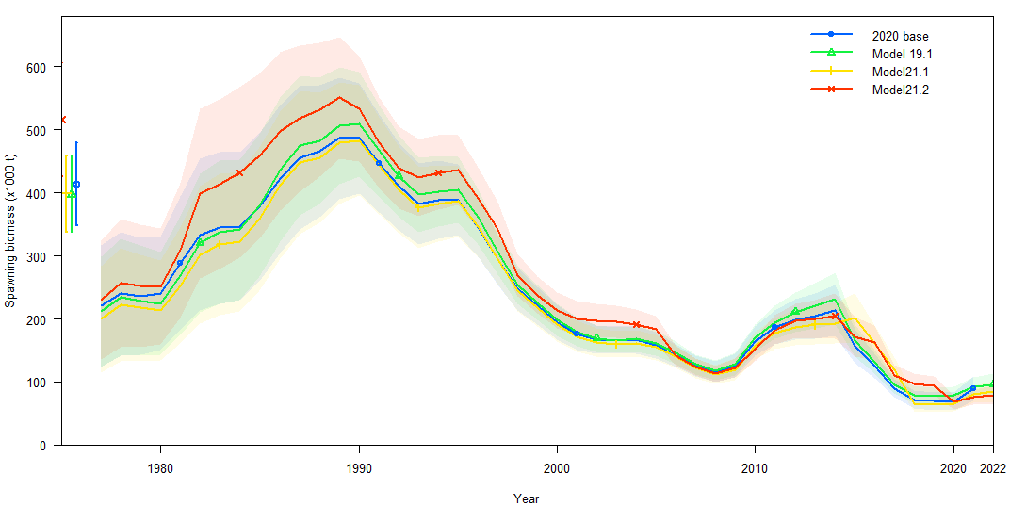

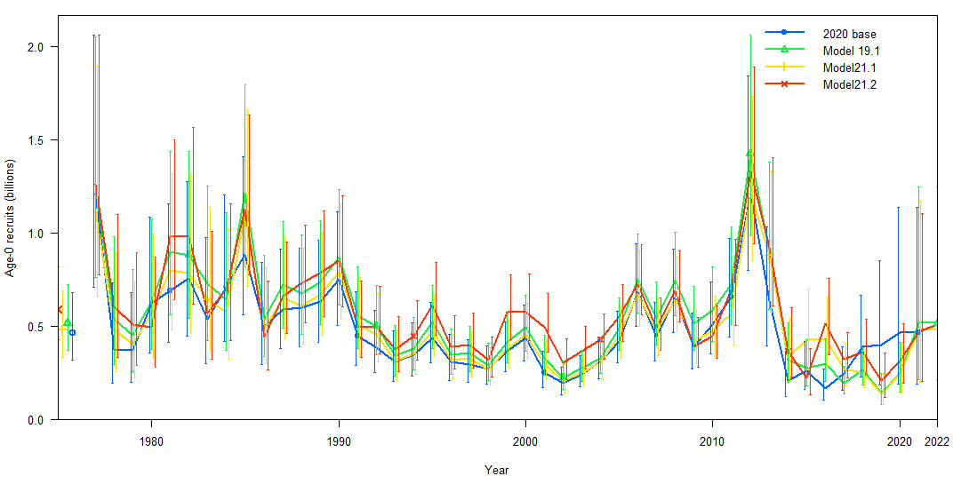

Figure 2.50 Estimates of female spawning biomass (t; top) and age-0 recruits (billions; bottom) for 2020 base model and 2021 proposed models.

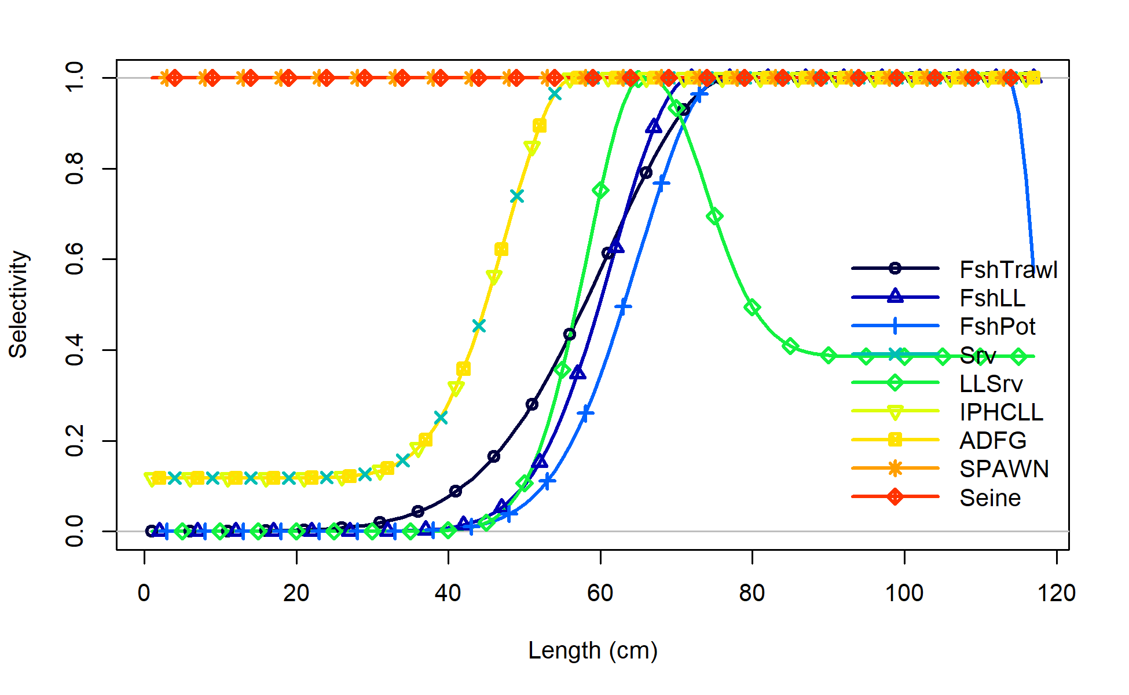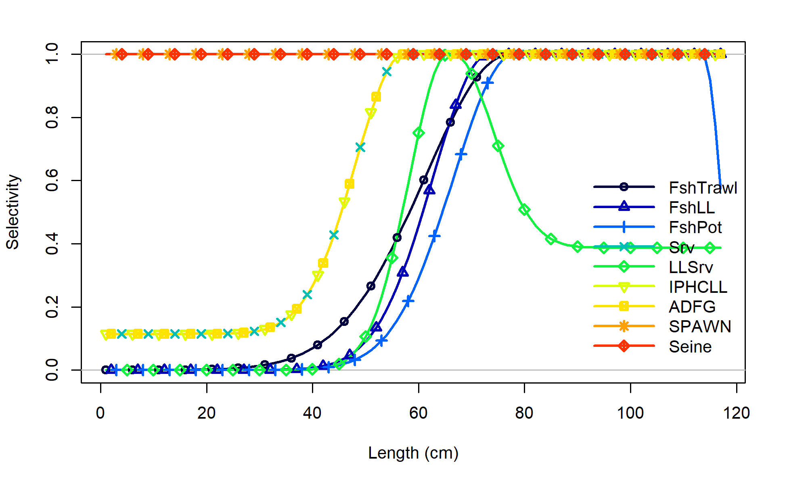

Model21.1

Model19.1

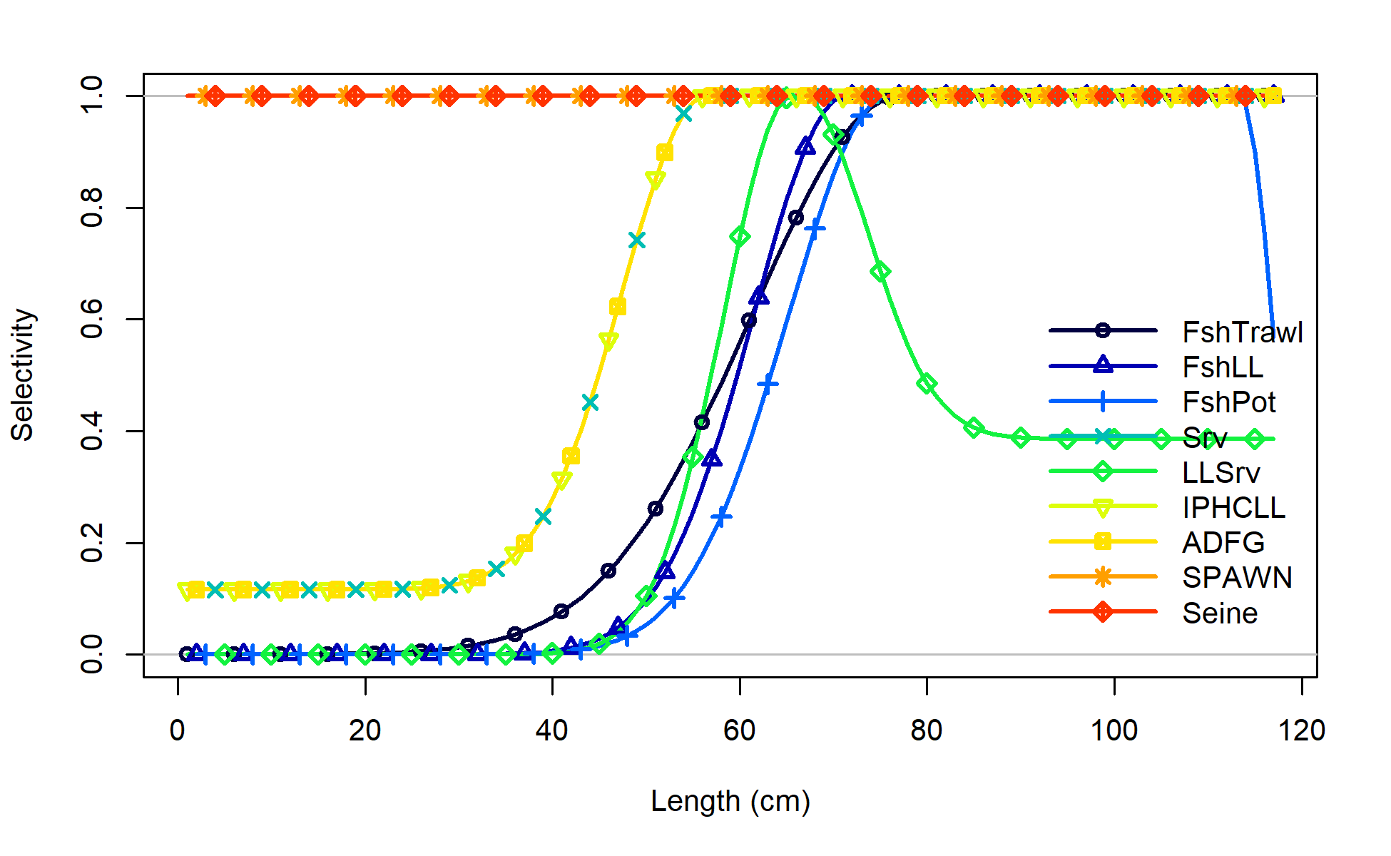

Model21.2

Figure 2.51 Model19.1, Model 21.1, and Model 21.2 selectivity for all size composition components for 2021.

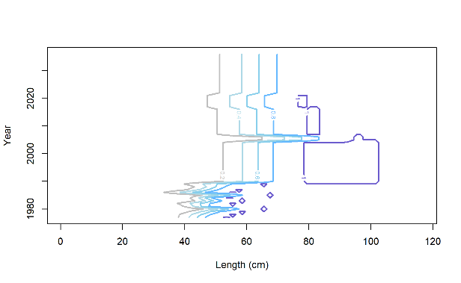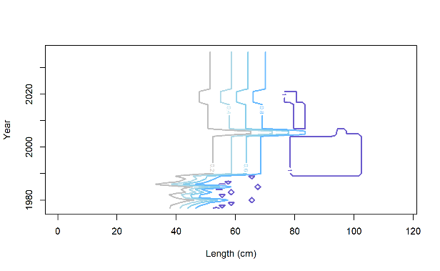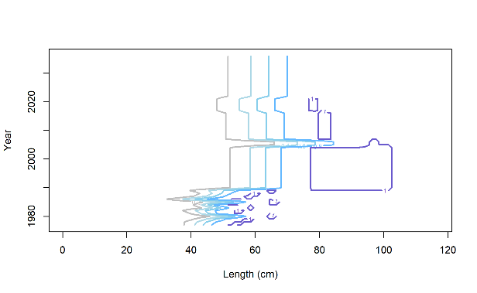

M 21.2

Trawl

M 21.1

Trawl

M 19.1

Trawl

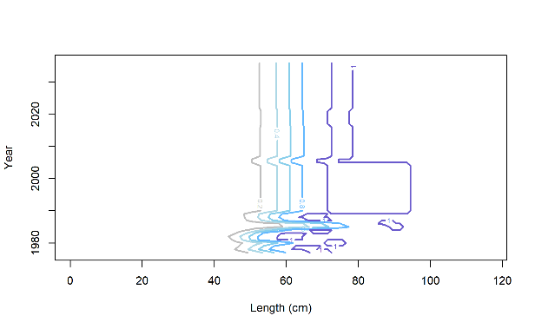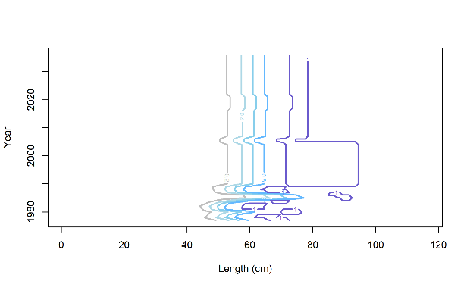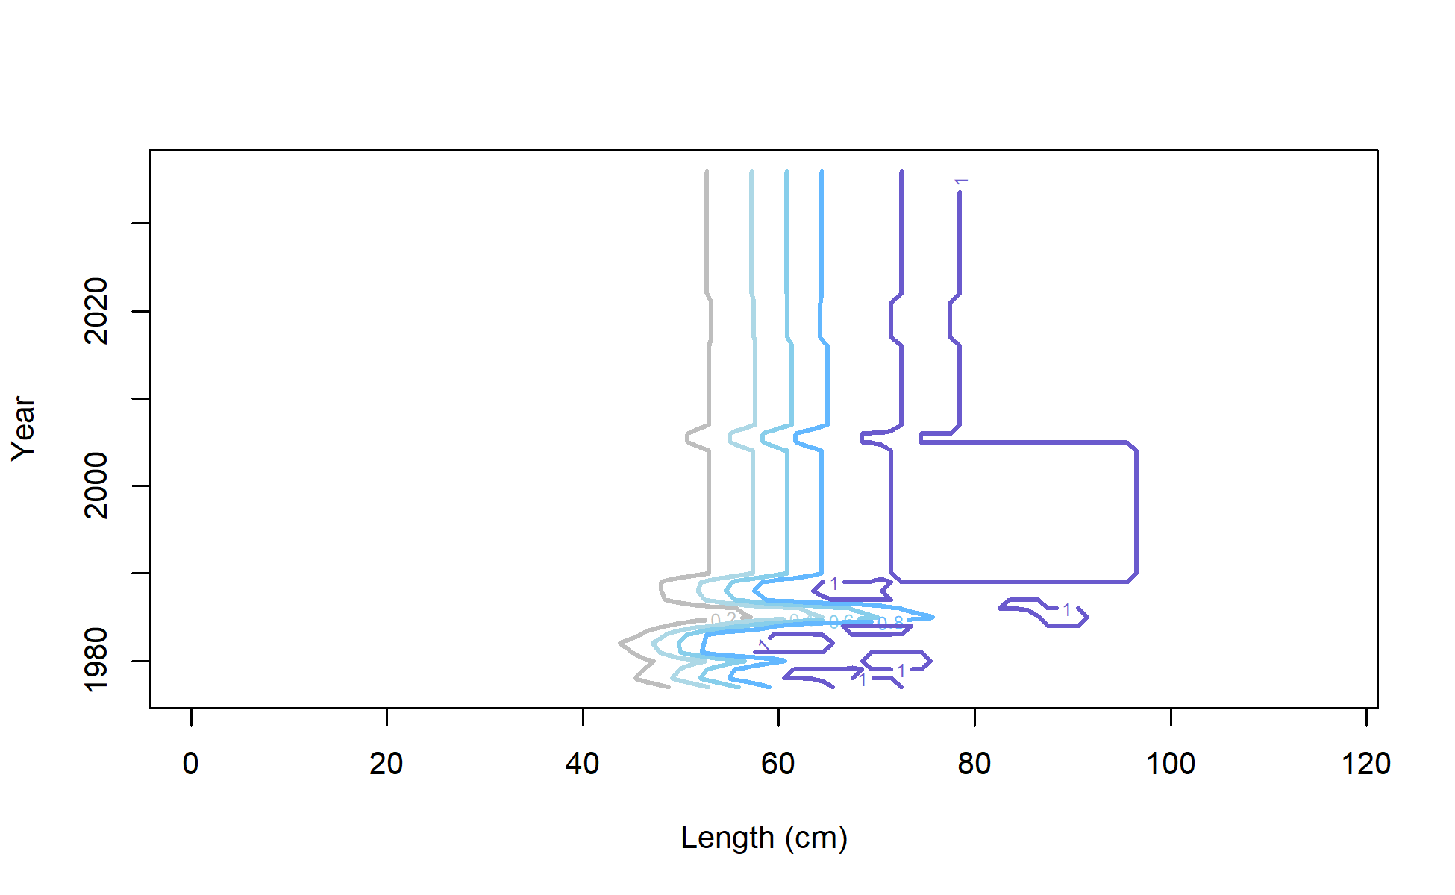

M 21.1

Longline

M 21.2

Longline

M 19.1

Longline

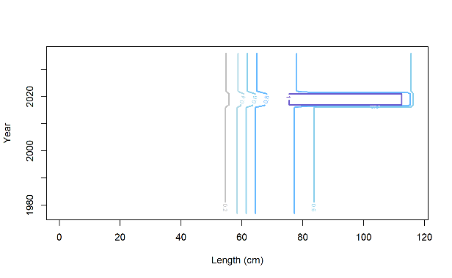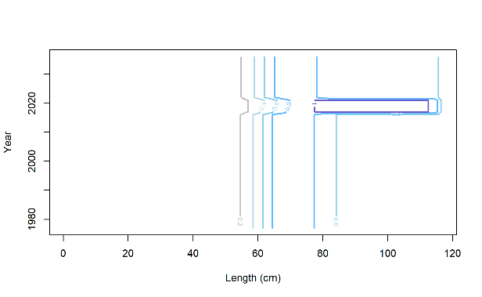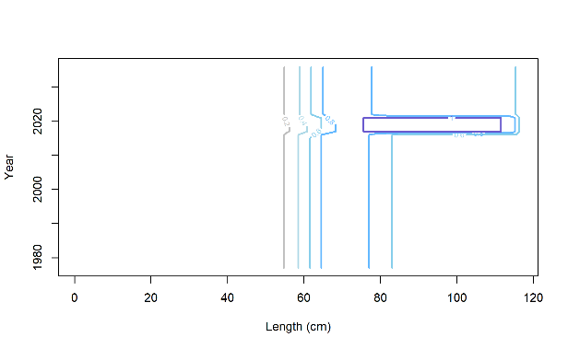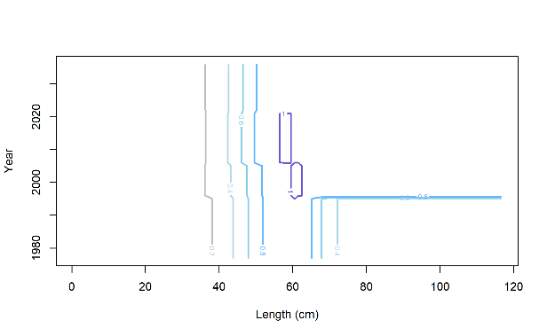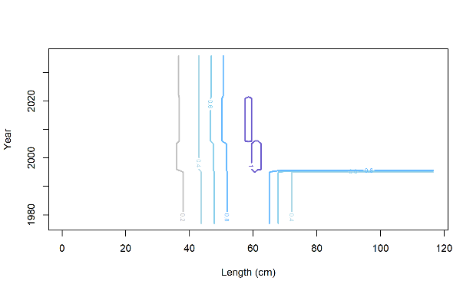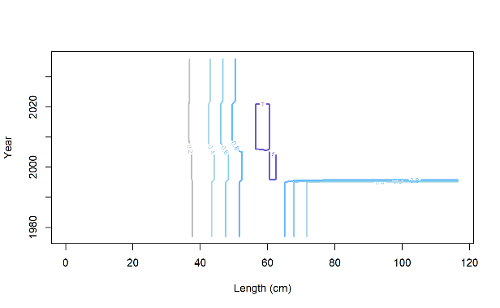

M 19.1

BT Survey

M 21.2

BT Survey

M 21.1

BT Survey

M 21.2

Pot

M 21.1

Pot

M 19.1

Pot

Figure 2.52 Estimates of fishery and AFSC bottom trawl survey selectivities for evaluated models. Red dashed line is the size at 50% mature.

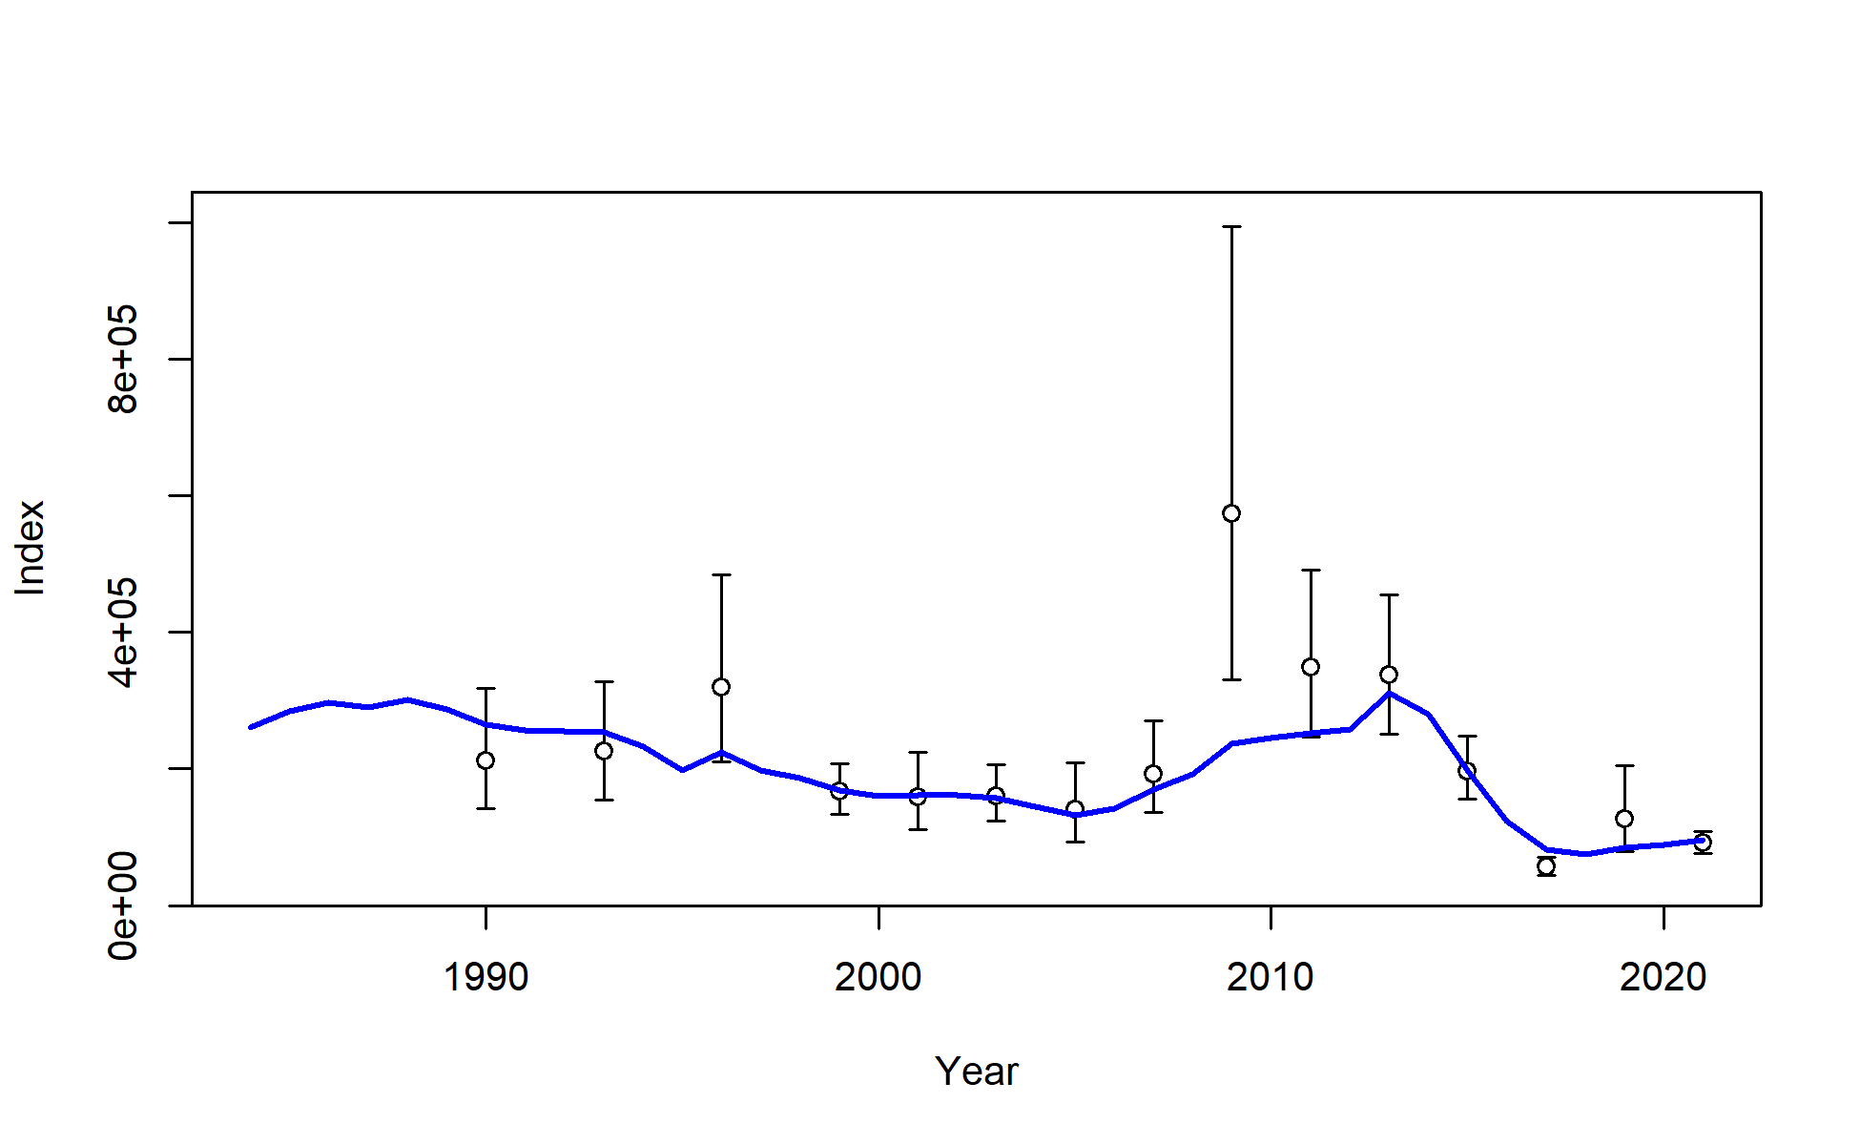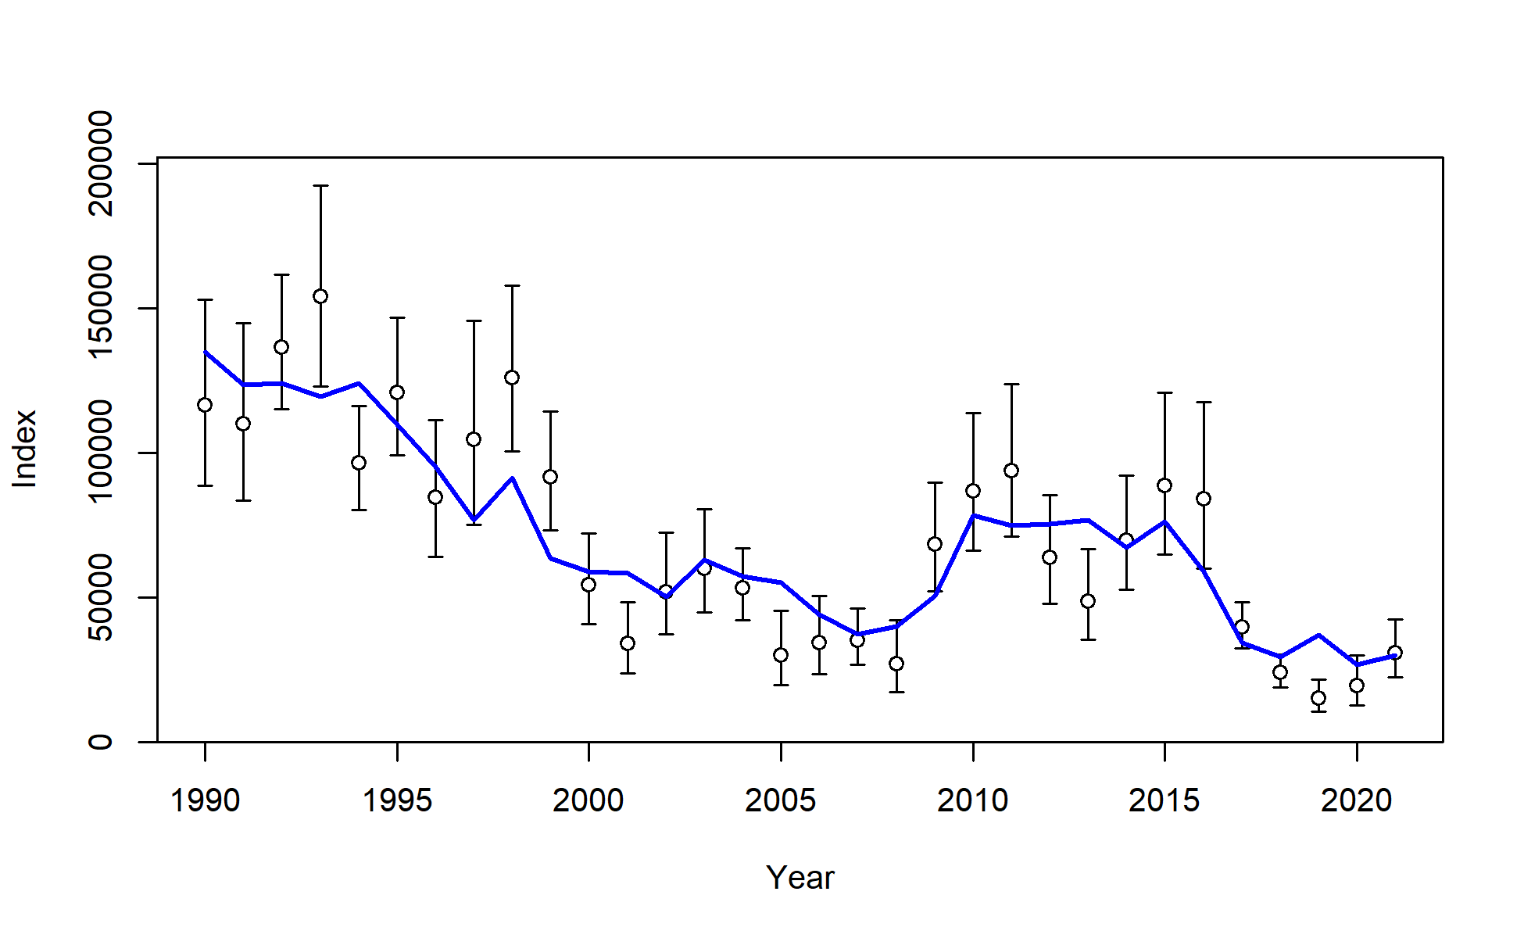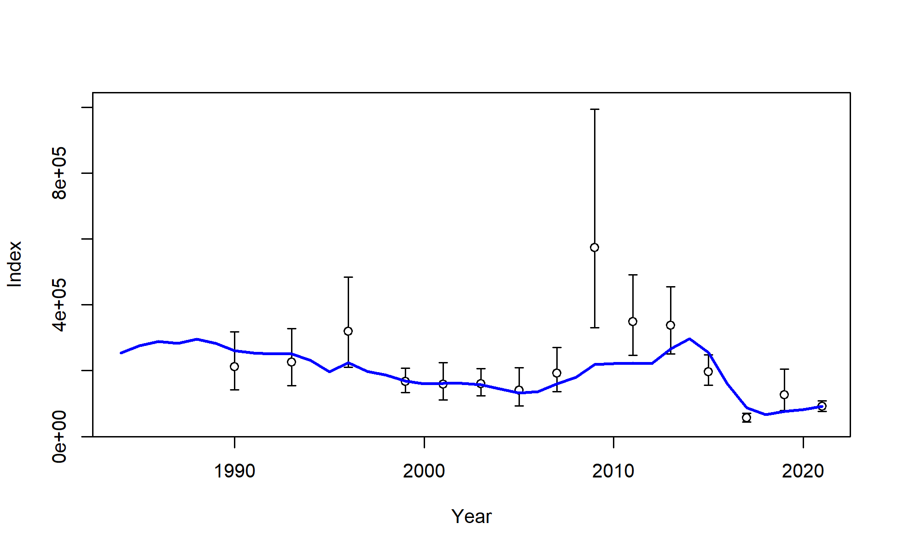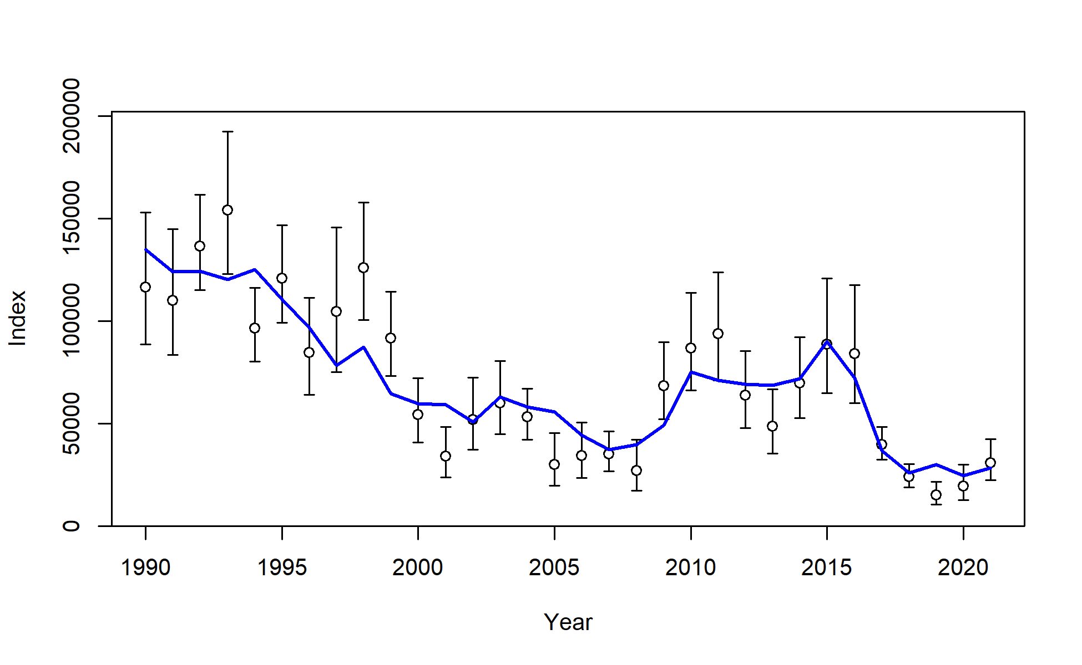

Model 19.1 AFSC longline survey

Model 21.1 AFSC longline survey

Model 21.1 AFSC trawl survey

Model 19.1 AFSC trawl survey

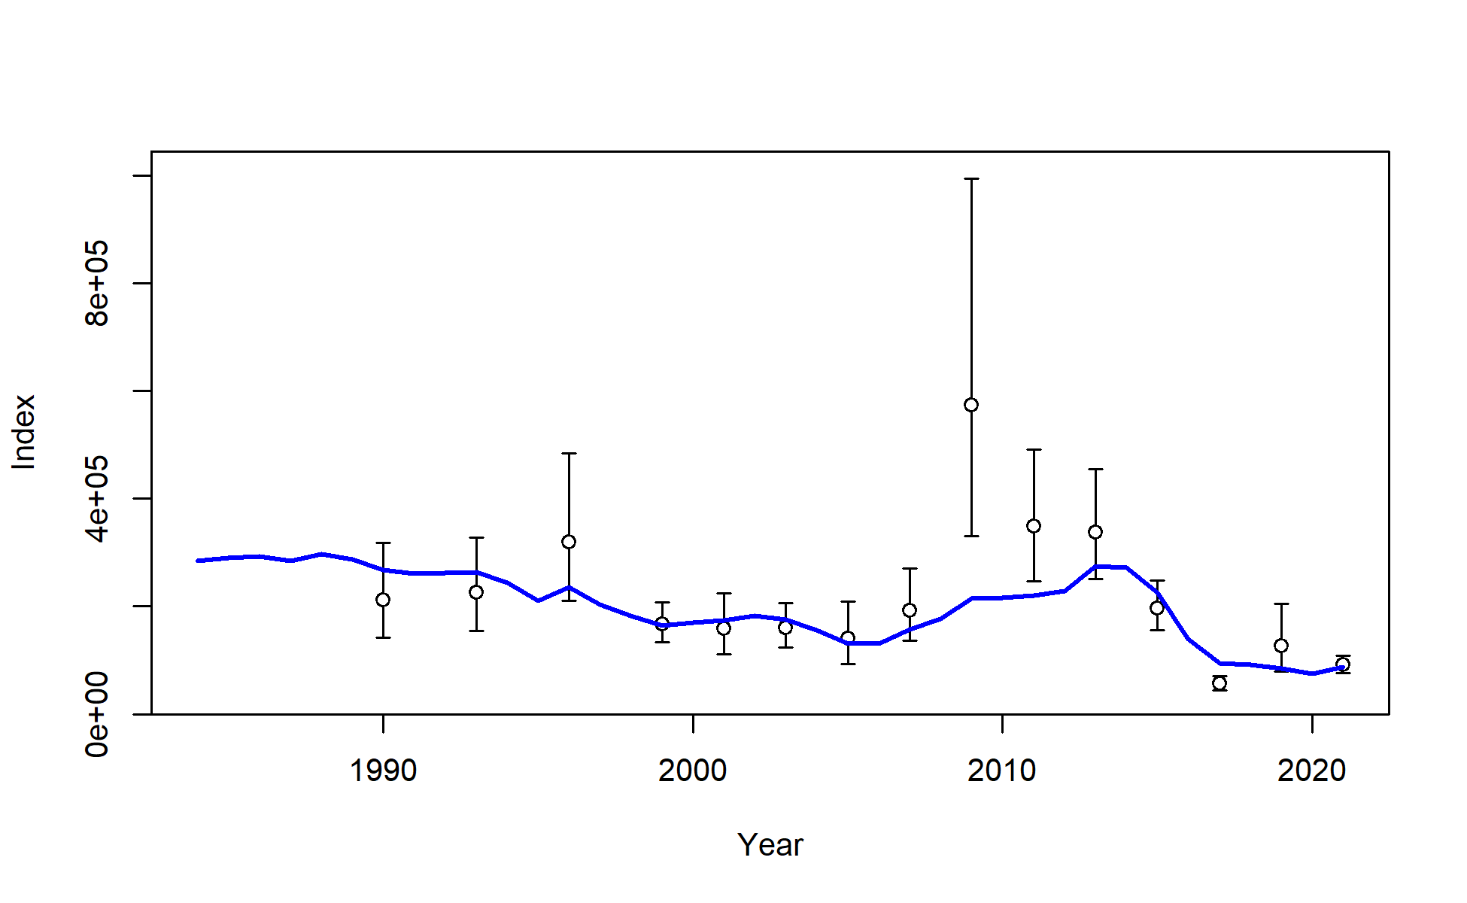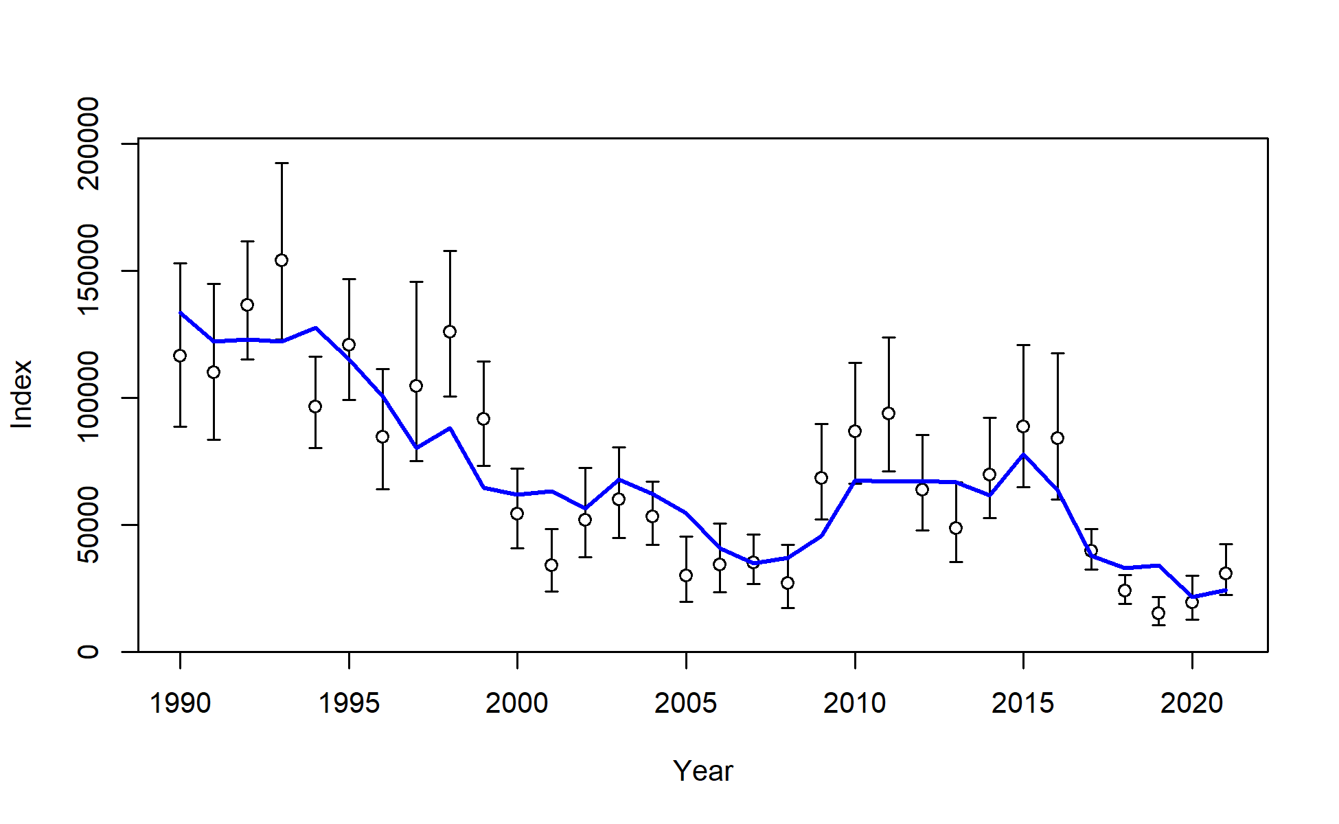

Model 21.2 AFSC longline survey

Model 21.2 AFSC trawl survey

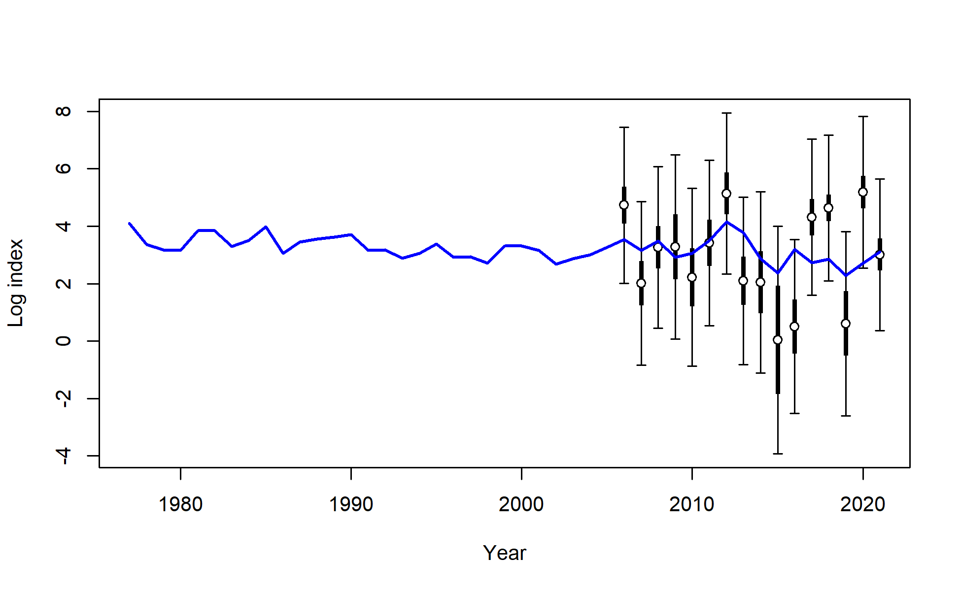

Model 21.2 beach seine

Figure 2.53 Model fits to AFSC bottom trawl (left), AFSC longline (right) survey, and age-0 beach seine (bottom middle) survey indices.

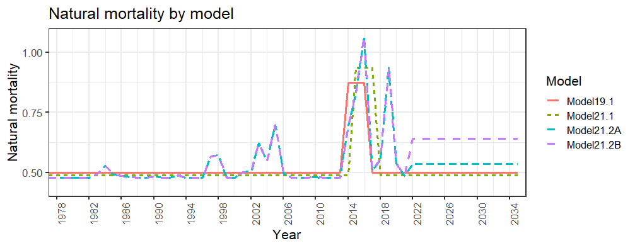

Figure 2.54 Natural mortality over time for the assessed models with projections for 2022-2036.

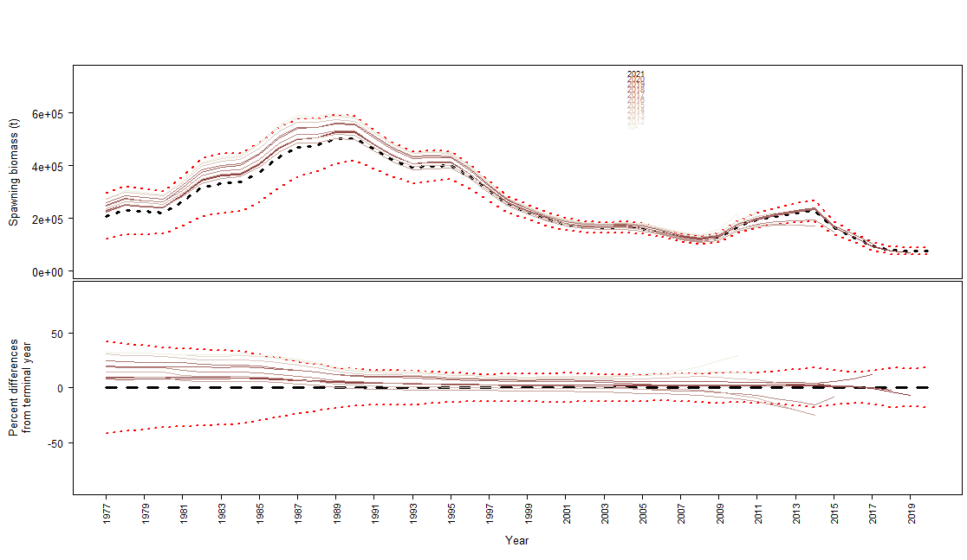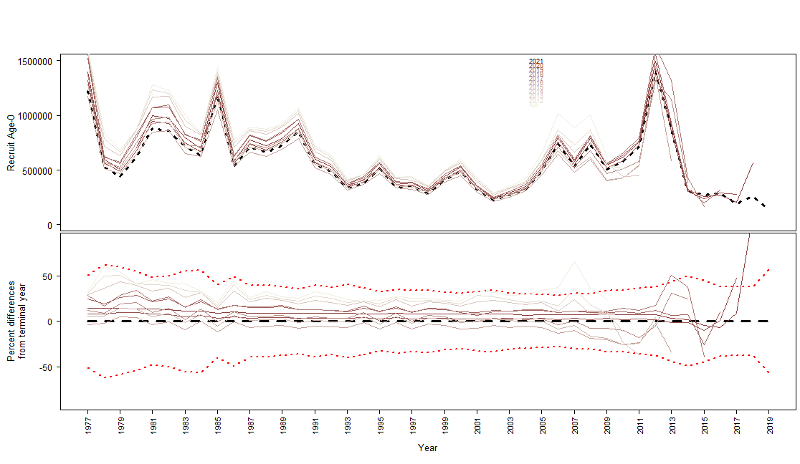

Figure 2.55 Retrospective analysis for Model 19.1 for female spawning biomass (top) and age-0 recruitment (bottom).

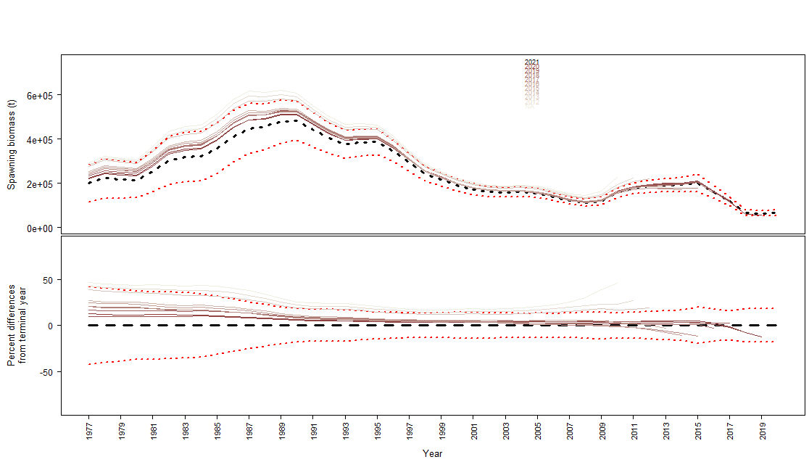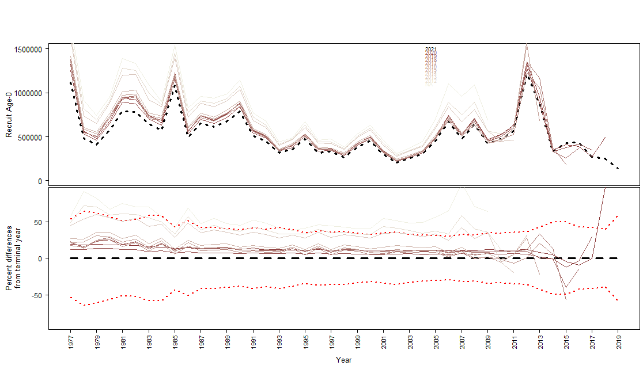

Figure 2.56 Retrospective analysis for Model 21.1 for female spawning biomass (top) and age-0 recruitment (bottom)..

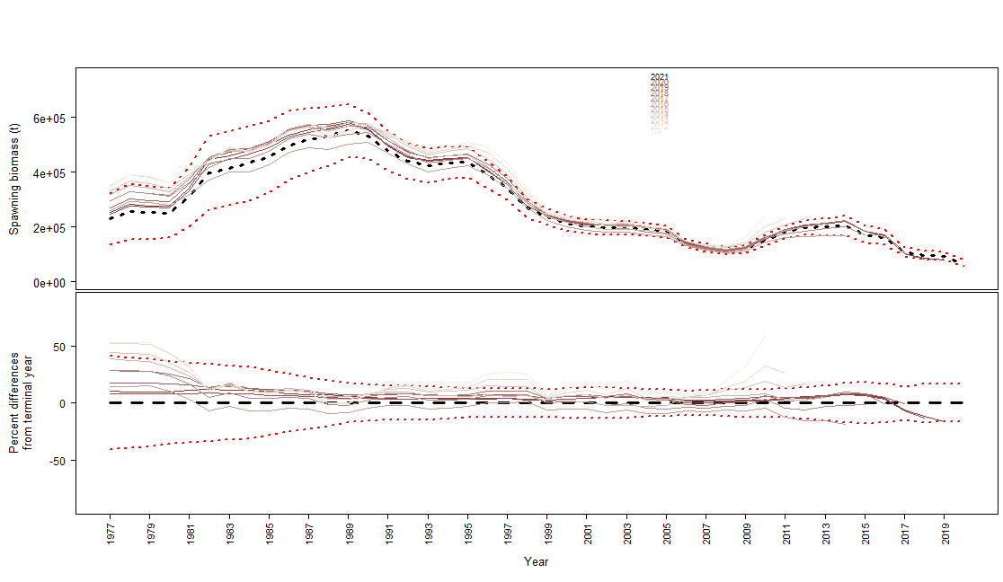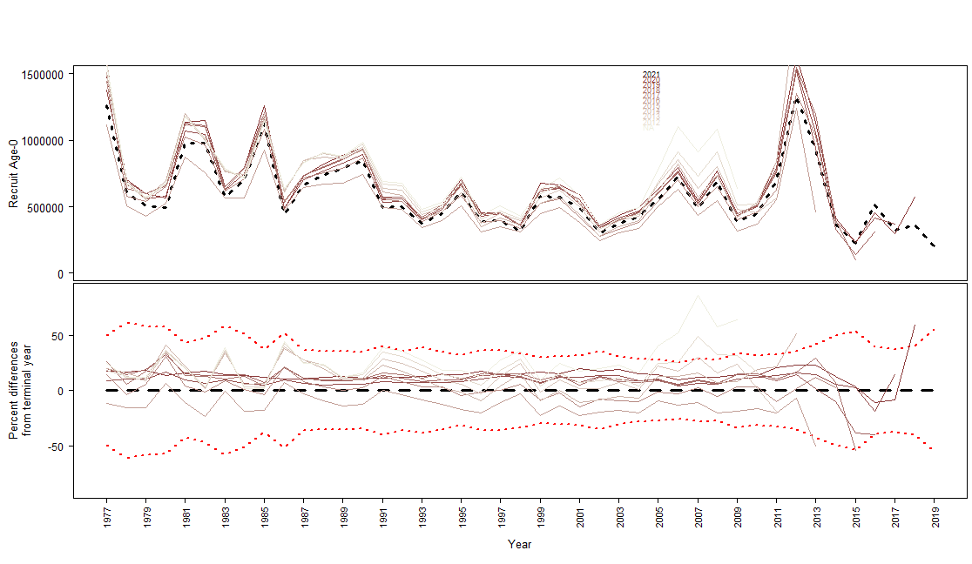

Figure 2.57 Retrospective analysis for Model 21.2 for female spawning biomass (top) and age-0 recruitment (bottom)..

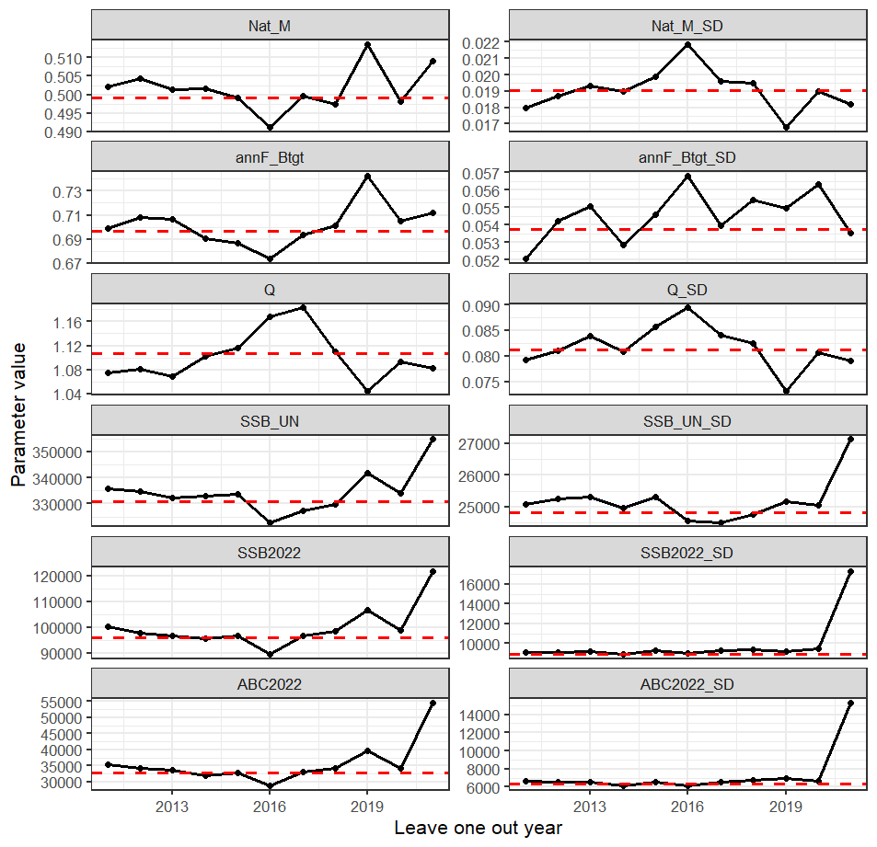

Figure 2.58 Model 19.1 leave-one-out analysis showing parameters and derived quantities as one year of data were removed from the model fit. Nat_M is the base natural mortality, annF_Btgt is the F40%, SSB_UN is the unfished spawning biomass, SSB2022 is the total spawning biomass for 2022 and ABC2022 is the estimated ABC for 2022. The SDs are the standard deviations of the estimates.

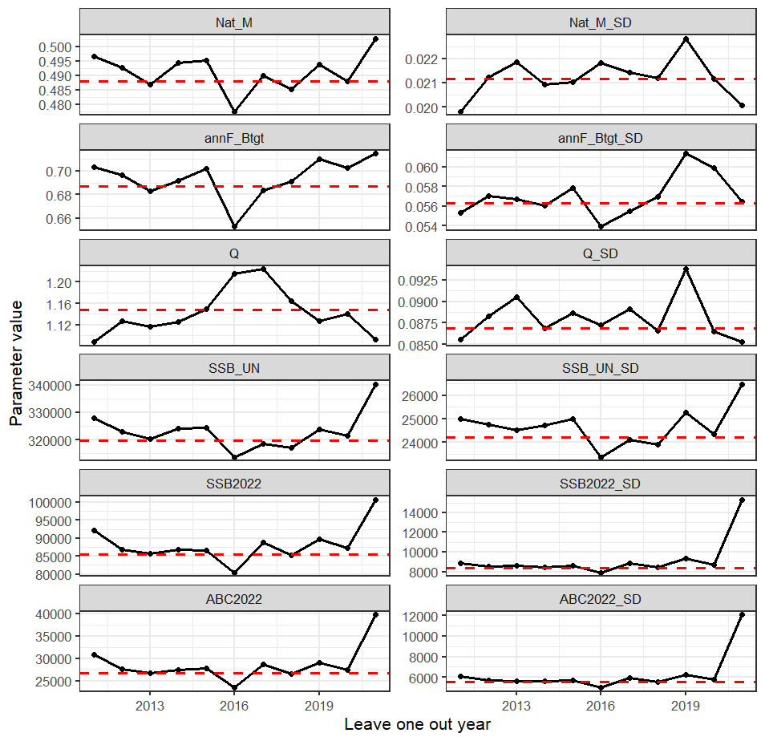

Figure 2.59 Model 21.1 leave-one-out analysis showing parameters and derived quantities as one year of data were removed from the model fit. Nat_M is the base natural mortality, annF_Btgt is the F40%, SSB_UN is the unfished spawning biomass, SSB2022 is the total spawning biomass for 2022 and ABC2022 is the estimated ABC for 2022. The SDs are the standard deviations of the estimates.

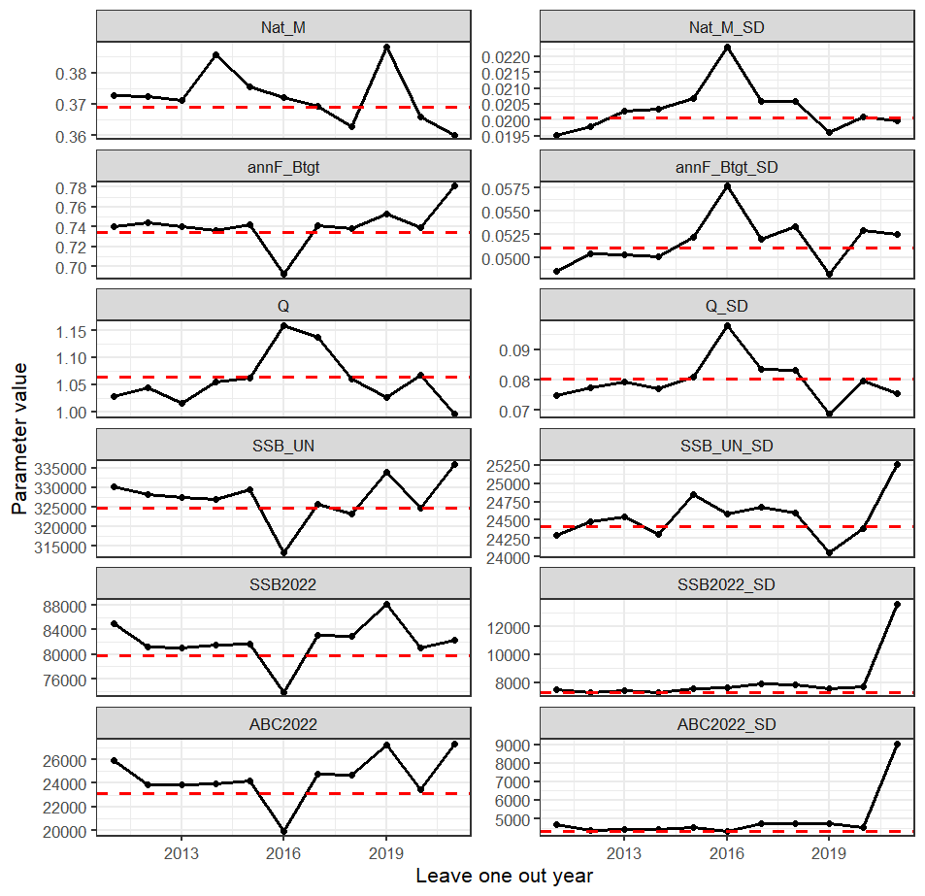

Figure 2.60 Model 21.2 leave-one-out analysis showing parameters and derived quantities as one year of data were removed from the model fit. Nat_M is the base natural mortality, annF_Btgt is the F40%, SSB_UN is the unfished spawning biomass, SSB2022 is the total spawning biomass for 2022 and ABC2022 is the estimated ABC for 2022. The SDs are the standard deviations of the estimates.

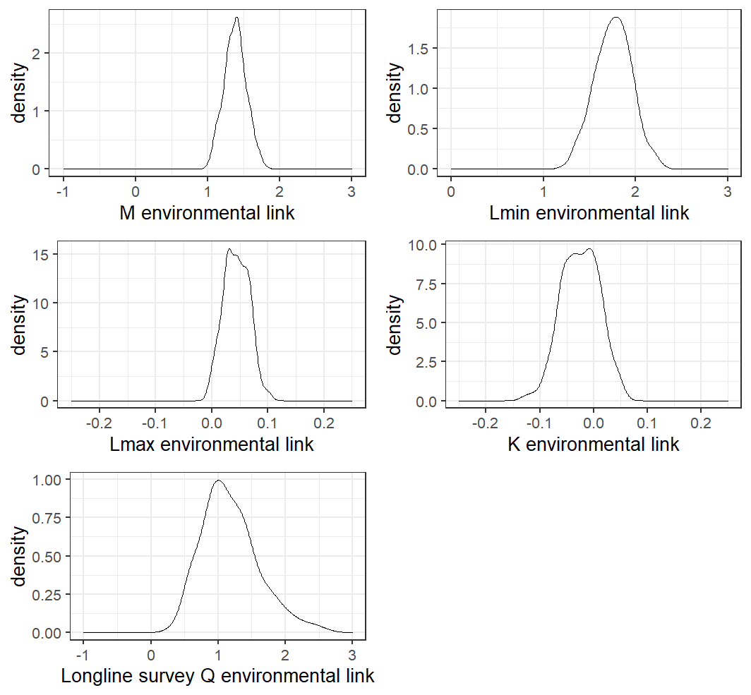

Figure 2.61 MCMC posterior distributions for the environmental link scaling parameters from Model 21.2 with uninformative priors.

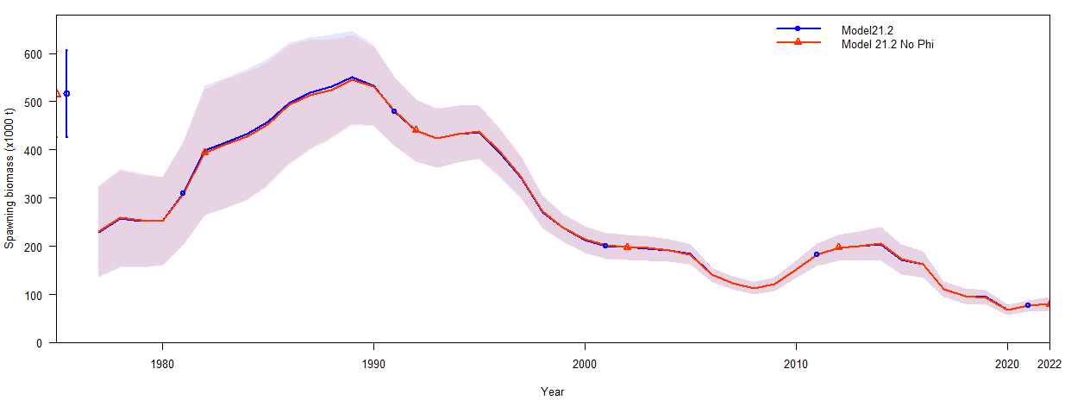

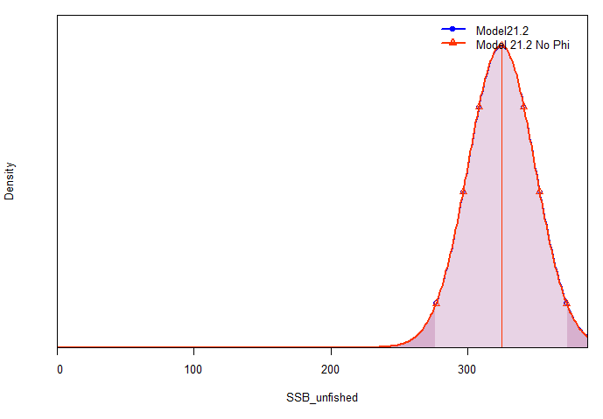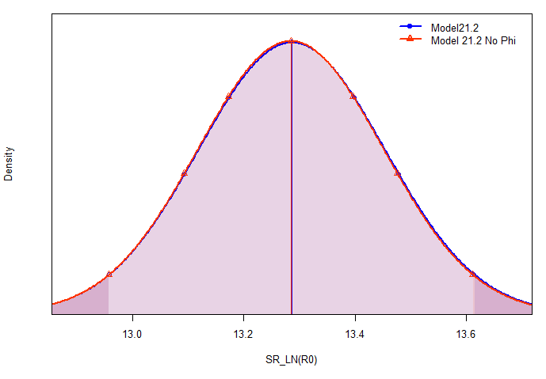

Figure 2.62 Model results from Model 21.2 with and without the ϕ link to K including total spawning biomass (top), unfished spawning biomass (bottom left), and the log of R0 (bottom right).

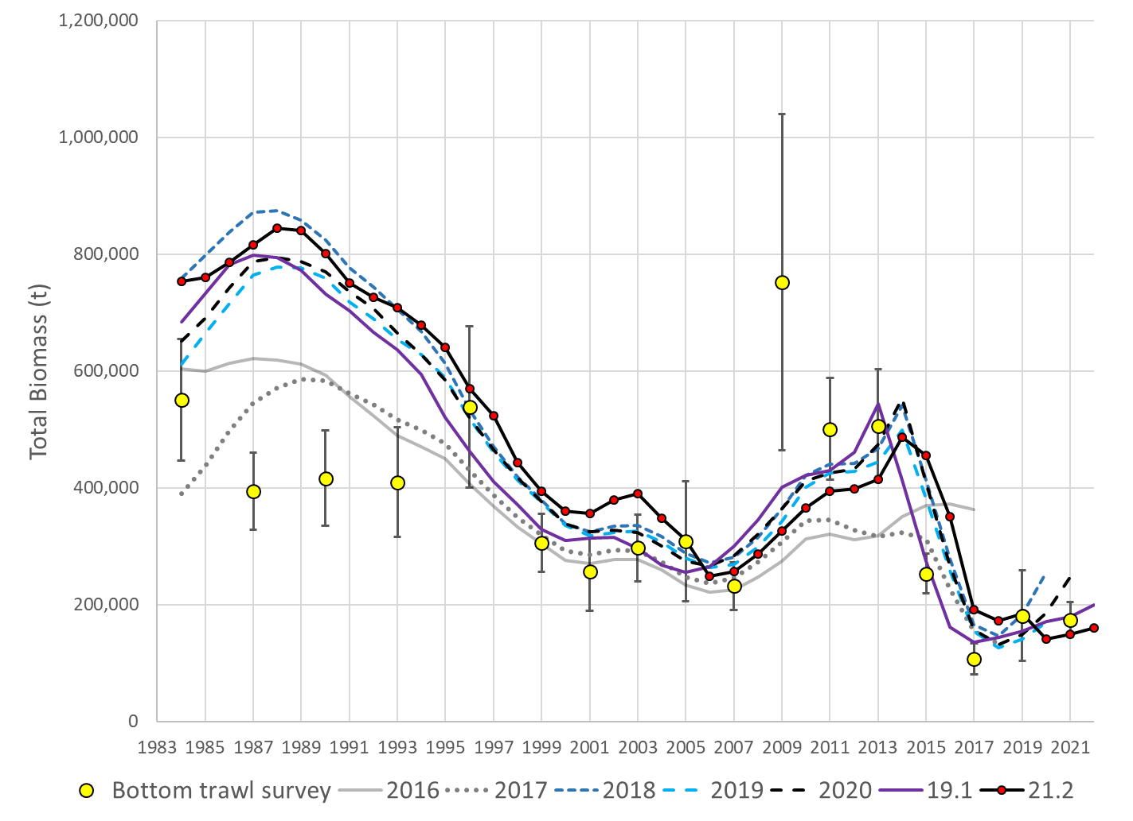

Figure 2.63 Total biomass estimates from reviewed models and NMFS bottom trawl survey biomass estimates with 95% confidence bounds.

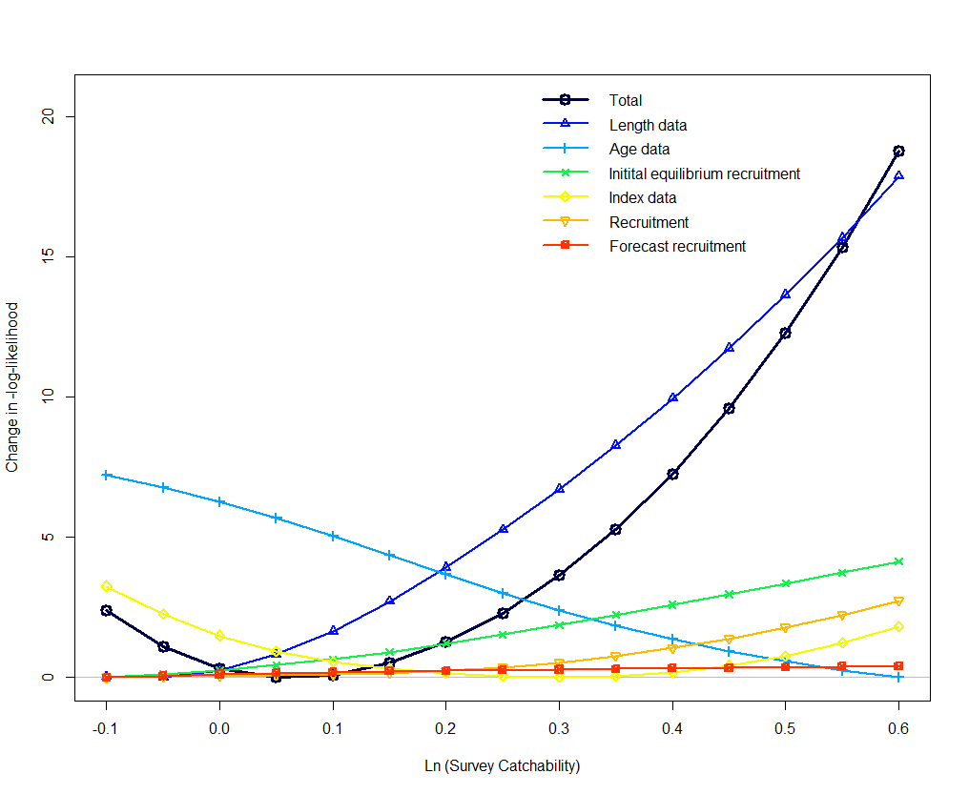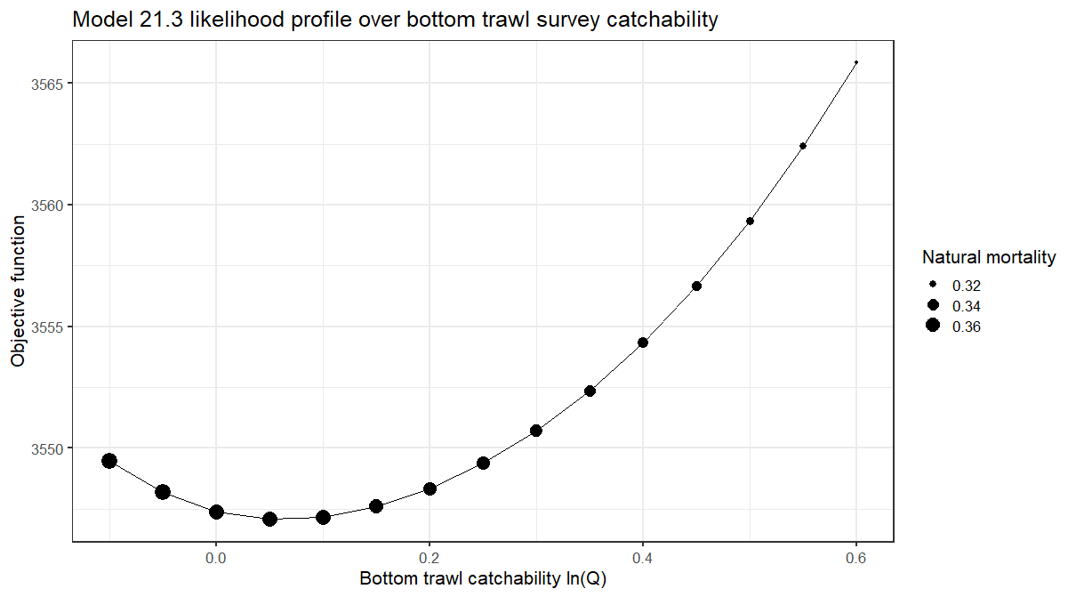

Figure 2.64 Model 21.2 likelihood profile on bottom trawl survey catchability.

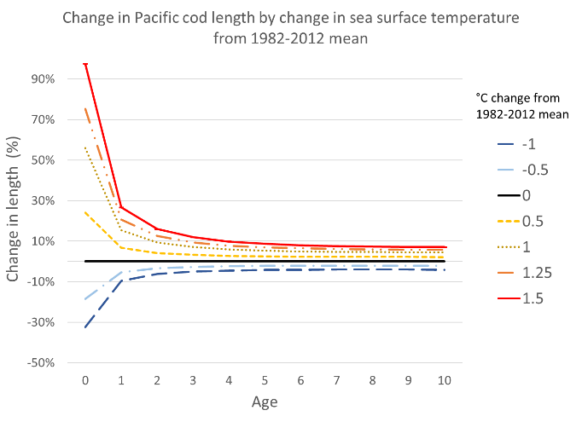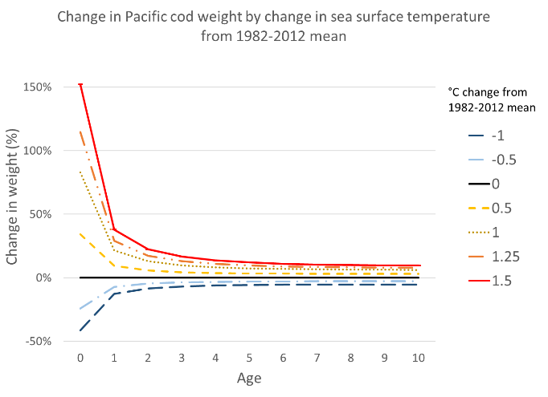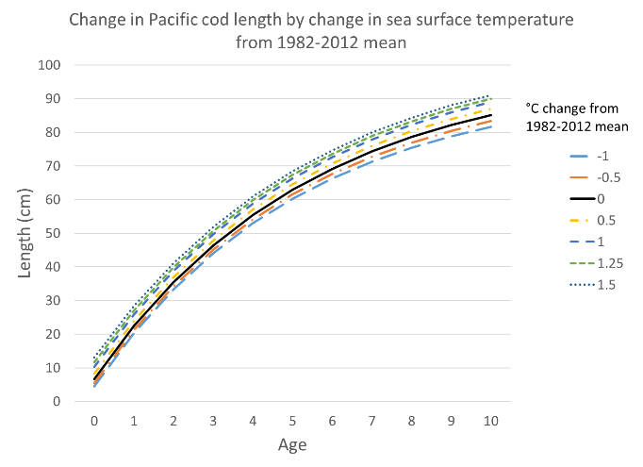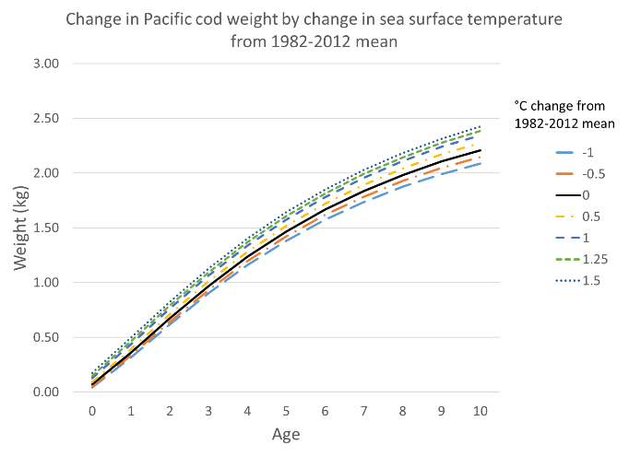

Figure 2.65 Model 21.2 change in length by age (left) and change in weight by age (right) by temperature anomaly from the 1982-2012 mean.

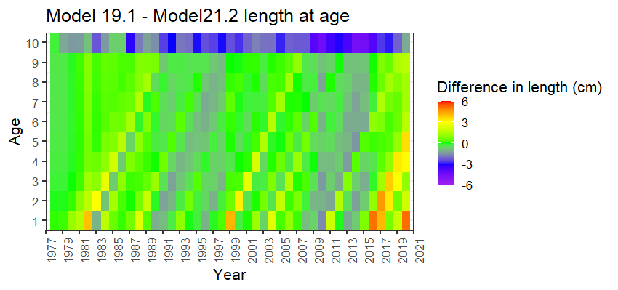

Figure 2.66 Difference in length at age from Model 19.1 with static growth to Model 21.2 with temperature dependent growth.

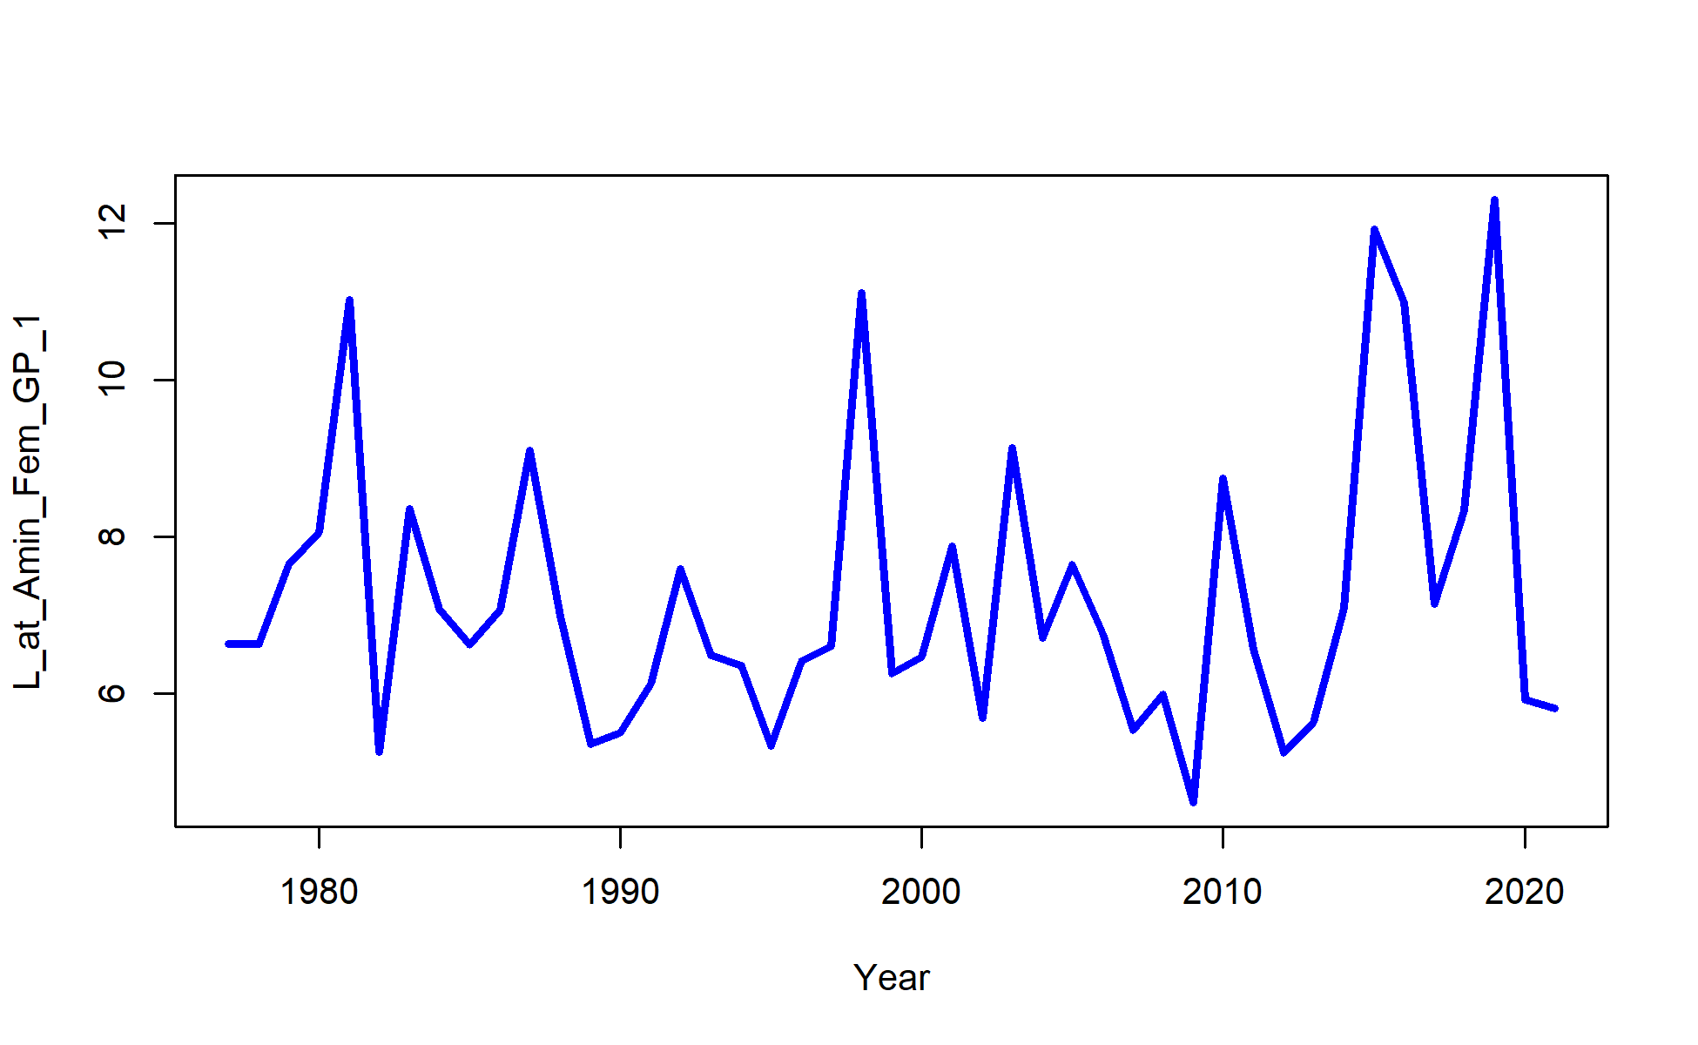

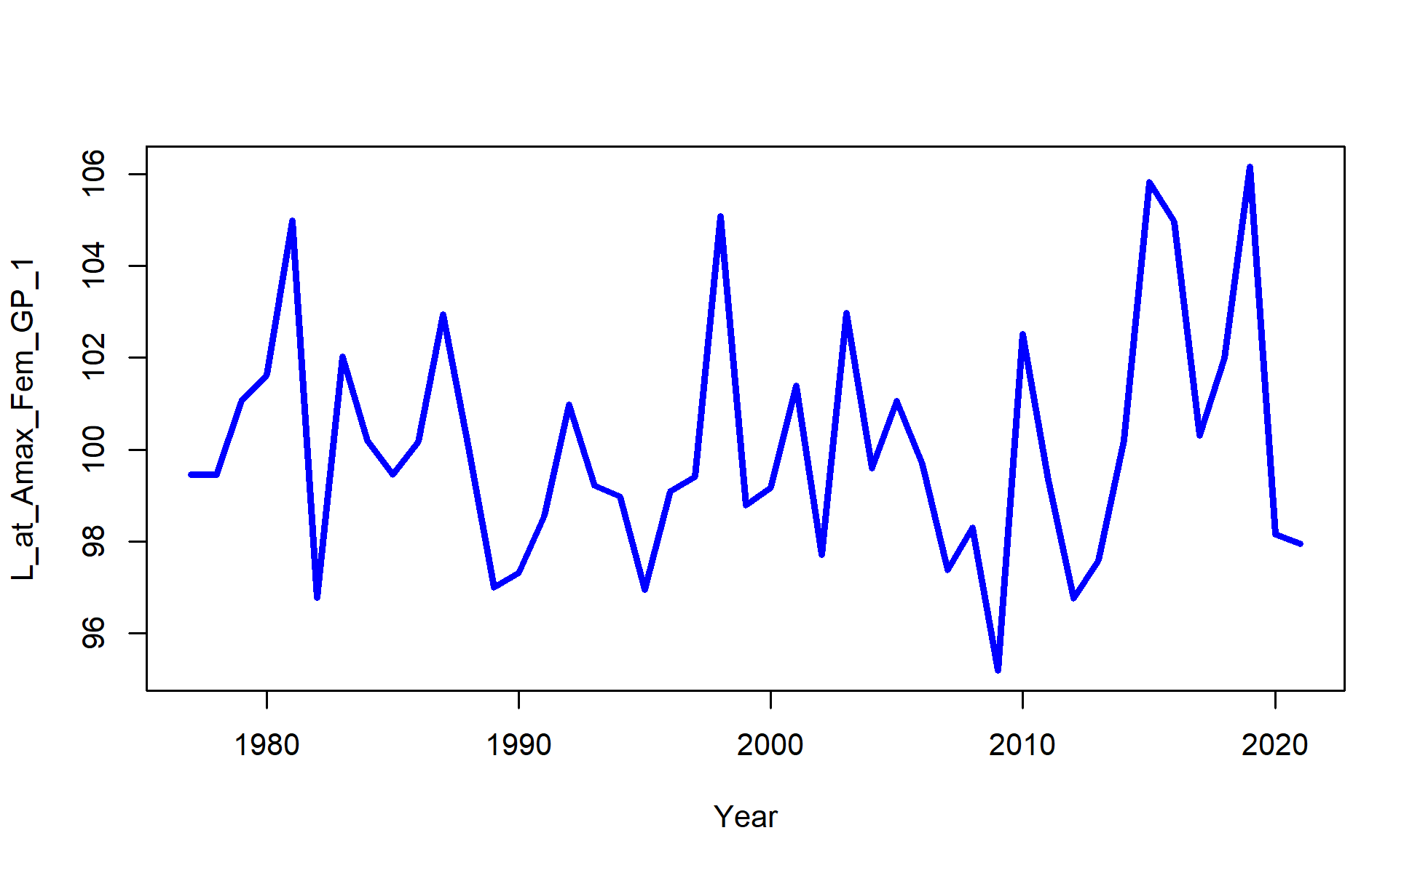

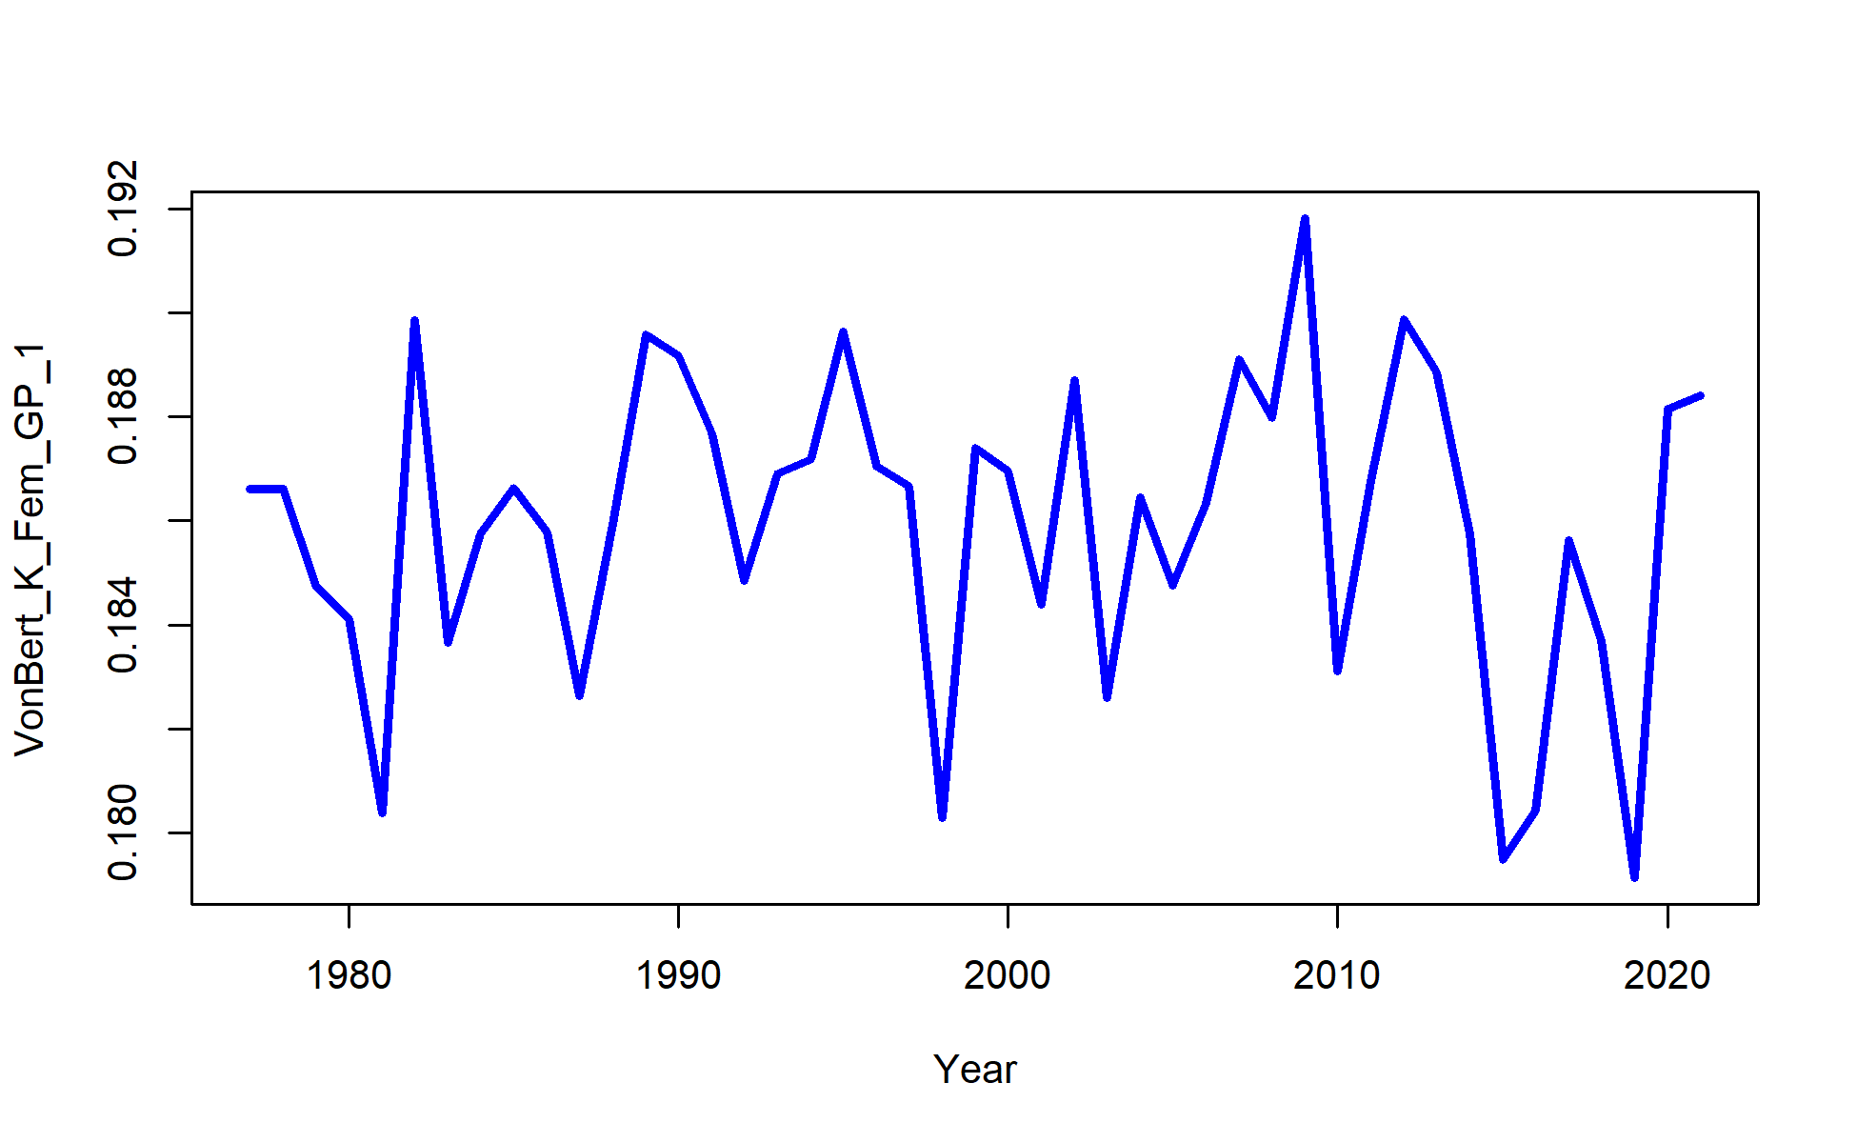

Figure 2.67 Model 21.2 Time-varying growth parameters, L1 (top), L2 (middle), and K (bottom).

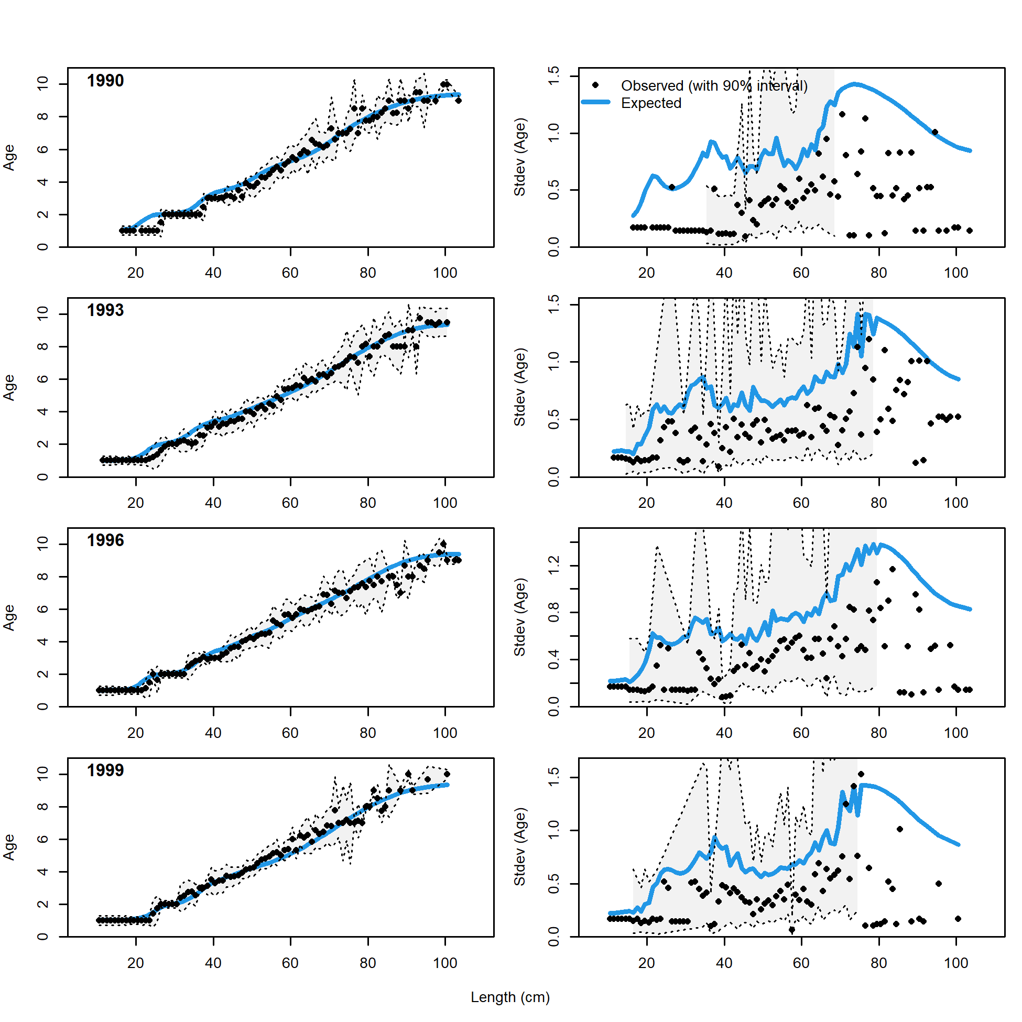 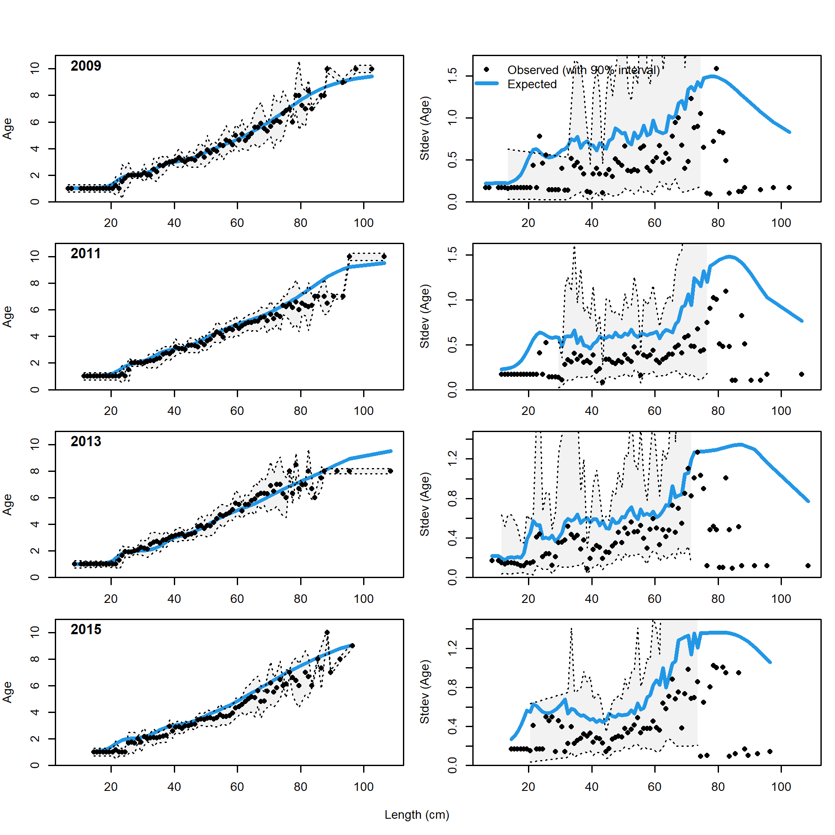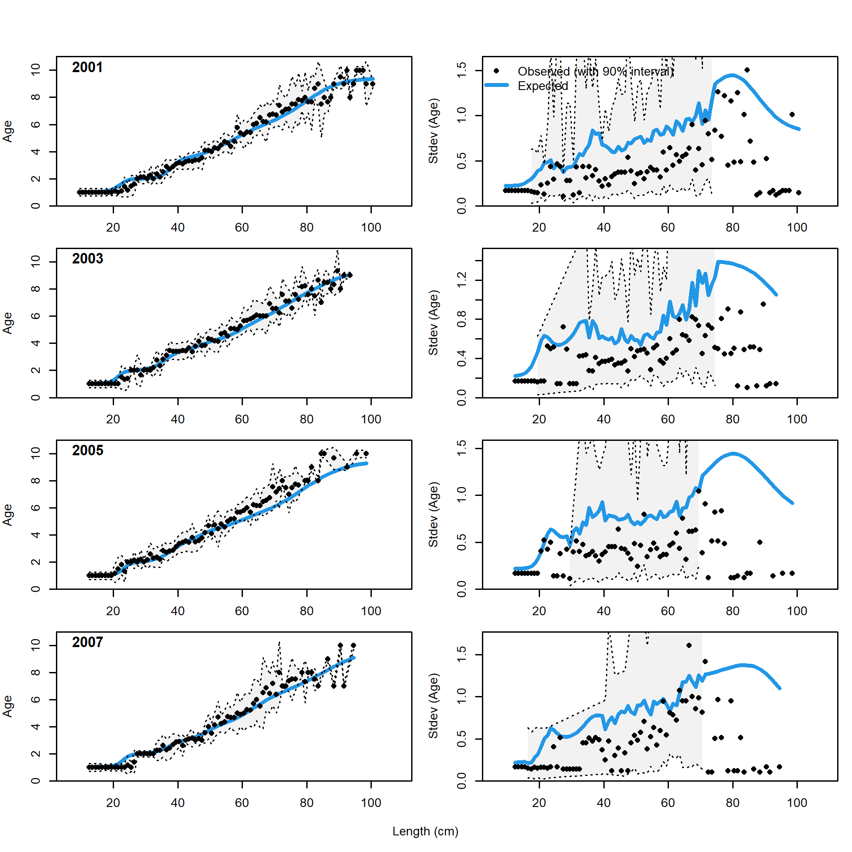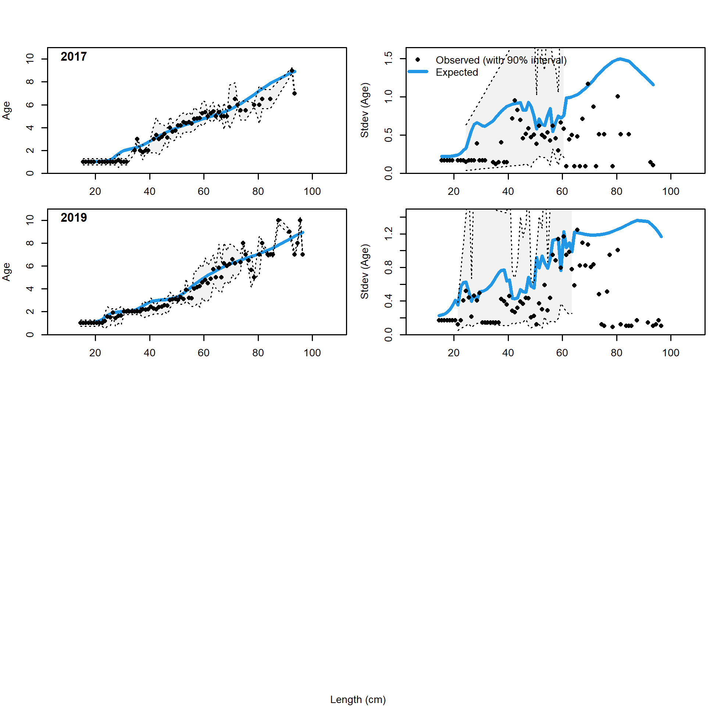

Figure 2.68 NMFS bottom trawl survey conditional age at length data and standard deviation with Model 21.2 fit (blue line).

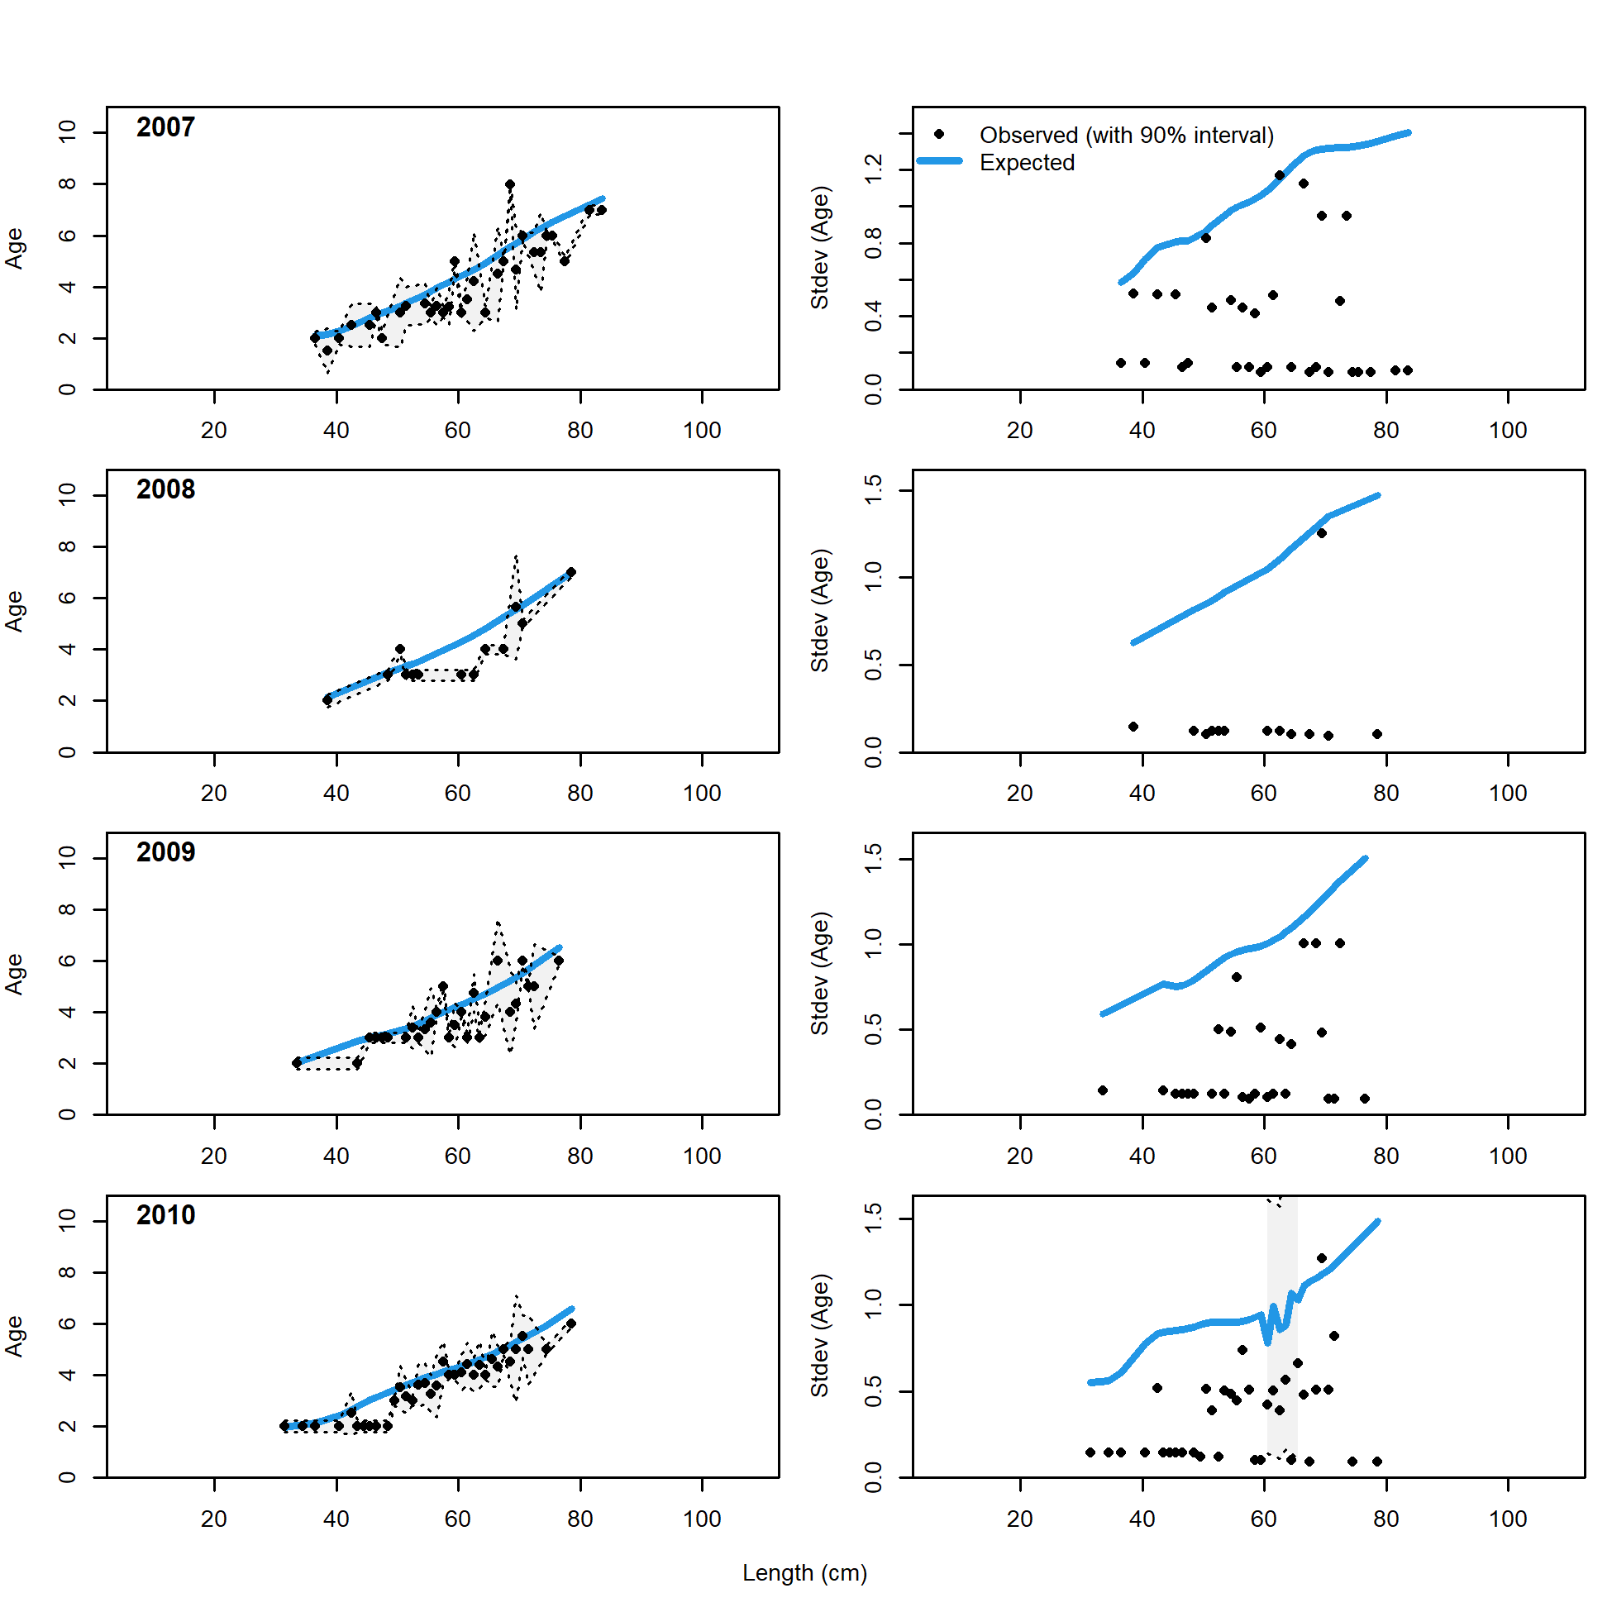 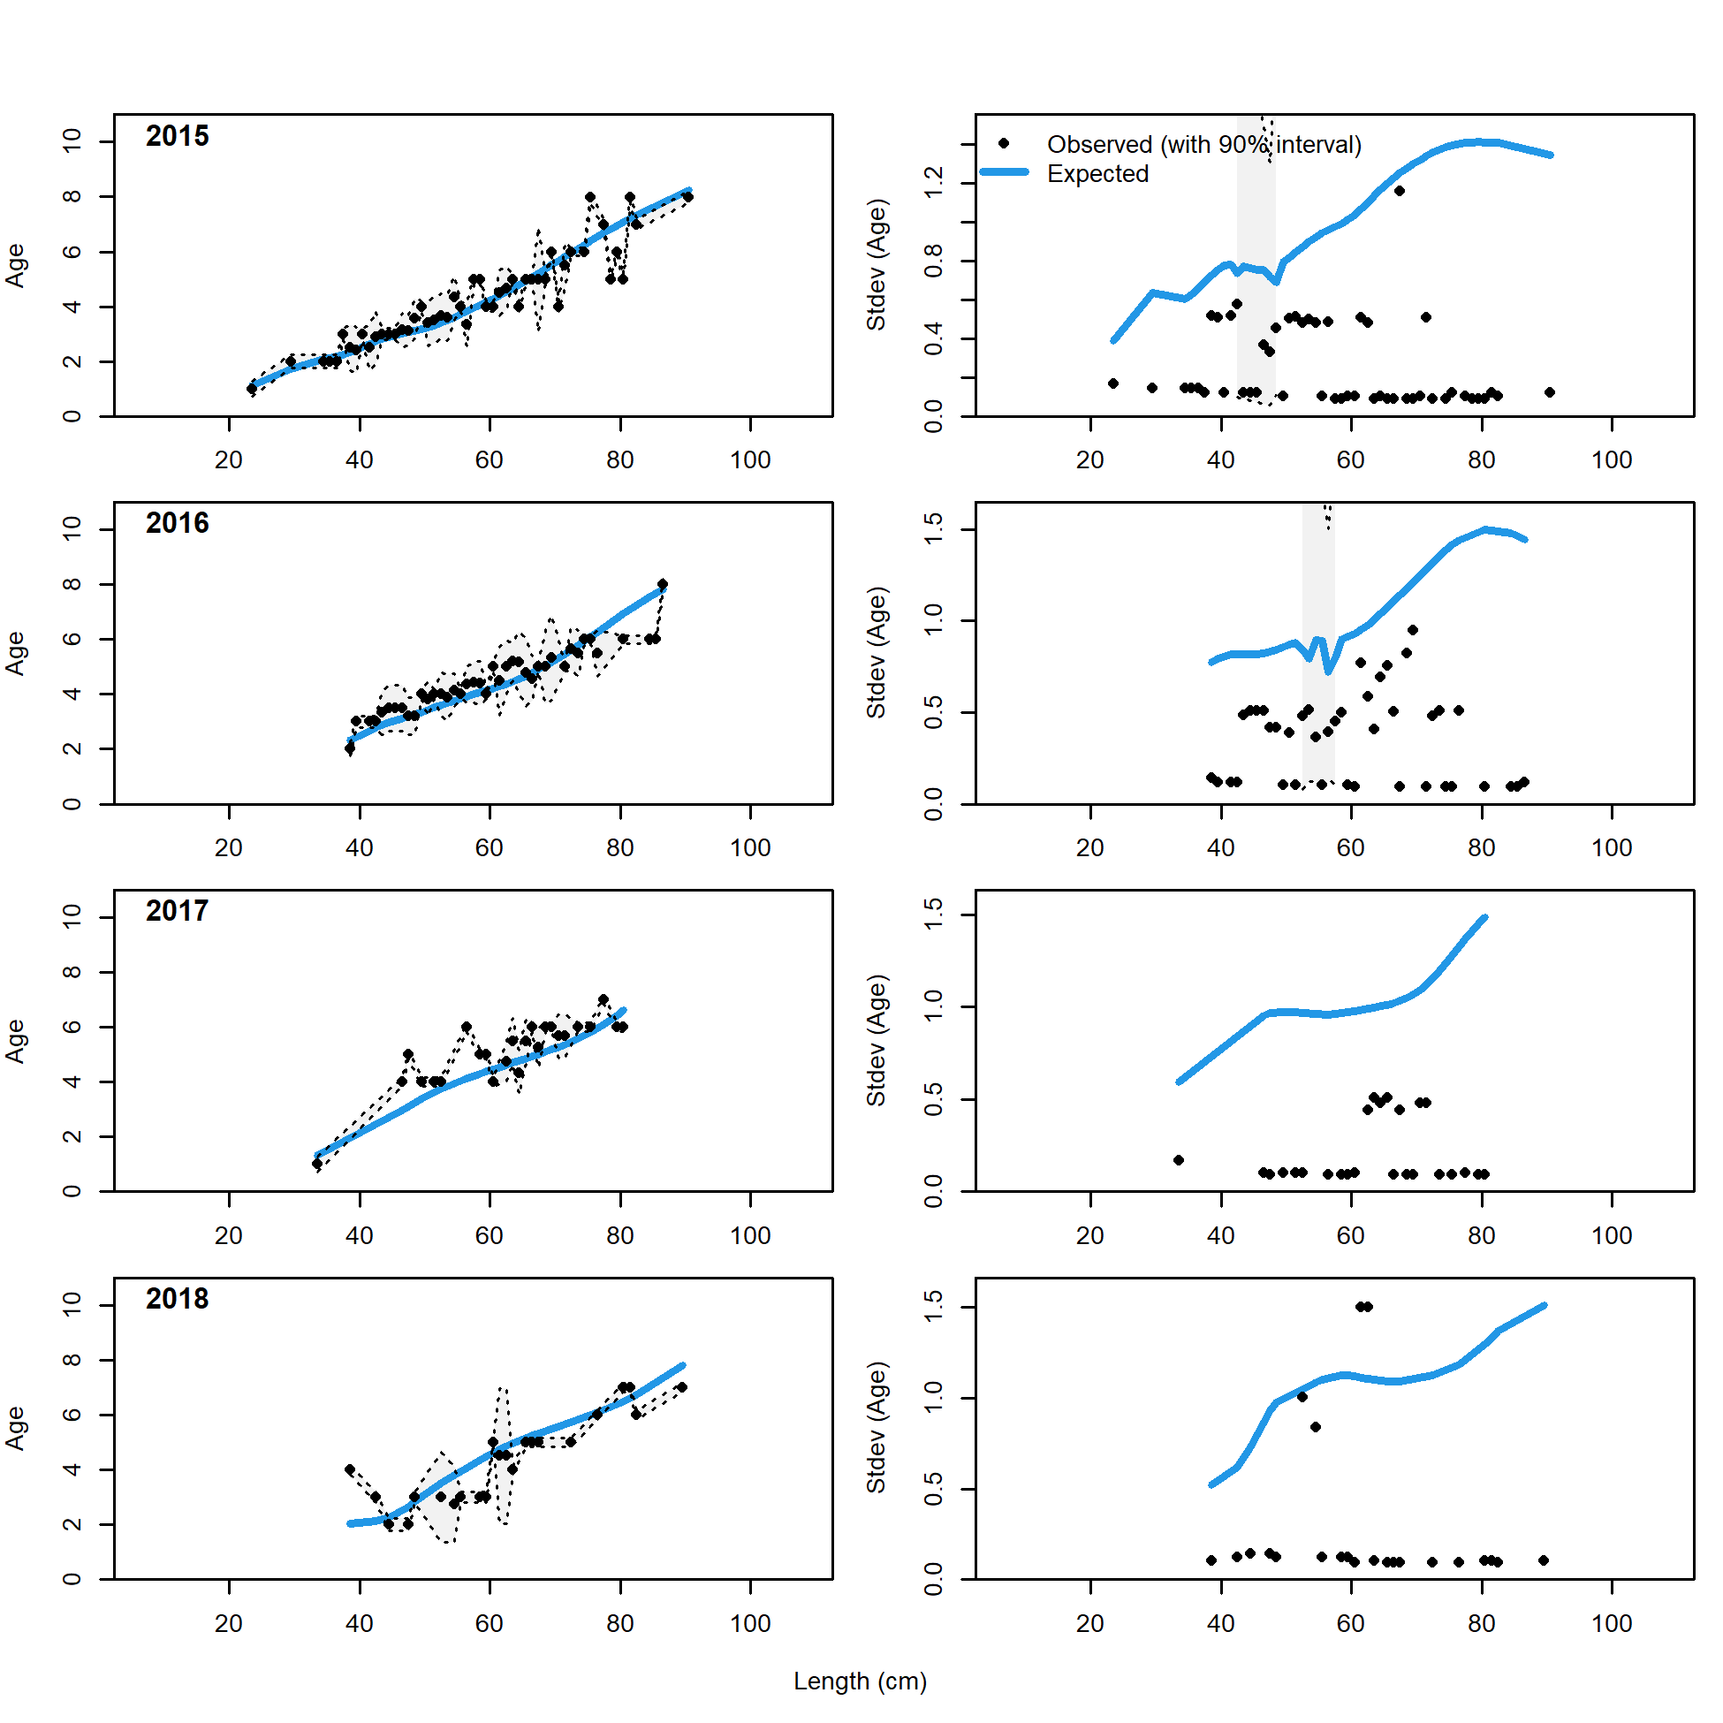

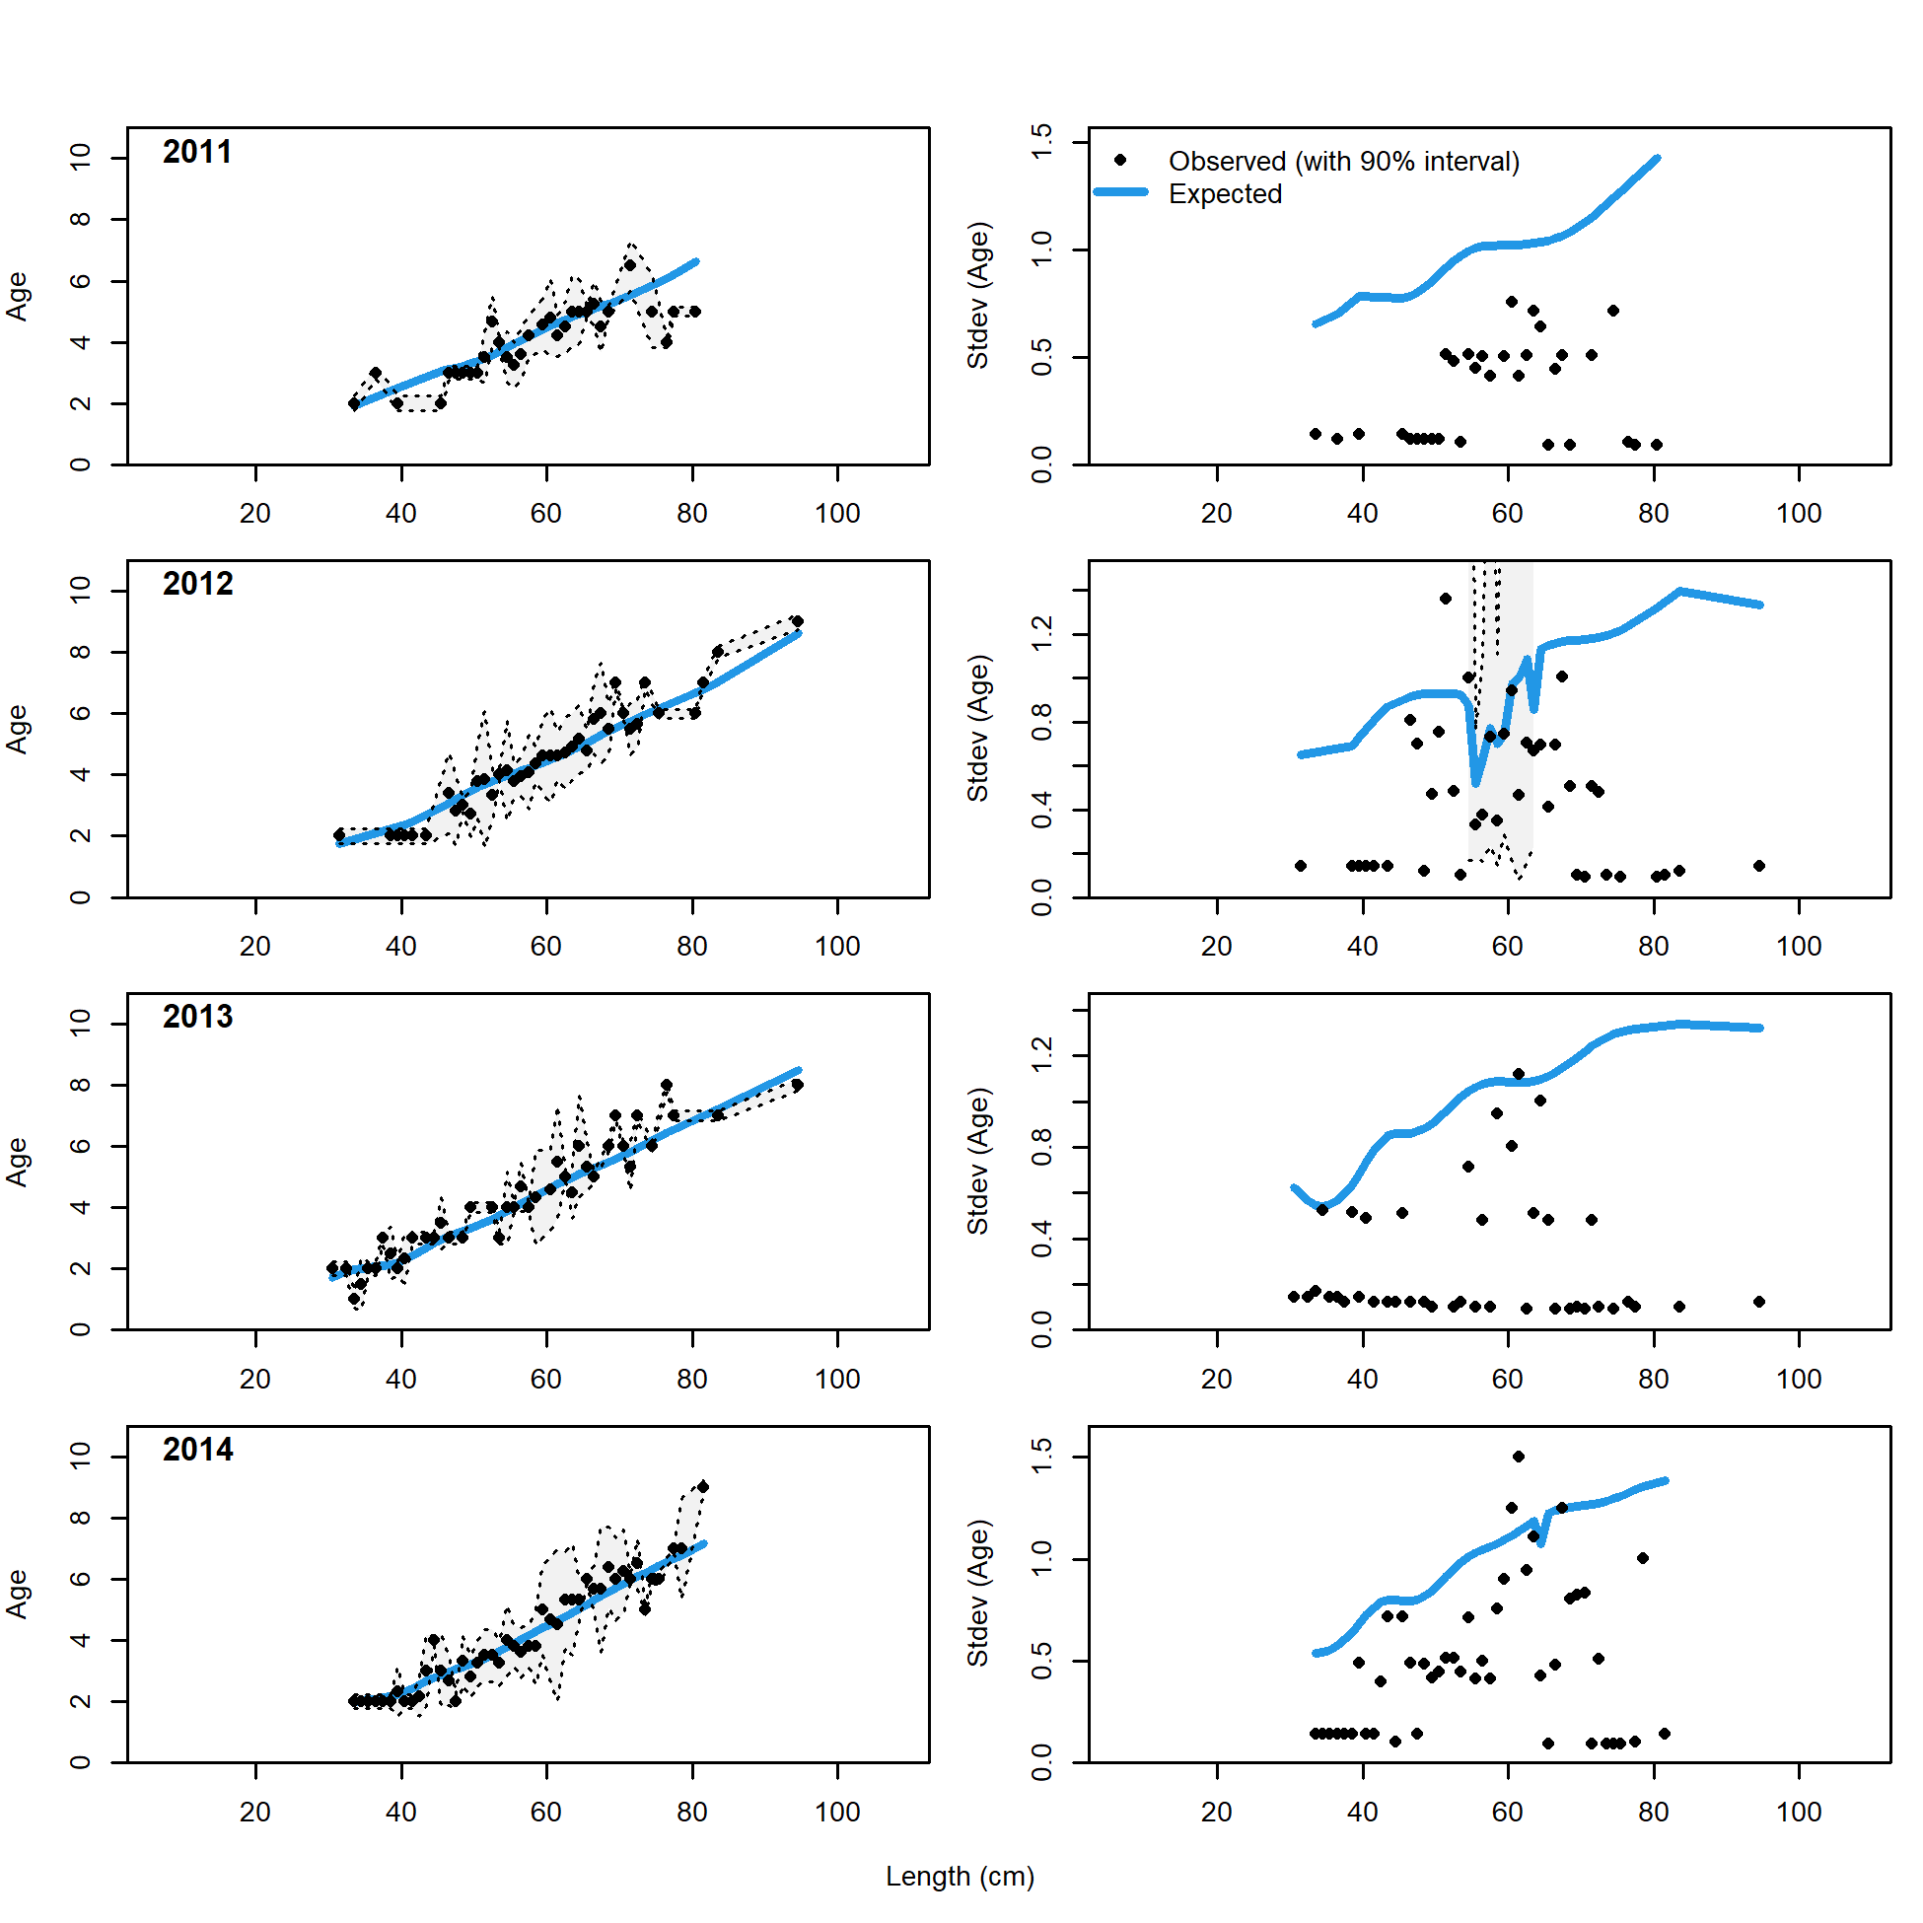 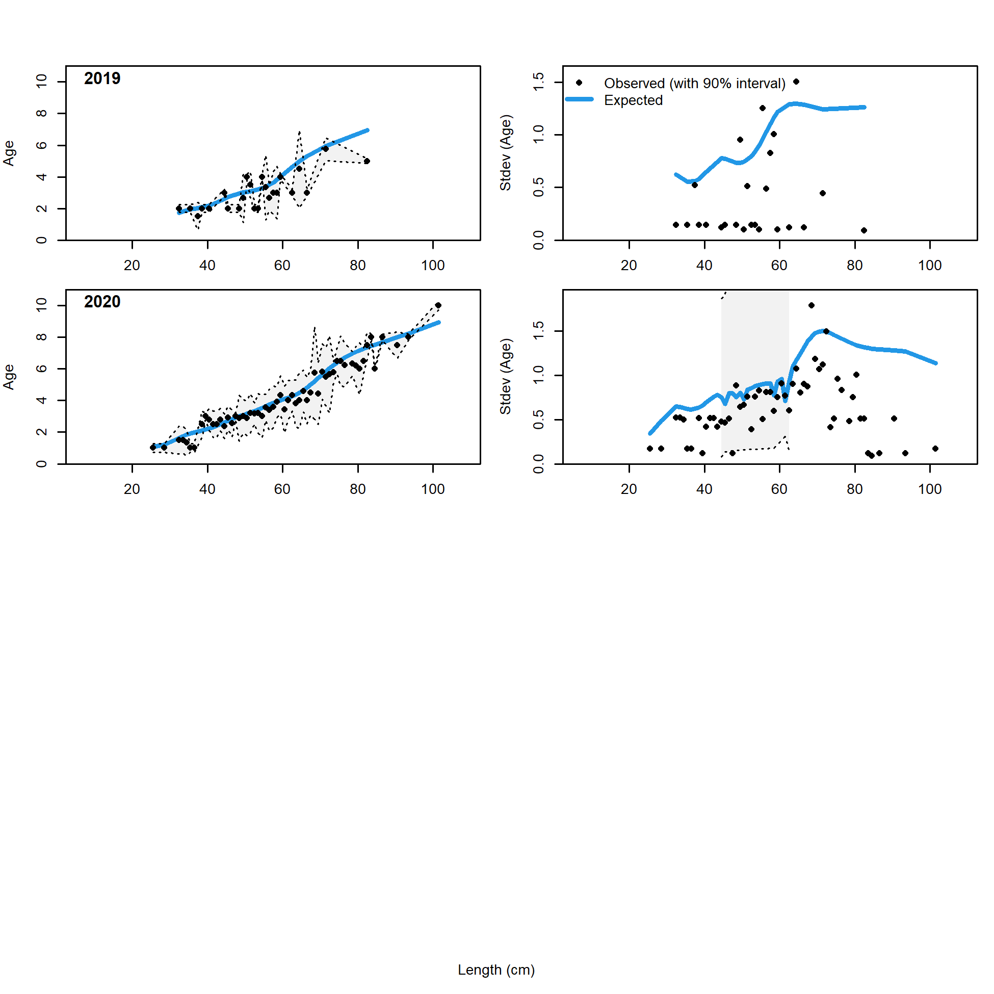

Figure 2.69 Trawl fishery conditional age at length data and standard deviation with Model 21.2 fit (blue line)..

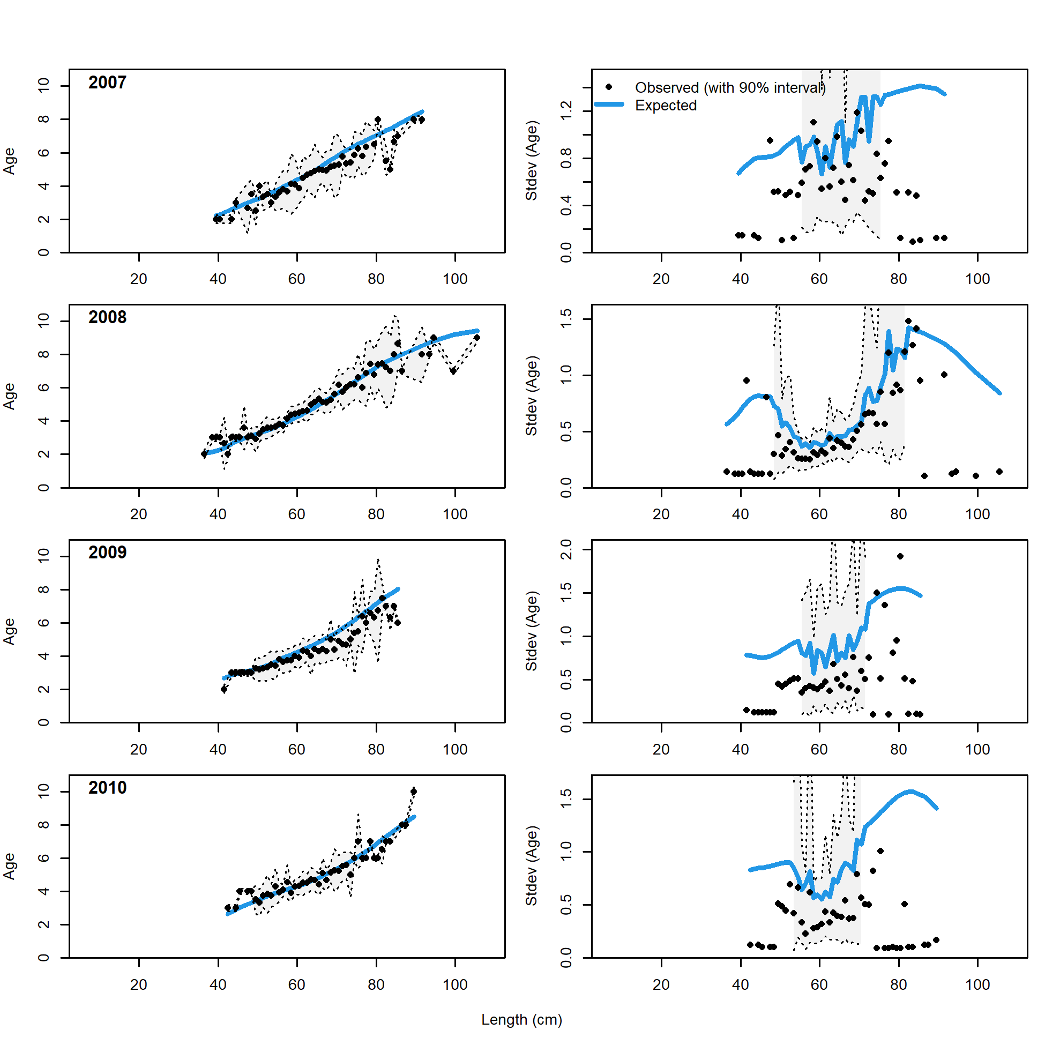 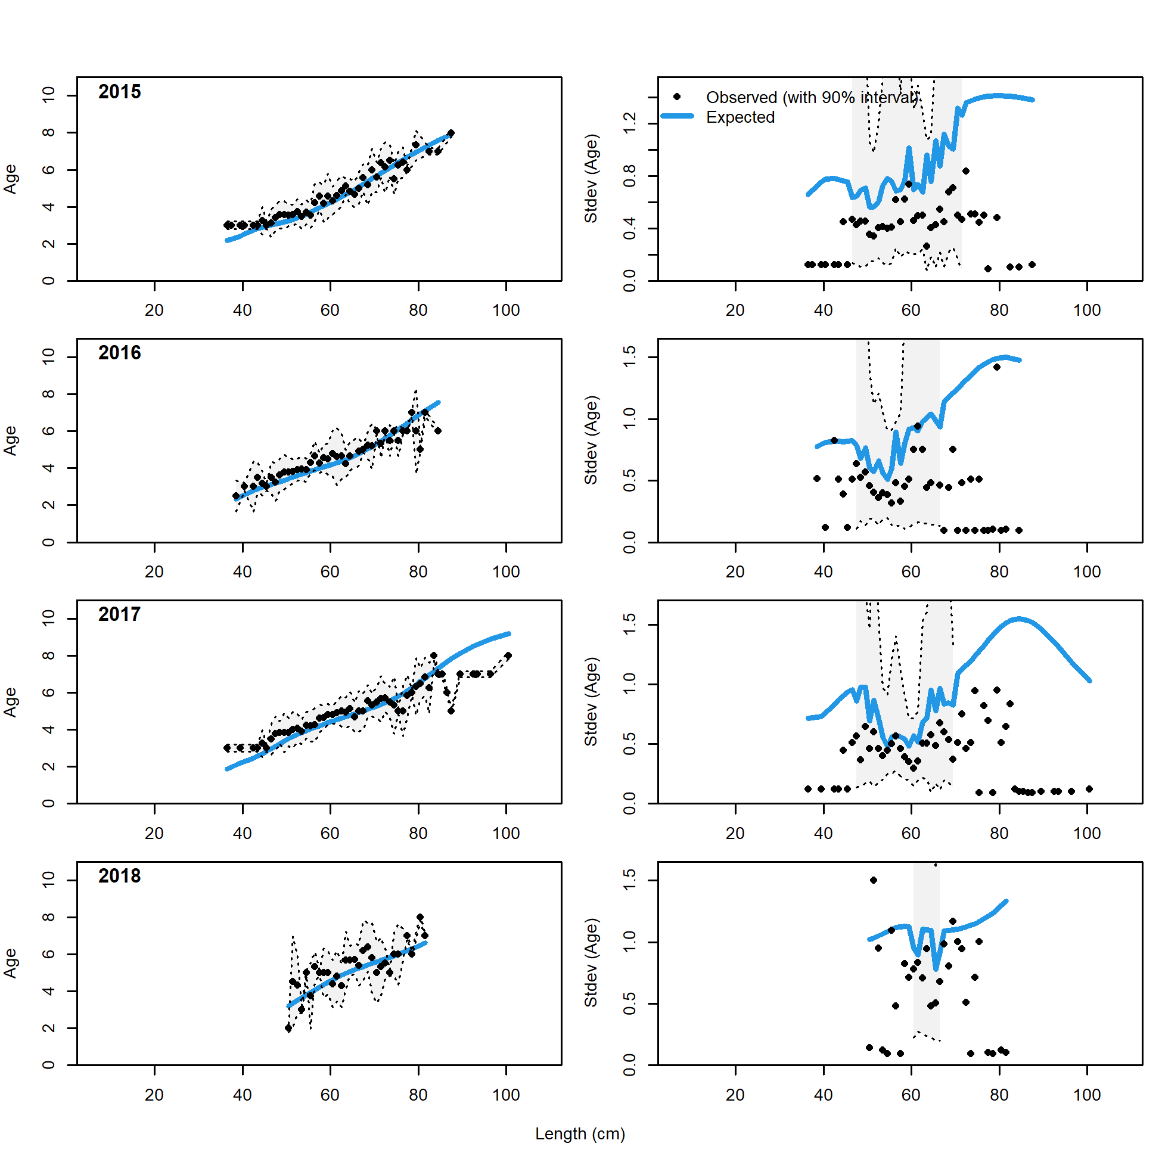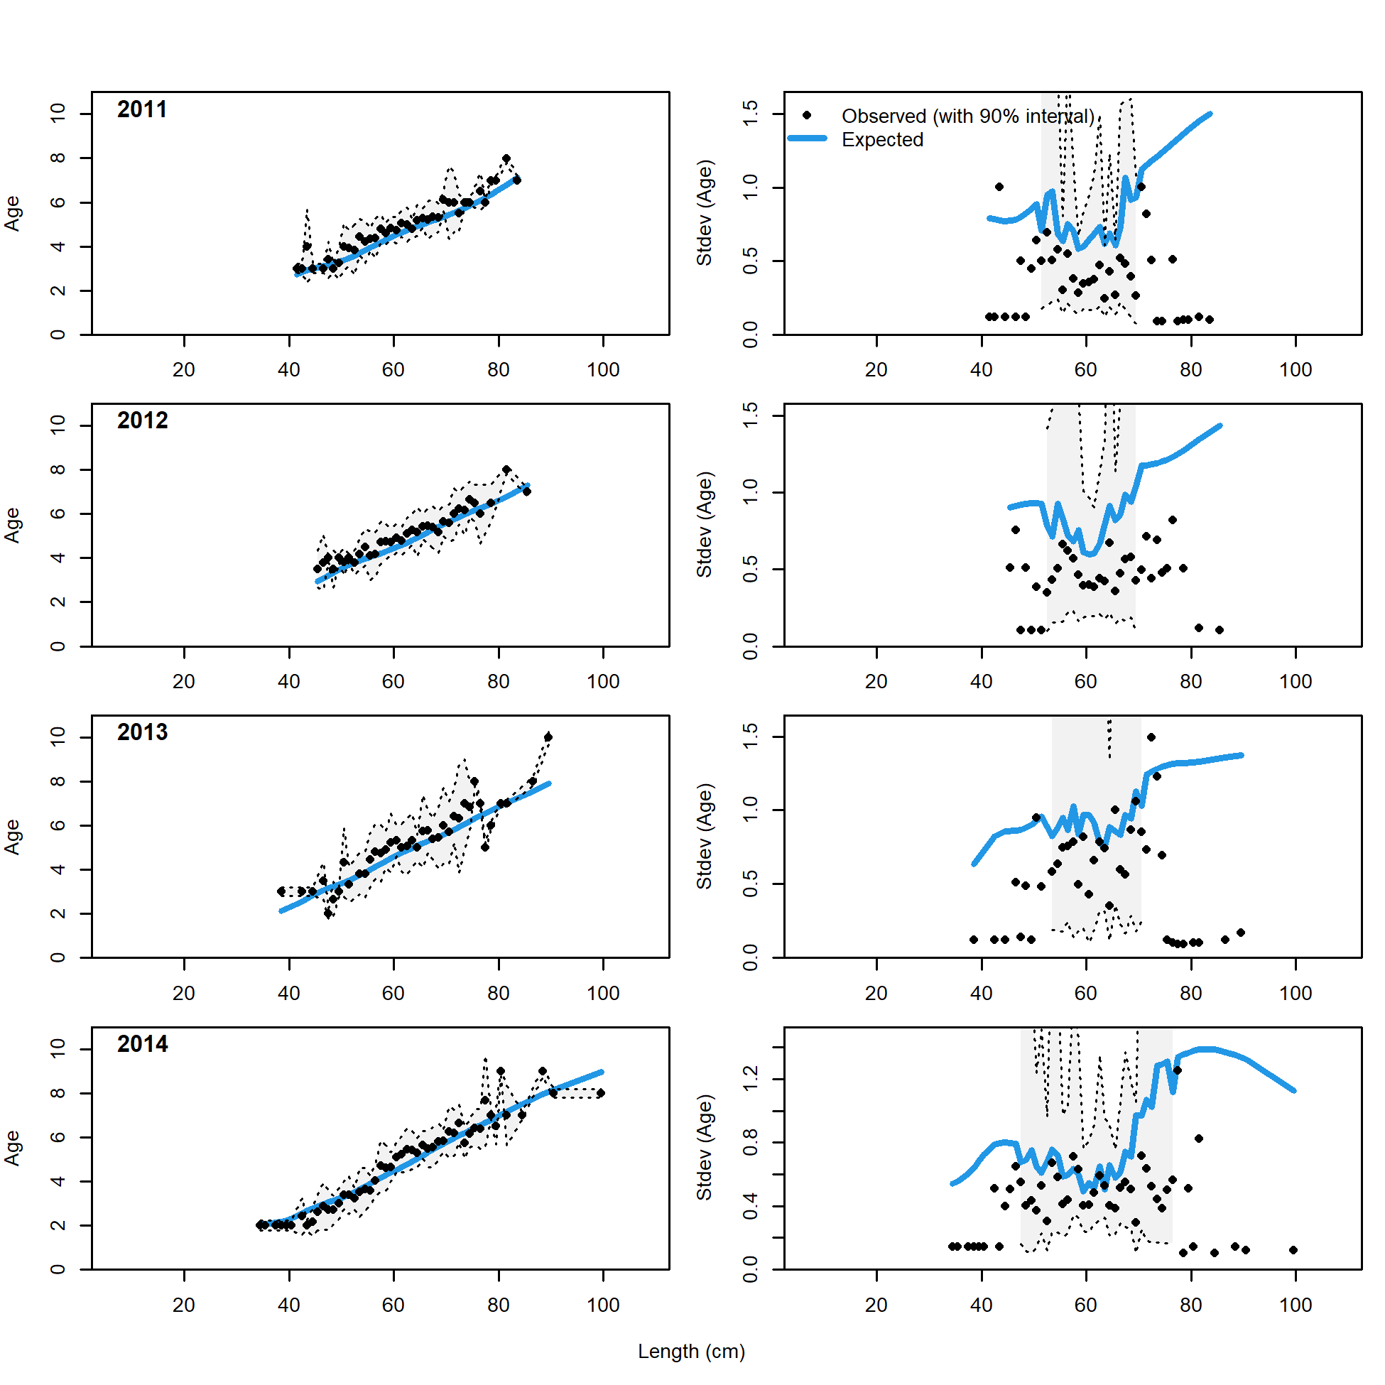 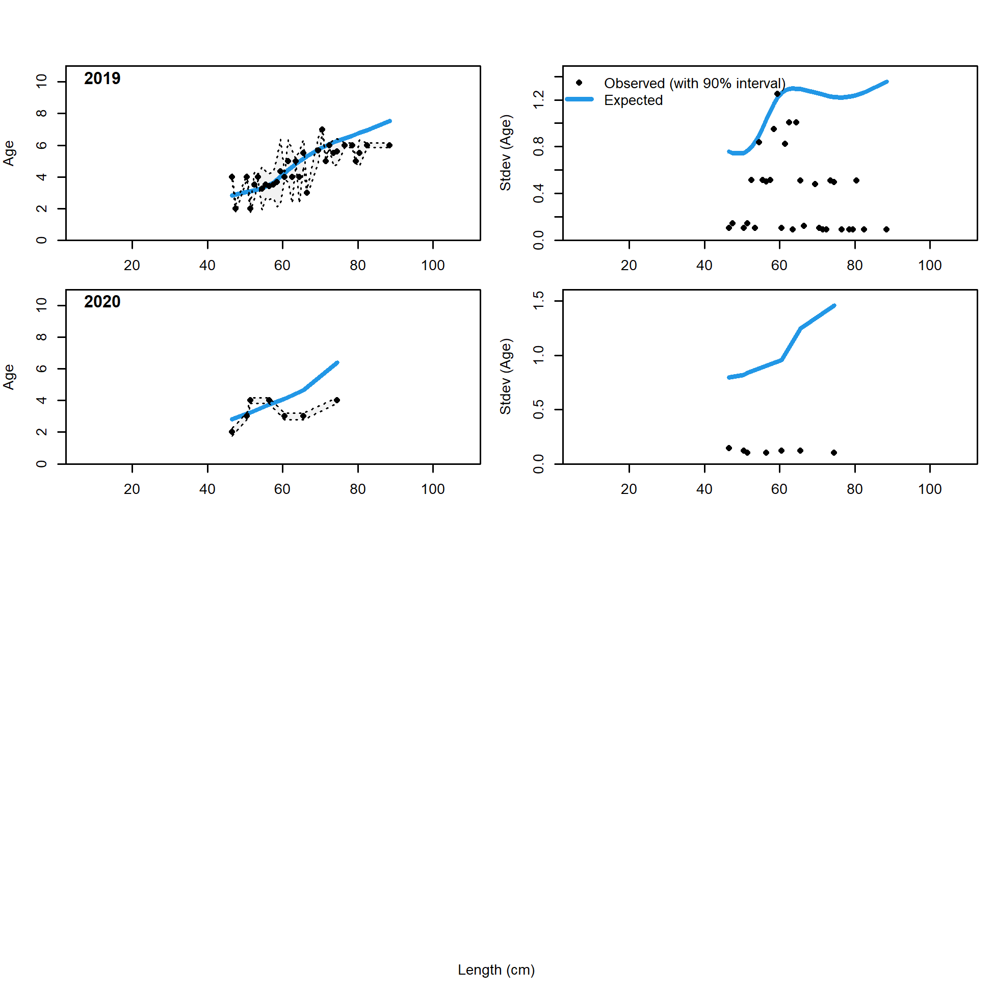

Figure 2.70 Longline fishery conditional age at length data and standard deviation with Model 21.2 fit (blue line)..

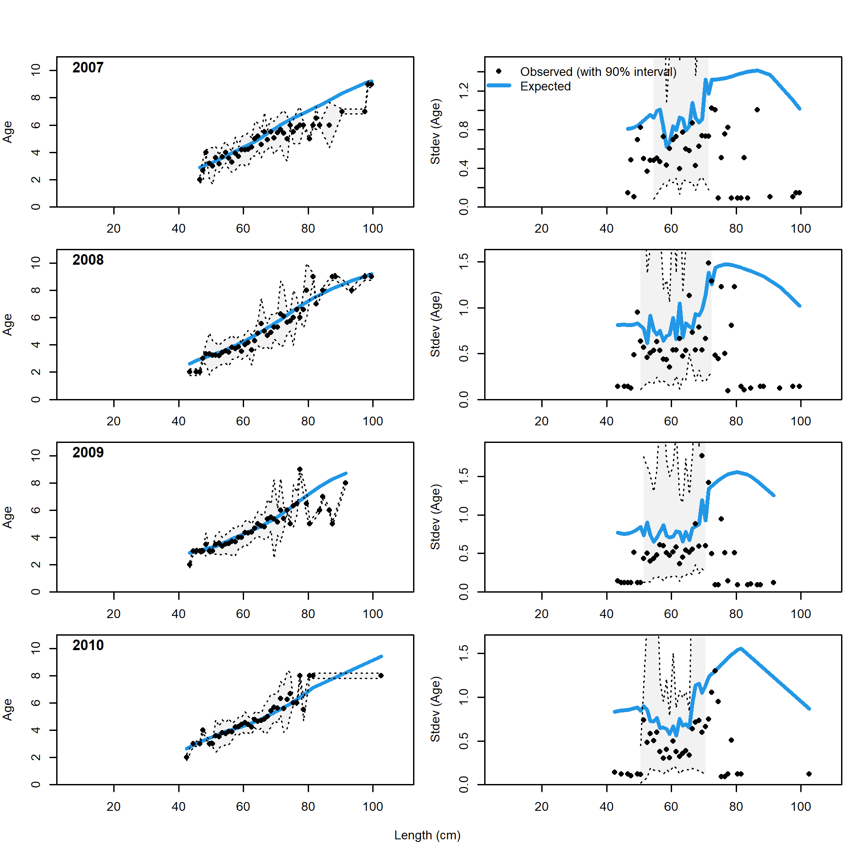 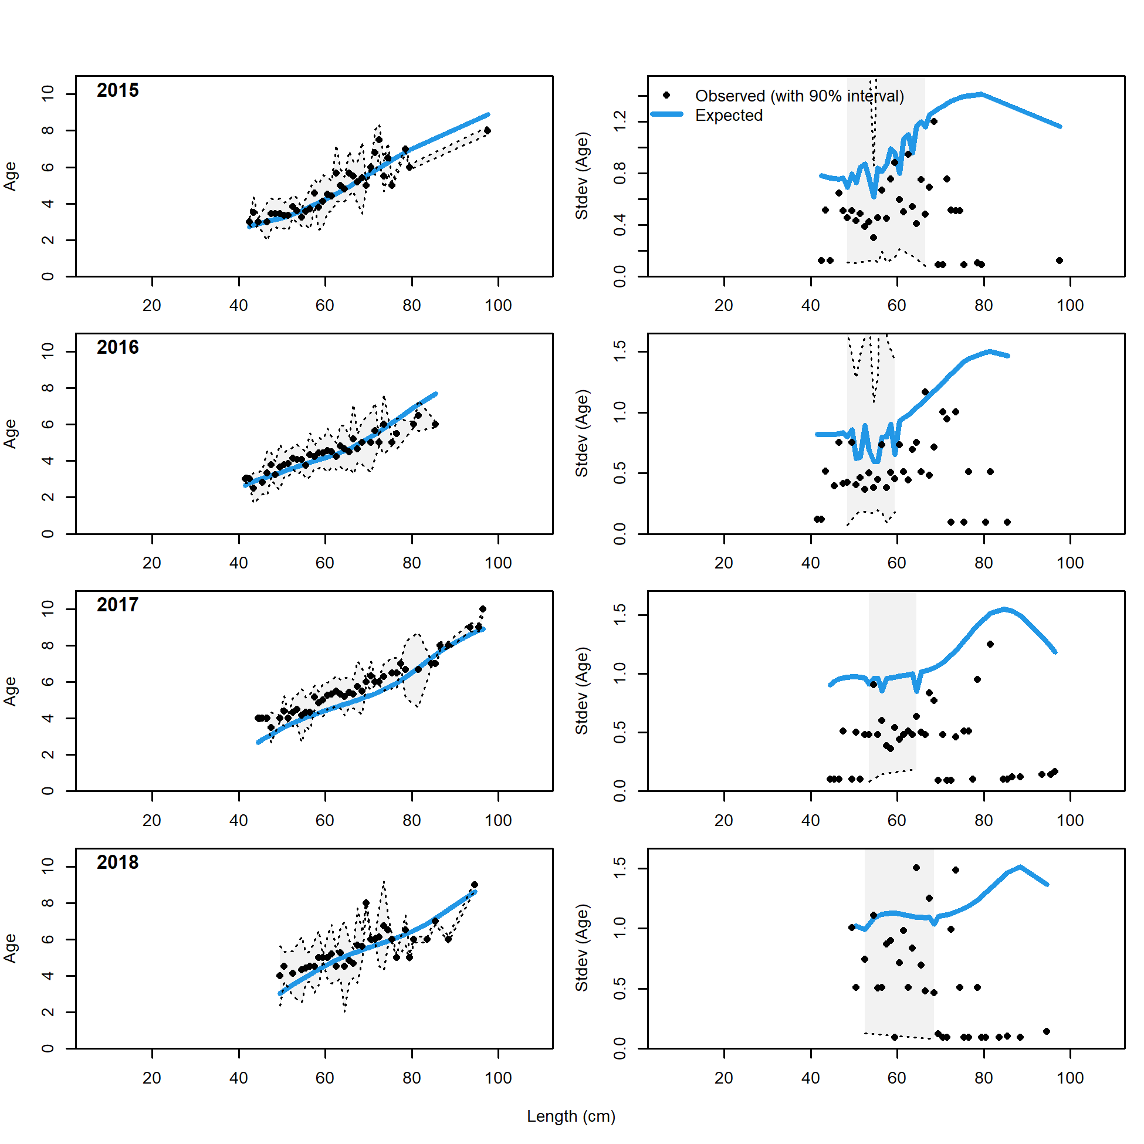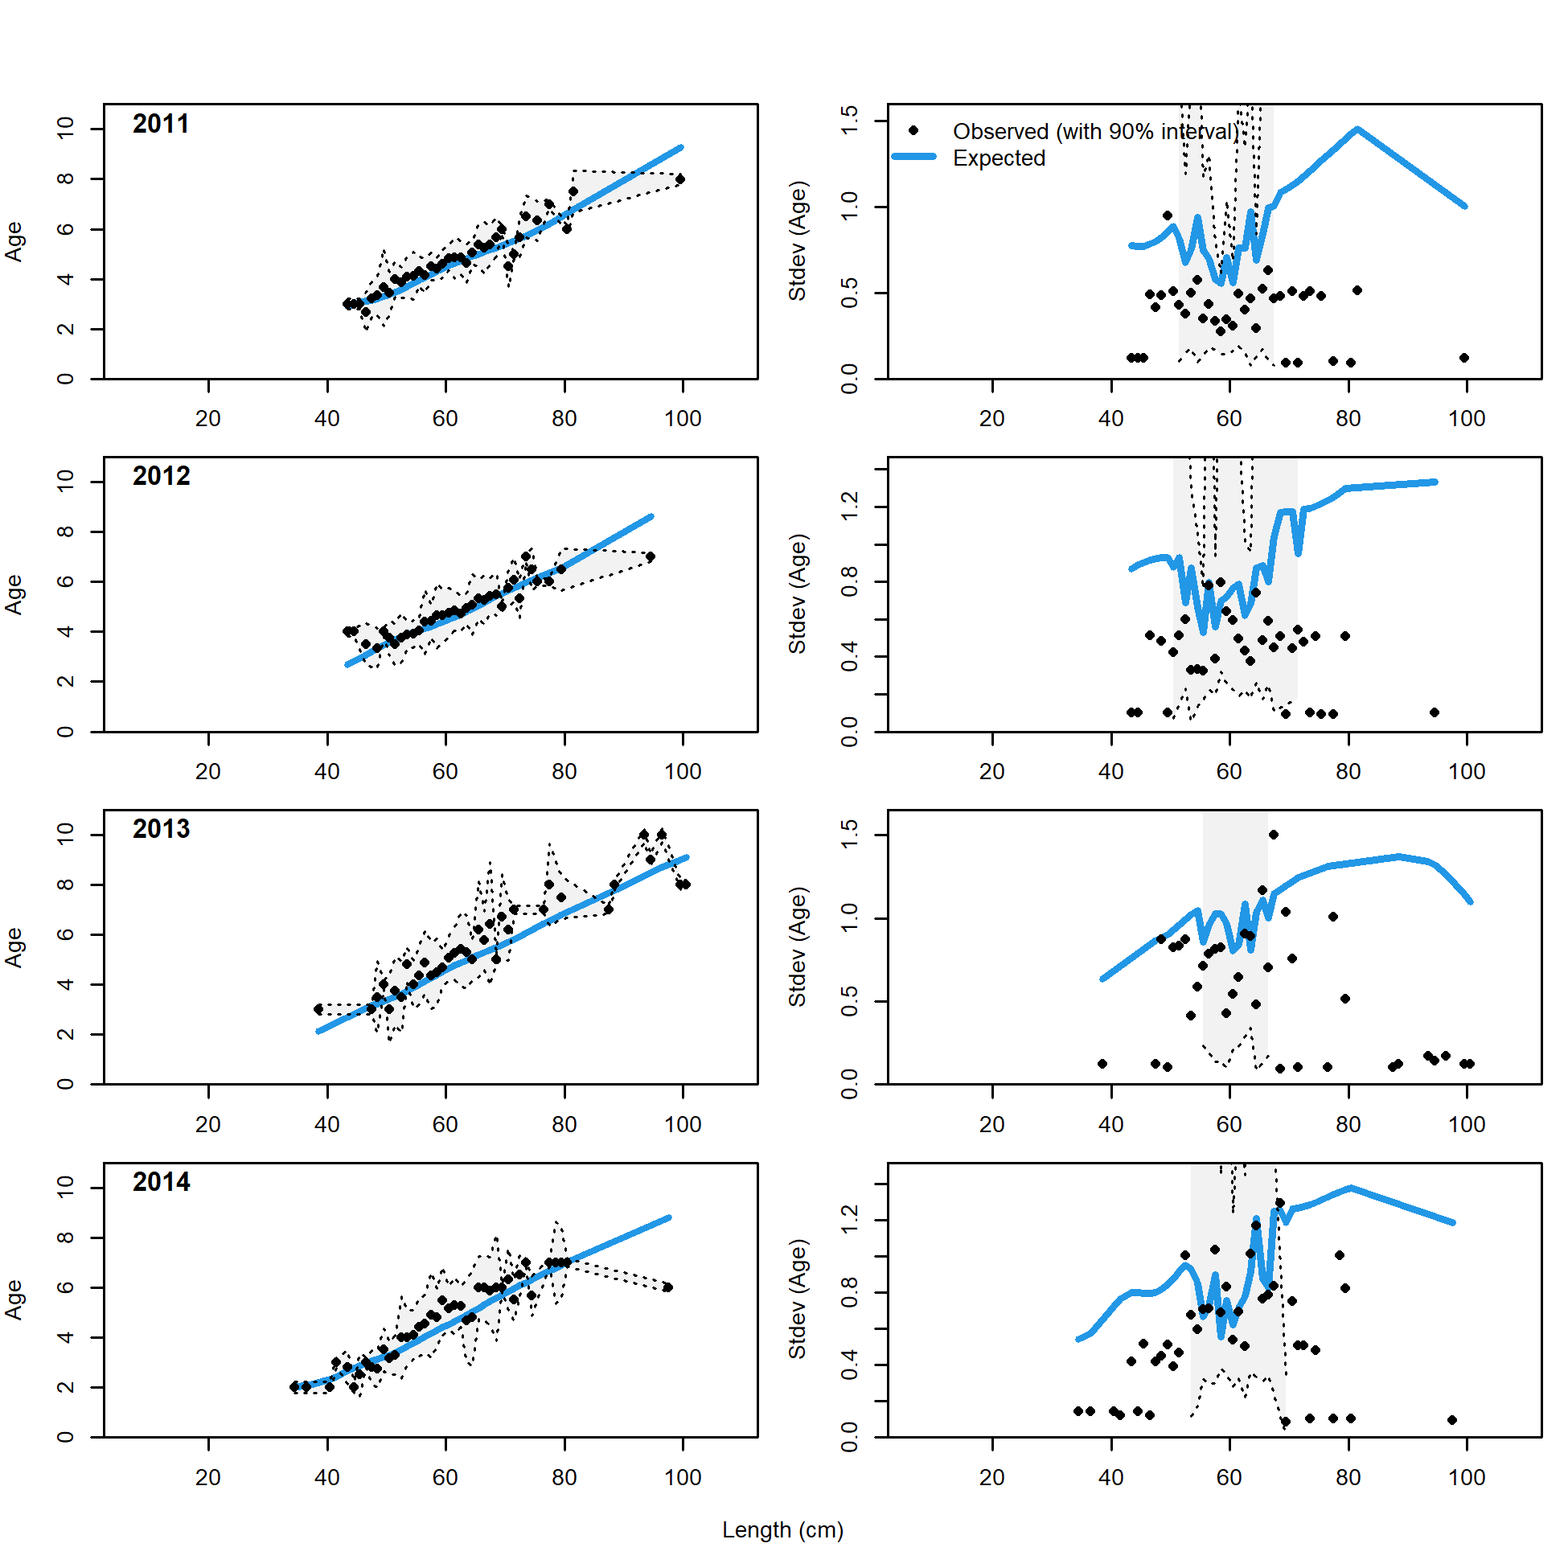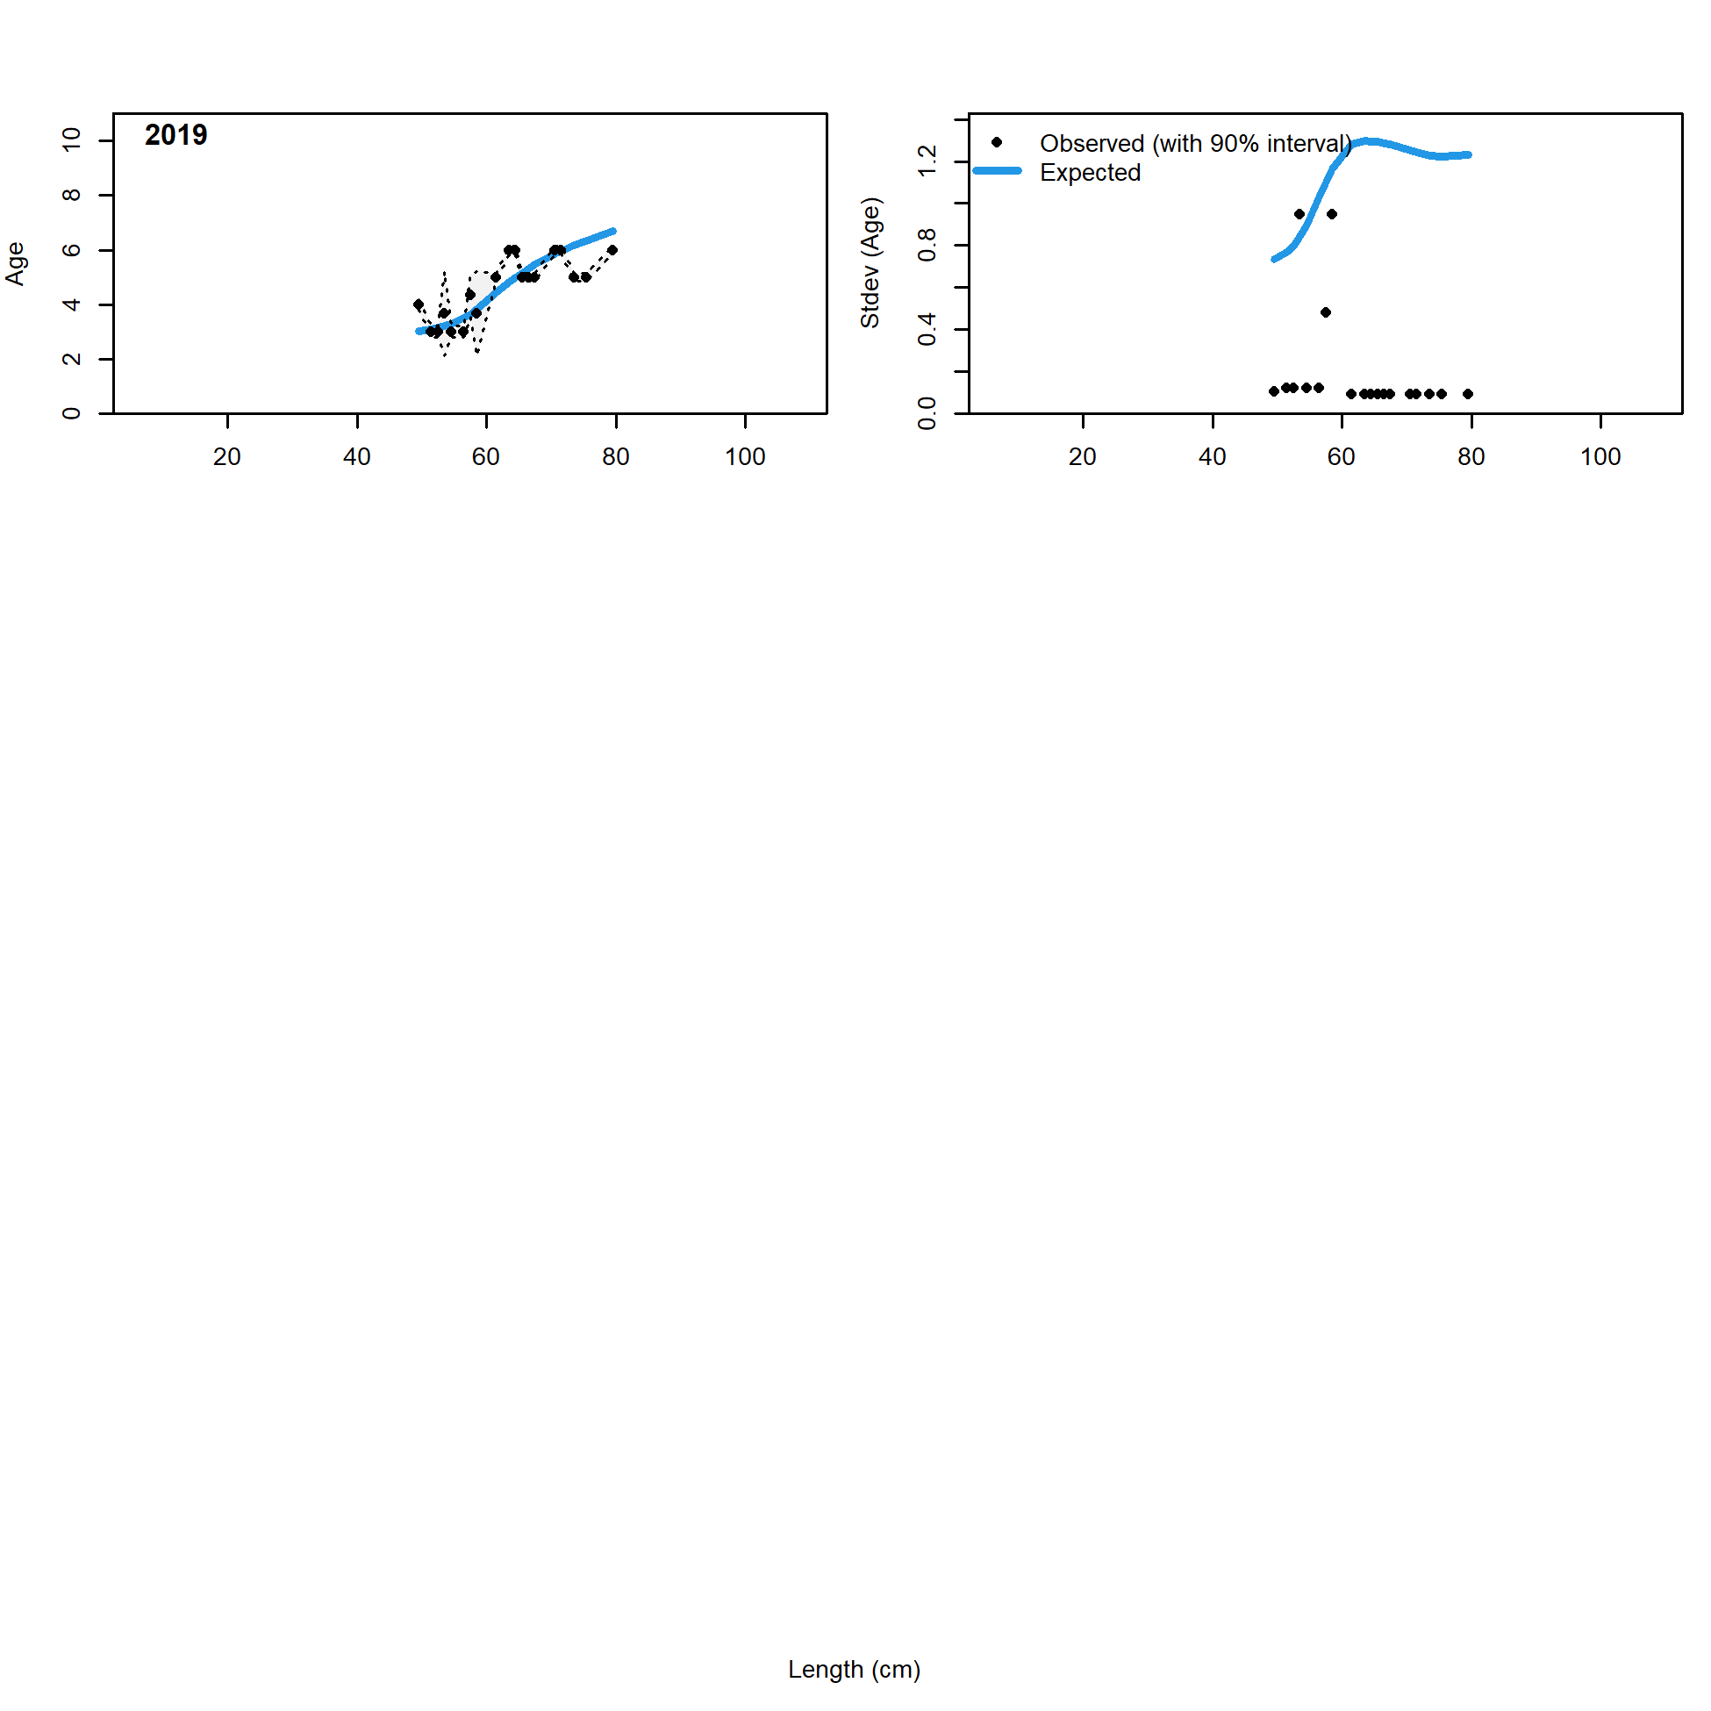

Figure 2.71 Pot fishery conditional age at length data and standard deviation with Model 21.2 fit (blue line).

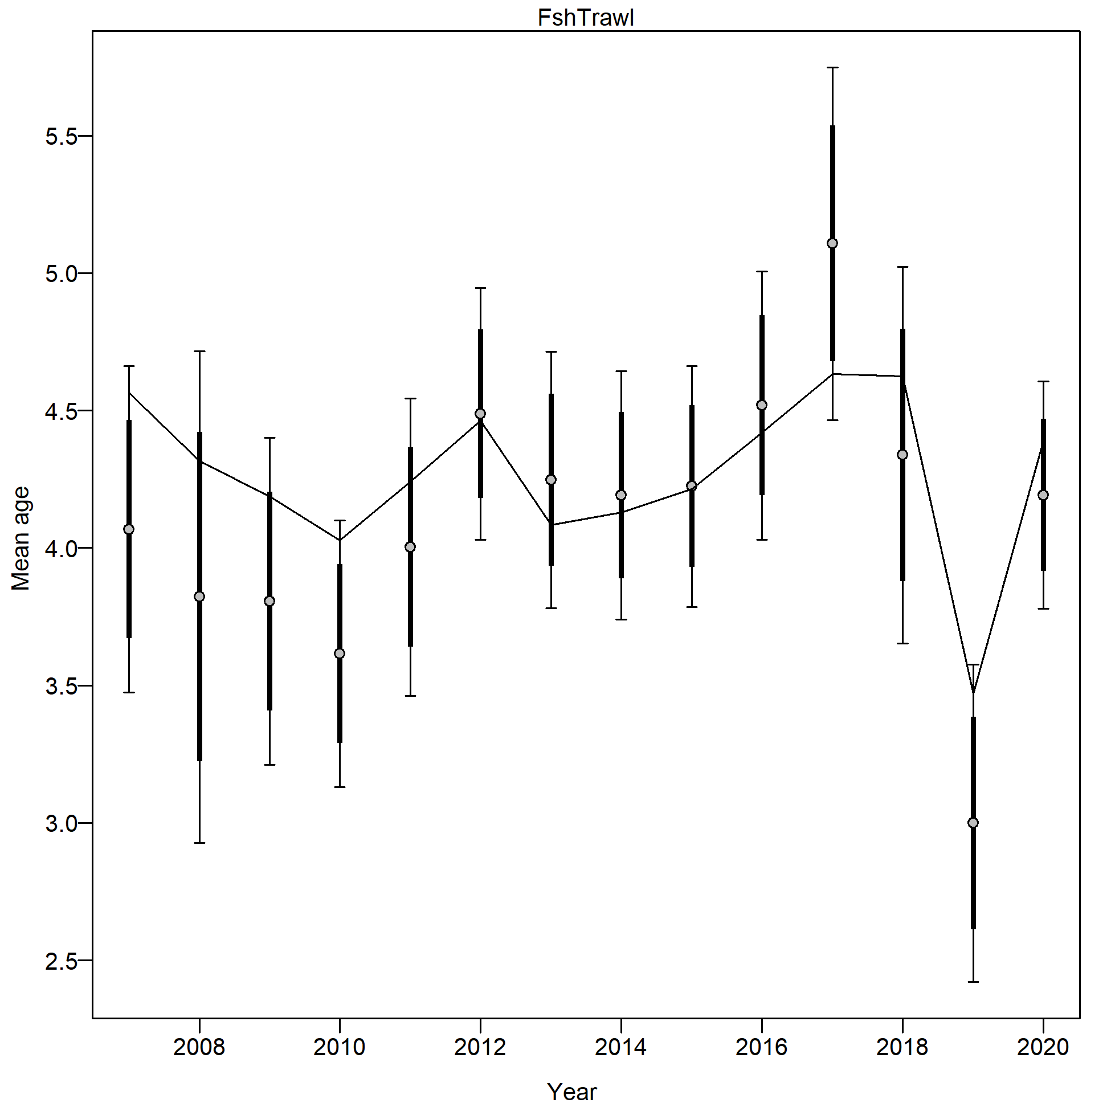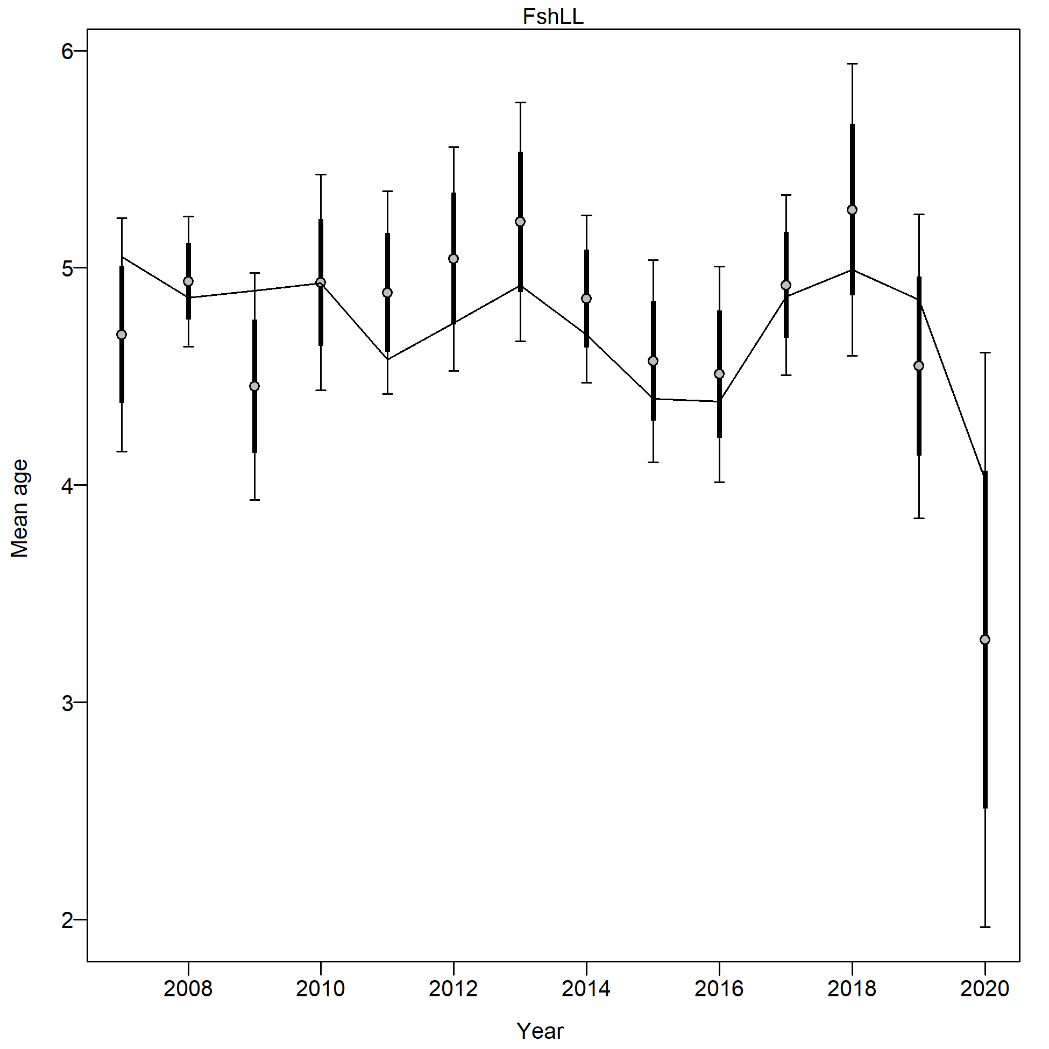

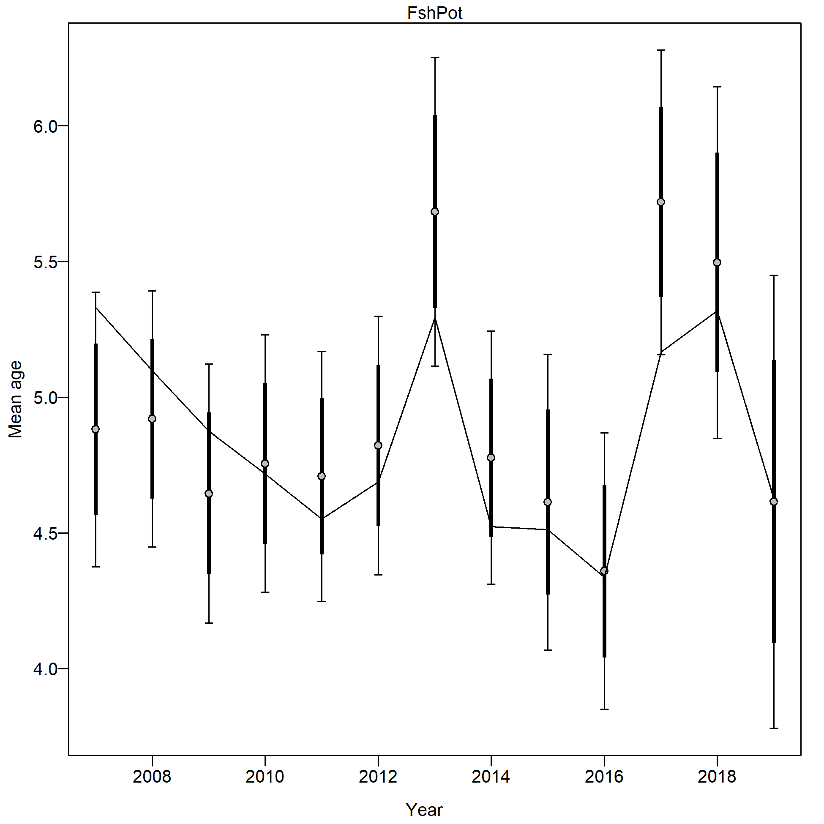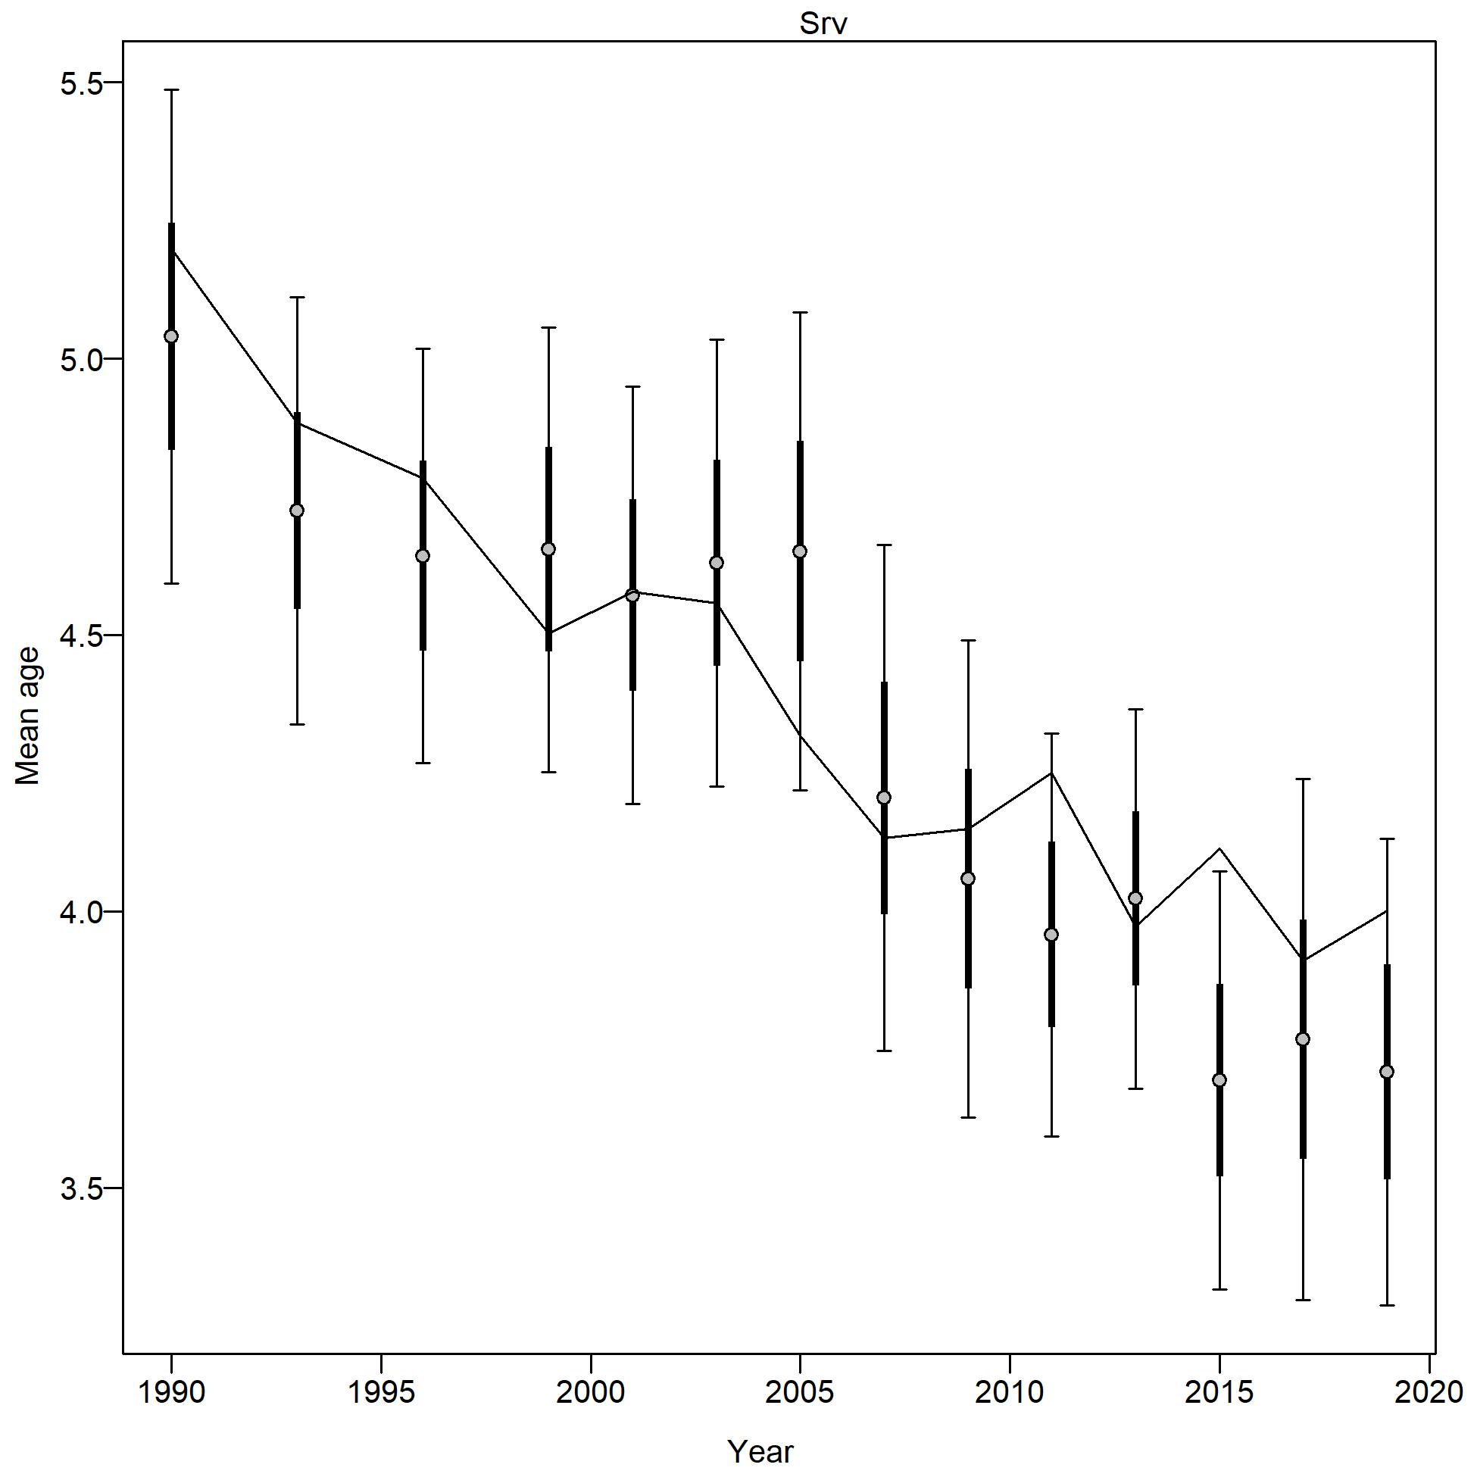

Figure 2.72 Mean age from conditional data (aggregated across length bins) with 95% confidence intervals based on current samples sizes for the trawl fishery (FshTrawl), longline fishery ( FshLL), pot fishery (FshPot) and bottom trawl survey (Srv) with Model 21.2 predictions (line).

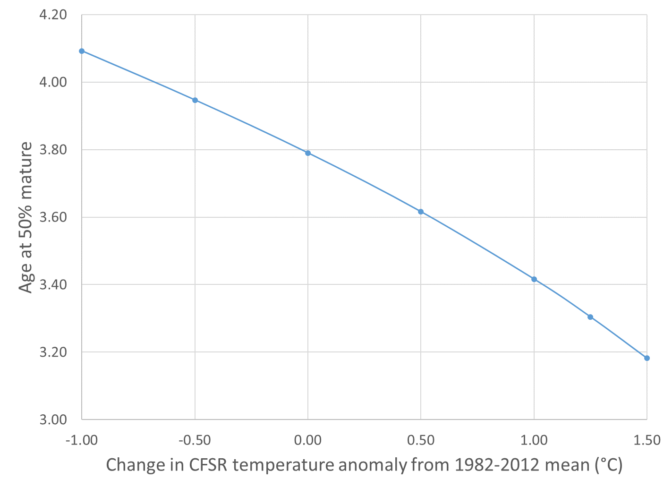

Figure 2.73 Relationship of maturity to temperature anomaly from the 1982-2012 mean for Model 21.2.

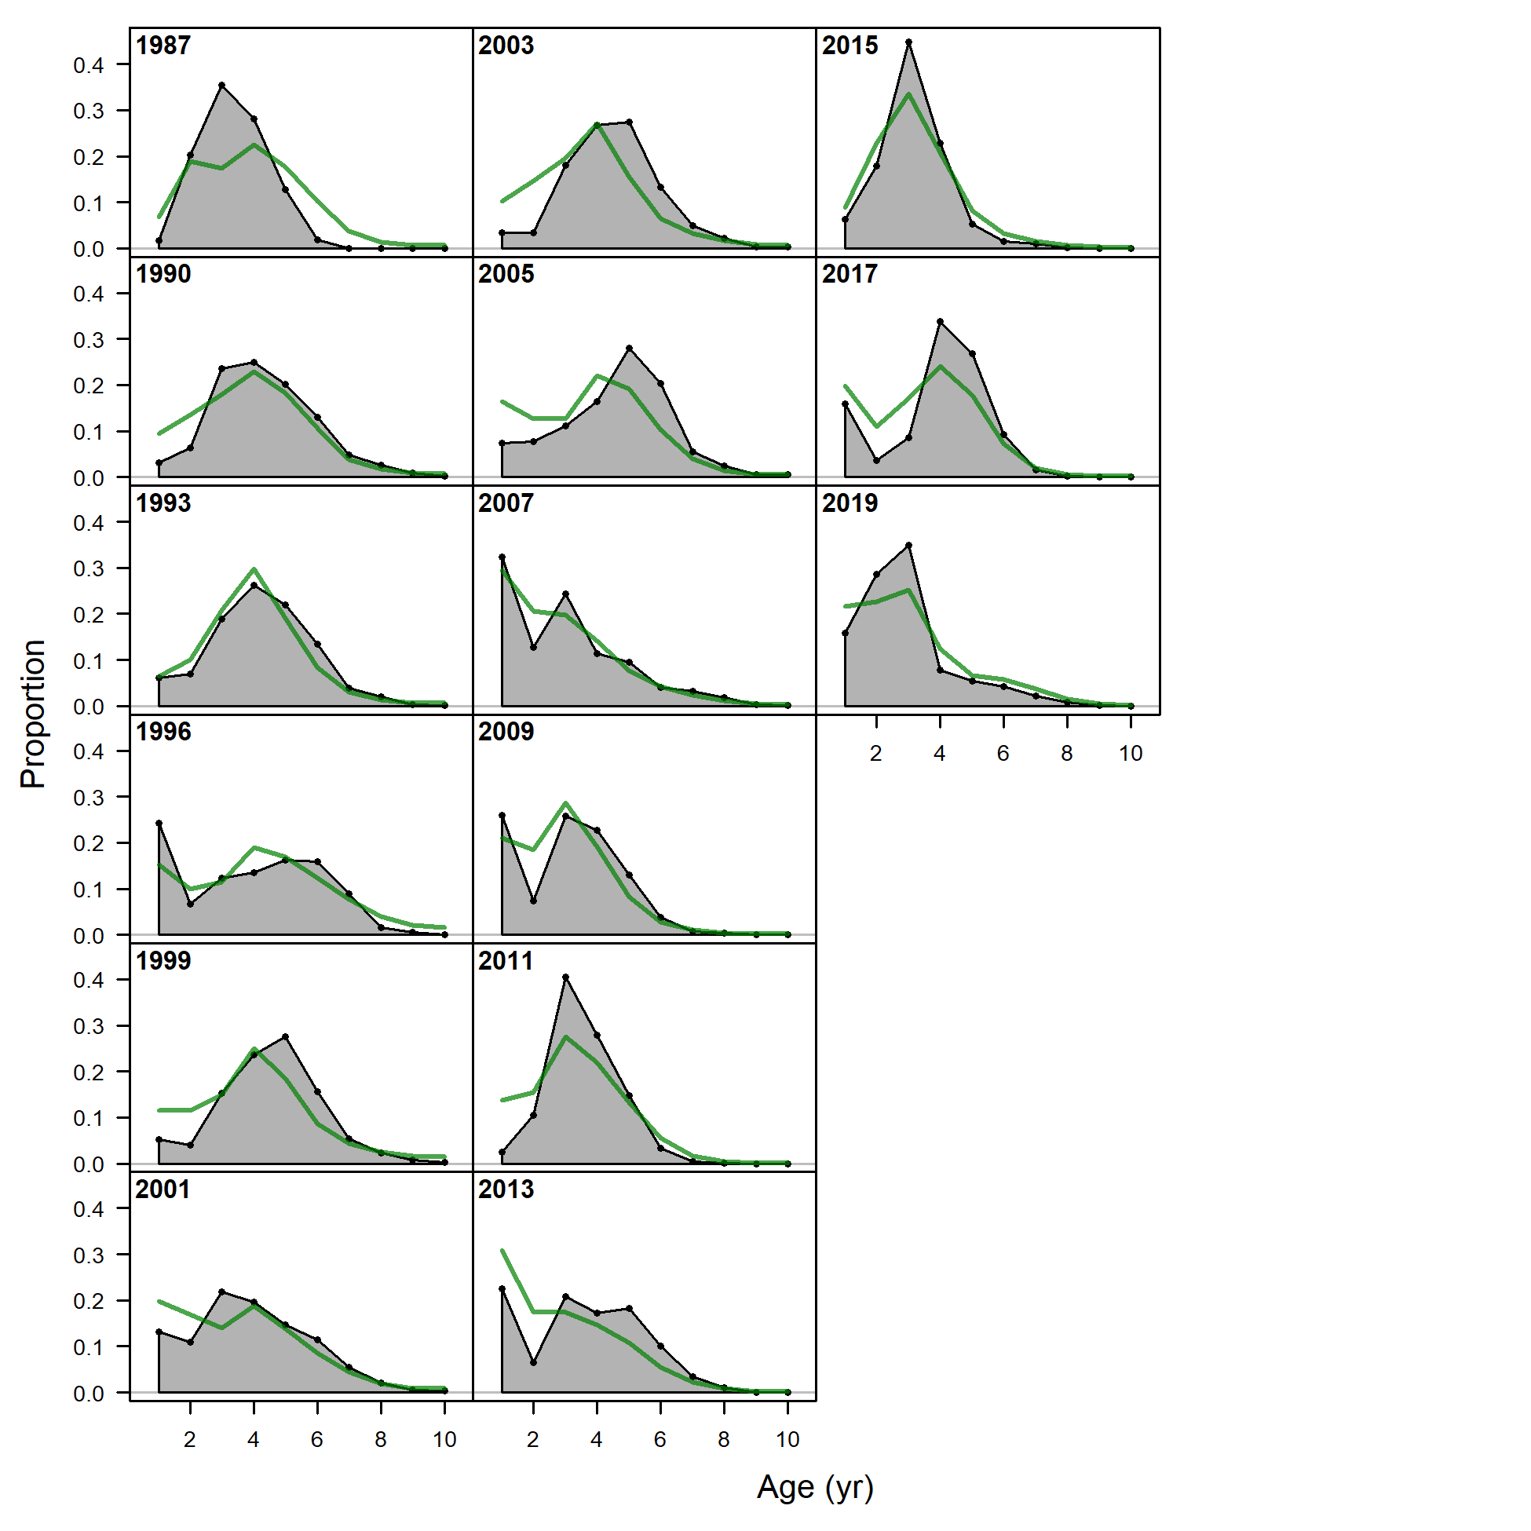

Figure 2.74 NMFS bottom trawl survey age composition and Model 21.2 fit (green line). Note the age data fits are not included in the objective function.

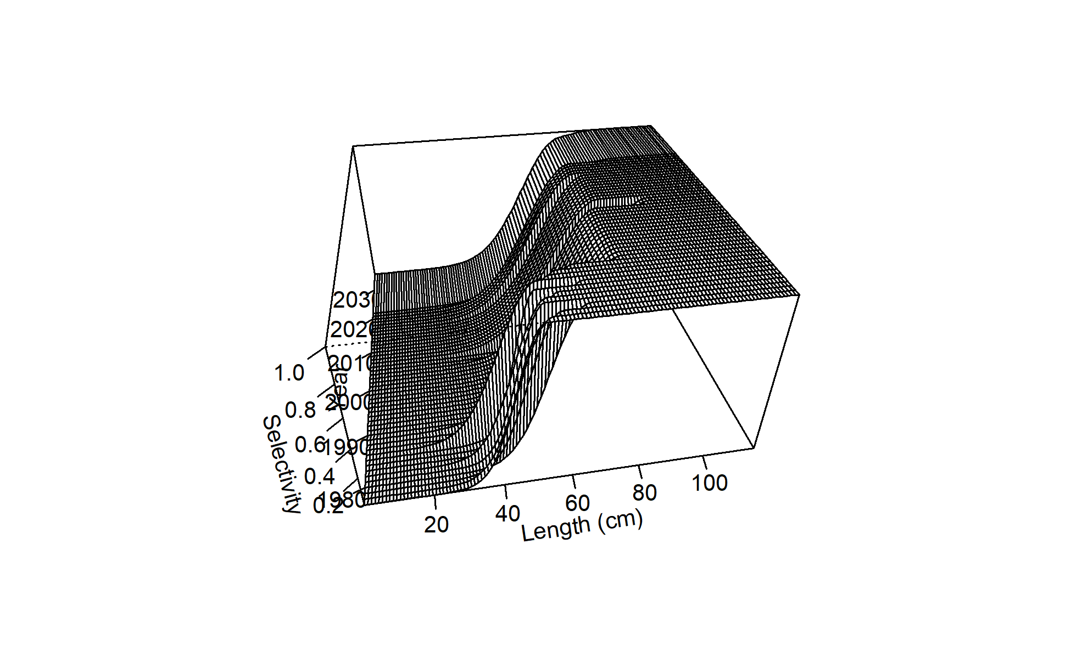 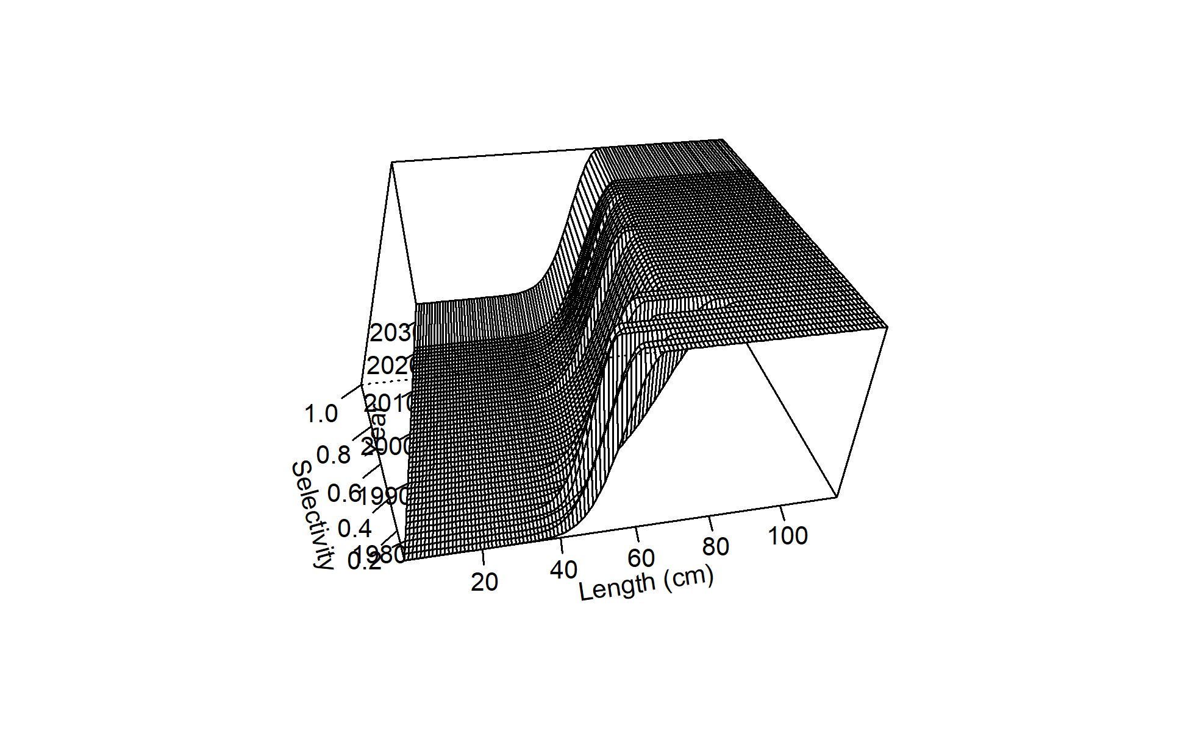 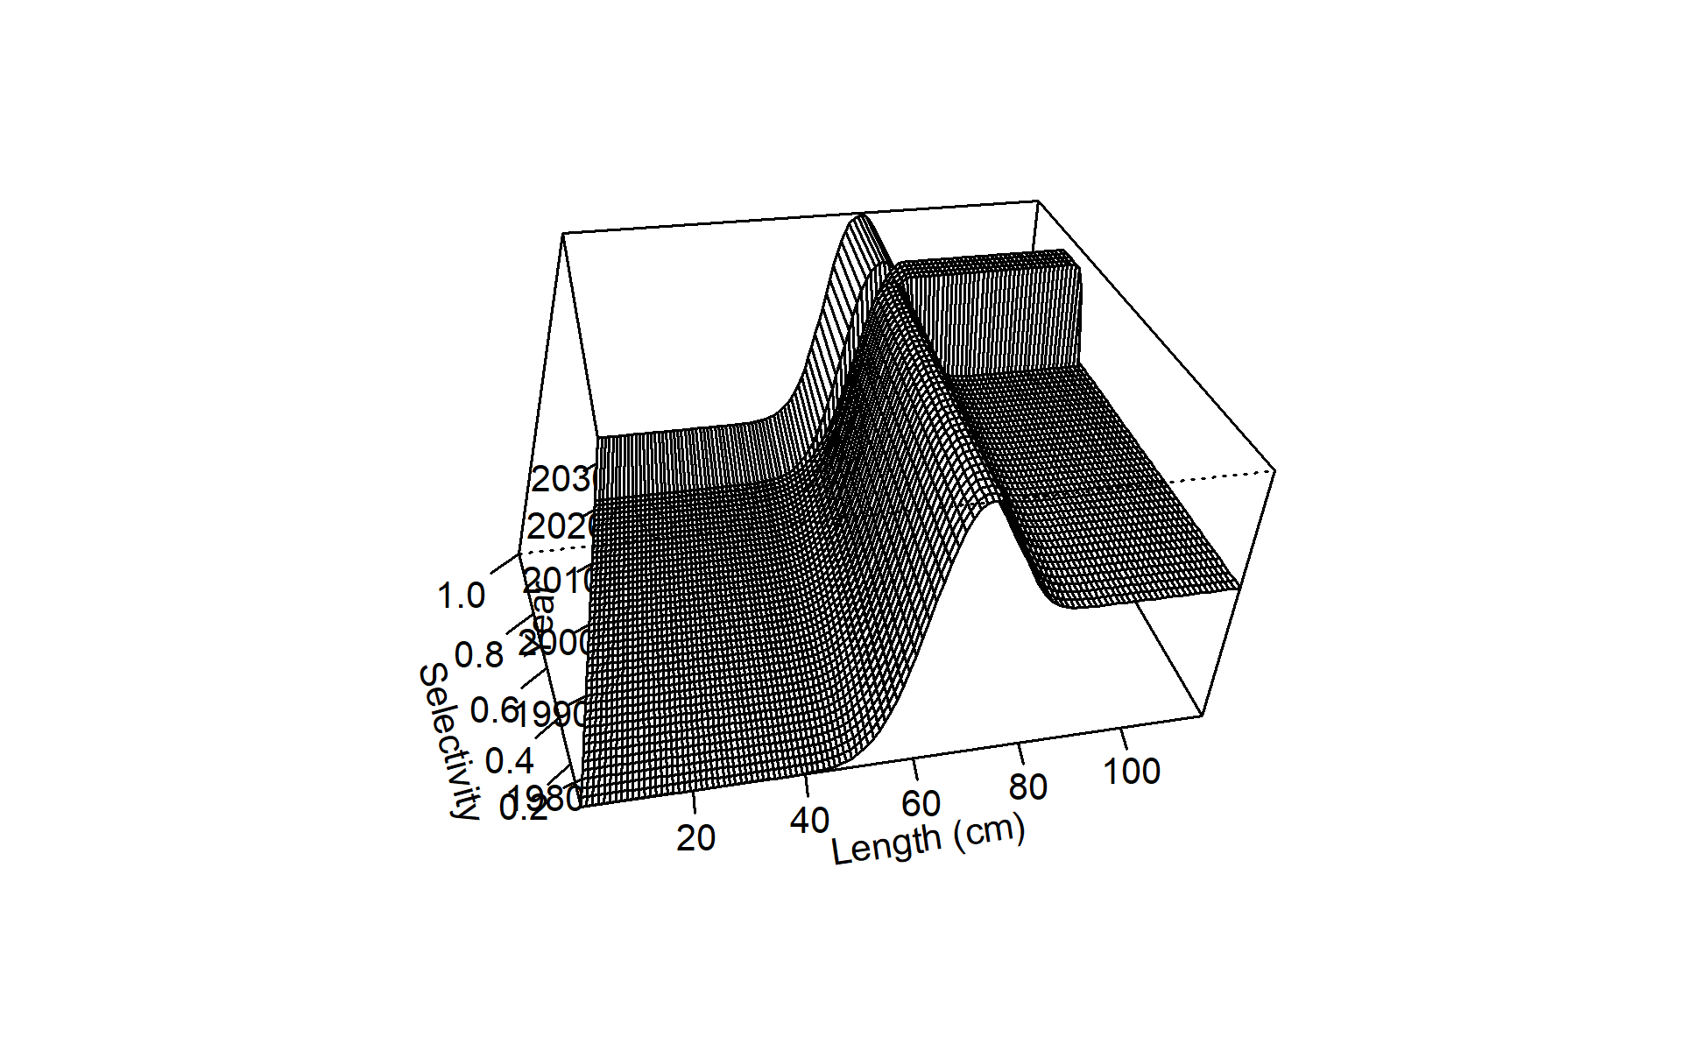 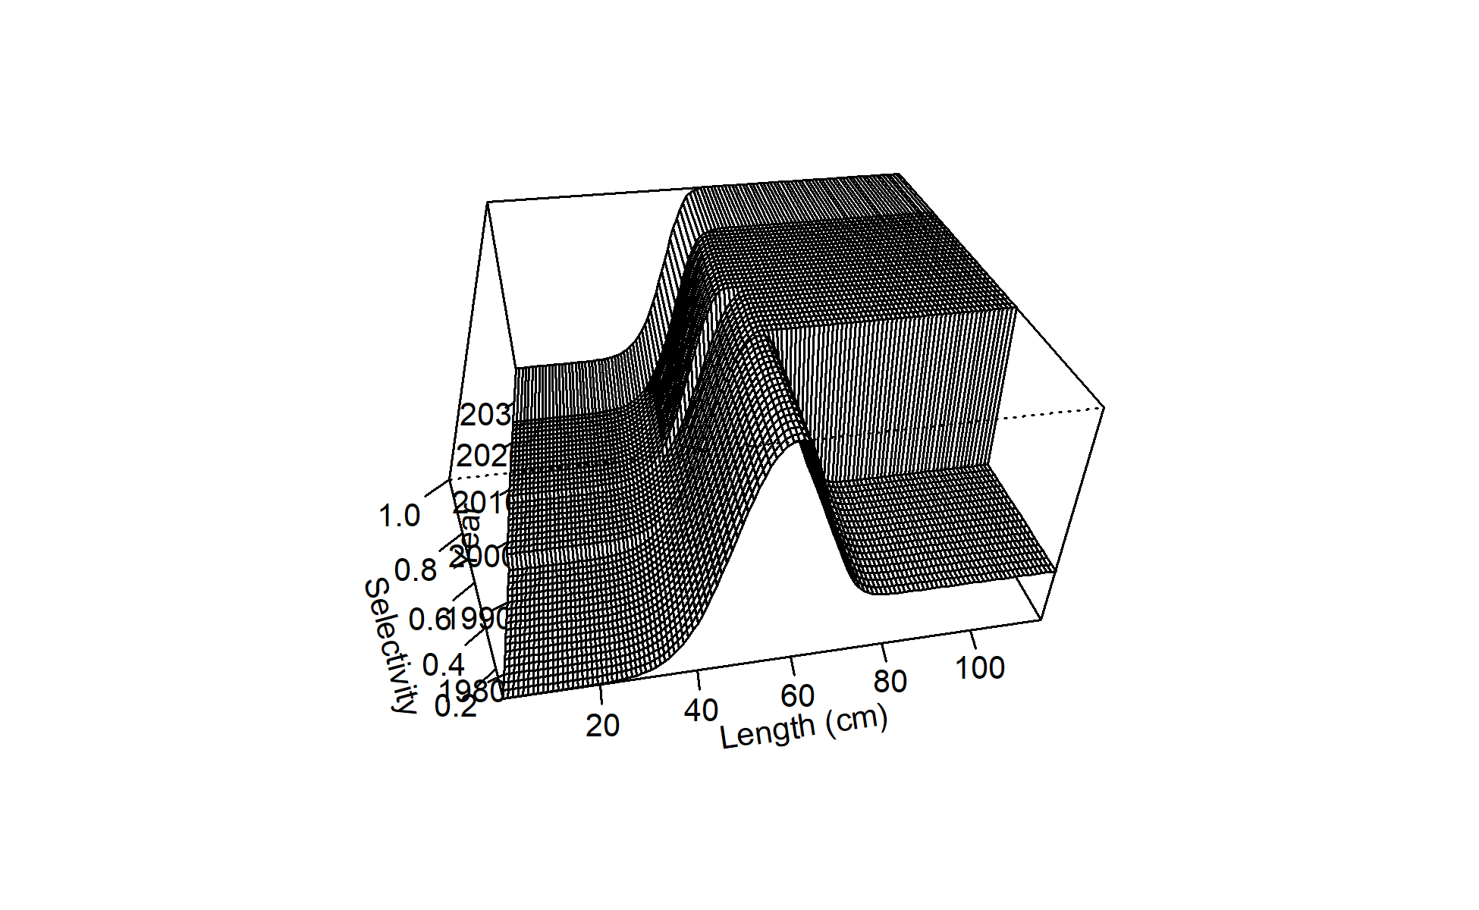 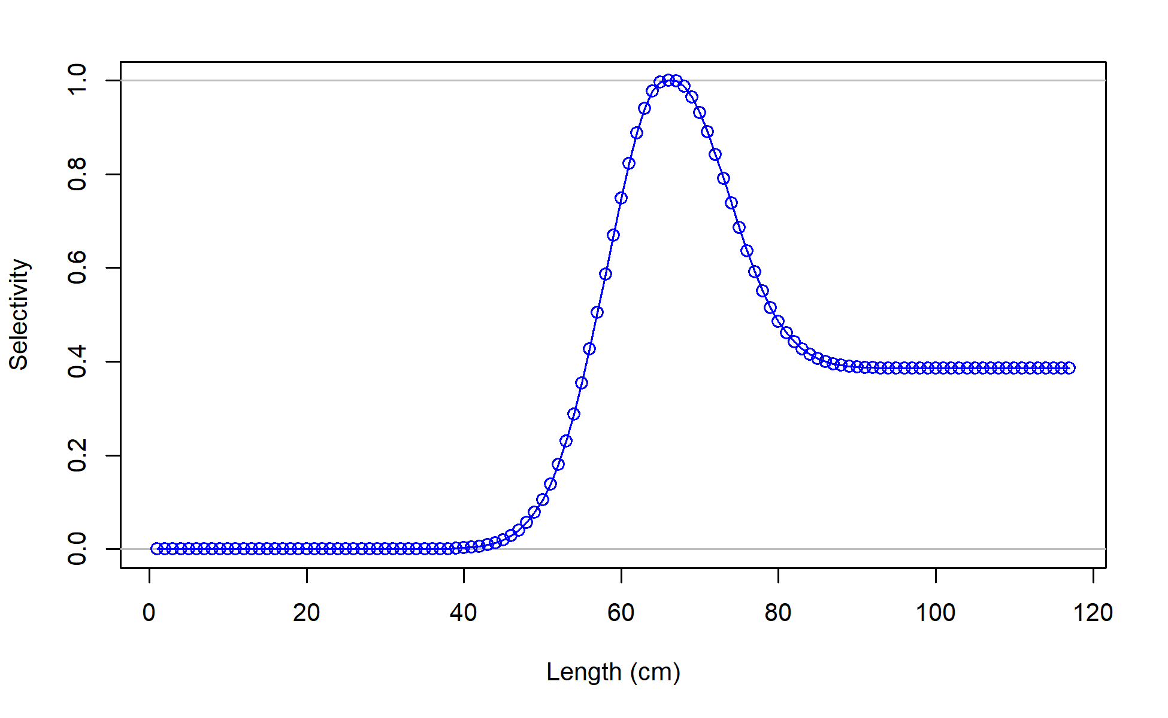

Figure 2.75 Selectivity curves for Model 21.2 Trawl fishery (top left), longline fishery (top right), pot fishery (middle left), NMFS bottom trawl survey (mid right), and AFSC Longline survey (bottom) length composition data.

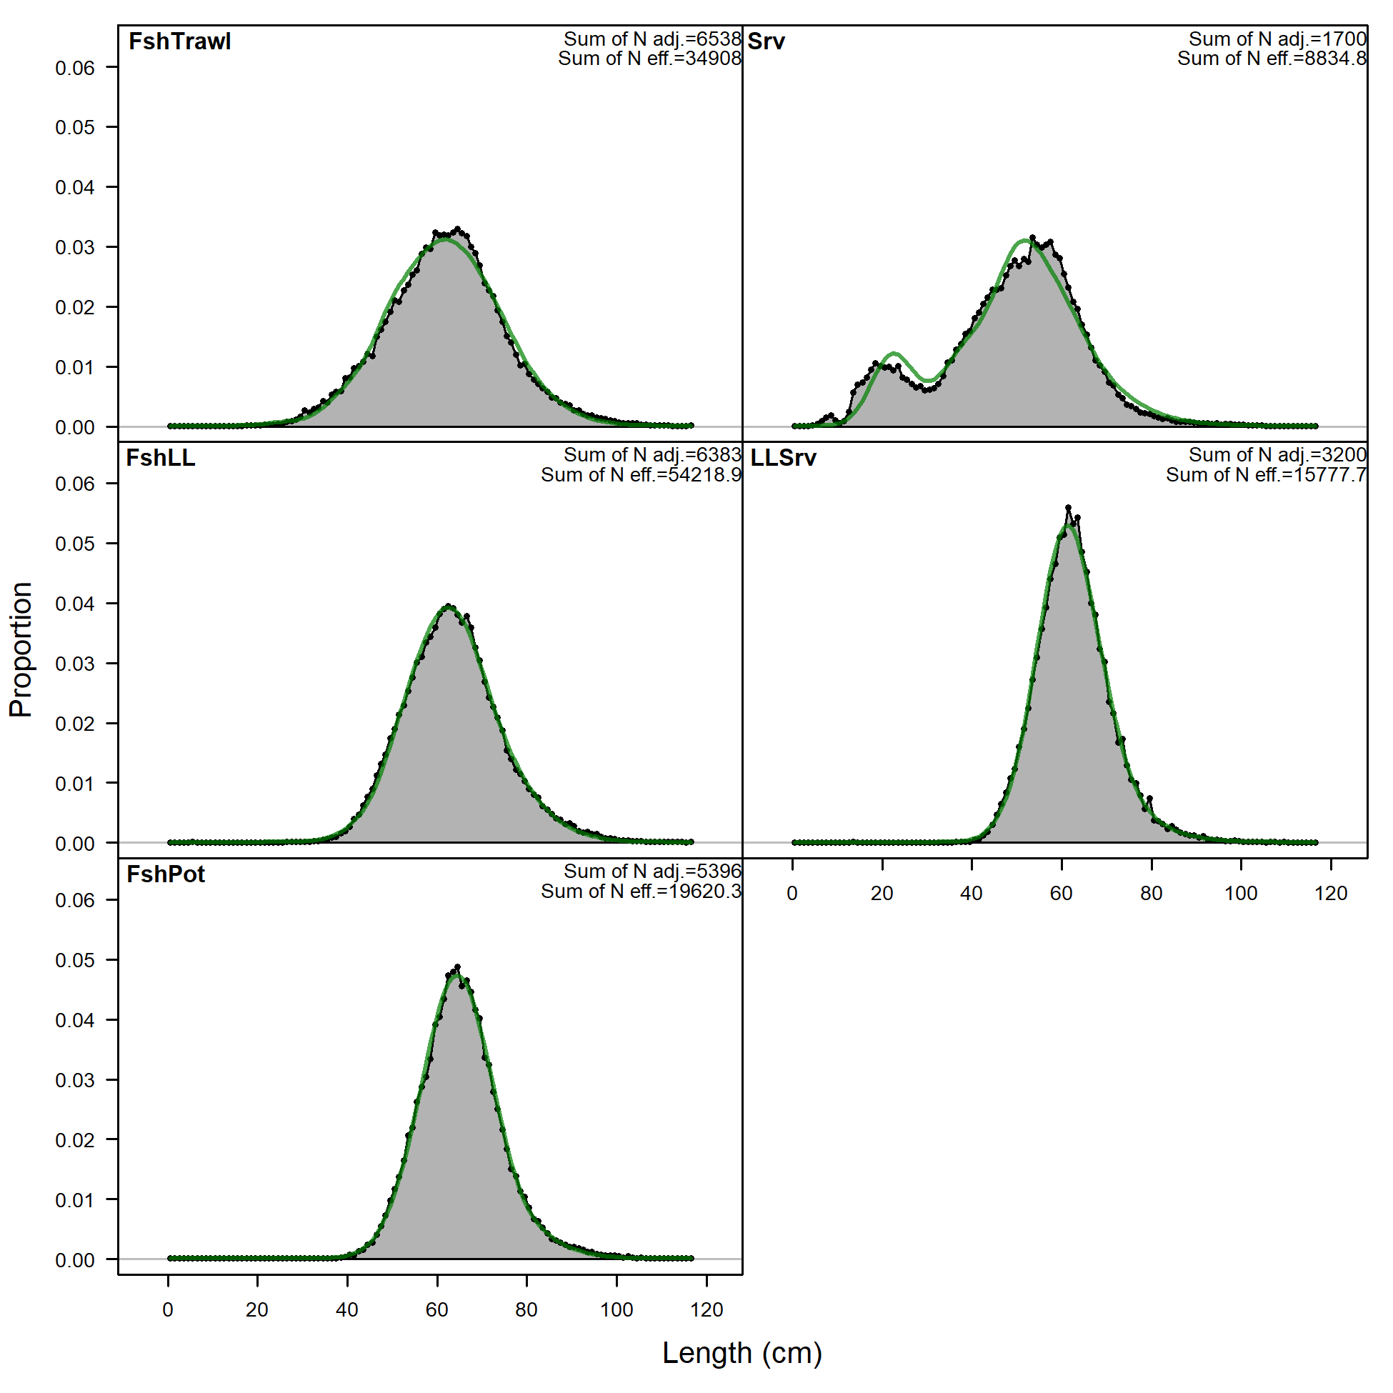

Figure 2.76 Overall Model 21.2 fits to Trawl fishery (FshTrawl), longline fishery (FshLL), pot fishery (FshPot), NMFS bottom trawl survey (Srv), and AFSC Longline survey (LLSrv) length composition data.

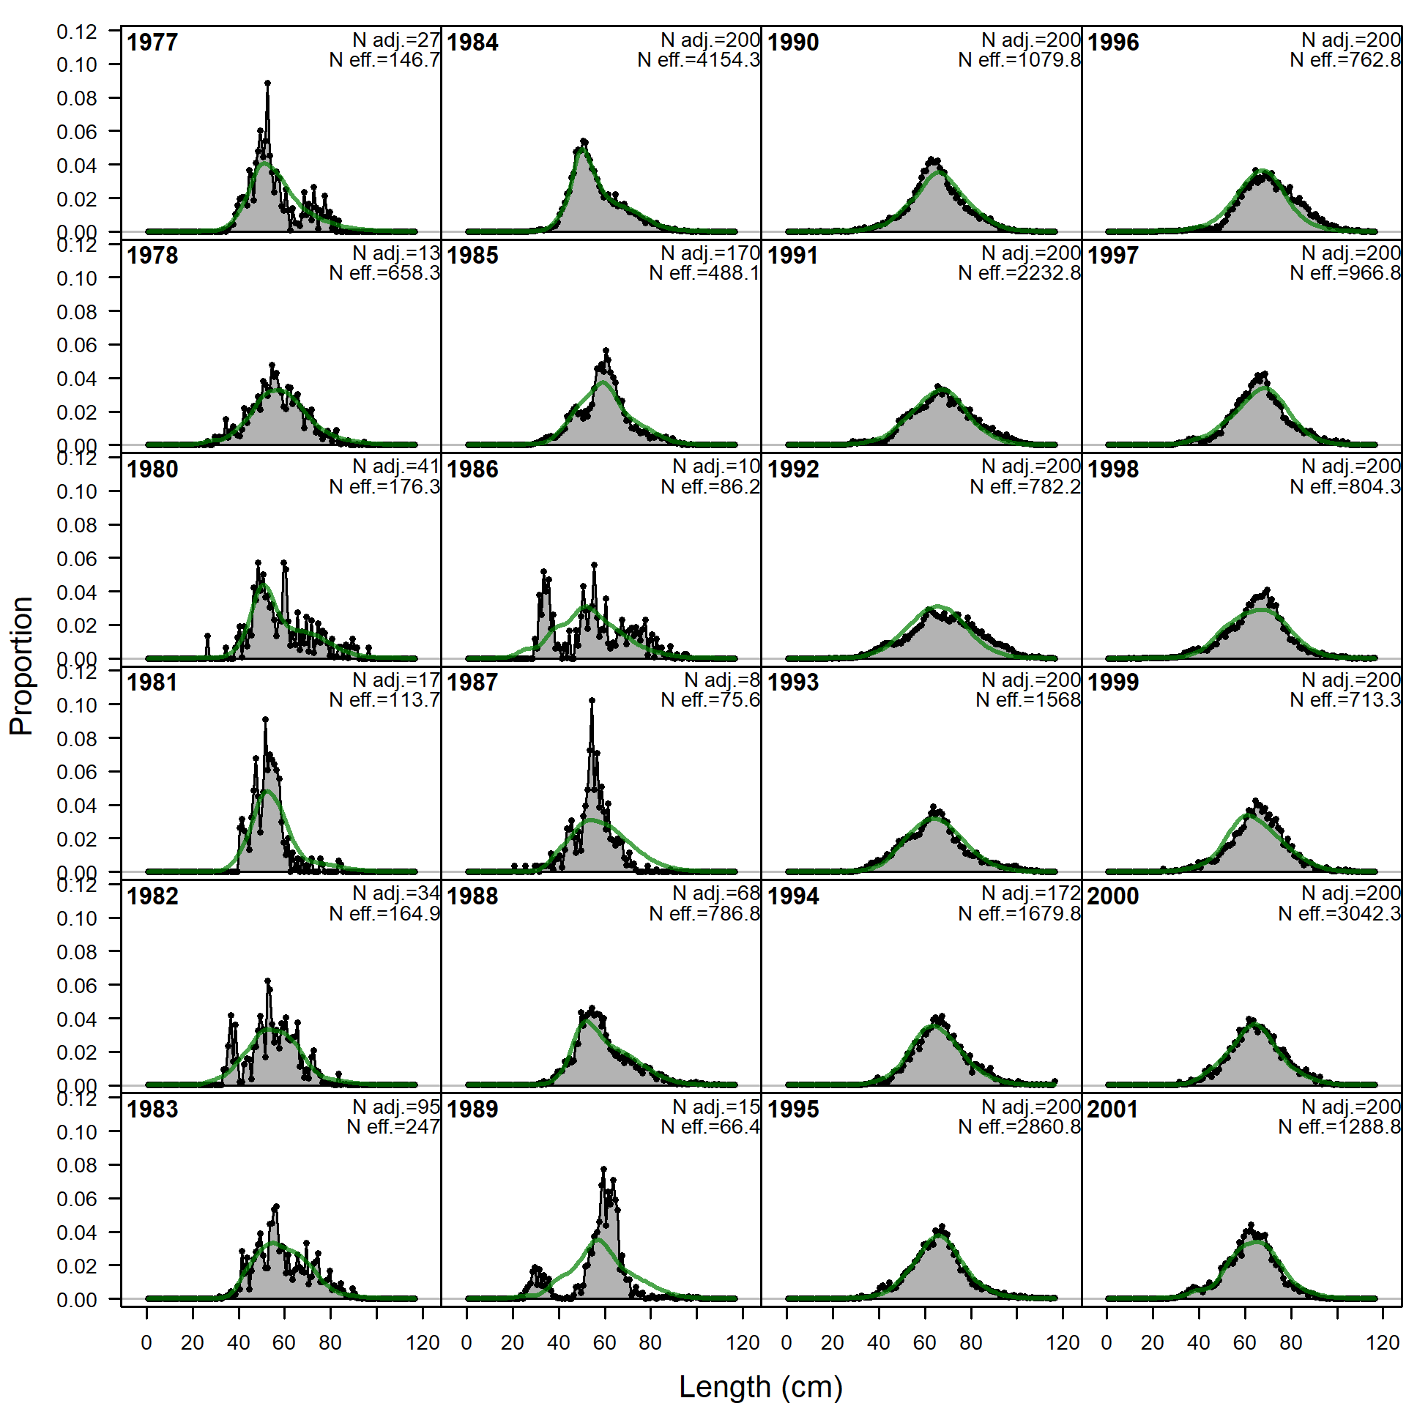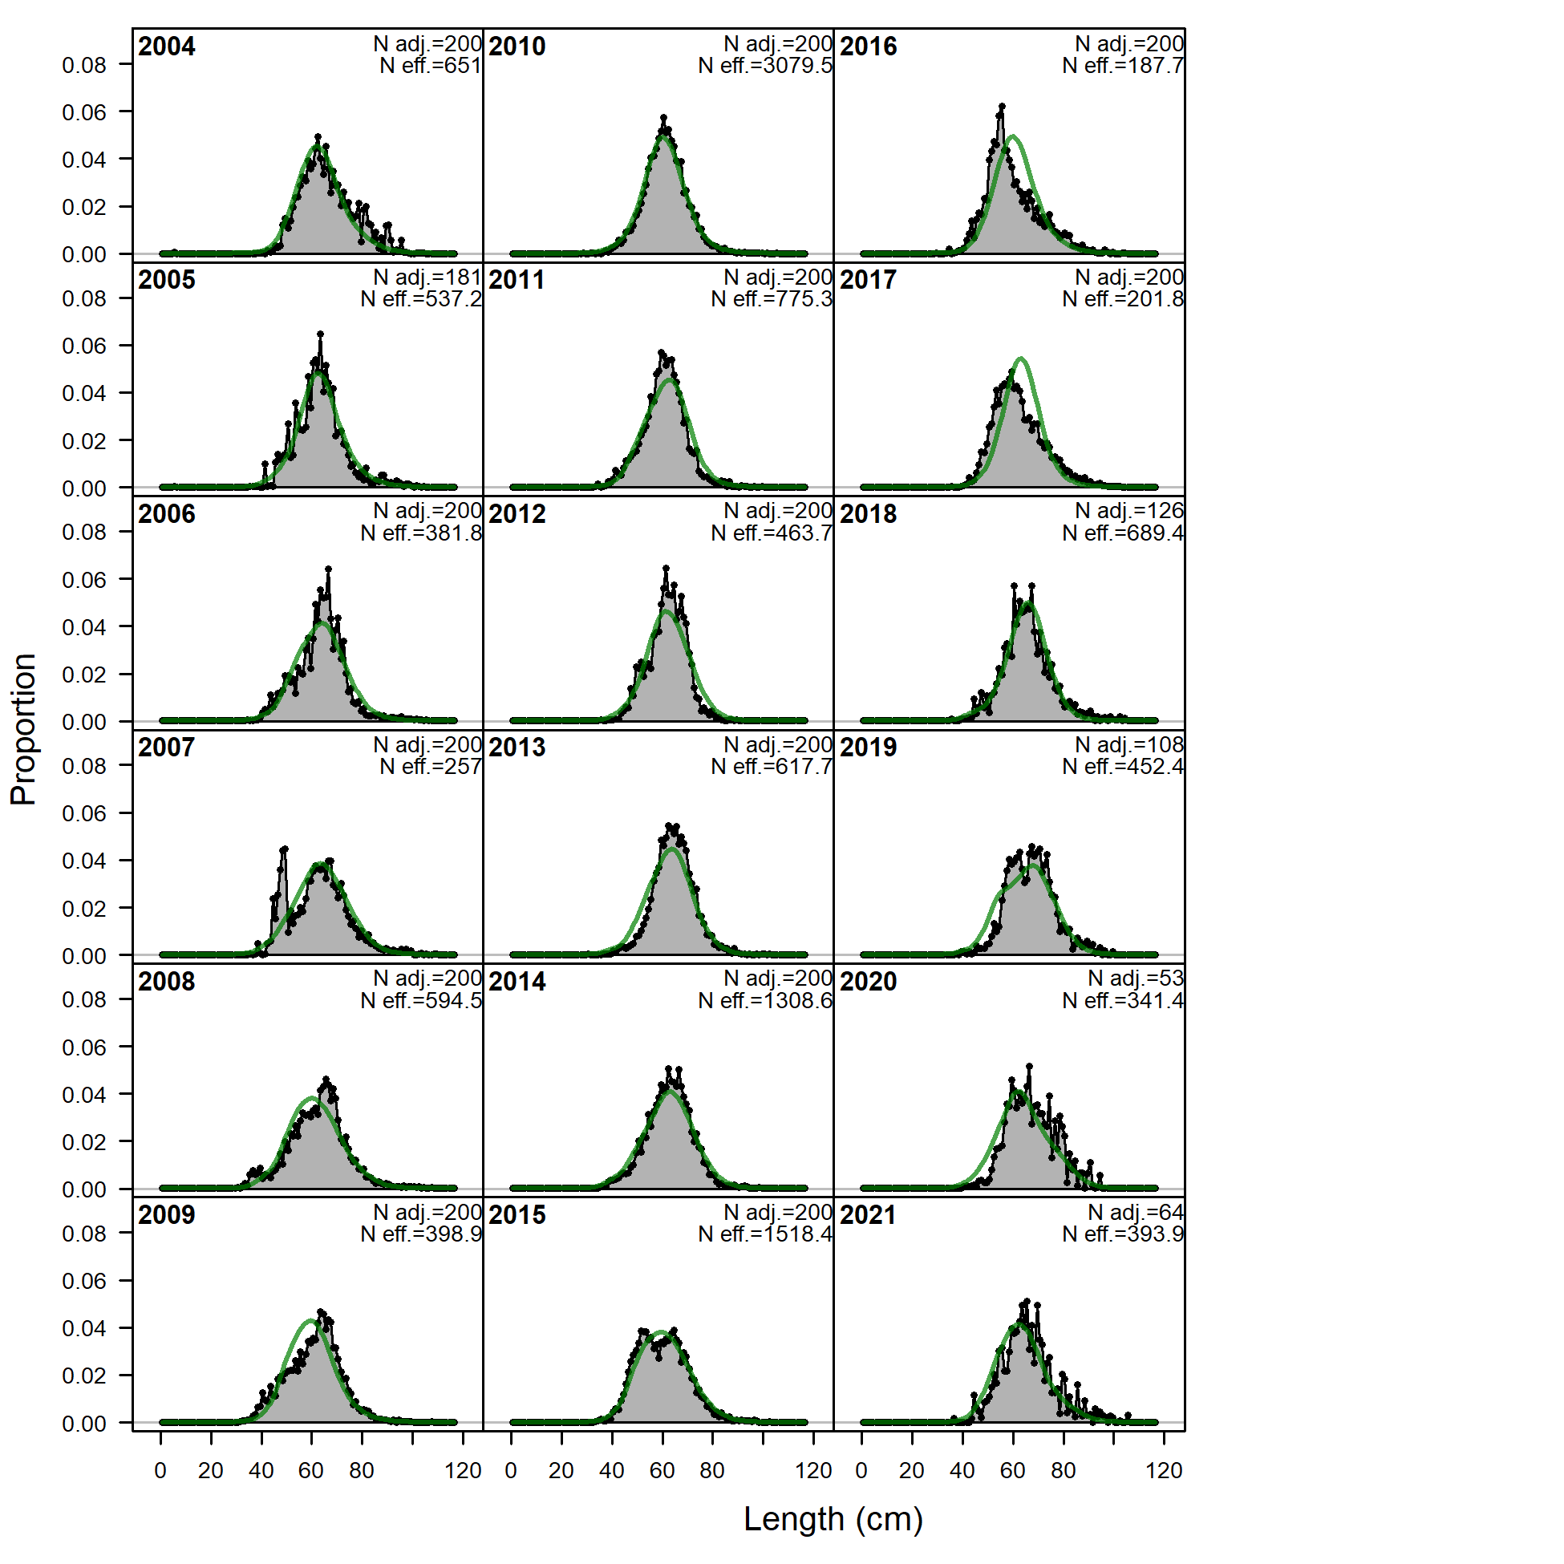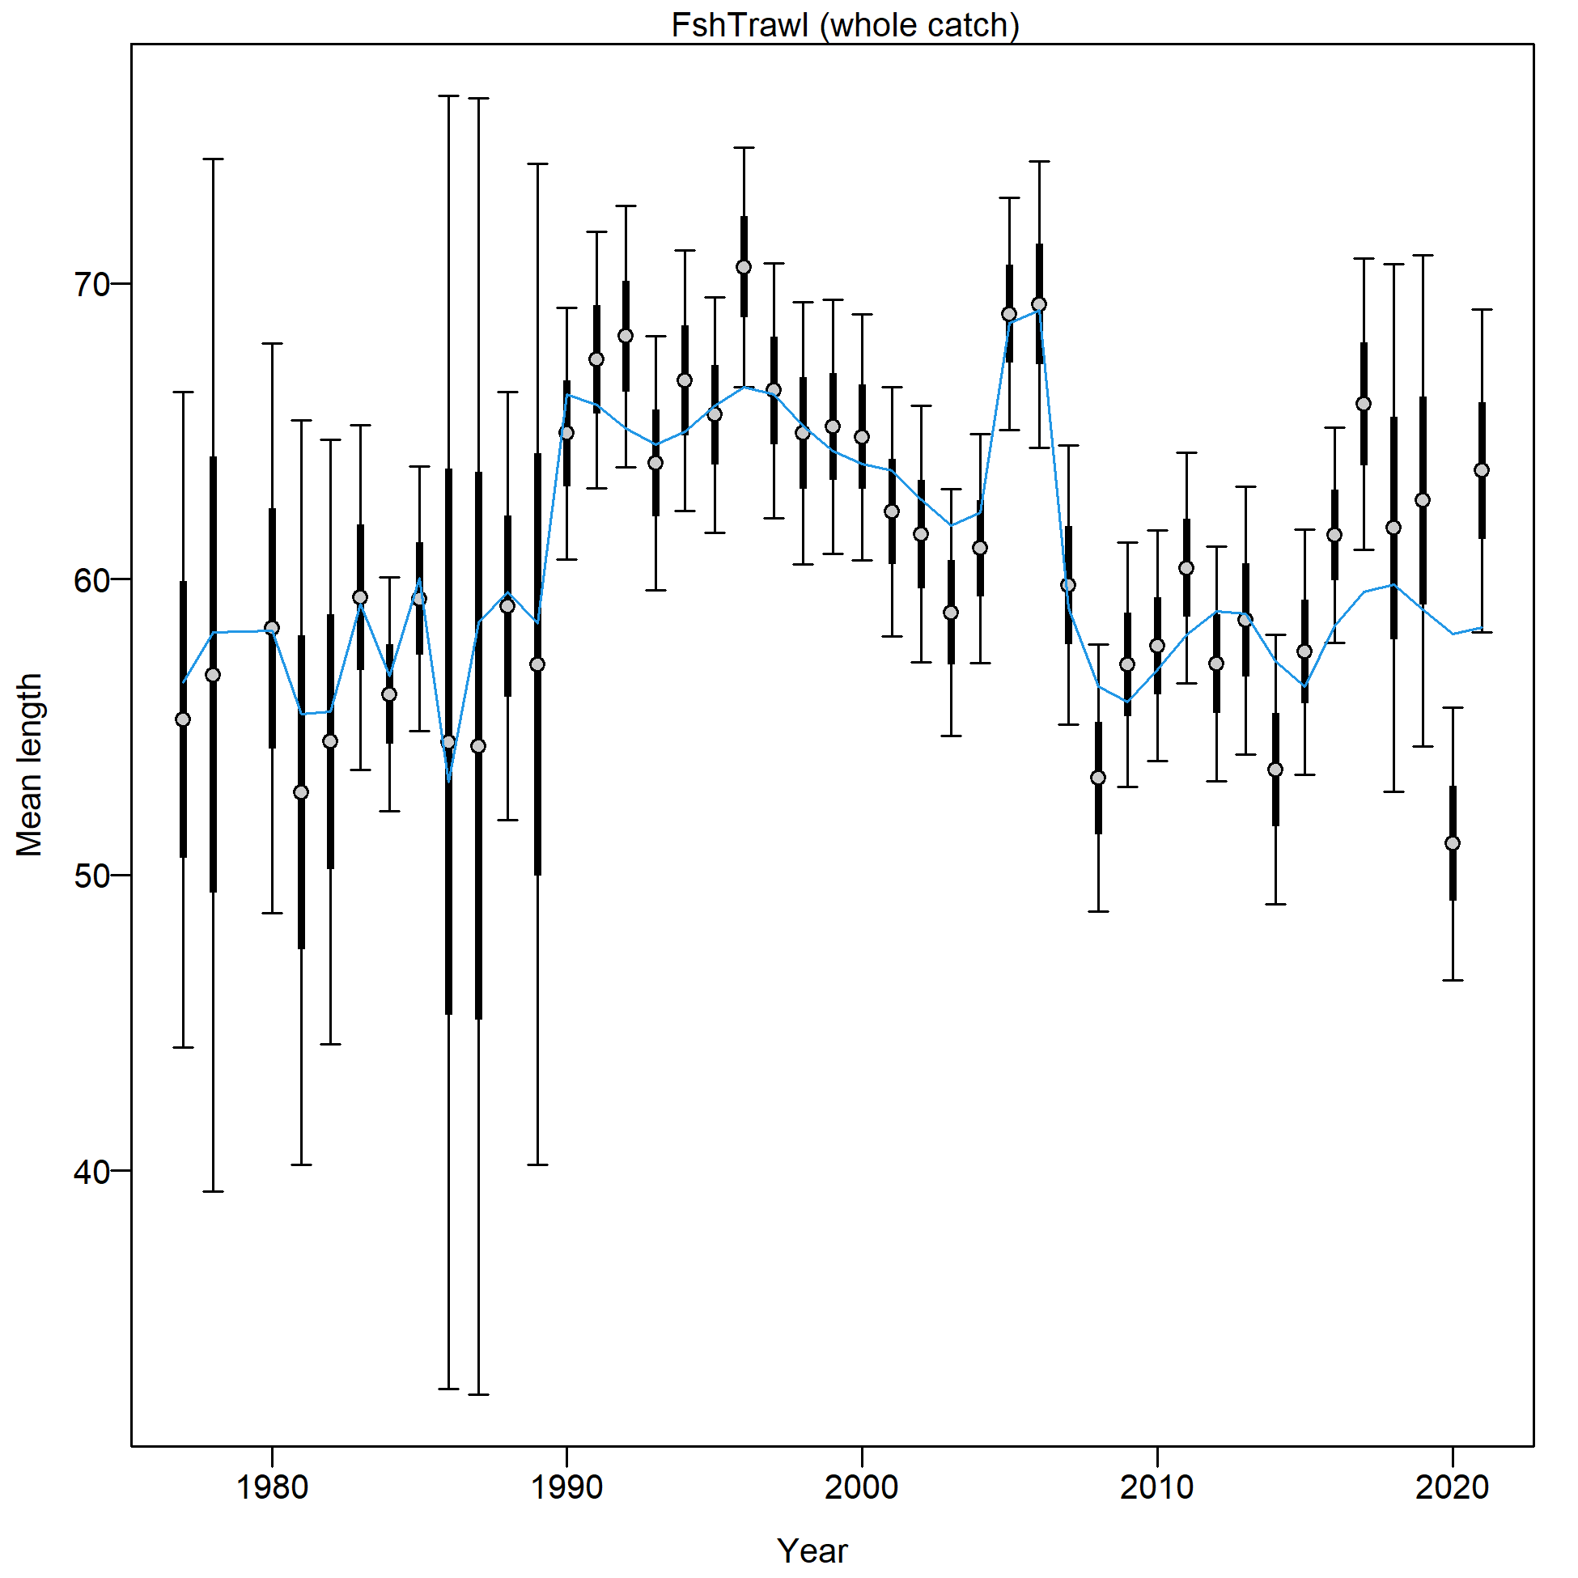

Figure 2.77 Trawl fishery length composition and Model 21.2 fit (top) and mean length (cm; bottom).

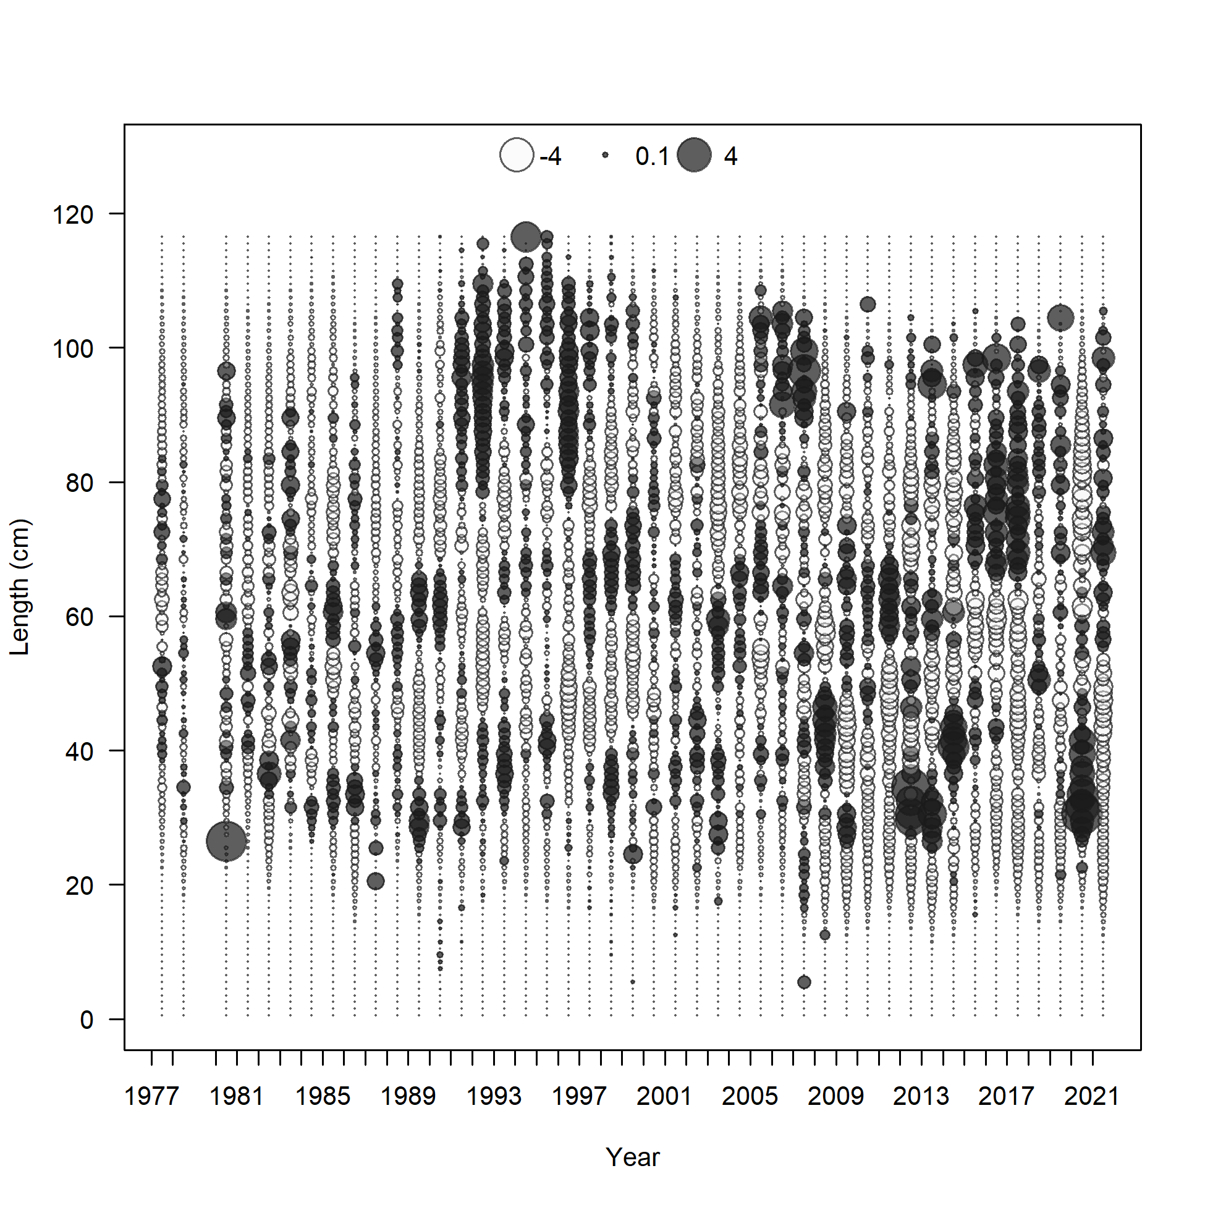

Figure 2.78 Trawl fishery length composition Pearson residuals (max = 5.69) for Model 21.2.

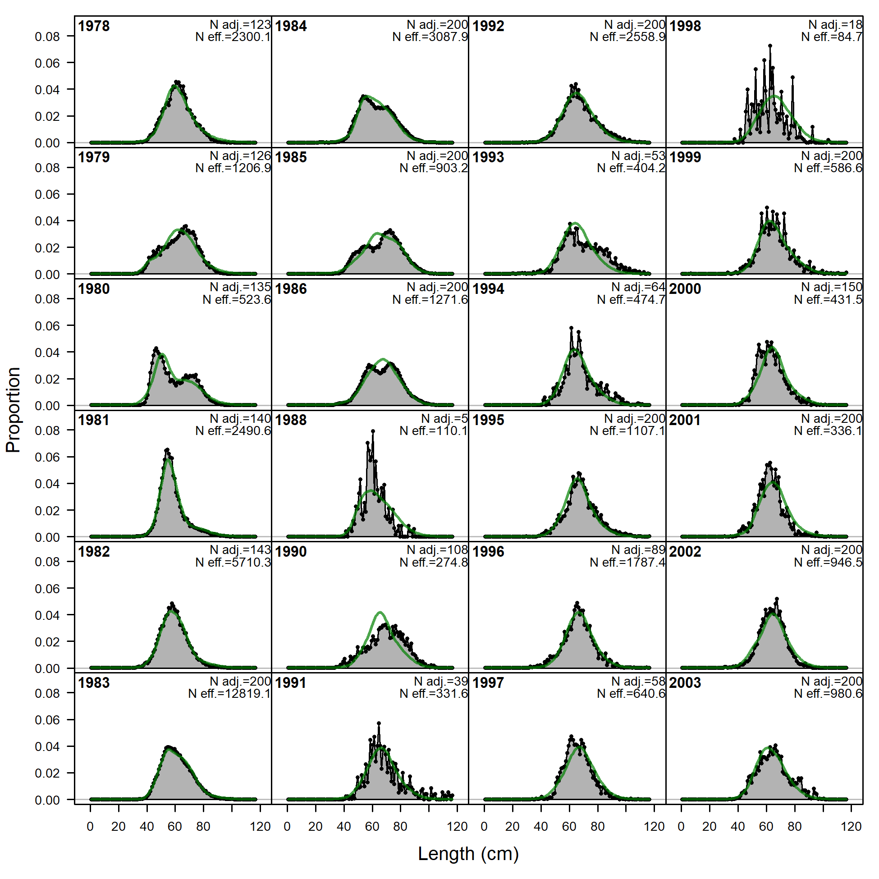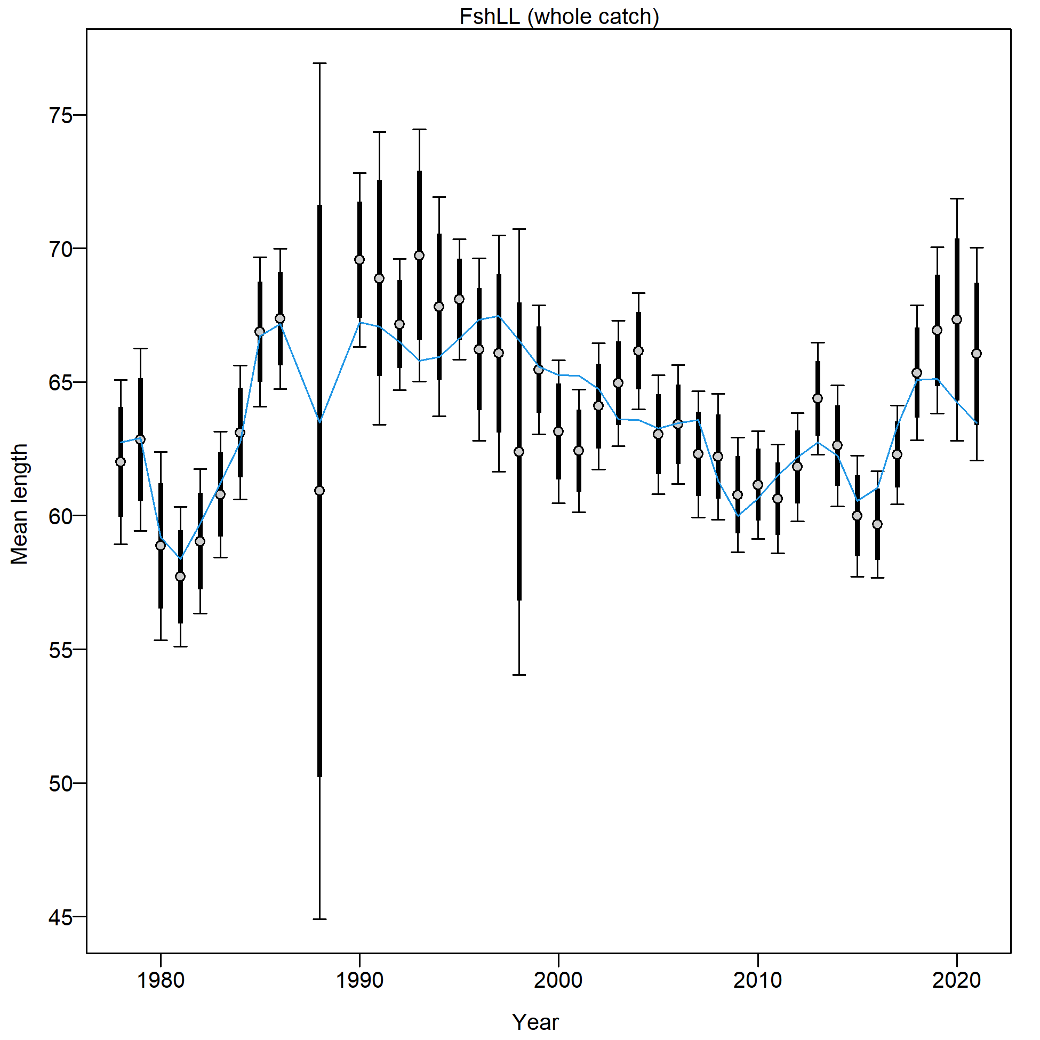

Figure 2.79 Longline fishery length composition and Model 21.2 fit (top) and mean length (cm; bottom).

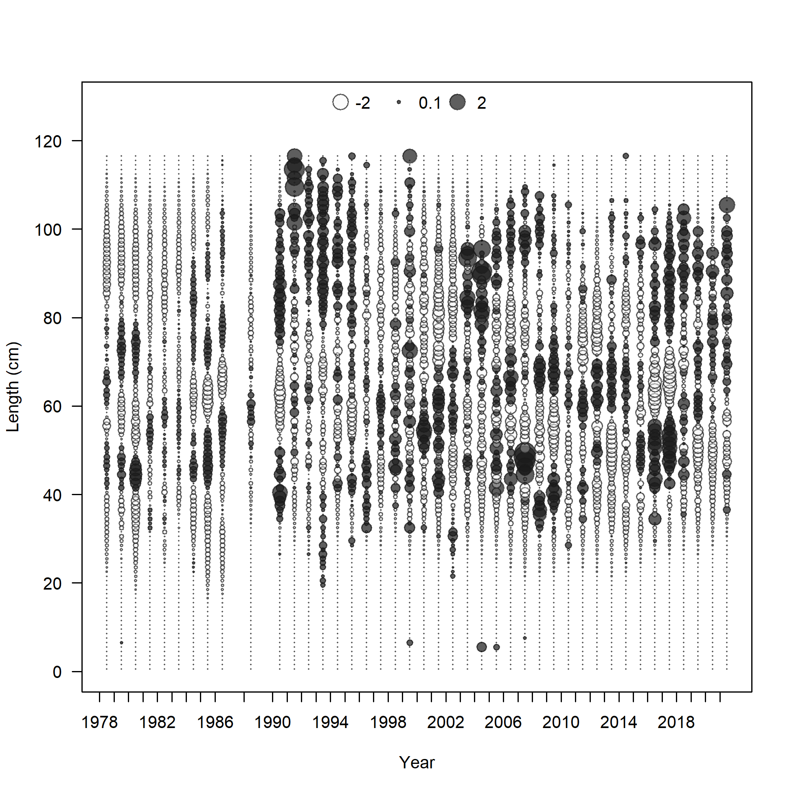

Figure 2.80 Longline fishery length composition and Model 21.2 fit Pearson residuals (max=3.76).

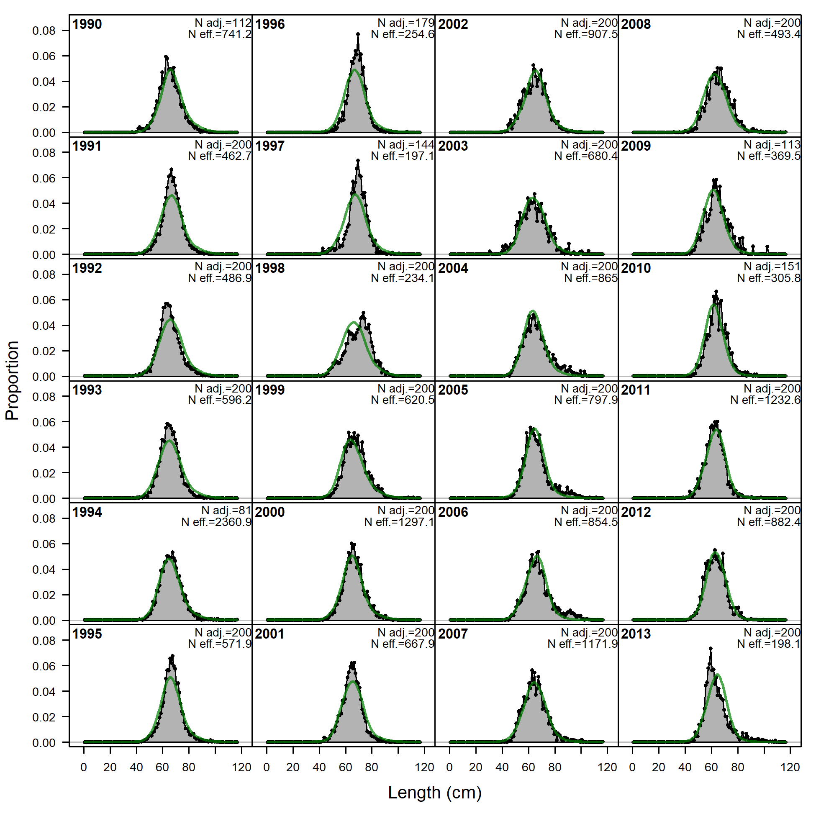 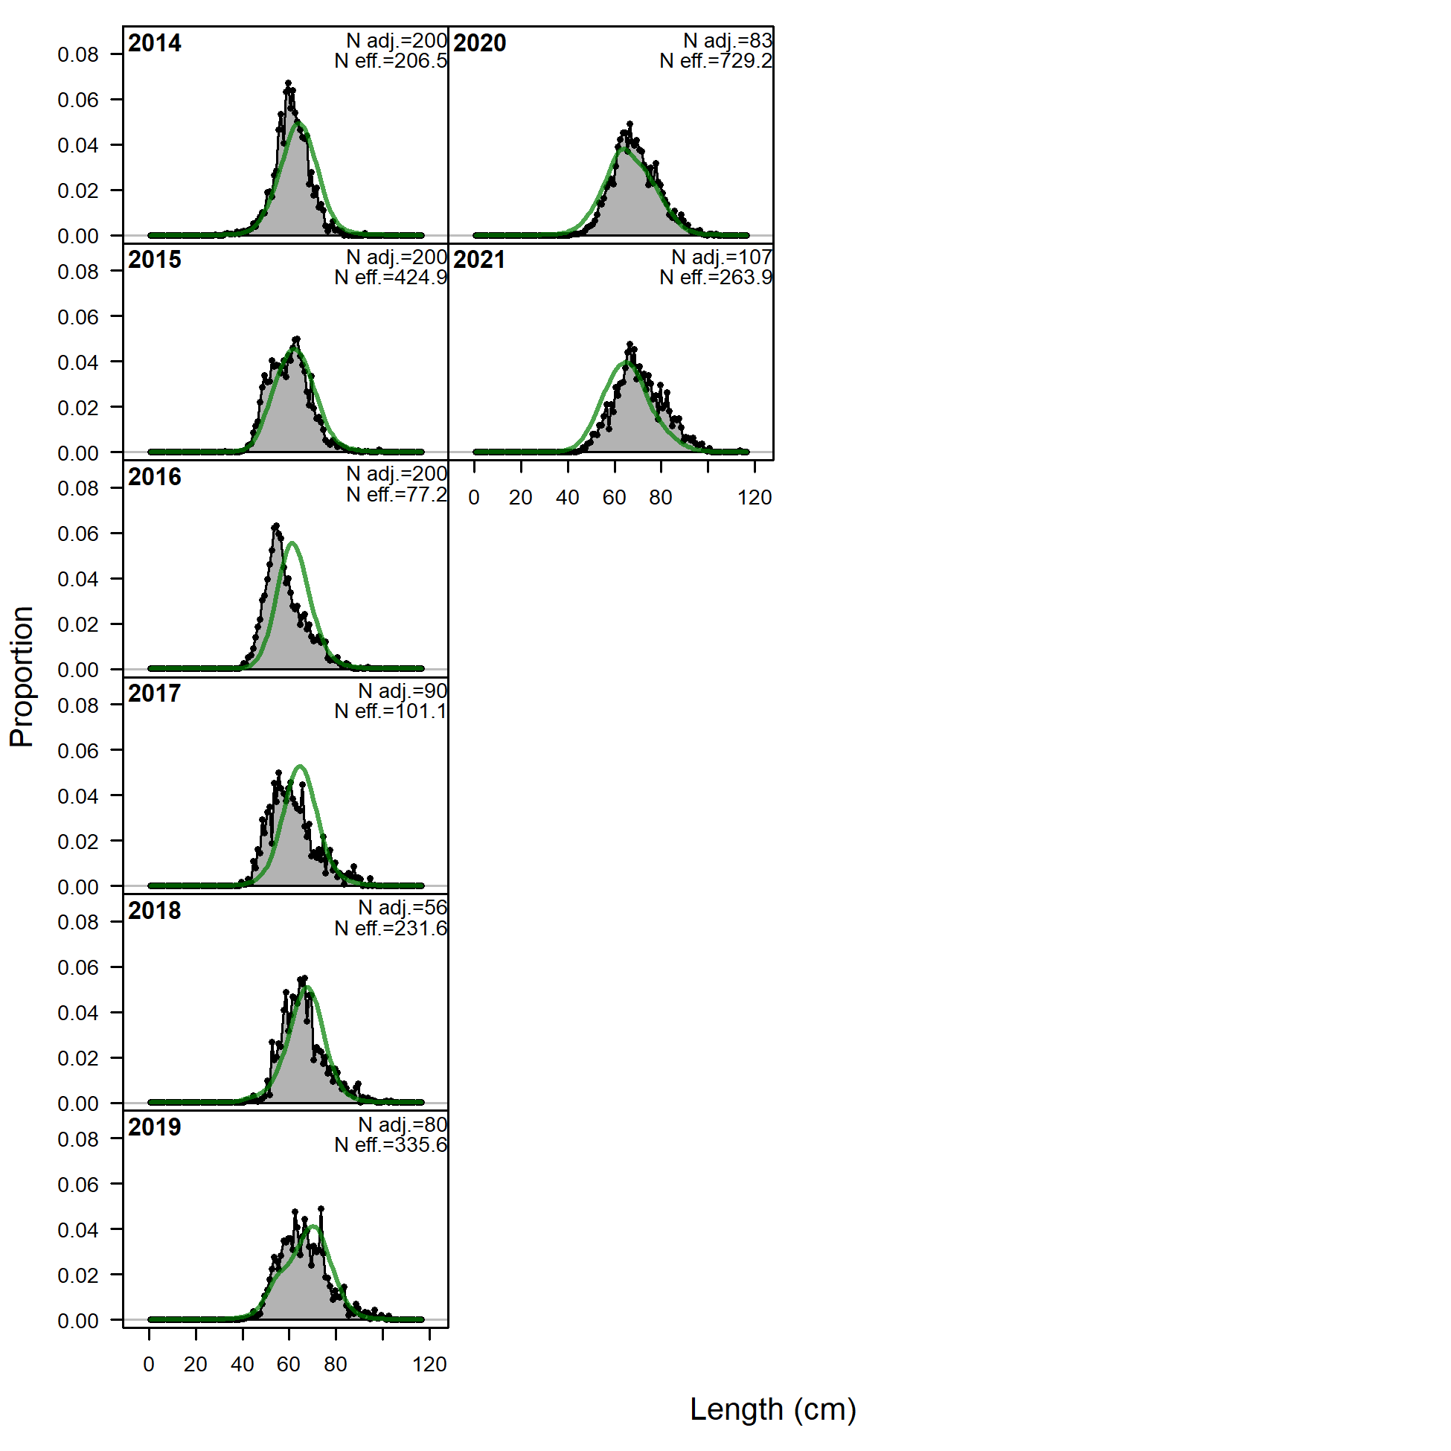 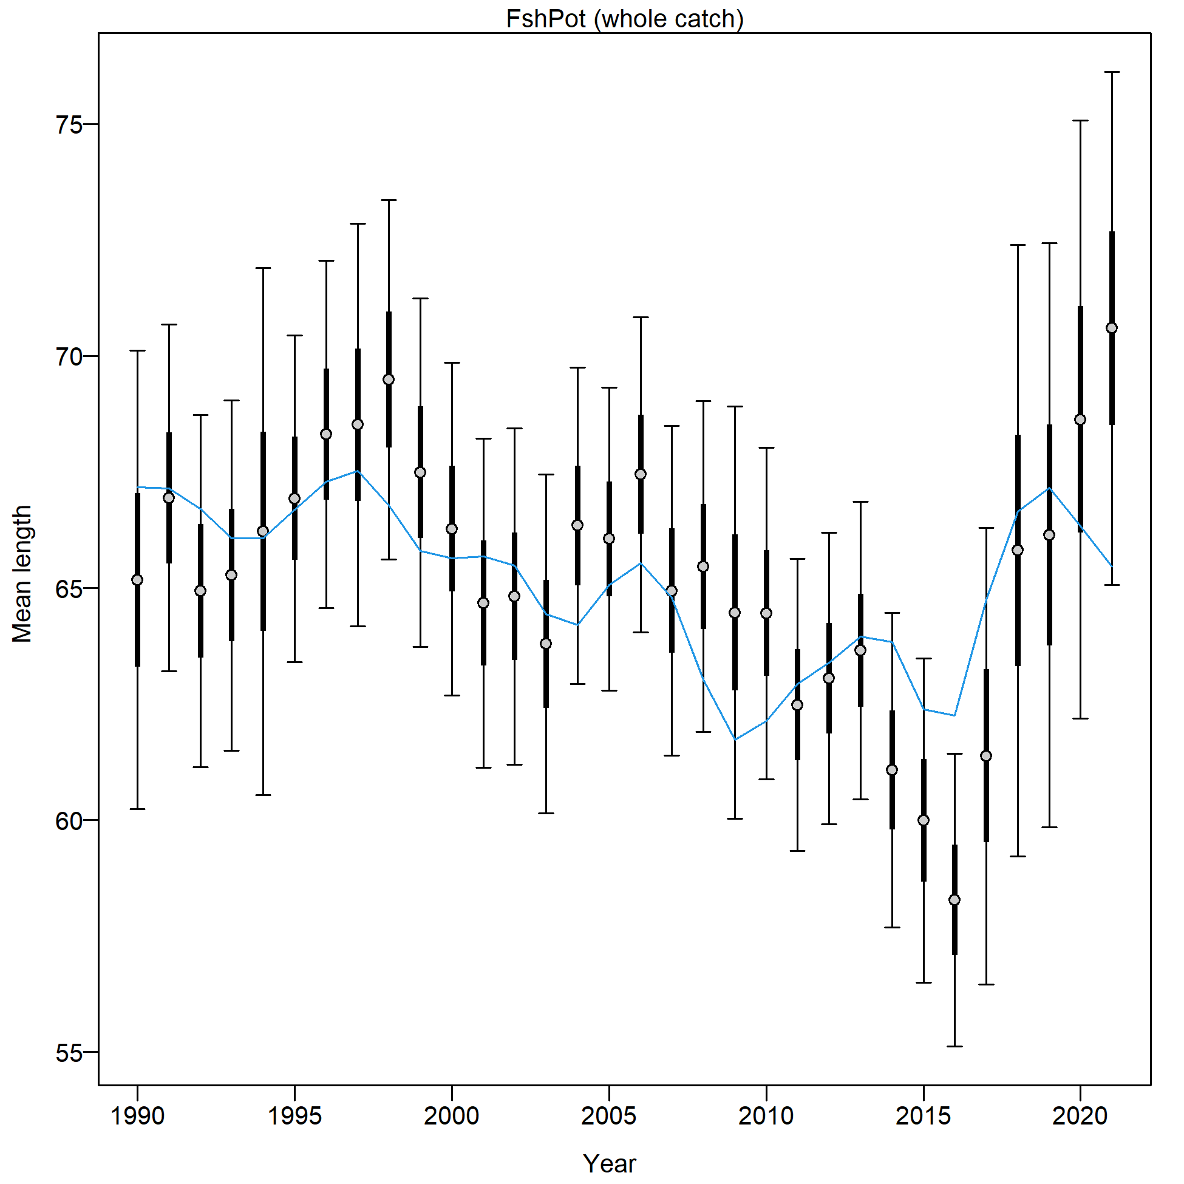 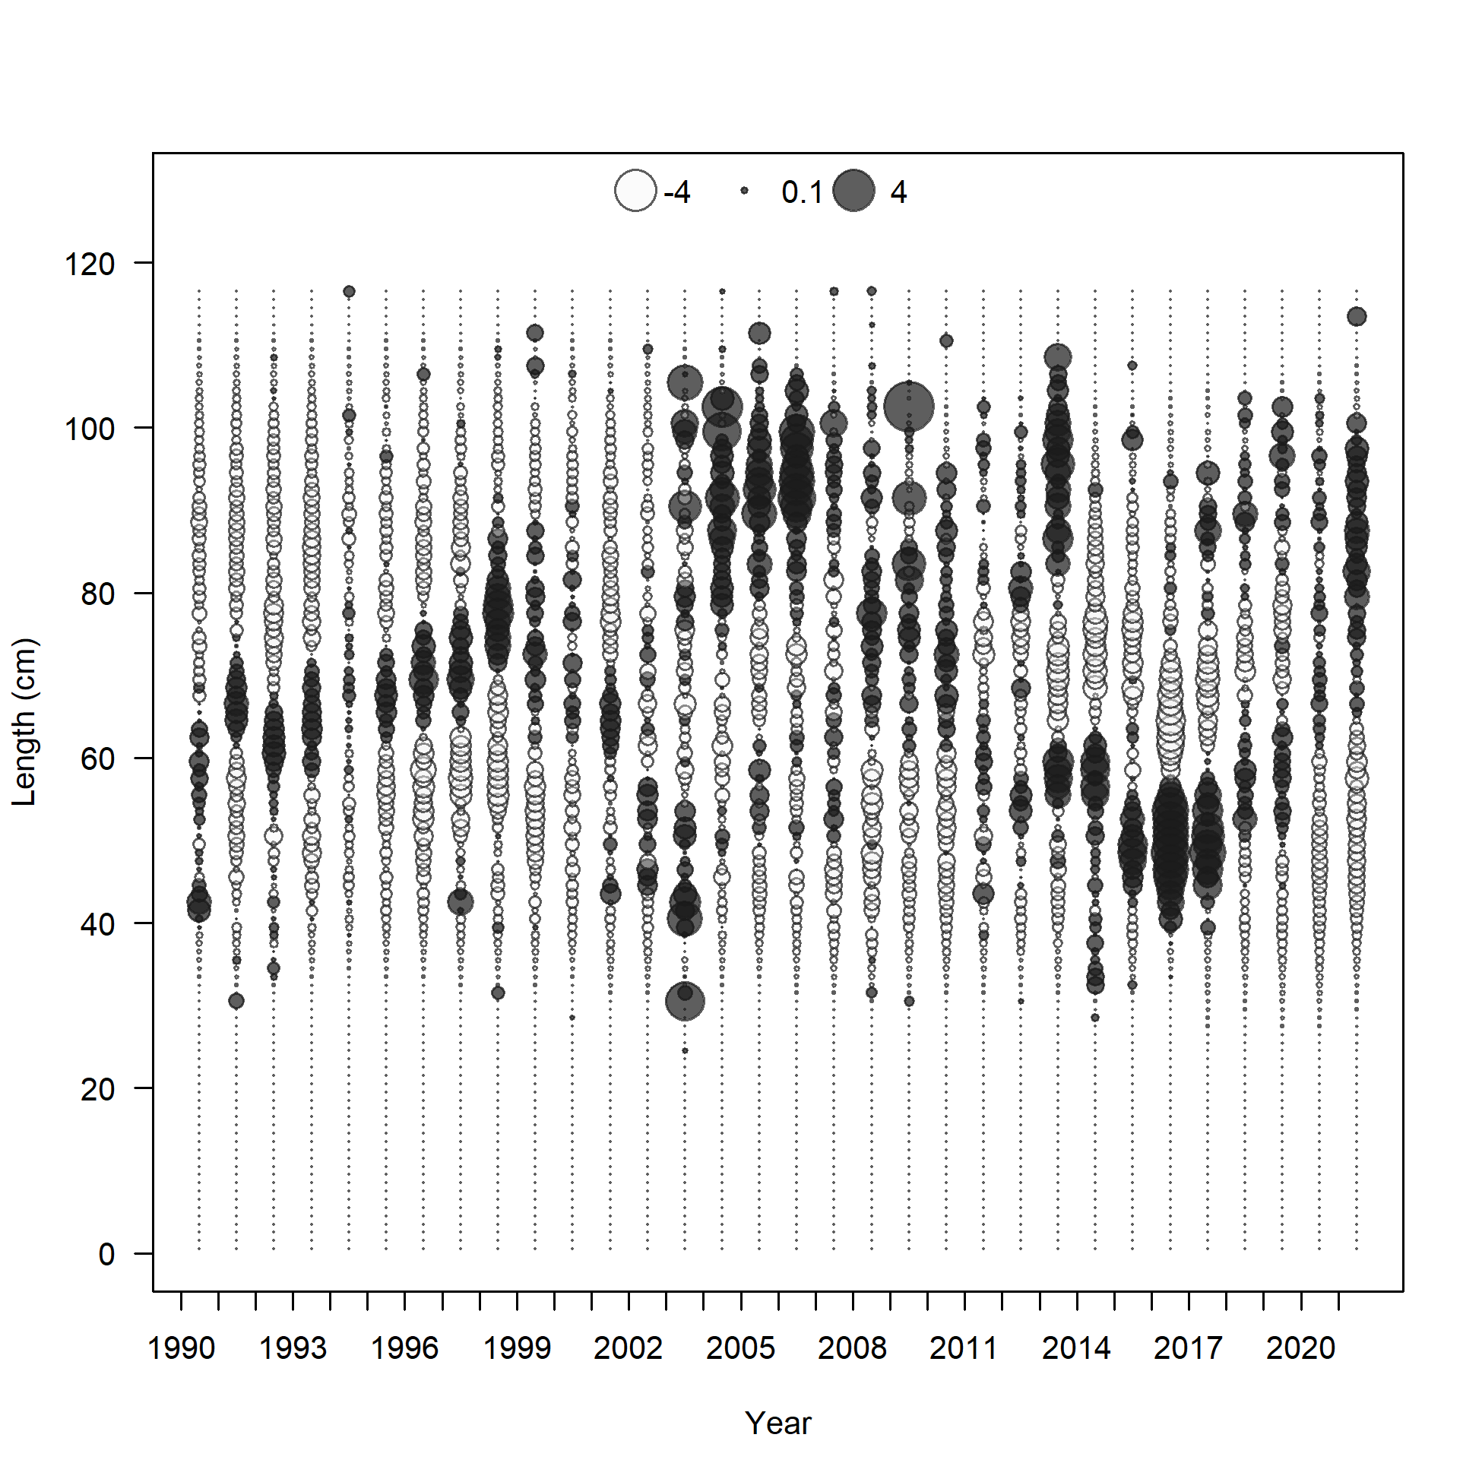

Figure 2.81 Pot fishery length composition and Model 21.2 fit (top), mean length (bottom left), and Pearson residuals (max=5.72; bottom right).

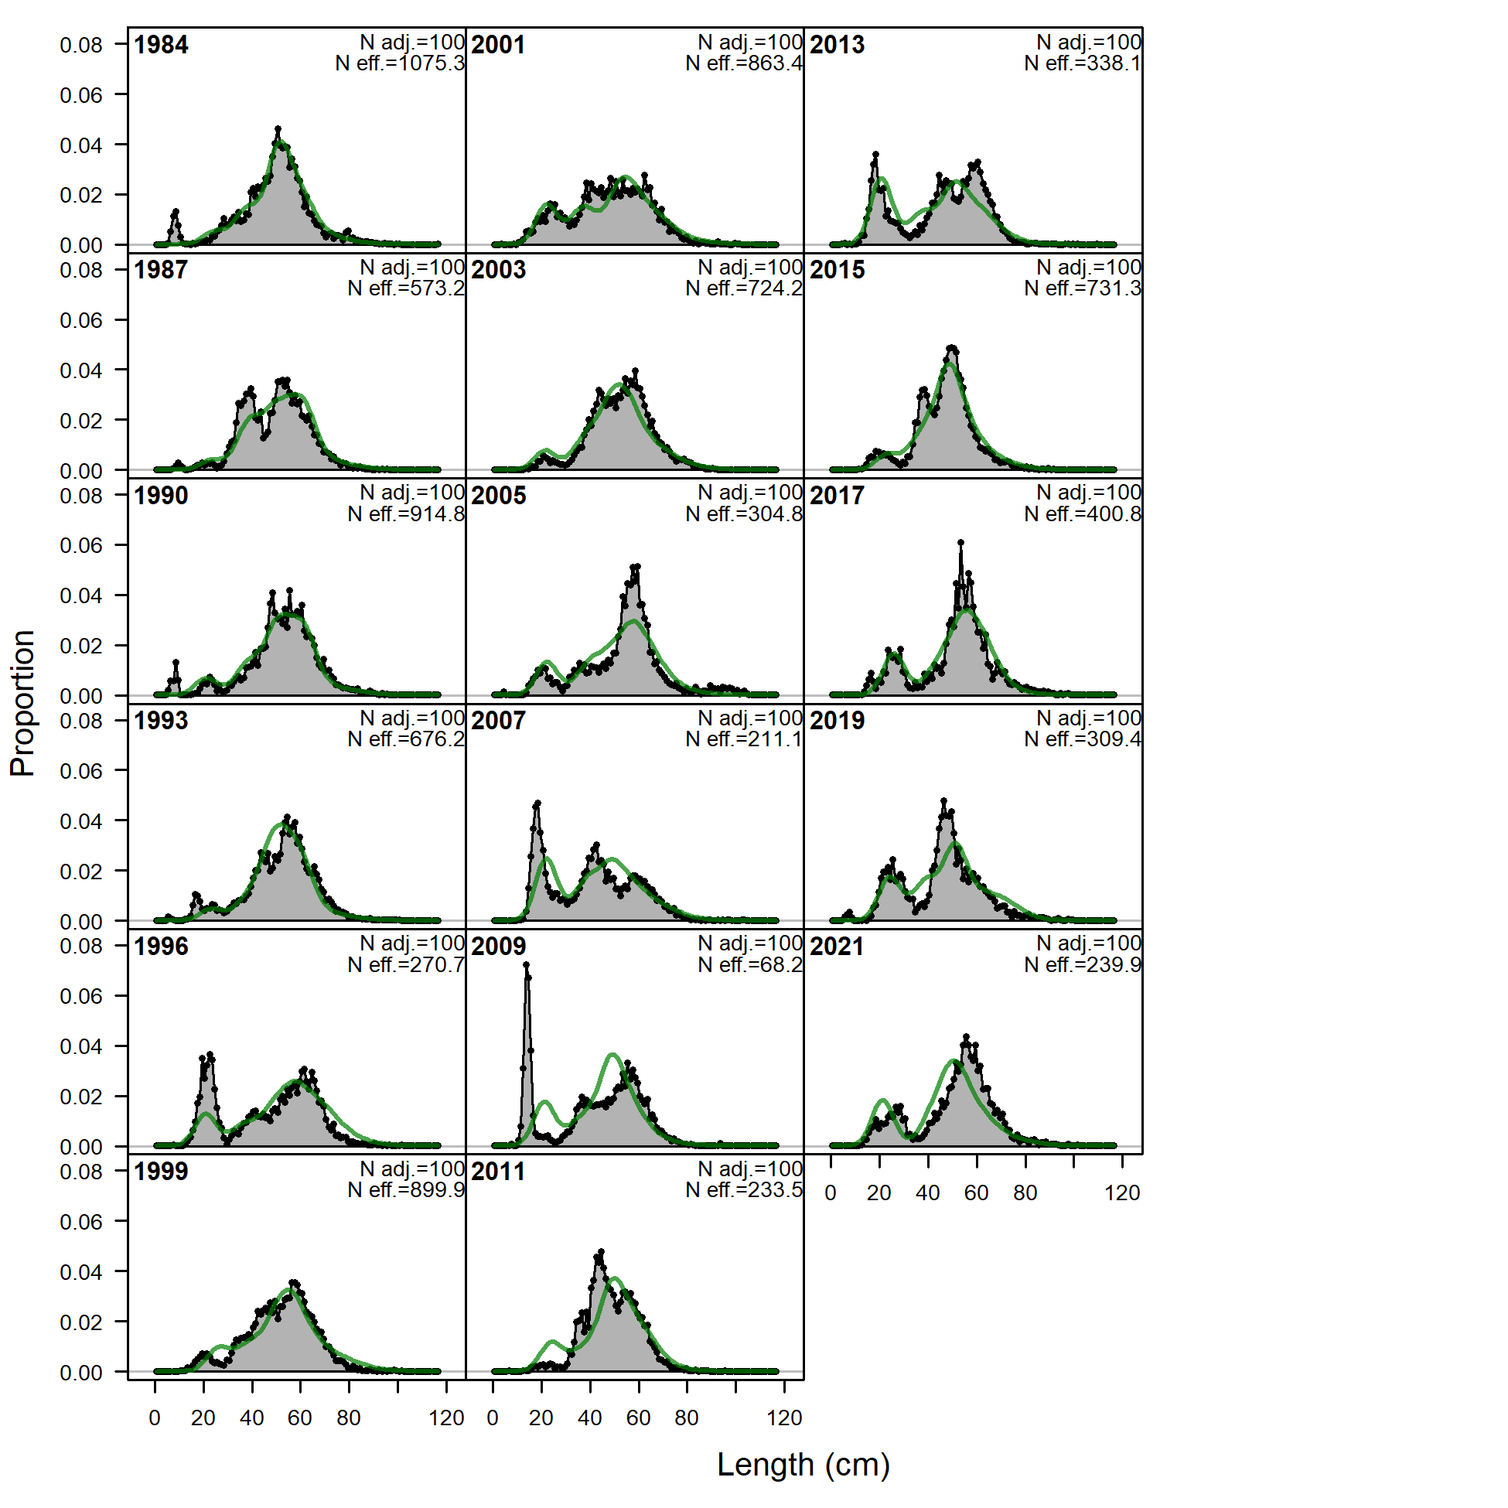

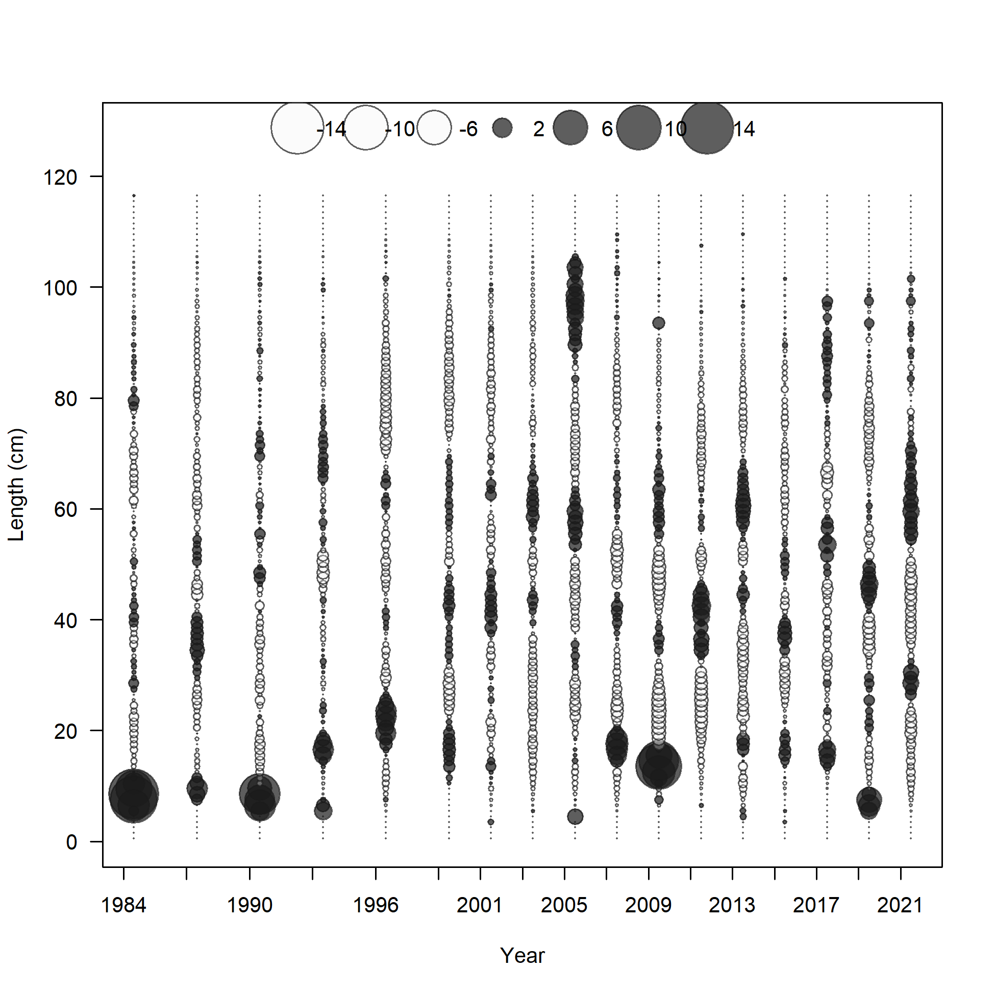 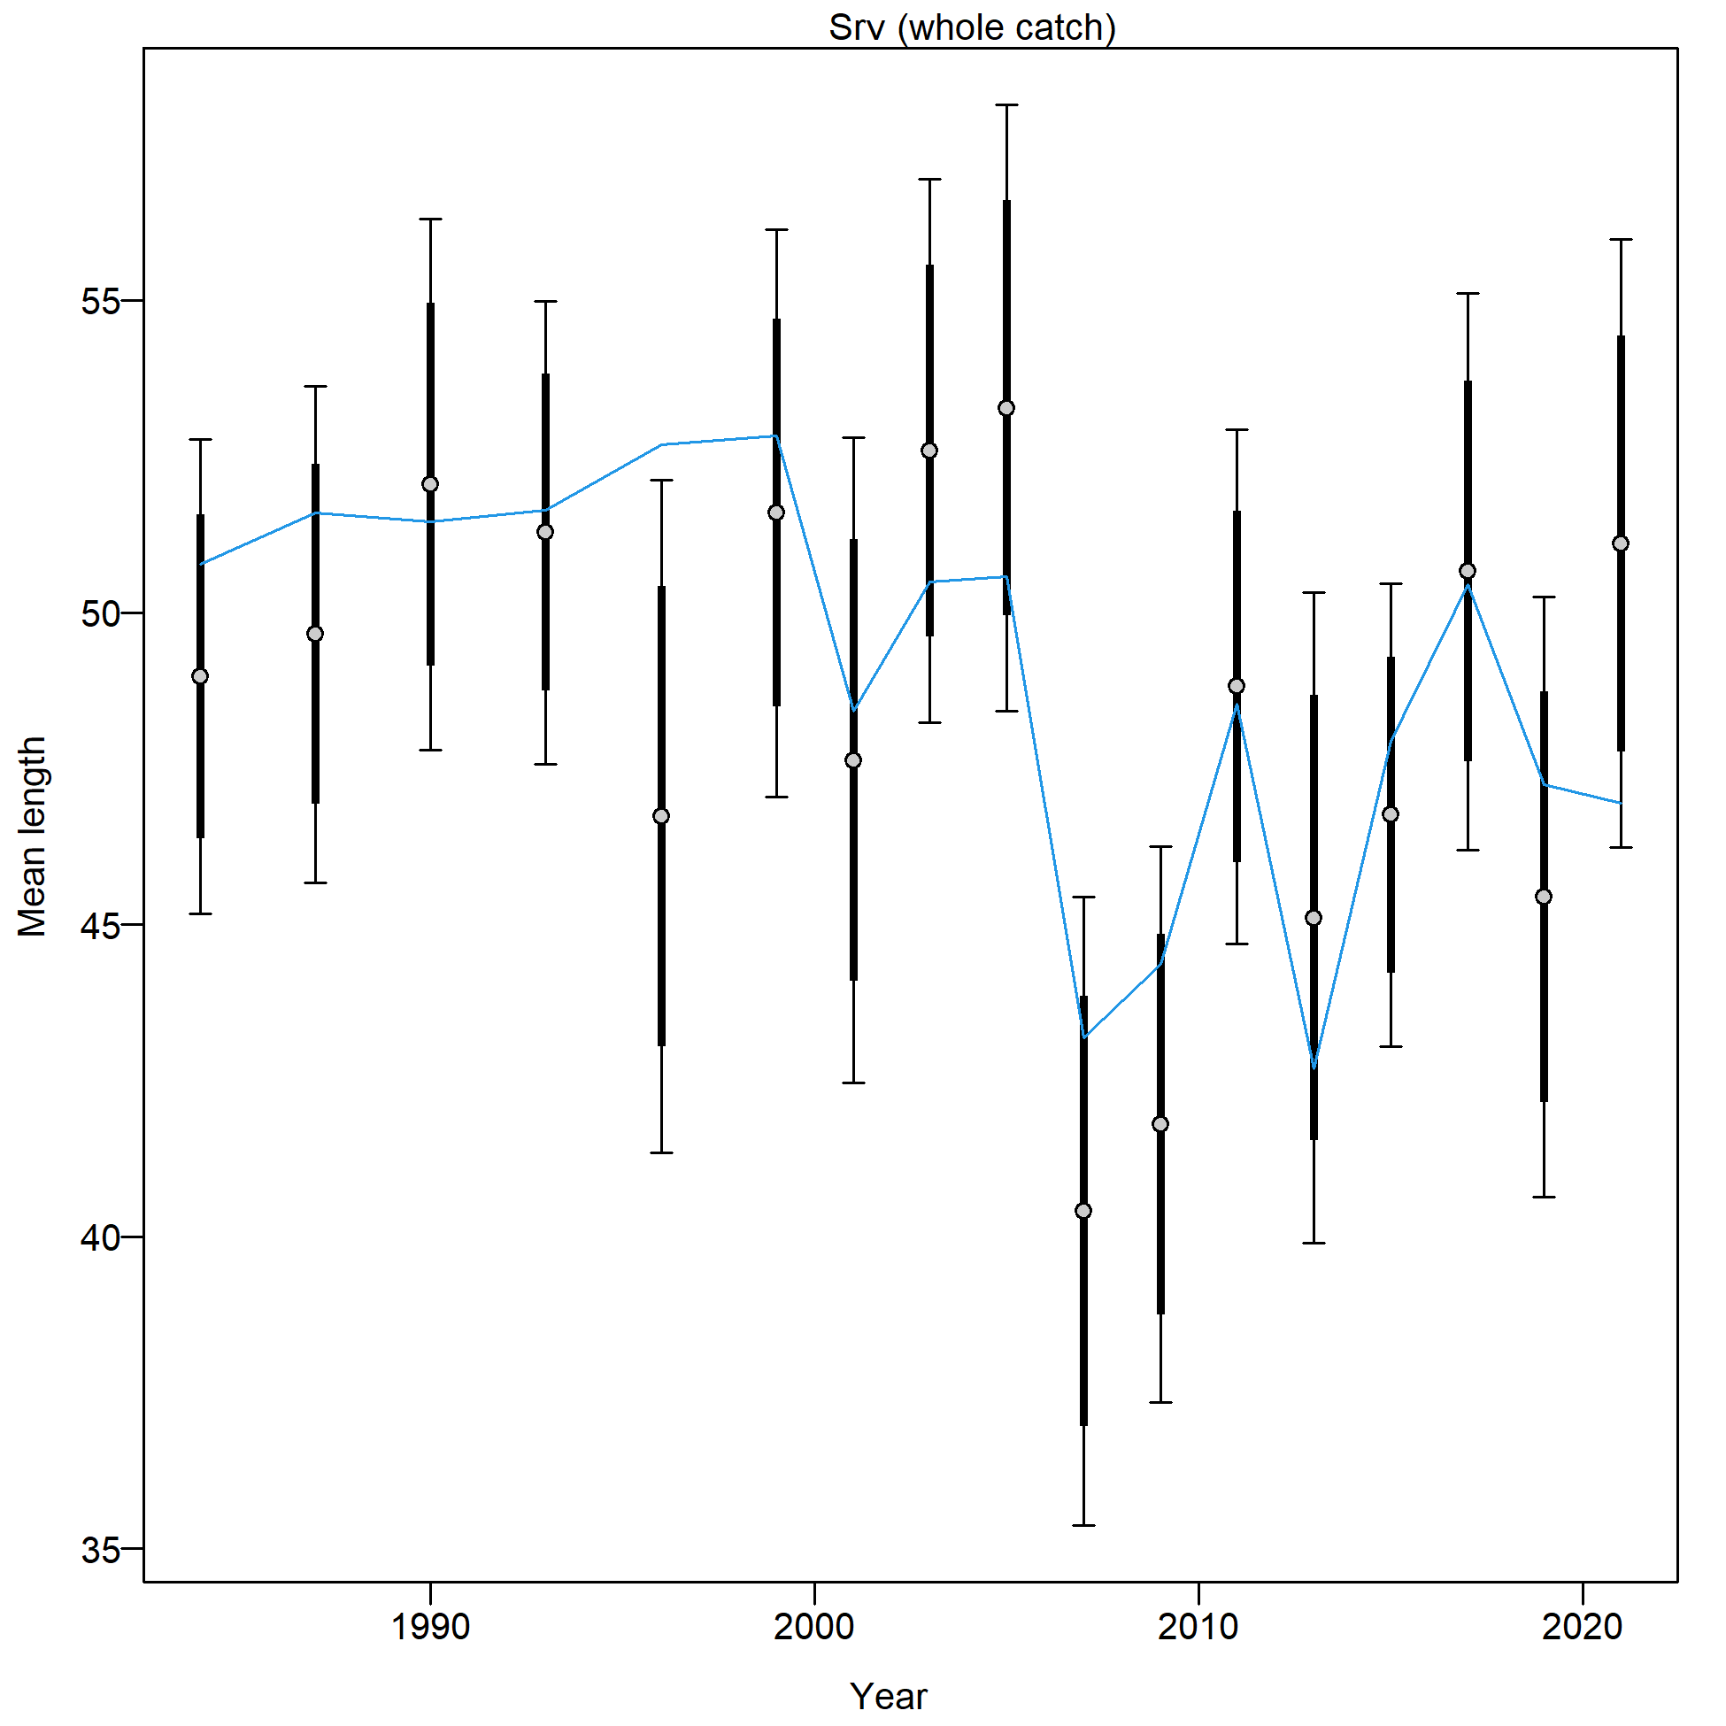

Figure 2.82 NMFS bottom trawl survey length composition and Model 21.2 fit (top), Pearson residuals (left bottom; max = 12.44), and mean length (cm; right bottom).

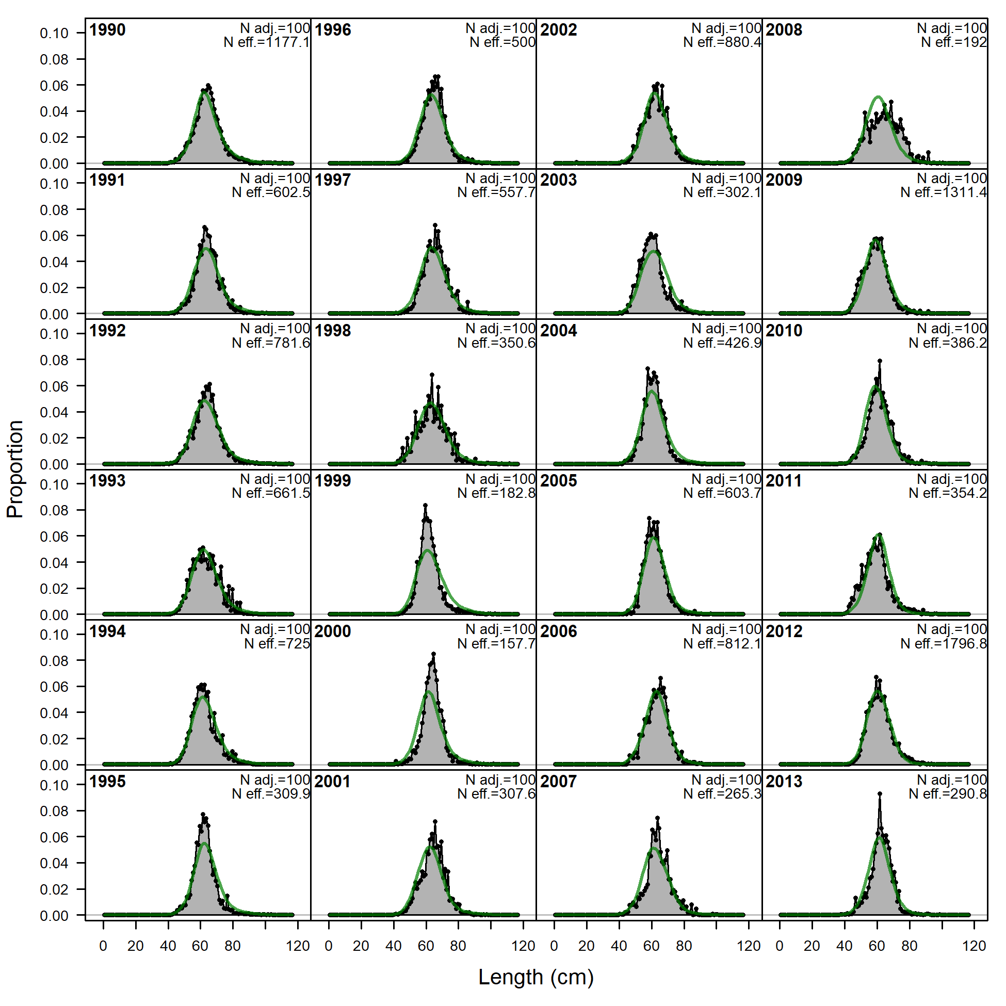 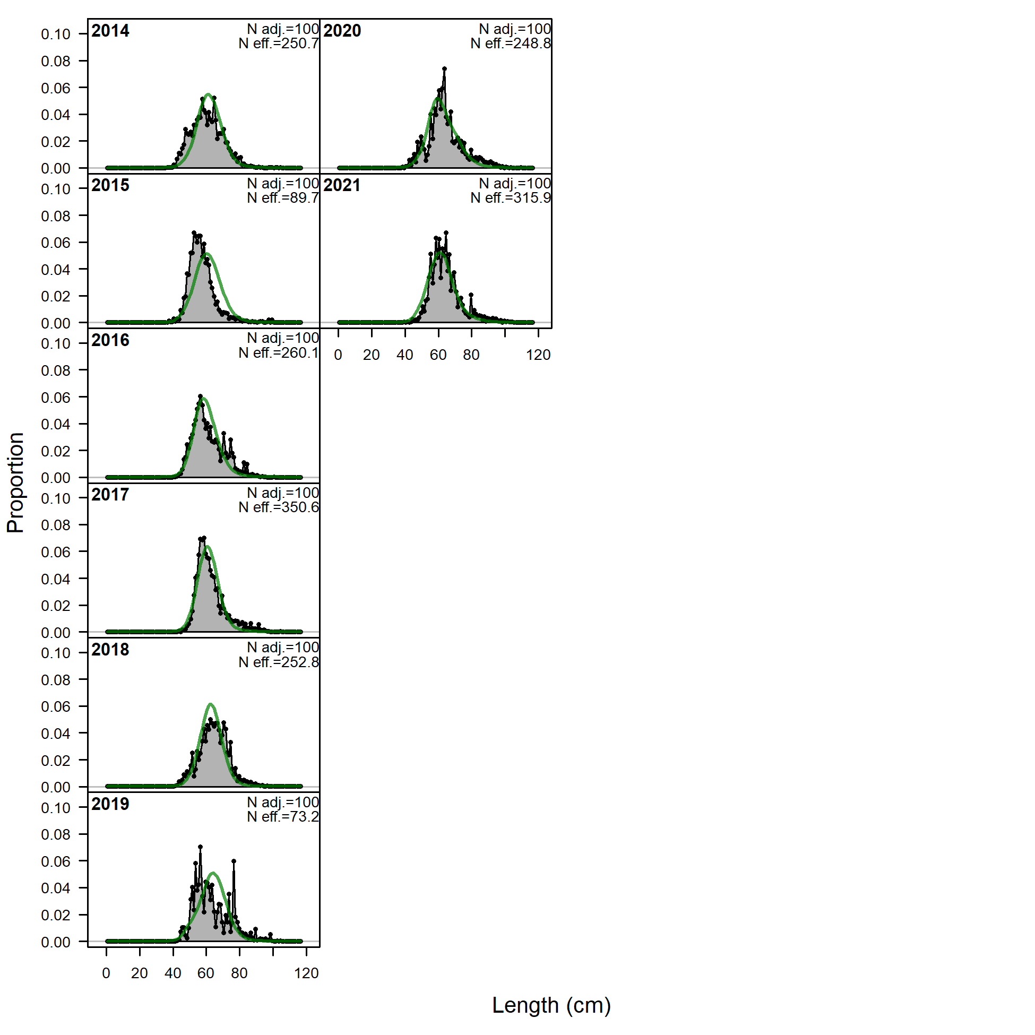

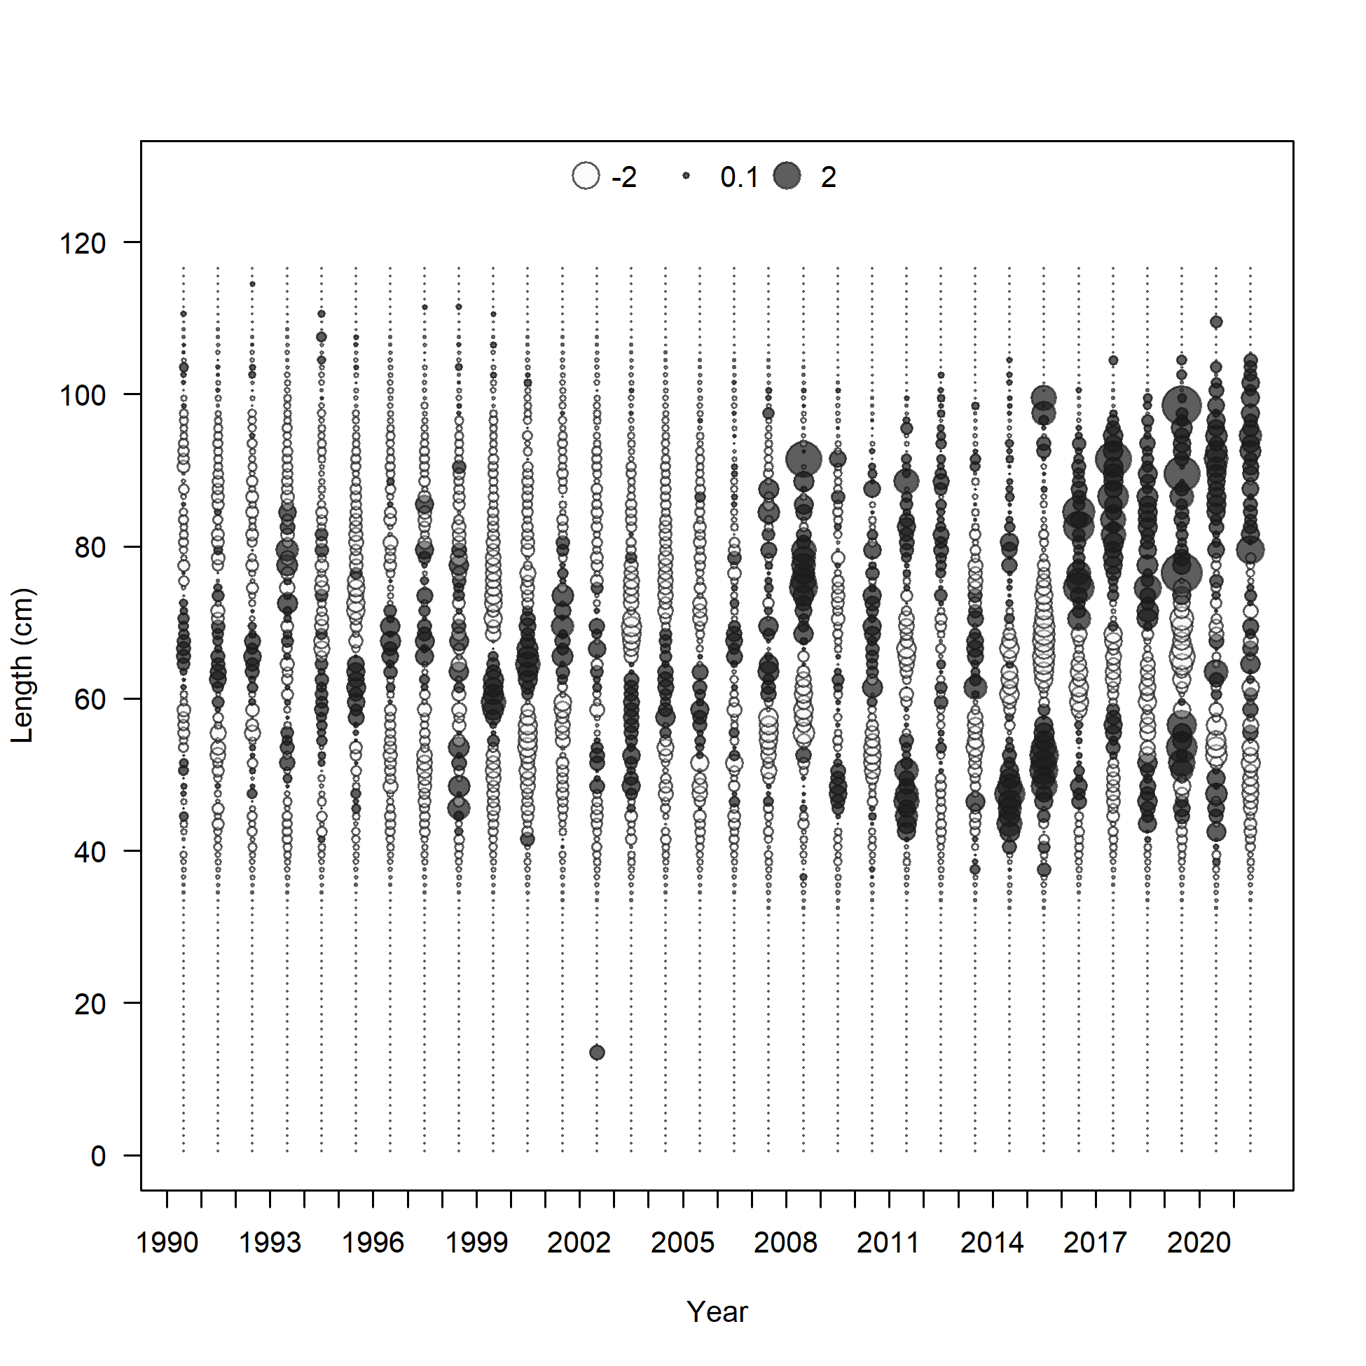 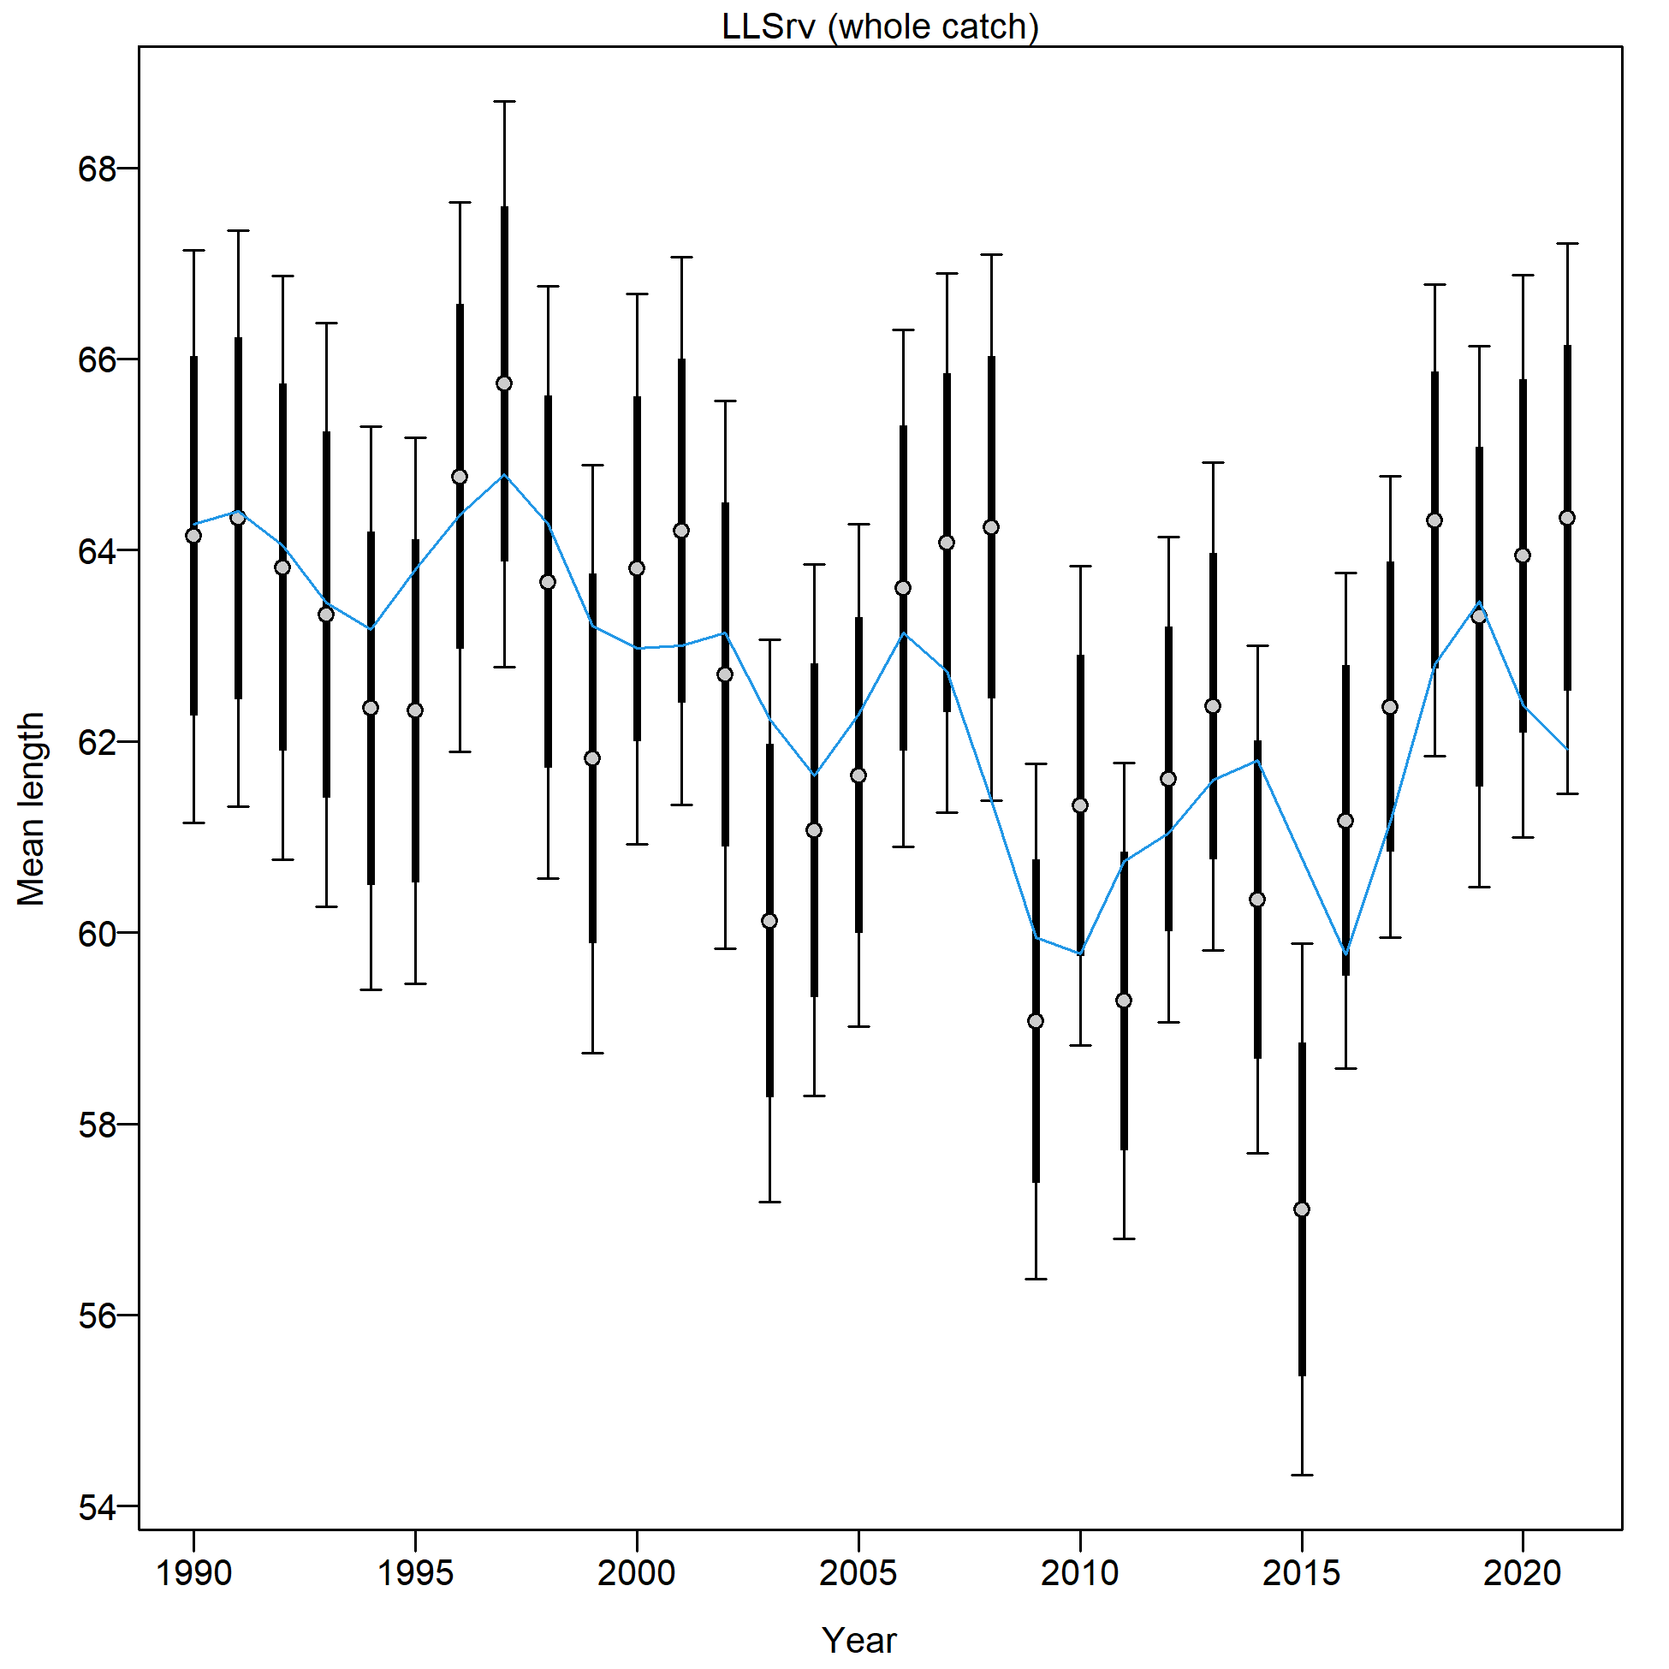

Figure 2.83 AFSC Longline survey length composition and Model 21.2 fit (top), Pearson residuals (left bottom; max=5.19), and mean length (cm; right bottom).

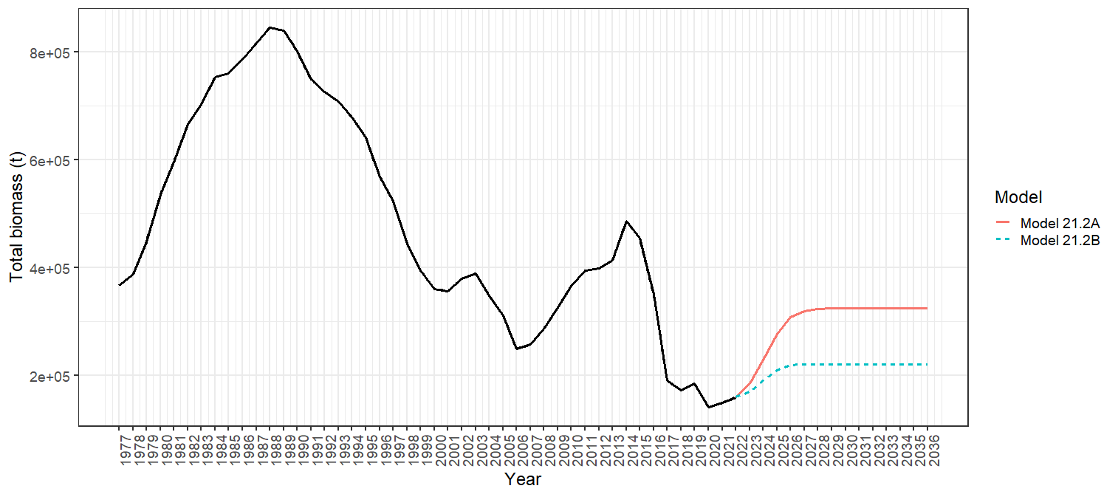

Figure 2.84 Total biomass 1977-2021 for Model 21.2 with Projection A (red solid line) and Projection B (blue dashed line) shown for 2022-2036.

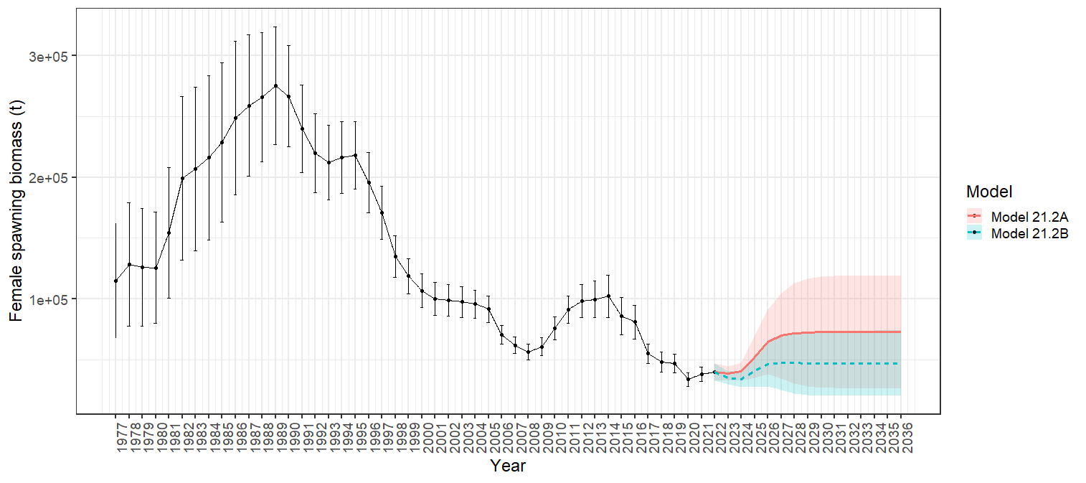

Figure 2.85 Model 21.2 female spawning biomass with 95% asymtotic error intervals with Projection A (red solid line) and Projection B (blue dashed line) shown for 2022-2036.

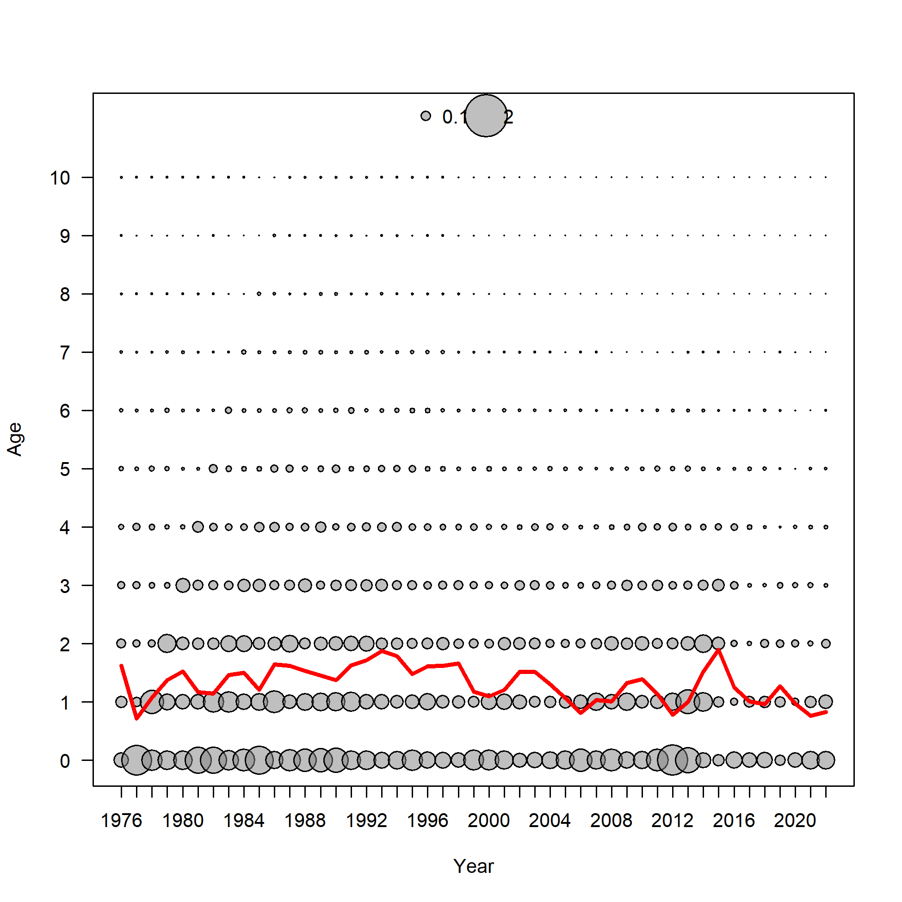 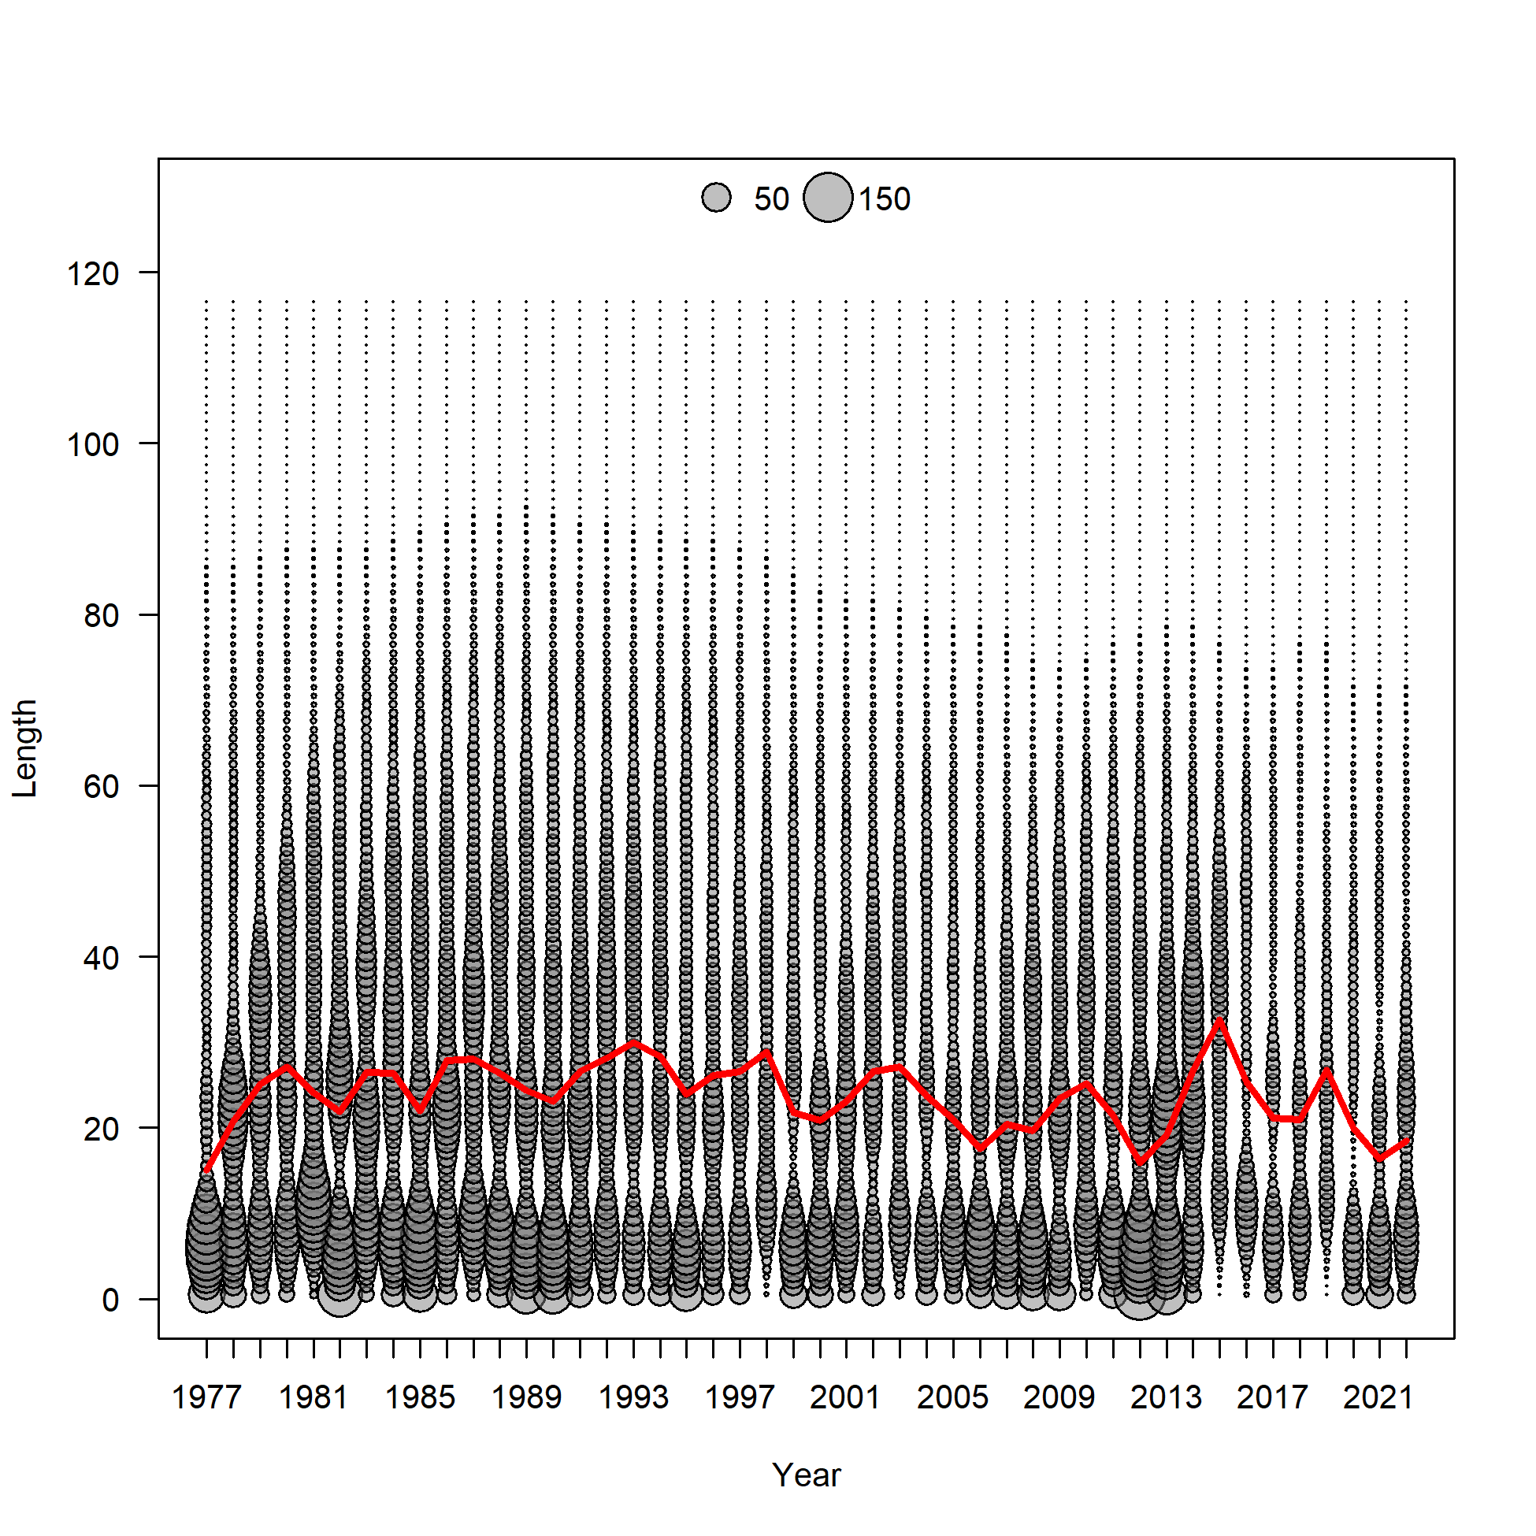

Figure 2.86 Model 21.2 predictions of middle of the year number at age (top) with mean age (red line) and number at length (bottom)with mean length (red line).

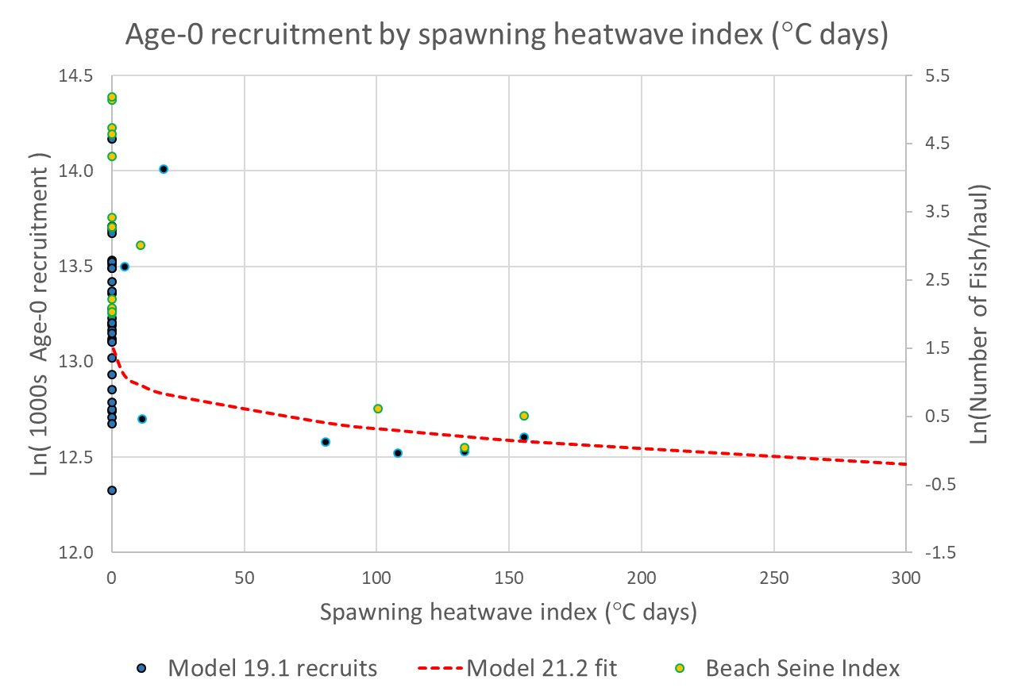

Figure 2.87 Log recruits (1000’1) by spawning heatwave index from the Model 19.1 (blue dots) with spawning heatwave linked recruitment model fit (red line) from Model 21.2. Shown on the secondary y-axis and in yellow are the log of the age-0 beach seine index values (number of fish/haul).

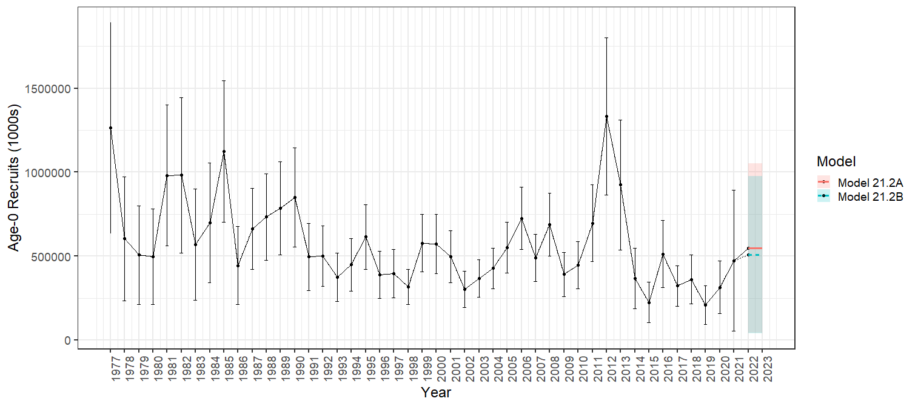

Figure 2.88 Model 21.2 age-0 recruitment (1000’s) with 95% asymtotic error intervals with Projection A (solid red line) and Projection B (dashed blue line).

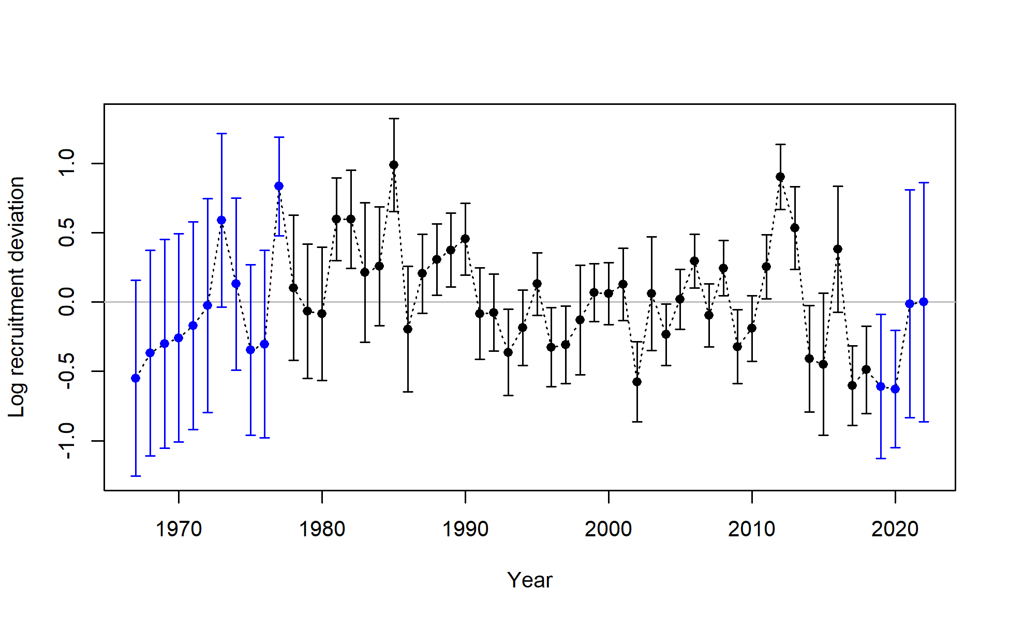

Figure 2.89 Model 21.2 log recruitment deviations with 95% asymtotic error intervals.

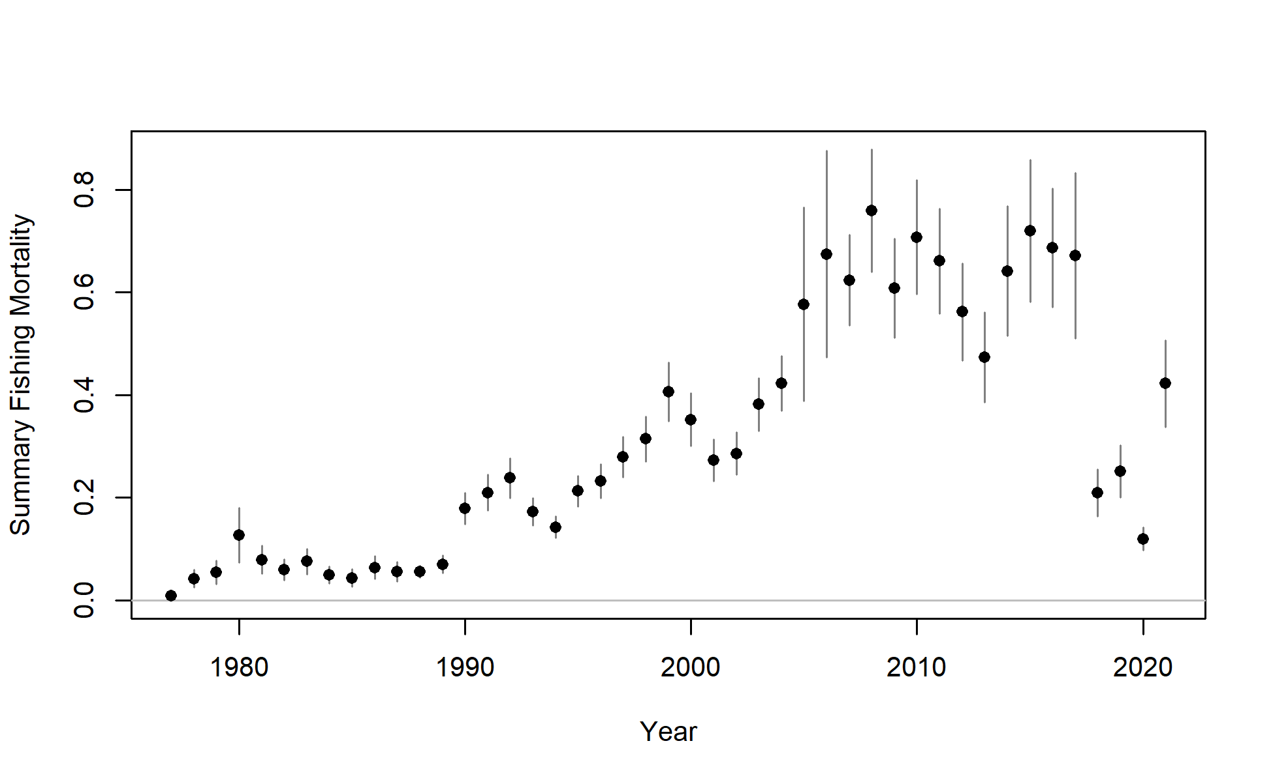 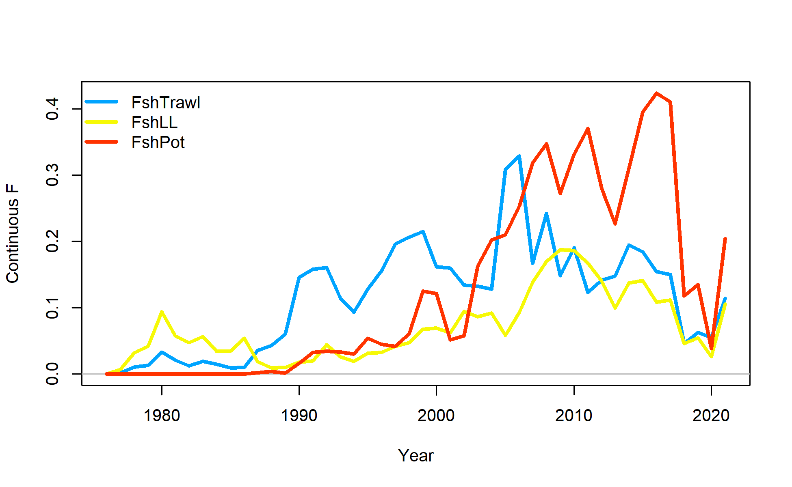

Figure 2.90 Model 21.2 sum of apical fishing mortality (top) and continuos fishing mortality by trawl (FshTrawl), longline (FshLL) and pot (FshPot) fisheries (bottom).

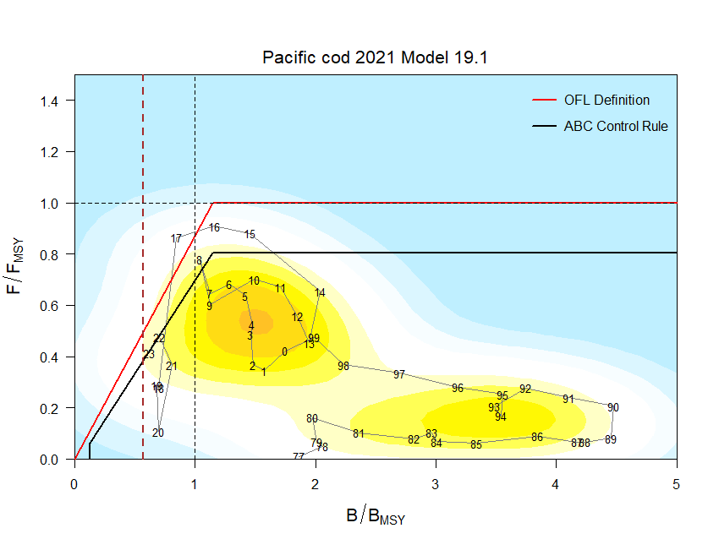 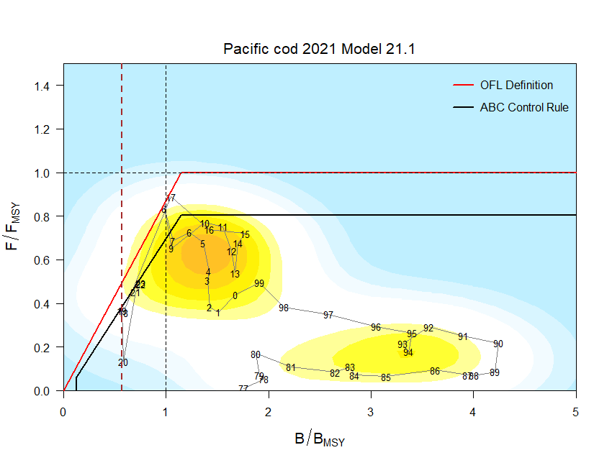

Figure 2.91 For (left) Model 19.1 and (right) Model 21.1 ratio of historical F/*Fmsy* versus female spawning biomass relative to *Bmsy* for GOA pacific cod, 1977-2023. Note that the proxies for *Fmsy* and *Bmsy* are *F35%* and *B35%*, respectively. The Fs presented are the sum of the full Fs across fleets. Dashed line is at B*20%*, Steller sea lion closure rule for GOA Pacific cod.

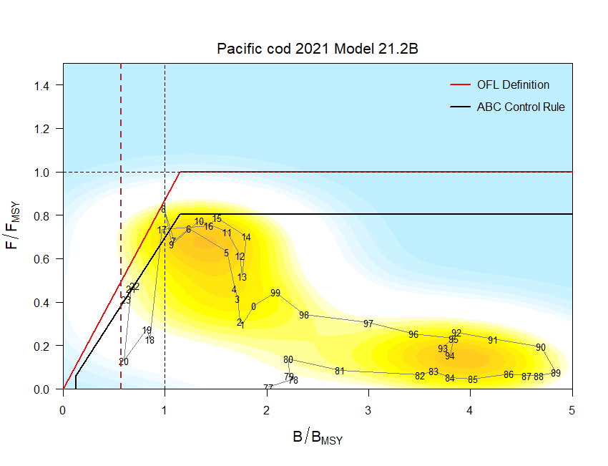

Figure 2.92 For Model 21.2 ratio of historical F/*Fmsy* versus female spawning biomass relative to *Bmsy* for GOA pacific cod, 1977-2023. Note that the proxies for *Fmsy* and *Bmsy* are *F35%* and *B35%*, respectively. The Fs presented are the sum of the full Fs across fleets. Dashed line is at B*20%*, Steller sea lion closure rule for GOA Pacific cod.

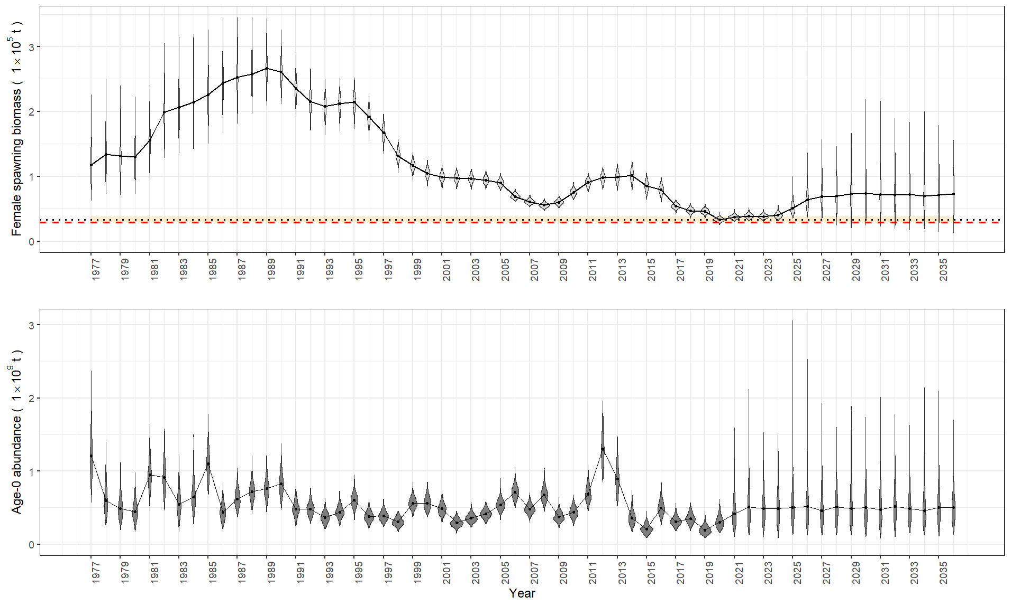

Figure 2.93 Model 21.2 with Projection A MCMC posterior distribitions of beginning of the year female spawning biomass (top) and age-0 abundance (bottom) for 1977-2036. Dotted line is the projected SSB*20%* with 95% confidence interval in orange and the red dashed line is SSB17.5%.

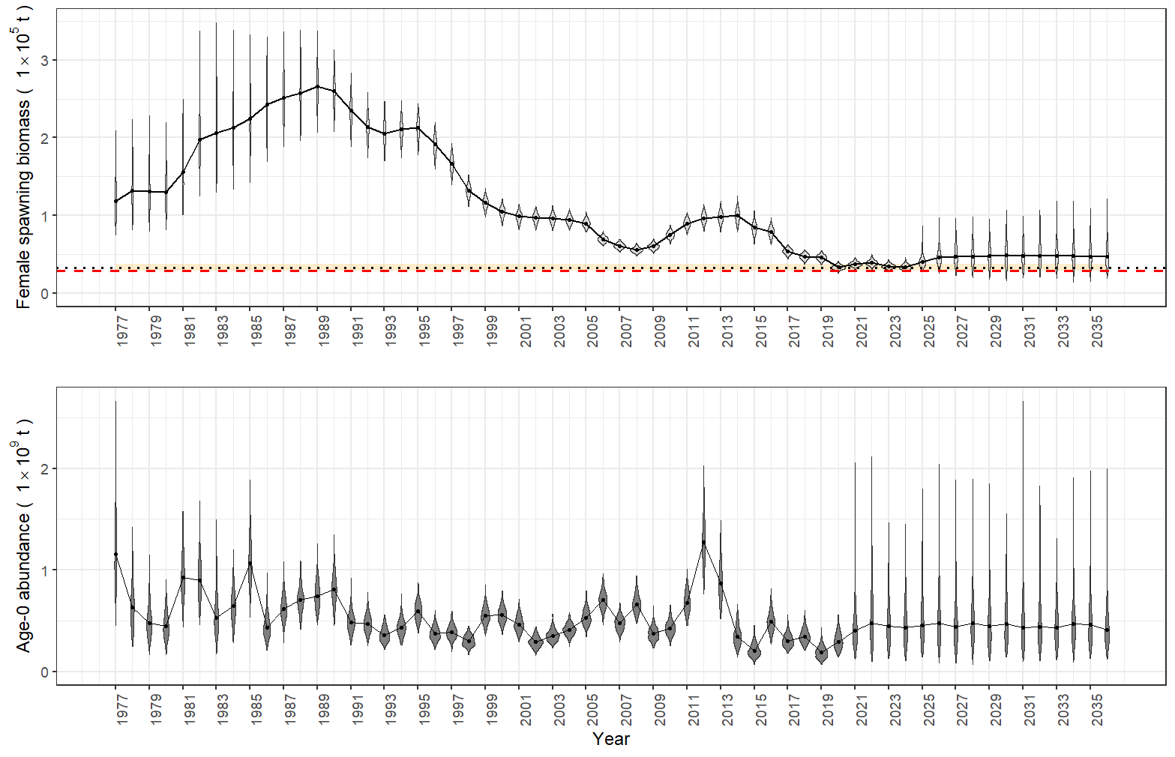

Figure 2.94 Model 21.2 with Projection B MCMC posterior distribitions of beginning of the year female spawning biomass (top) and age-0 abundance (bottom) for 1977-2036. Dotted line is the projected SSB*20%* with 95% confidence interval in orange and the red dashed line is SSB17.5%.

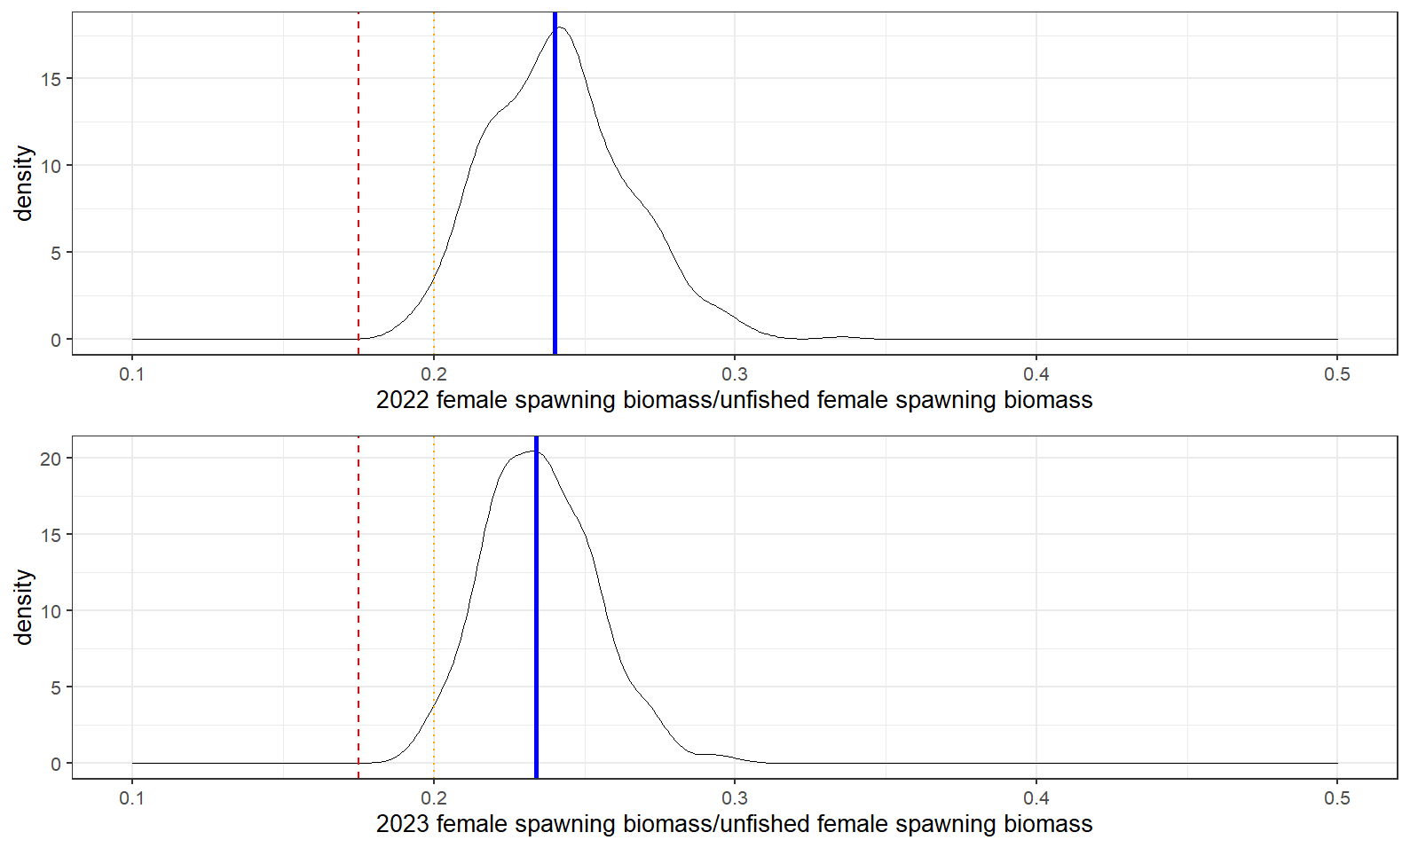

Figure 2.95 Model 21.2 MCMC Projection A posterior distribitions of the 2022 (top) and 2023 (bottom) spawning stock biomass ratio with estimates for SSB20% (orange dotted line) and SSB17.5% (Red dashed line) from the projection model, and posterior median (blue solid line) for beginning year 2022 and 2023.

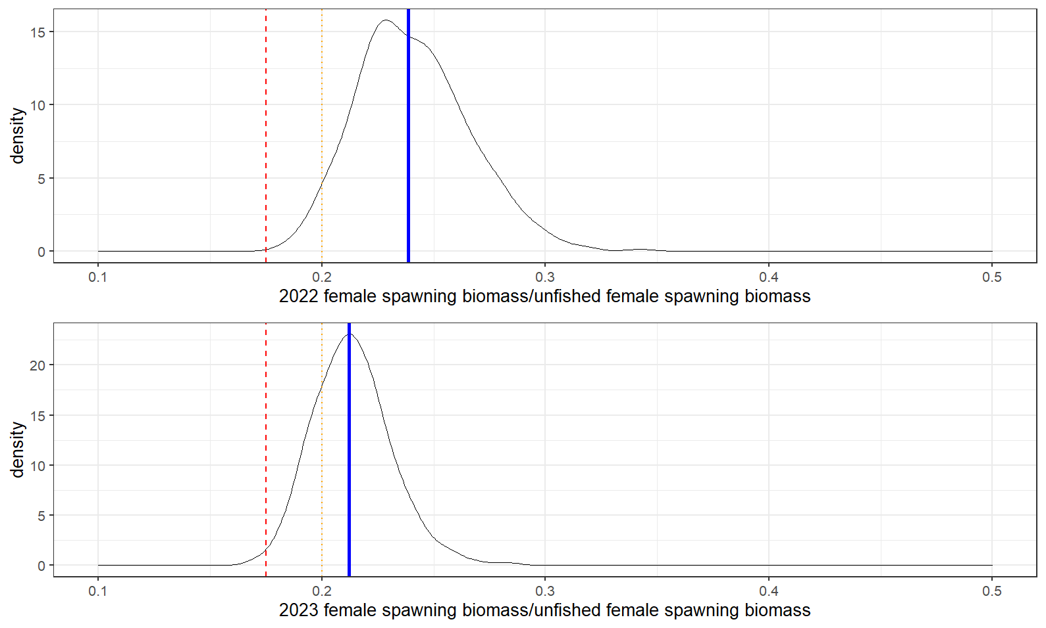

Figure 2.96 Model 21.2 MCMC Projection B posterior distribitions of the 2022 (top) and 2023 (bottom) spawning stock biomass ratio with estimates for SSB20% (orange dotted line) and SSB17.5% (Red dashed line) from the projection model, and posterior median (blue solid line) for beginning year 2022 and 2023.

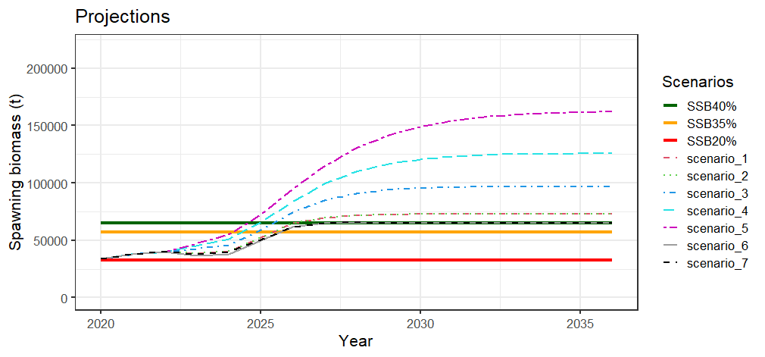 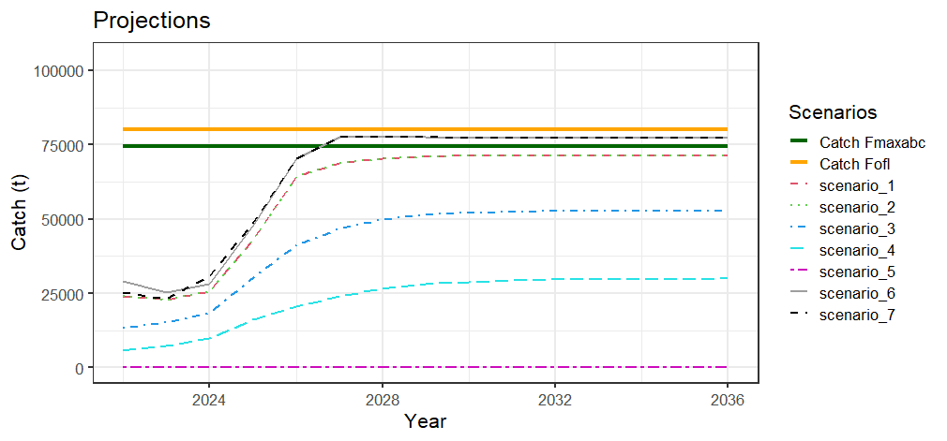

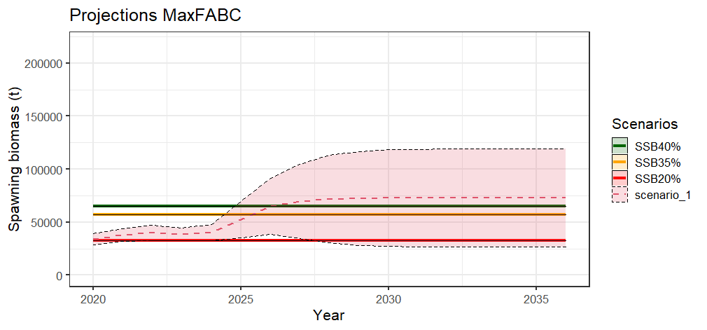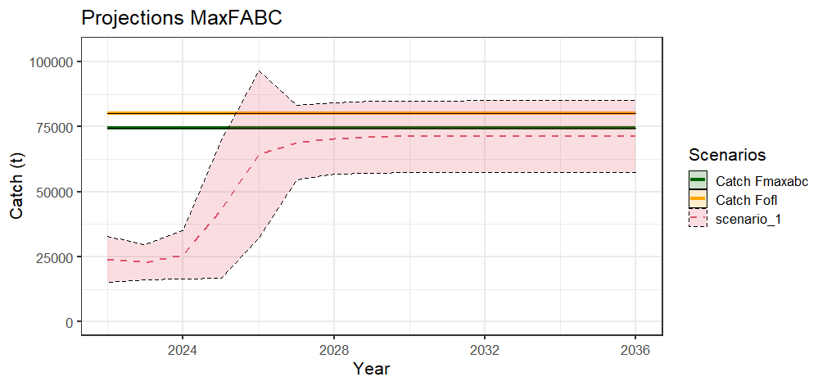

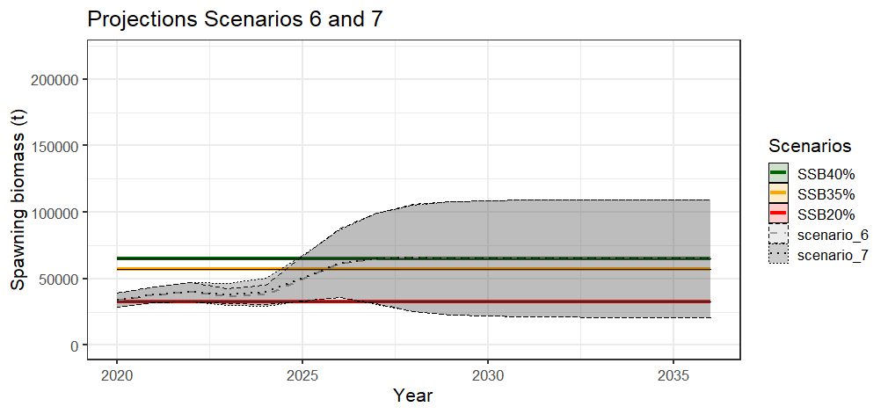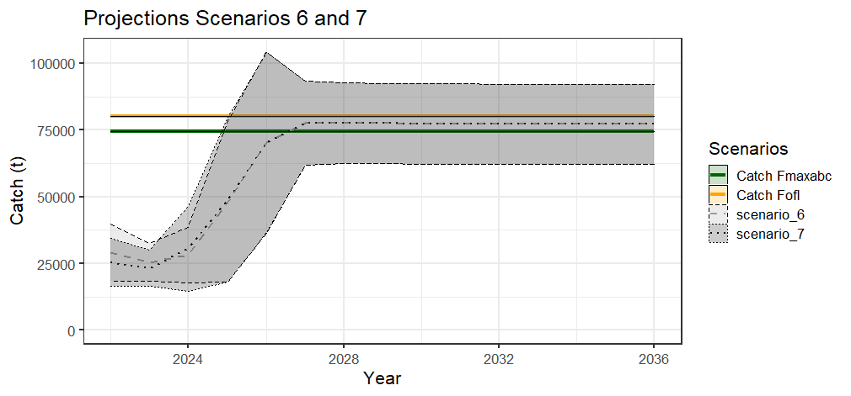

Figure 2.97 Model 21.2A projections of female spawning biomass (top left ) and catch (top right) for the seven management scenarios, for scenario 1 a max ABC (middle), and scenarios 6 and 7 for status determination (bottom ).

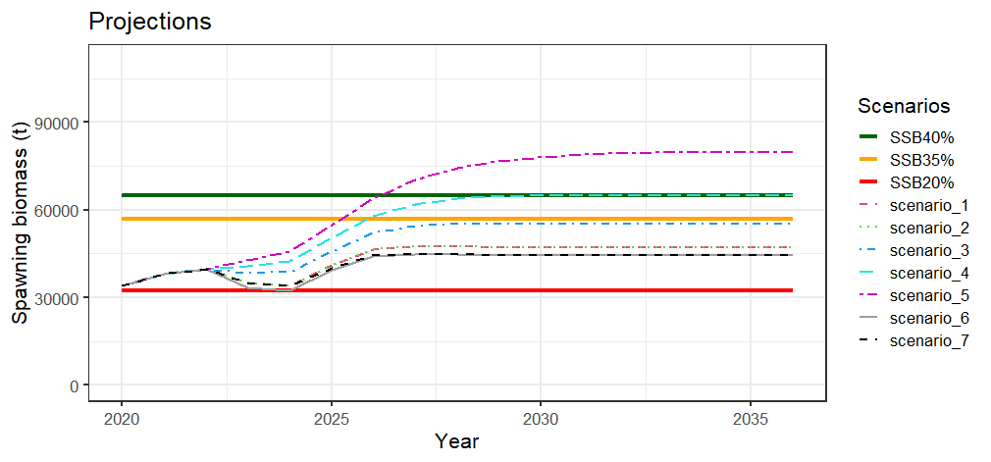 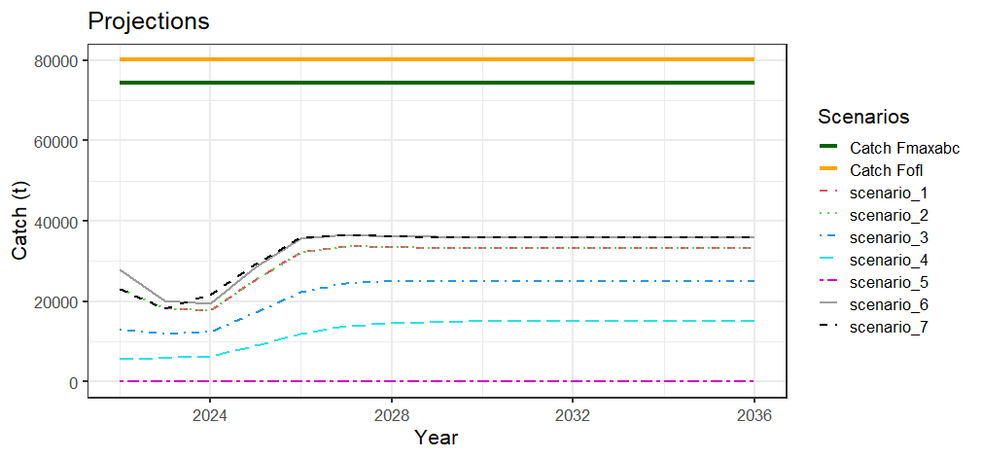

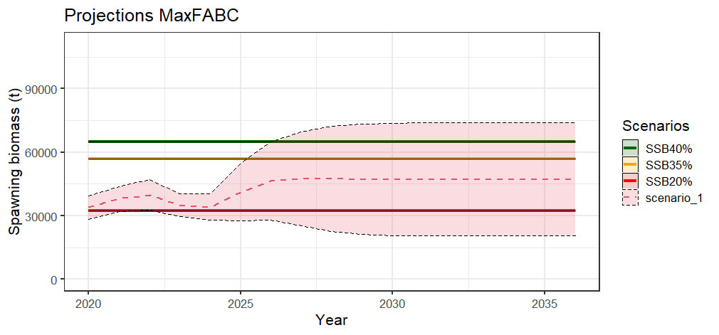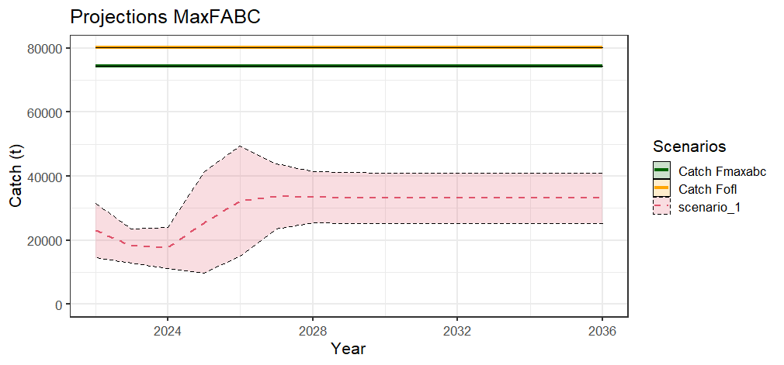

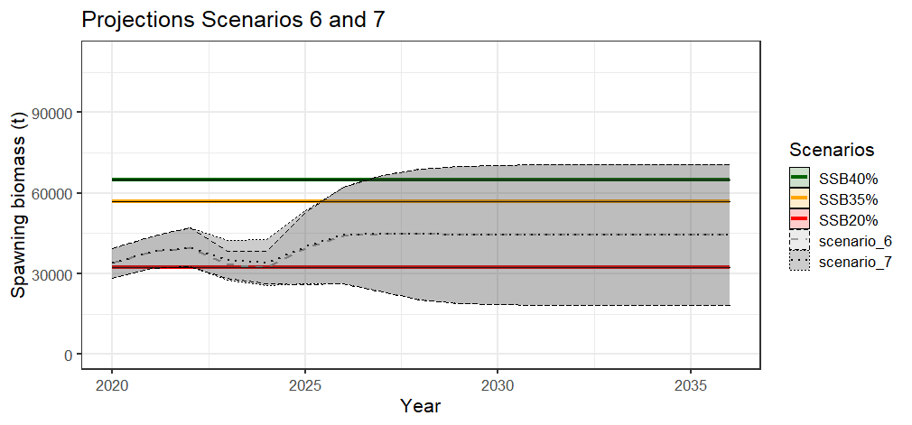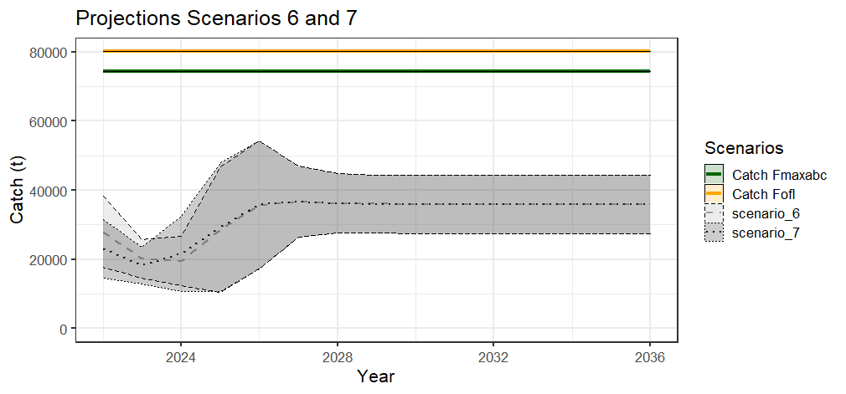

Figure 2.98 Model 21.2B projections of female spawning biomass (top left ) and catch (top right) for the seven management scenarios, for scenario 1 a max ABC (middle), and scenarios 6 and 7 for status determination (bottom ).

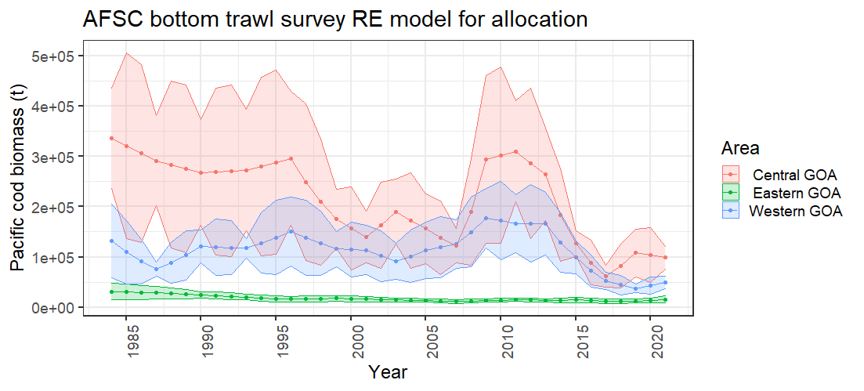

Figure 2.99 Random effects model results for the AFSC bottom trawl survey area used for area allocation.